Human OCR | Gemini OCR | CER (Character Error Rate)
33. x–y+1 = 0  If x =2 if x = 0 if x =1  2–y + 1 = 0 0 – y + 1 = 0 1 – y + 1 = 0  3 = y 1 = y 2 = y  Image: image7.wmf  Image: image8.wmf  if x = 2 3x+2–12=0 If x = 4  12–+2y = 0  y =0  Image: image9.png  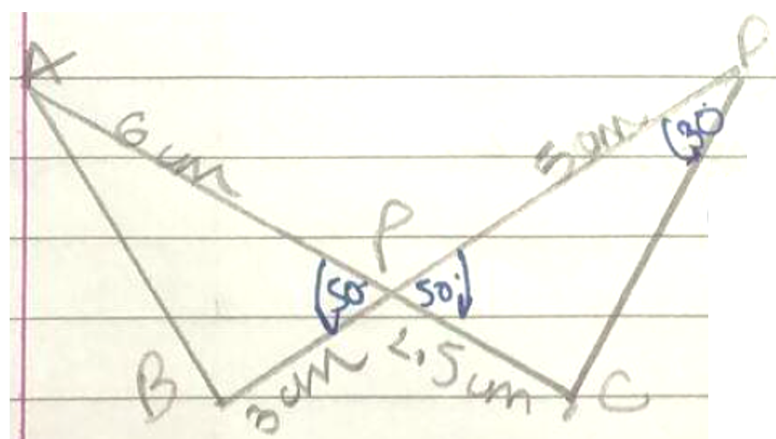  Virti us of  A – (2, 3)  B – (–1, 0)  C – (4, 0)  x1 = 2 y1 = 3  x2 = (–1) y2 = 0  x3 = 4 y3 = 0  area of  area of | <diagram_1>  m:n=3:1  m=3x  n=x  x₁=4 x₂=8  y₁=(-3) y₂=5  x = mx₂+nx₁ / m+n  = 3x(8)+x(4) / 3x+x  = 4x(6+1) / 4x ⇒ x=7  y = my₂+ny₁ / m+n  = 3x(5)+x(-3) / 3x+x  = 3x(5-1) / 4x ⇒ [3=y] | 82.8%

