Human OCR | Gemini OCR | CER (Character Error Rate)
Image: image153.png  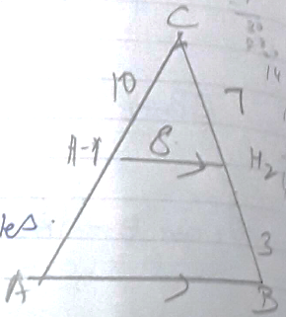  16. Given  To prove that  Statement Reason  DE ̸ ̸ BC Basic proportionality theorem Common angle By SAS similarity criteria. | 16. Given  ΔABE ≈ ΔACD  <diagram_3>  To Prove that  ΔADE ≈ ΔABC  | Statement | Reason |  |---|---|  | AE/AB = AD/AC | Given |  | If two sides are equal from equal  wholes are equal. |  | DB/AB = EC/AC (2) | Basic Proportionality Theorem |  | DB/AB = AD/AB | |  | AE/AC = EC/AC | |  | AD/DB = AE/EC | Basic Proportionality Theorem |  | DE || BC | |  | ∠A=∠A | Common angle |  | P ΔADE ≈ ΔABC | By SAS similarity criteria | | 789.2%

