Human OCR | Gemini OCR | CER (Character Error Rate)
18.  Image: image1.png  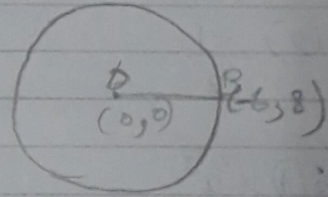  18. | 18. A(-2,1) B C(x,y)  B= (x₀,m₁+x₁m₂ / m₁+m₂ ; y₀m₁+y₁m₂ / m₁+m₂)  = (1x3+(-2)x2 / 3+2 ; 1x3+7x2 / 3+2)  = (3-4/5 ; 3+14/5)  = (-1/5, 17/5) | 463.6%

