Human OCR | Gemini OCR | CER (Character Error Rate)
25. Section formula  Image: image10.png  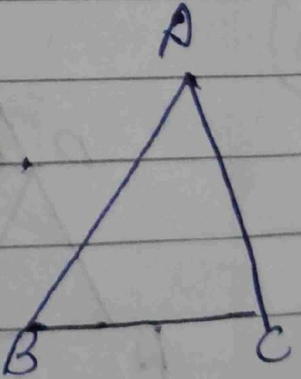  →  → 1 (1) + x | 26) cosecθ-sinθ=m, secθ-cosθ=n  ((cosecθ-sinθ)²(secθ-cosθ))²/³ + | 119.0%

