Human OCR | Gemini OCR | CER (Character Error Rate)
Image: image1.png  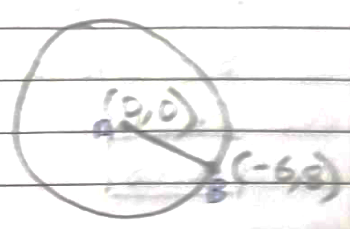  10. Given  PD||BC,  To prove,  PE||AC  Proof,  As AD||BC  [BPT] ……(i)  Also,  (given) ……(ii)  From equation (i) and (ii)  By converse of BPT,  Hence, proved. | Given,  PD||BC,  AD/DC = CE/BE  To prove,  PE||AC  Construction,  Join DE  Proof,  As PD||BC,  AD/DC = AP/PB (BPT) --- (i)  Also,  AD/DC = CE/BE [given] --- (ii)  From eq. (i) and (ii),  AP/PB = CE/BE  By converse of BPT,  [PE||AC]  Hence, proved <diagram_1> | 84.8%

