12. Given are, u = –25 cm
f = – 15 cm
h1 = 4 cm
v = ?
ho = ?
(i) Using mirror formula =
⇒
⇒
⇒
U = –37.5

(ii)

= –6 cm

(iii)
Image: image33.png
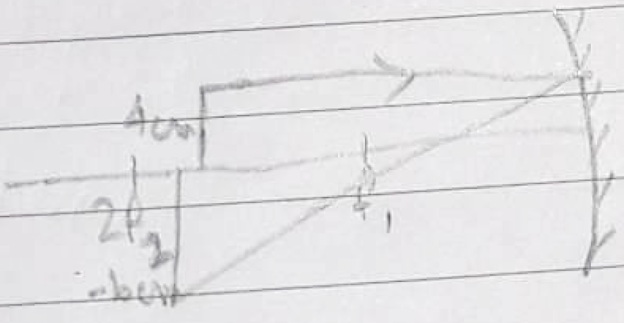
Real, Inverted

