4. (2) Common defect of vision
(1) Myopia
(2) Hypermetropia
Myopia can be corrected by using concave lens
Image: image9.png
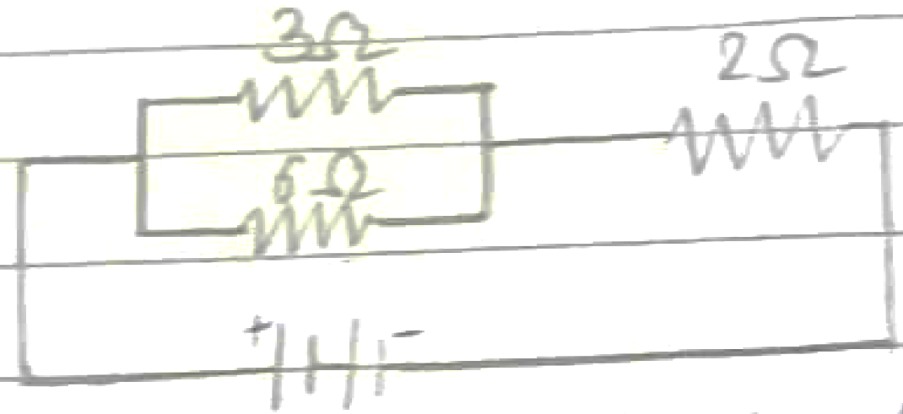

Correction for Myopia

Hypermetropia can be corrected by using convex lens
Image: image10.wmf

Correction for Hypermetropia

