7. Circuit symbol of five important components are –
(1)
Image: image27.wmf

(2)
Image: image28.png
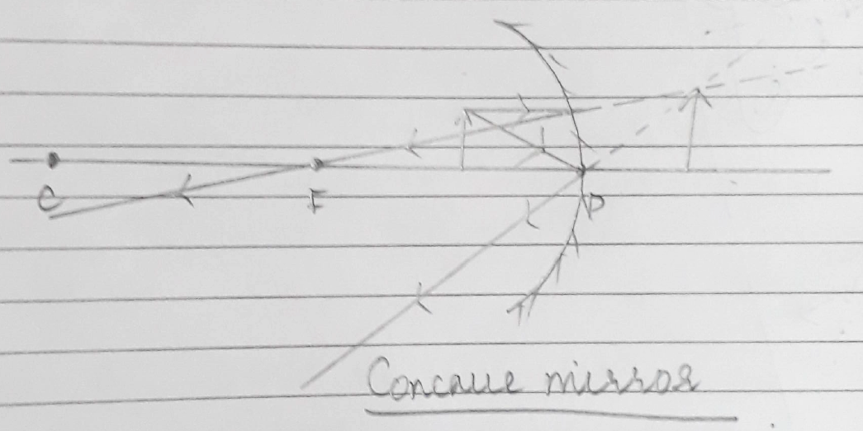
(2)
(3)
Image: image25.wmf

(3)
(4)
Image: image1.wmf

(4)
(5)
Image: image2.wmf

(5)
(6)
Image: image3.wmf

(6)
(7)
Image: image4.wmf

(7)
(8)
Image: image5.png
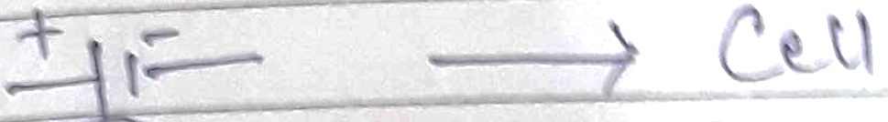
(8)

