Human OCR | Gemini OCR | CER (Character Error Rate)
12. Given are, u = –25 cm  f = – 15 cm  h1 = 4 cm  v = ?  ho = ?  (i) Using mirror formula =  ⇒  ⇒  ⇒  U = –37.5  (ii)  = –6 cm  (iii)  Image: image33.png  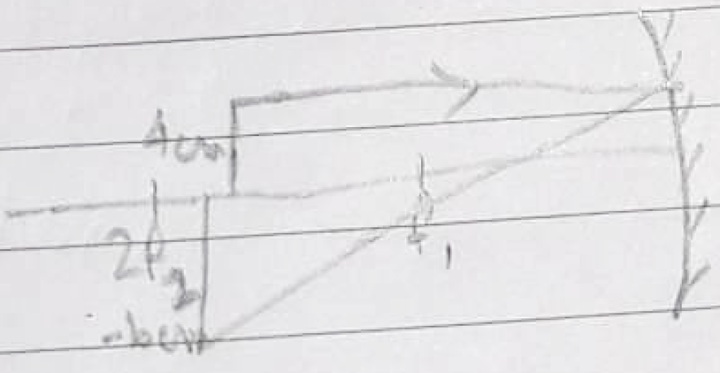  Real, Inverted | 12. (i) given are, u = -25 cm  f = -15 cm  h_o = 4 cm  v = ?  h_i = ?  i) By using mirror formula : 1/f = 1/v + 1/u  1/-15 = 1/v + 1/-25  => 1/v = 1/-15 + 1/25 => 1/v = -5 + 3 / 75 = -2 / 75  => v = -75/2 => v = -37.5  v = -37.5  (ii) hi/ho = -v/u => hi/4 = -(-37.5) / -25 => 4 = 37.5 / 25 => 100/37.5  hi = -4 x 37.5 / 25  hi = -150/25 = -6cm  (iii) Real, Inverted  <diagram_2> | 156.5%

