Human OCR | Gemini OCR | CER (Character Error Rate)
4. (2) Common defect of vision  (1) Myopia  (2) Hypermetropia  Myopia can be corrected by using concave lens  Image: image9.png  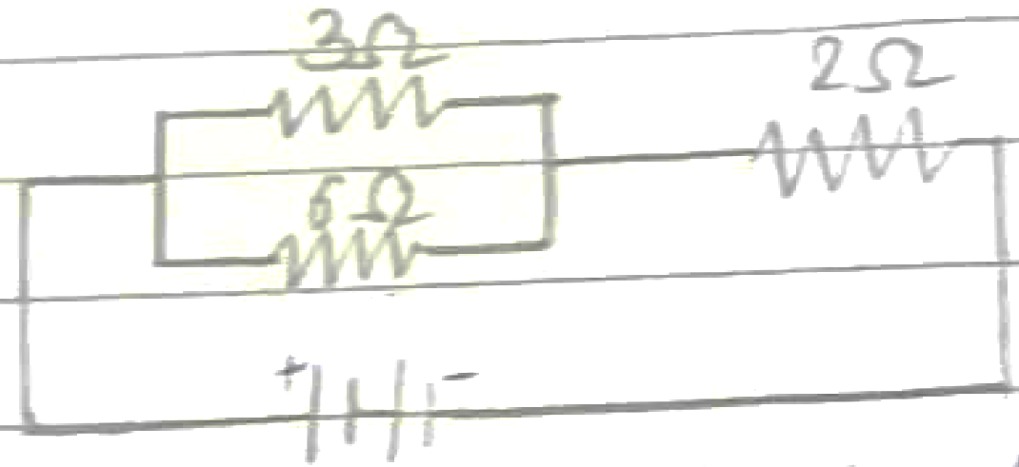  Correction for Myopia  Hypermetropia can be corrected by using convex lens  Image: image10.wmf  Correction for Hypermetropia | 4) Ans -> 2 common deffect defects of vision :-  (i) Myof Myopia  (ii) Hypermetropia  Myopia can be corrected by using concave lens  <diagram_1>  Correction for Myopia.  Hypermetropia can be corrected by using Convex lens.  <diagram_2>  Correction for Hypermetropia | 24.8%

