Human OCR | Gemini OCR | CER (Character Error Rate)
7. Circuit symbol of five important components are –  (1)  Image: image27.wmf  (2)  Image: image28.png  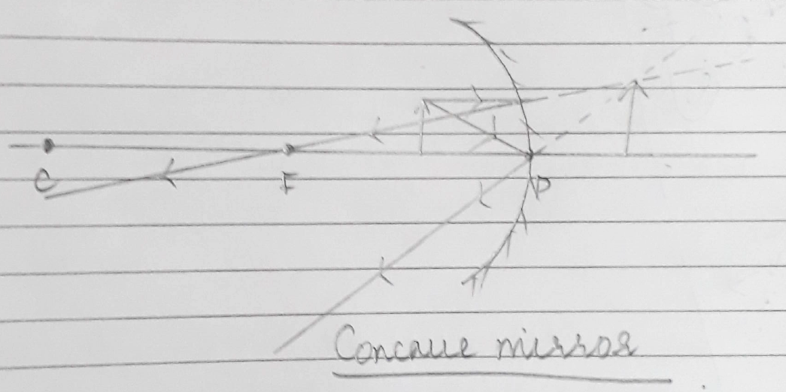  (2)  (3)  Image: image25.wmf  (3)  (4)  Image: image1.wmf  (4)  (5)  Image: image2.wmf  (5)  (6)  Image: image3.wmf  (6)  (7)  Image: image4.wmf  (7)  (8)  Image: image5.png  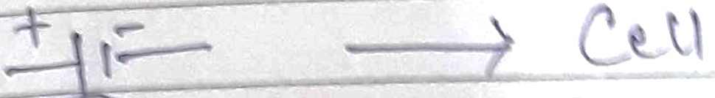  (8) | Characteristics of observed image  1) Magnified Image  2) Erect and behind the mirror.  3) Virtual Image.  RAY DIAGRAM  <diagram_2> | 77.3%

