

DEPARTMENT OF ELECTRICAL, COMPUTER AND TELECOMMUNICATION ENGINEERING
EEEN 414: DIGITAL SIGNAL PROCESSING

LAB 1: FILTER DESIGN AND ANALYSIS LESANG CHARLES MATABANA 19001113 ATANG KGOTLAESELE 19001124 PRINCE AOBAKWE PAPATSO 19001127

TABLE OF CONTENTS
ABSTRACT 2
INTRODUCTION 2
PROCEDURE 3
Designing the Filters 3
Designing the Filters in Simulink 4
RESULTS 5
Designing the Filters in Simulink 6
DISCUSSIONS 23
CONCLUSION 23
REFERENCES 24

ABSTRACT
This experiment deal with the design of Finite Impulse Response FIR using Blackman window and Infinite Response Filter design. Filtering is a form of signal processing where a device is used to processes by completely or partially suppresses components of a signal. Evaluation of Finite impulsive response and Impulsive filter responses time response and selection of filter types of filter types (high-pass/low-pass/band- pass/band-stop; finite/infinite impulse response, FIR/IIR). Design,comparison and evaluation ,Simulation ,Build the circuit ,Test the circuit and implementation as well as user interfacing.The design and test was done using MATLAB/Simulink via the filter design and analysis tool and the filters design techniques.

INTRODUCTION
Digital frequency-selective filters to be used to remove or filter out noise from a signal. Recall the concept of the ideal lowpass filter, which is simply visualized in the frequency domain as the rectangle function (of a specified width and cantered at the origin). Also recall that this filter, although handy in theory, is not implemented in practice. There are several reasons why ideal (lowpass, bandpass, high pass, and band-stop) filters are not used in real-life:
- The impulse response, h[n] is non-causal because of the Paley-Wiener theorem, which implies these filters cannot be implemented in practice on a DSP. Another way to think about this is that h[n] has infinite support for any of the ideal filters. Thus, it cannot be zero for n < 0 making it necessarily non-causal.
- When implemented in software or hardware, due to the finite number of elements employed for processing, an ideal filter exhibits the undesirable Gibbs phenomenon. In signal and image processing, this shows up as the infamous ringing effect, i.e. it introduces extra unwanted artifacts. To bypass the above inadequacies, the design of digital filters using the windowing technique is an alternative to ideal filters. These filters can be implemented as FIR filters, and make use of the well-known Bartlett, Blackman, Hamming, Hanning, and Kaiser windows. The shortcoming of digital filter design via windowing techniques is that one cannot individually control the design parameters of the filter.

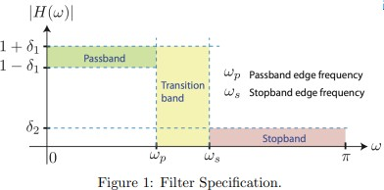

By making the transition band (frequencies between ωp and ωs) narrower, you must make a sacrifice in the form of larger undesirable ripples in the pass-band (frequencies between 0 and ωp) and stop-band (frequencies exceeding ωs); that is smaller ωs − ωp necessitates δ1 and δ2 larger These trade-offs are all due to bypassing the two inadequacies of ideal filters. The above specifications are general and do not delineate the form of the digital filter. In practice we would prefer either a rational system function corresponding to FIR or IIR filters discussed in the lectures. Thus, we consider using the difference equation, or ARMA (autoregressive moving average) model given in equations
- and (2) representing the descriptions in the time-and frequency-domain, respectively.
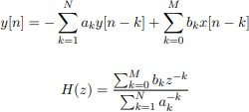

Also, IIR filters are generally less complex than FIR filters (the difference being that for FIR filters there is a restriction that ak = 0 for all k), as they require fewer parameters and less memory for the same “quality” of filter performance. IIR filters can often be defined analytically as a rational function in the z-transform domain, and the general description of the filter in Figure 1 is not z-transform friendly (yet) - it’s analogue[1]. Fortunately one can design a filter meeting Figure 1 specifications, and then transform the resulting filter to a z-transform friendly filter by using popular transformation techniques such as approximation of derivatives, impulse response, bilinear transformation (most popular), and matched z-transform techniques. Luckily, MATLAB has a little GUI driven filter design program, the FDA tool or the Filter designer tool which we can use by just a click of buttons[2].

PROCEDURE

Designing the Filters
The following steps were used to complete this lab. Digital filters were designed using Filter Designer application on MATLAB software assuming that the sampling rate was 8 kHz.
  - Design a minimum order, stable (check if the filter is stable using information “i” button), lowpass Butterworth filter with a passband frequency of 1 kHz and a stopband frequency of 1.4 kHz. Make the attenuation 1 dB at the passband frequency and 80 dB at the stopband frequency.
  - Design a minimum order, stable, lowpass Chebyshev Type I filter with the same specifications as the Butterworth filter.
  - Design a lowpass FIR filter using the Blackman Window with a cutoff frequency of 1 kHz. Specify the order of the filter such that the first minimum in the stopband (preceding the first lobe) is as close to 1.4 kHz as possible without exceeding it.

Designing the Filters in Simulink
Now that the filters have been designed using filter Designer, they are to be implemented in MATLAB/SIMULINK application.
- Open a new Simulink model and create a block diagram.
- Export a filter from the three that have been designed in the filter Designer to the Simulink model.
- Input a noisy signal to the model that generate numbers between -5 and 5.
- The highpass filter block should have an impulse response that is IIR, a minimum order, frequency in units of Hz, a Fs of 8000, Fstop of 3600, Fpass of 3800, Astop of 60 and Apass of 1.
- The Sine Wave source block is a continuous-time source. The Zero-Order Hold block is used to convert it to discrete-time and thus acts like an analog-to-digital converter.
- The Smoothing Filter is just a lowpass analog filter that interpolates the digital output of the Digital Filter and thus acts like a digital-to-analog converter. Recall from DSP theory that the cutoff frequency of this filter should be half of the sampling frequency.
- Finally, choose a reasonably low filter order (like 4) because an analog filter tends to be the computational bottleneck that impedes the real-time simulation greatly.
- For any scope output, to ensure that a greater number of points are stored and hence displayed, on the scope window go to Parameters! Data History. Enter an appropriate number for the “Limit data points to last” field.
- Test each of the three filters you designed in the block diagram (to change filters, just delete the old one and import a different one from Filter Designer).
- Provide information on the specific frequencies used for the sinusoidal source and the filter parameters used for generating the noise. Write down any observation that you may have about the signals and interpret the obtained results.
- Perform the following tasks for each filter, note the various filter responses and every case, save, and insert the oscilloscope displays on your report.
- Generate and test sine waves with frequencies in the following regions. For each frequency, set the stop time of the simulation so that you can see several periods of the sine wave. For these tests, you can disconnect the noise from the input signal and terminate it with a Terminator block.
  - Passband region
  - Transition region
  - Stopband region
- Reconnect the noise to the input signal. Change the frequency of the sine wave to be in the passband and set the stop time of the simulation appropriately. Add noise to the sine wave whose frequency is in the following three regions (Note: in order to contain the noise to the correct region, you’ll have to change the filter after the noise generator to the appropriate highpass, lowpass, or bandpass filter):
  - Passband region
  - Transition region
  - Stopband region

- To measure the effectiveness of your noise filtering approach, using basic Simulink blocks, find a way to calculate the mean squared error between the input sine wave (without noise) and the output of the overall system (please note that if your filter shifts the sine wave so it has a different shift/phase compared to the original source, then you must re-shift it back before you compute this error so that both the original and filtered sinusoids are aligned). Please show how you implement this in your report; you may need a different shift for each of your filters. Discuss the performance of each filter for the various input sinusoid and noise considered. Explain in what situations you have the best/worst mean square error and why. Therefore, to test each of your filters, please make sure that the sine wave is set to a frequency in the passband. Then, add noise to the sine wave whose frequency is in the following three regions: passband, transition, and stopband. Run a simulation for each type of noise. Repeat this for all three filters you designed. For every case, save and insert the oscilloscope displays on your report. Write down any observation that you may have about the signals and interpret your results.

RESULTS

Butterworth filter
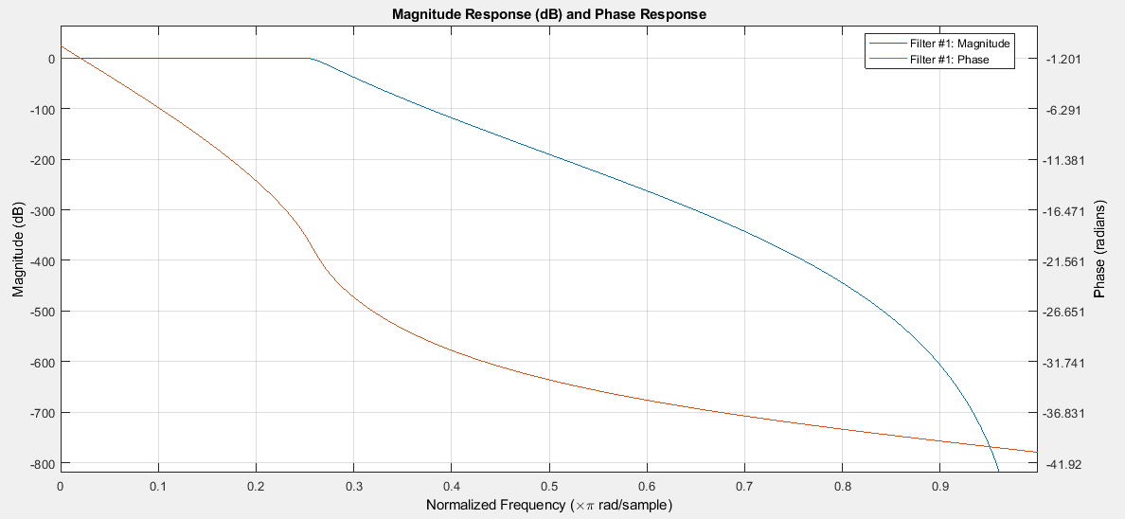
- CHEBYSHEV

Q3 black window
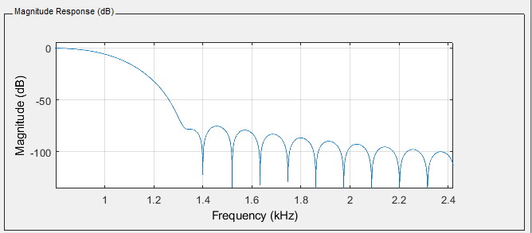

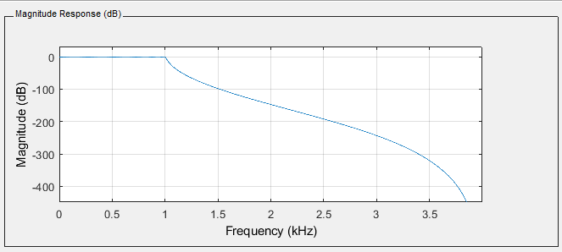

Designing the Filters in Simulink
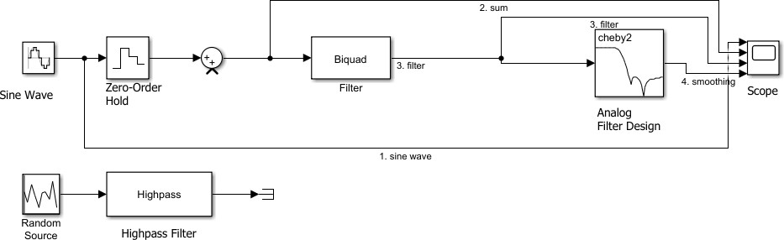
Generate and test sine waves with frequencies. Random source terminated
Figure 1:Diagram for step 12 in Procedure.

Butterworth (1)
Passband 0.5kHz
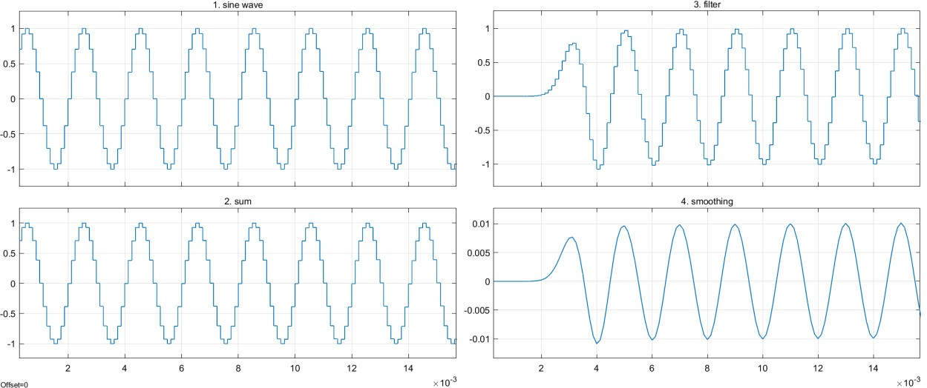
Transition region 1.1 kHz

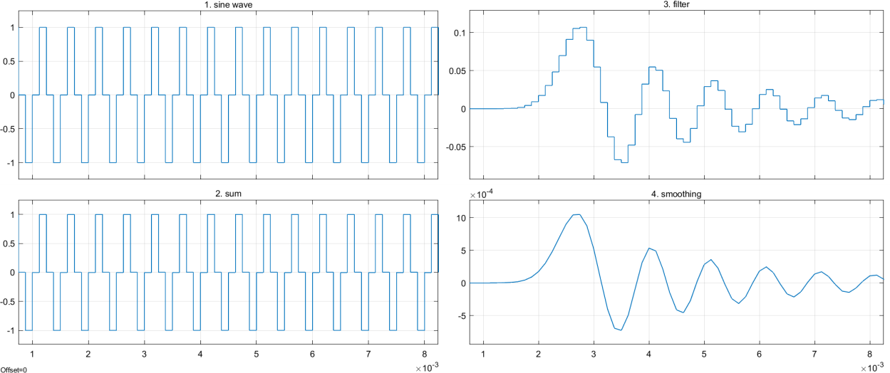

Stopband- 3kHz

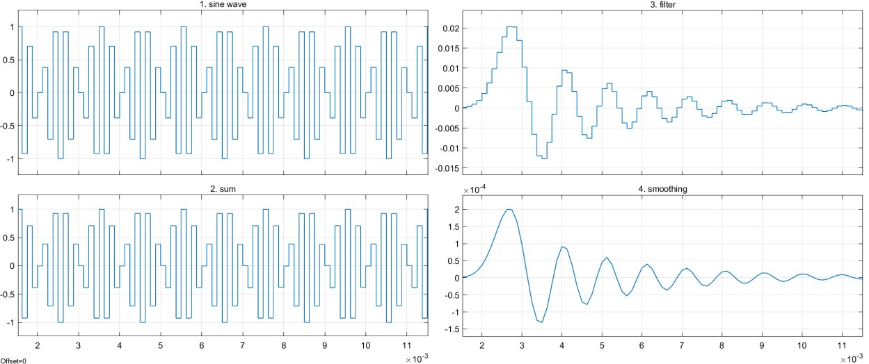
CHEBYSHEV
Passband – 0.5kHz

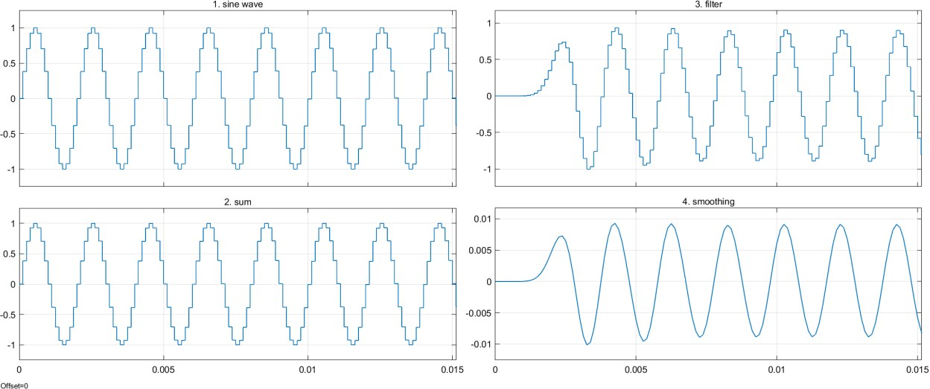

Transition – 1.5kHz

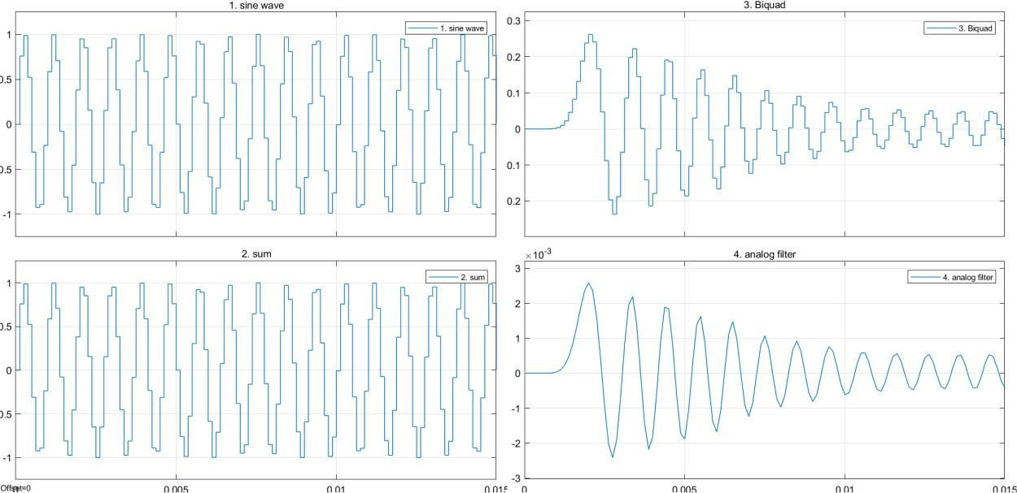
Stopband 3.5kHz

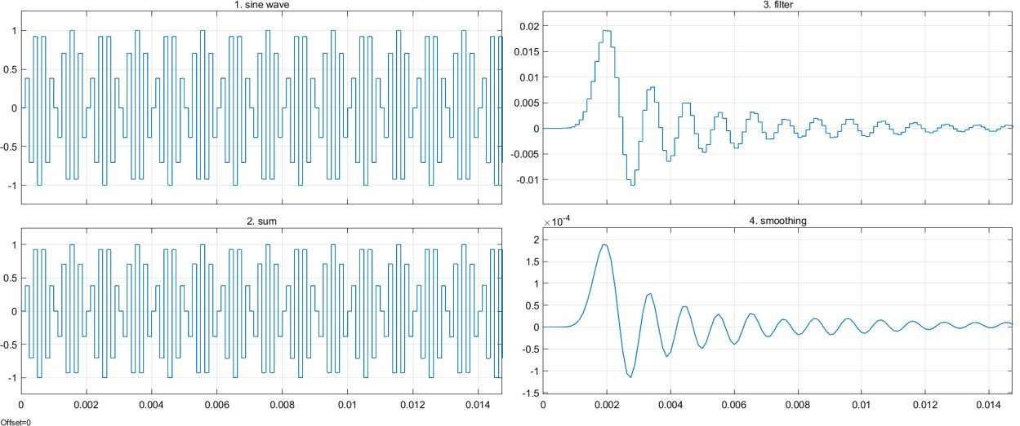

FIR
Passband – 0.5kHz
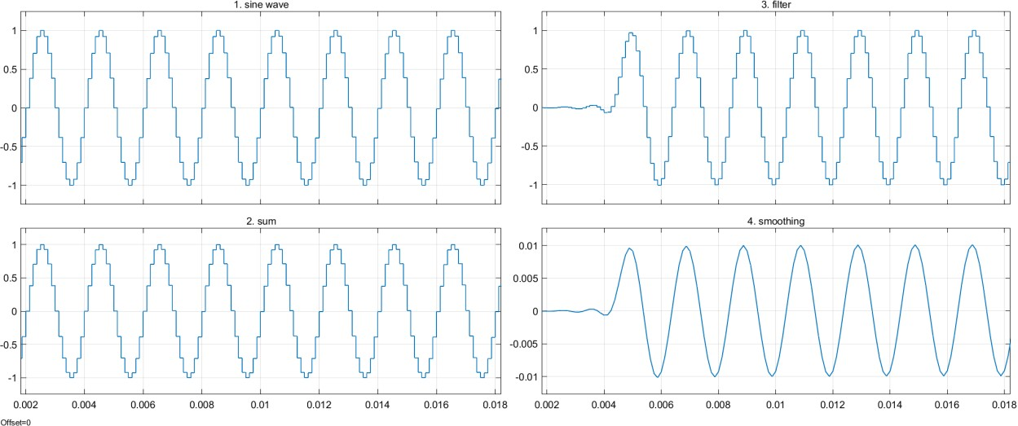
Transition – 1.1kHz

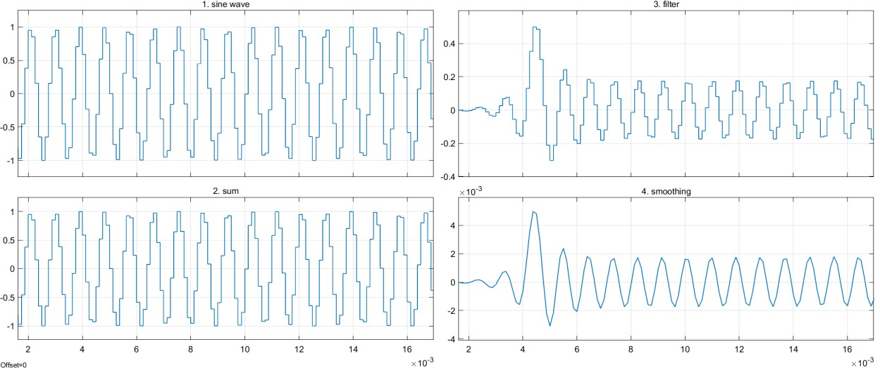

Stopband 2.5kHz
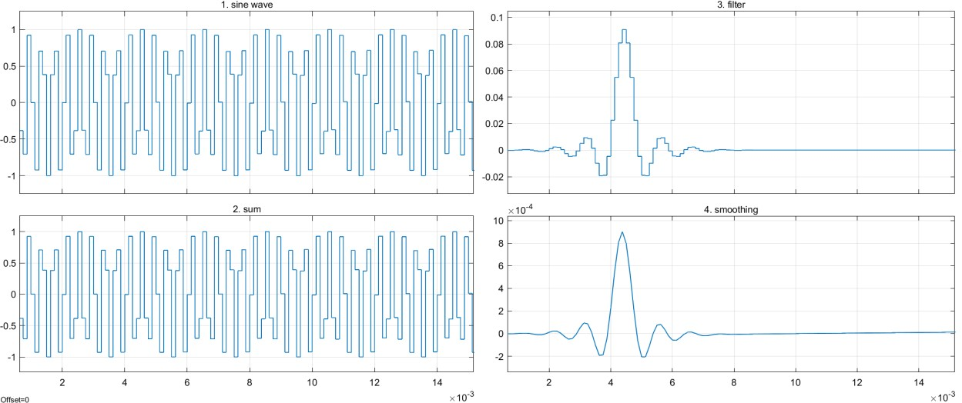

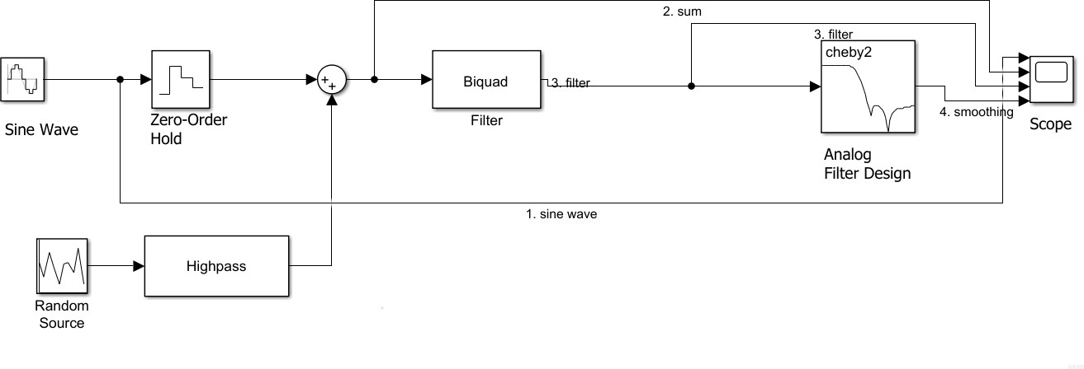
Butterworth
HIGHPASS FILTER
Passband – 0.5kHz

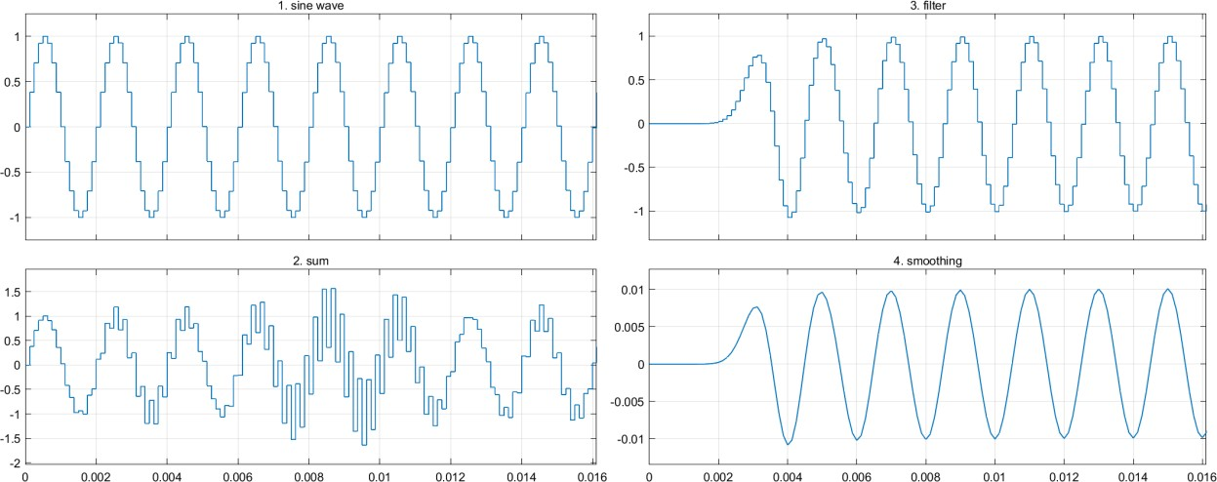

Transition – 1.1kHz
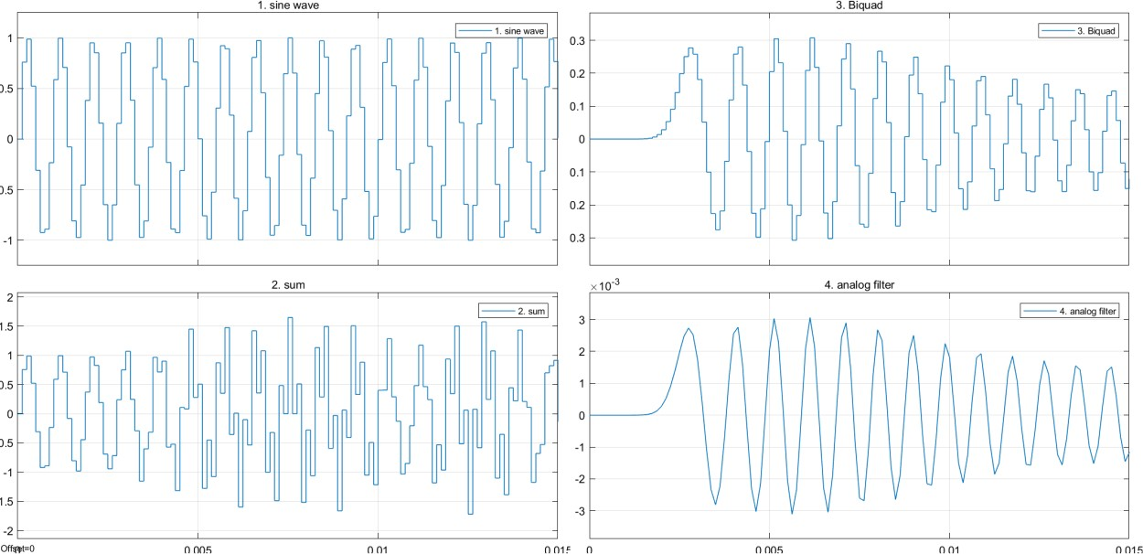
Stopband – 3.2kHz
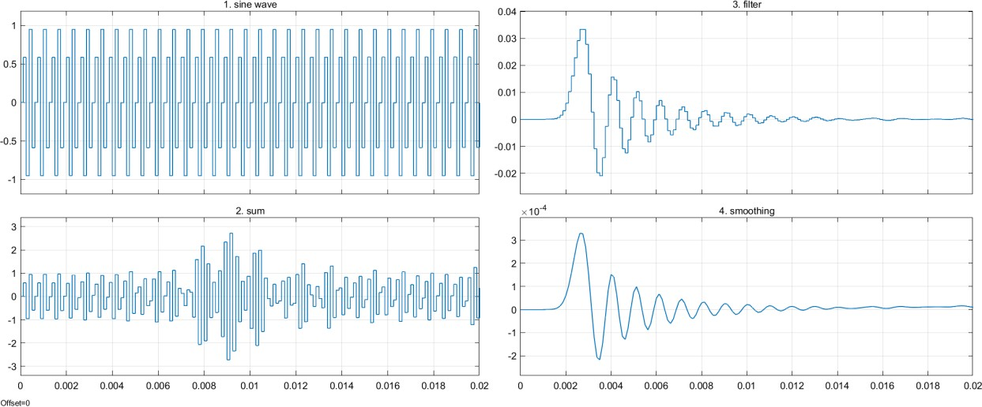

LOWPASS FILTER --BUTTERWORTH
Passband -0.5kHz
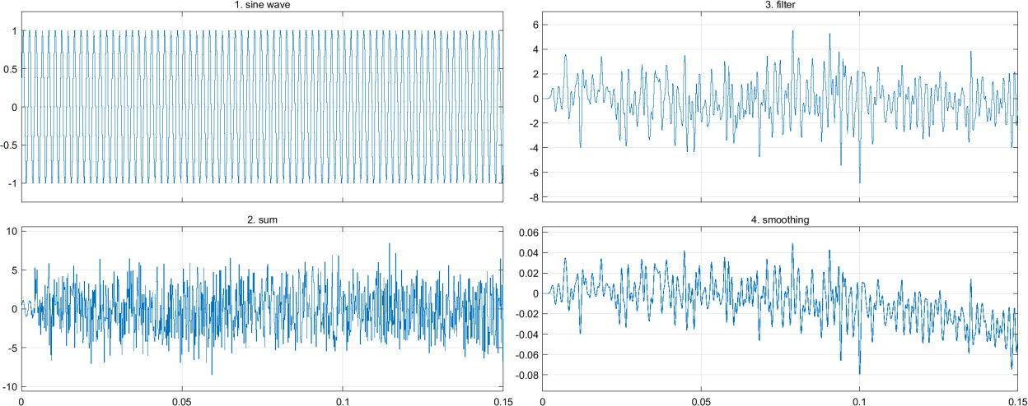

Transition – 1.1kHz
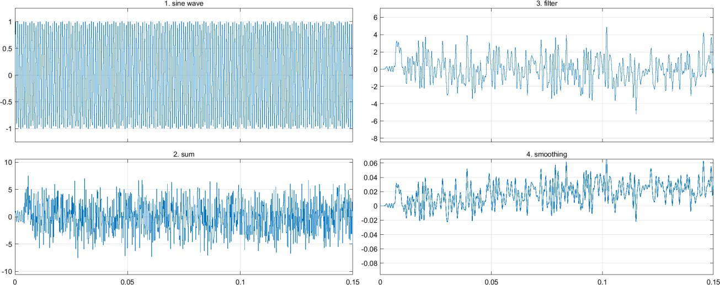

Stopband – 3.5kHz

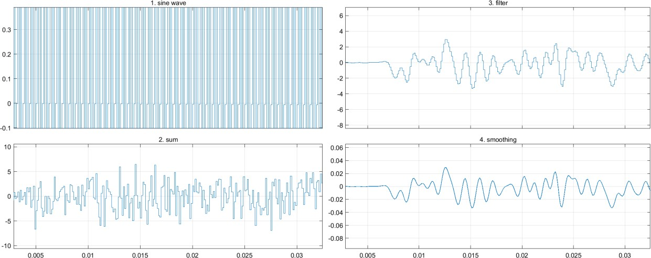

BANDPASS FILTER --BUTTERWORTH
Passband – 0.5kHz
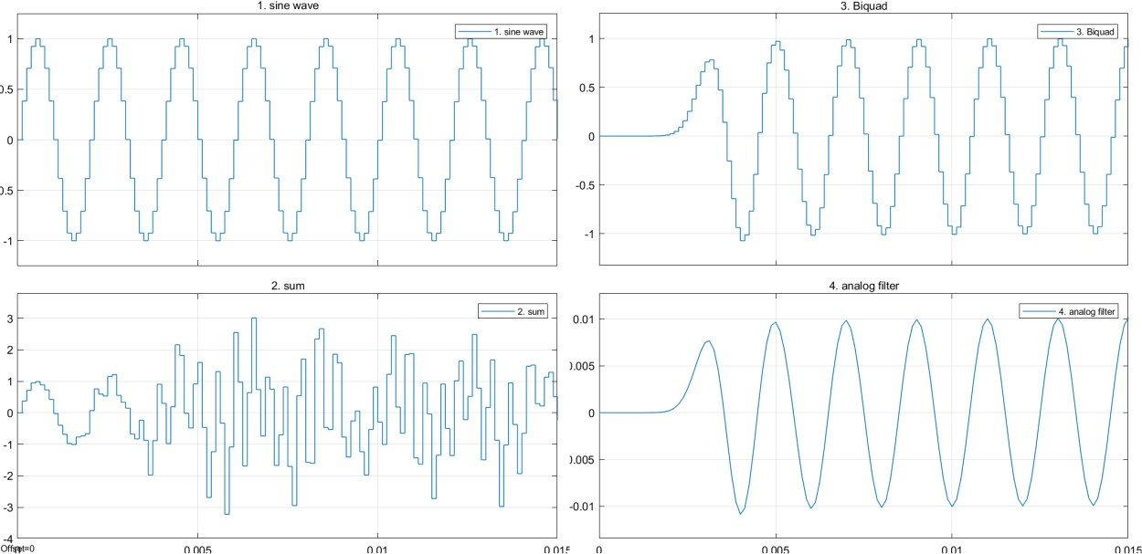
Transition – 1.1kHz



Stopband – 3.5kHz
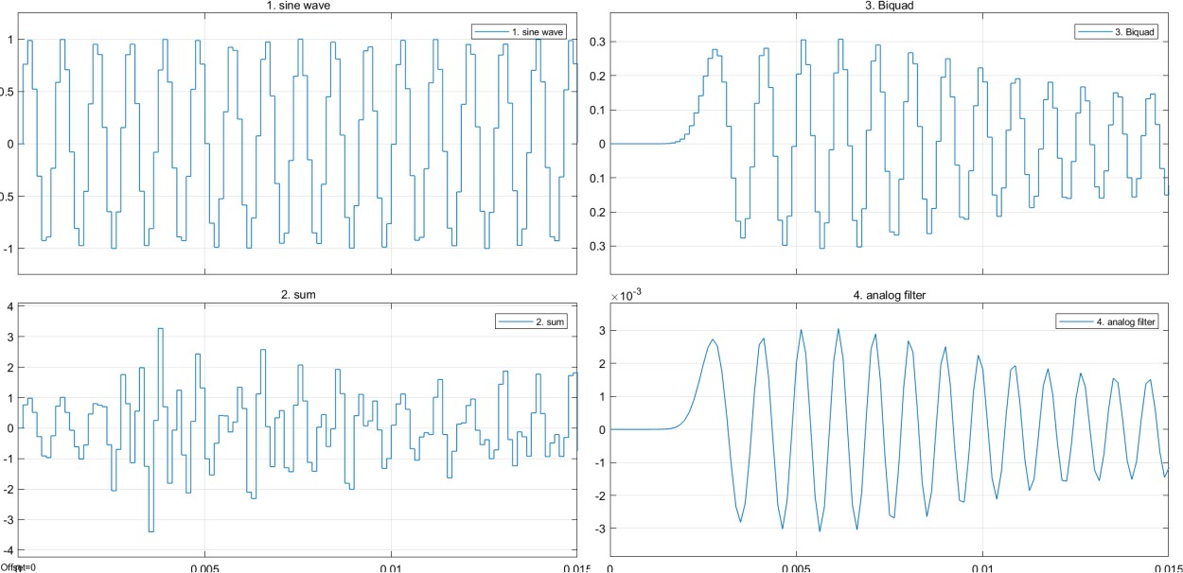
Chebyshev HIGHPASS FILTER
Passband 0.5kHz

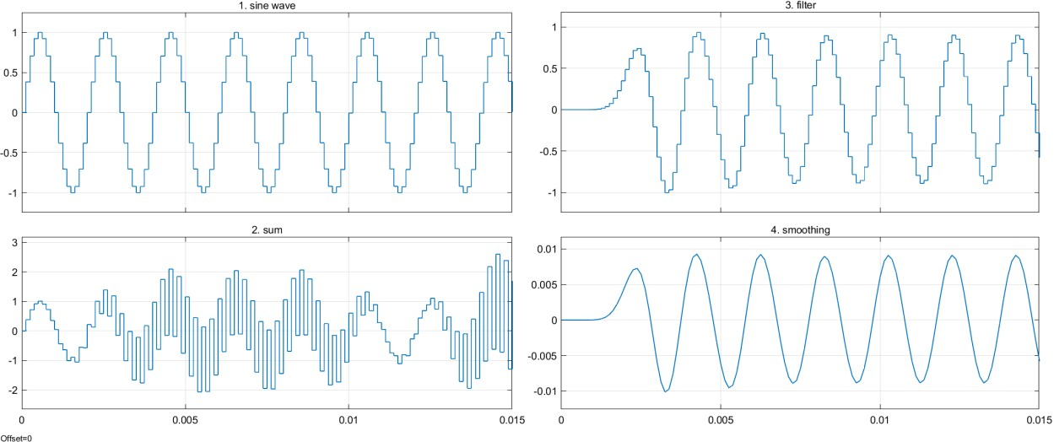

Transition – 1.1kHz
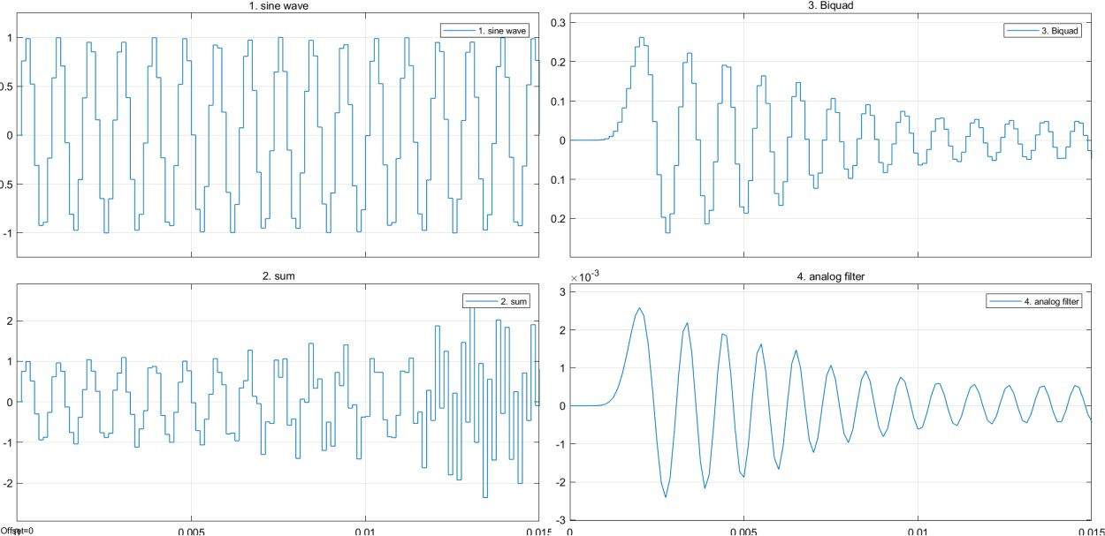
Stopband – 3.5kHz
LOWPASS FILTER --CHEBYSHEV
Passband

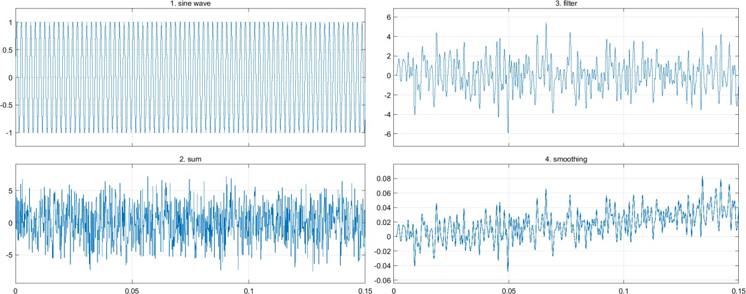

Transition
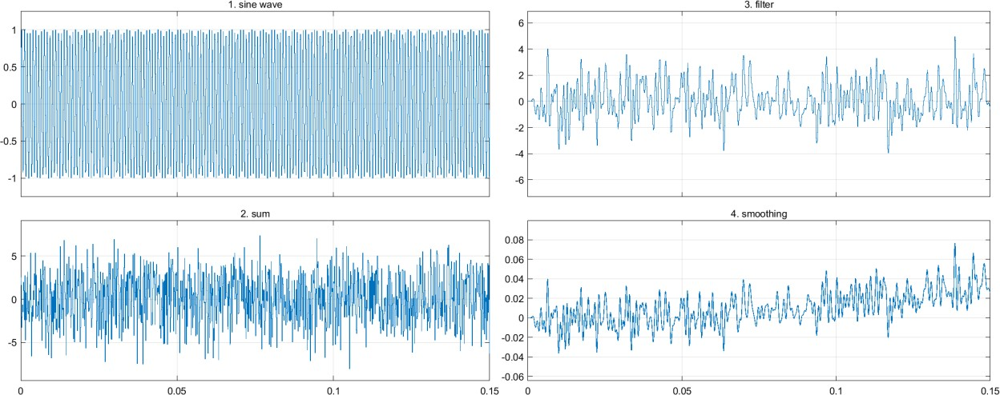

Stopband
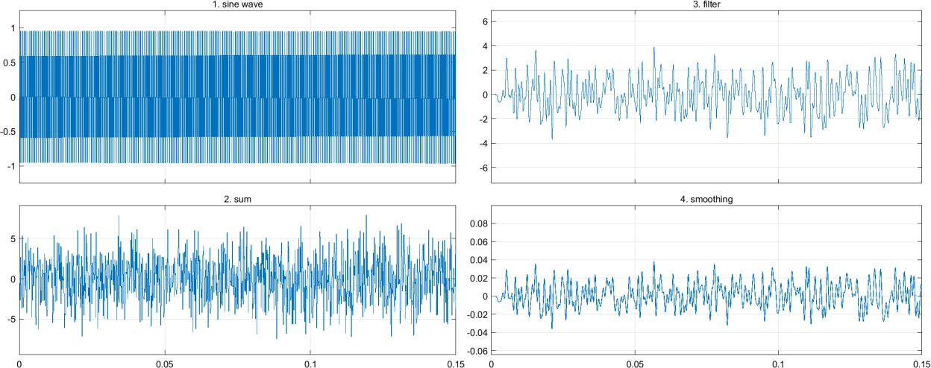

BANDPASS FILTER --CHEBYSHEV
Passband – 0.5kHz

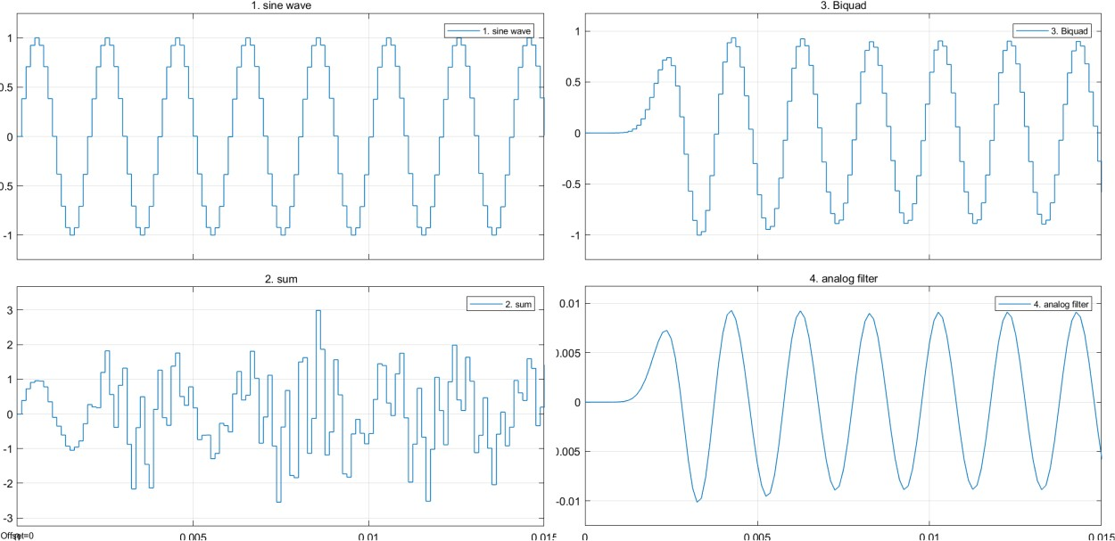

Transition – 1.1kHz
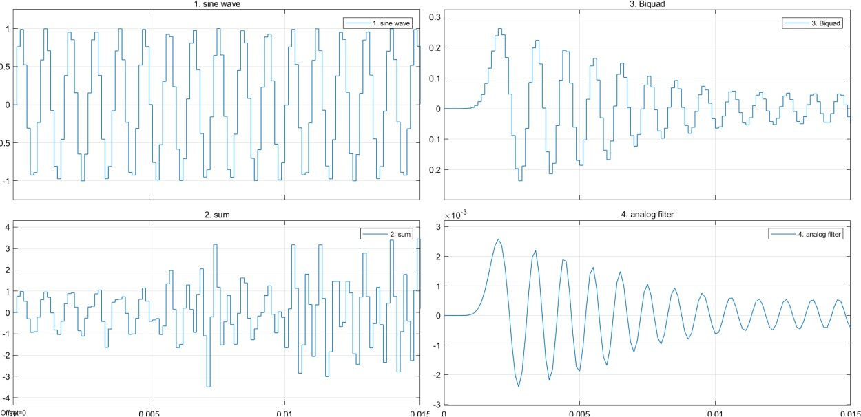
Stopband – 3.5kHz



FIR
HIGHPASS FILTER
Passband – 0.5kHz
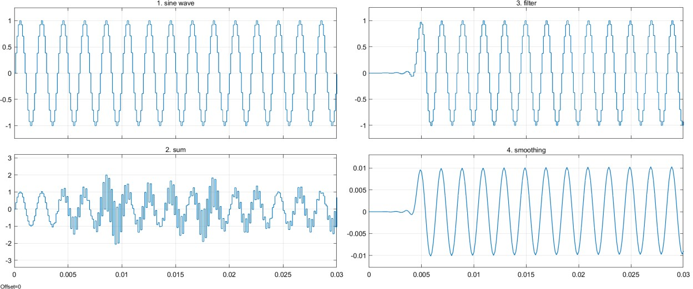
Transition – 1.2kHz

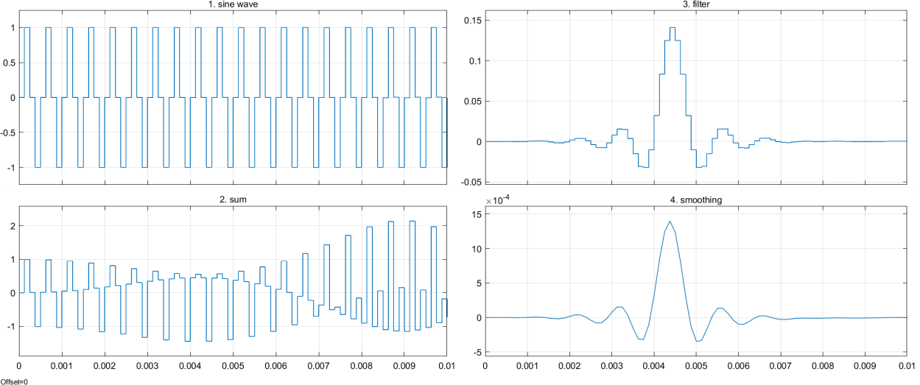

Stopband – 2.5kHz
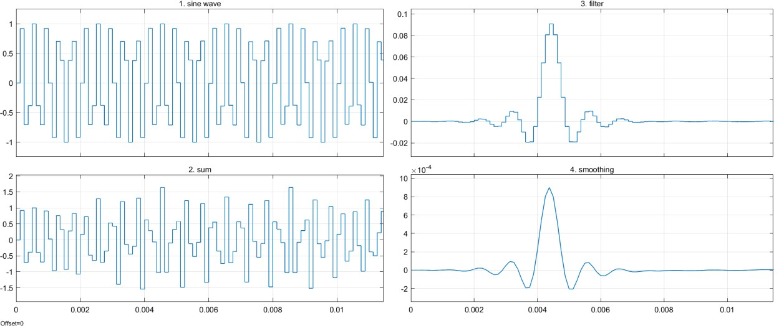

LOWPASS FILTER --FIR
Passband – 0.5kHz
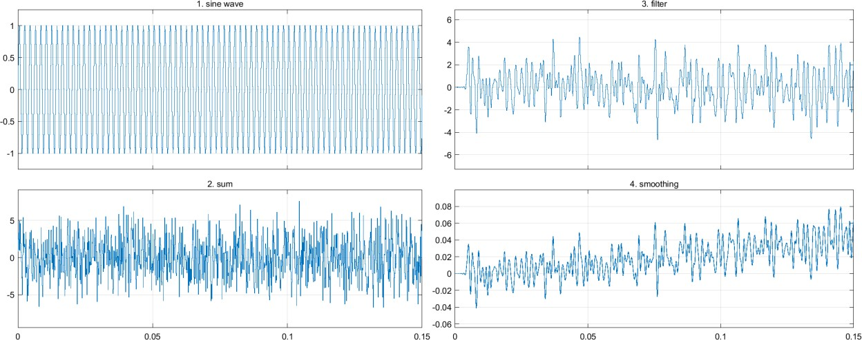

Transition – 1.1kHz
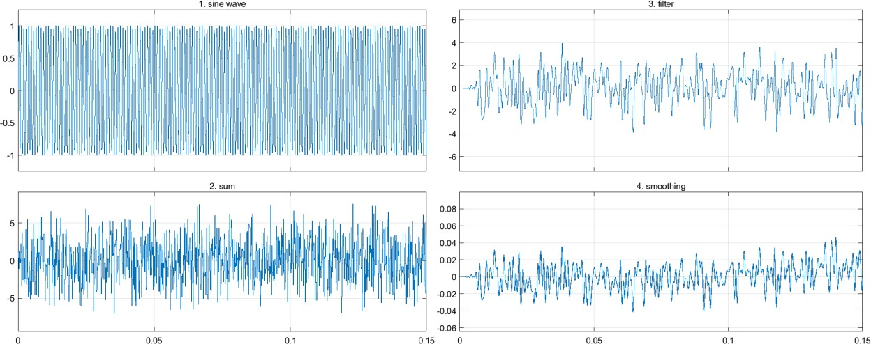

Stopband –3.2kHz
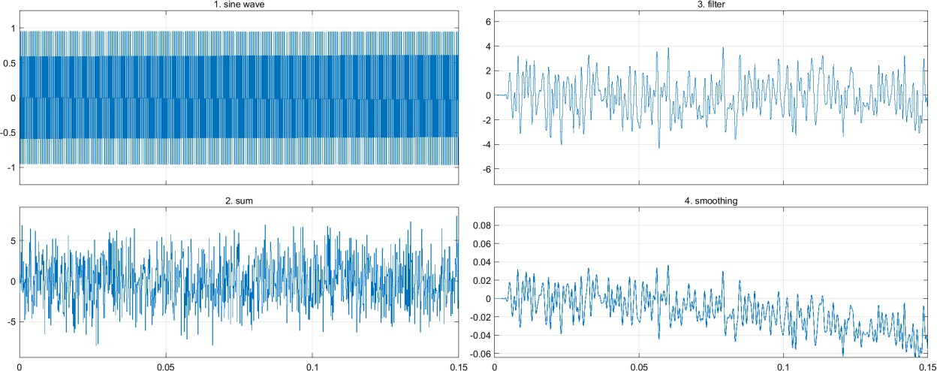

BANDPASS FILTER --FIR
Passband – 0.5

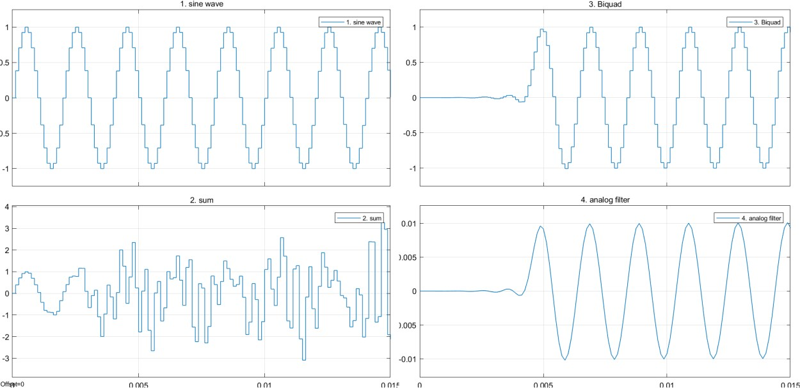

Transition – 1.1kHz
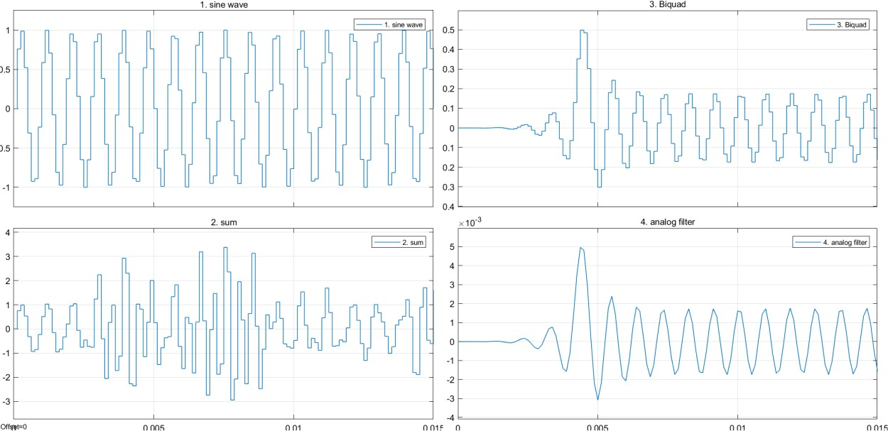
Stopband – 3.5kHz



DISCUSSIONS
The order of the lowpass Butterworth filter you designed is 26. The order of the lowpass Chebyshev Type I filter we designed is 12. Memory usage of each of the filters assuming a a Direct Form II realization is employed is represented by the number of adders in each Filter. The filter with the highest memory is IIR filter Butterworth is 52 followed by IIR Chebyshev at 24 and FIR filter at 58. Windowing technique takes a lot of memory space comparing with other techniques which makes it more expensive in terms of memory space. Blackman is less reliable than Chebyshev and Butterworth since the filter is achieved at very high order which takes more memory.

CONCLUSION
The passband for all the three chosen filters (i.e., Butterworth filter, Chebyshev filter and FIR filter) the output is a delayed sine wave. The transition region for the Butterworth and the Chebyshev shows a delayed damped sine wave with Butterworth output being more damped than the Chebyshev in this region, while the transition band for the FIR filter is a delayed sine wave with the first peak less than all the other peaks and the second peak more than the successive peaks while the rest of the peaks are equal for the part of the signal that can be seen on the screen. The Stopband region for the Butterworth shows a delayed damped sine wave which is more damped than the output of the same filter in the transition region. The stopband band for the Chebyshev is a damped sine wave which more damped than the output in the transition region for the same filter but less damped than the outputs in both the transition region and the stopband region of the Butterworth filter. The output of the FIR filter in the stopband region stopband is more like an impulse response function.

REFERENCES

[1] | J. . Yli-Kaakinen, M. . Hu, R. . Uusikartano, T. . Kupiainen and M. . Renfors, "Multirate digital filter design for a PAL TV modulator," IEEE Transactions on Consumer Electronics, vol. 45, no. 3, pp. 970-974, 1999.
[2] | F. W. Isen, "DSP for MATLAB and LabVIEW III: Digital Filter Design," , 2009. [Online]. Available: https://morganclaypool.com/doi/abs/10.2200/s000163ed1v01y200811spr006.
[3] | O. . Herrmann, "On the approximation problem in nonrecursive digital filter design," IEEE Transactions on Circuit Theory, vol. 18, no. 3, pp. 411-413, 1971.
[4] | Z. . Sun, W. . Yu and C. . He, "FIR digital filter design and MATLAB simulation," , 2012. [Online]. Available: https://ieeexplore.ieee.org/document/6273383.

