BOTSWANA INTERNATIONAL UNIVERSITY OF SCIENCE & TECHNOLOGY
(SEMESTER 1, 2023/2024 FINAL EXAMINATIONS)

FACULTY/DEPARTMENT: | FOE/MEIEM
MODULE CODE: | MINS 311
MODULE TITLE: | Measurement and Instrumentation
DATE: | 26th September 2024
TIME: | 08:00-09:00 (1 hours) plus 10 minutes reading time
VENUE(s): | Block 124/001-002
EXAMINER(s): | Mrs Matebejana

Instructions to Candidates:

- Answer all questions.
- Use only a Blue or Black pen for written answers and a pencil for all sketches/ drawings.
- Ensure that your question paper contains all pages.
- Only non-programmable calculators are allowed in this examination.
- Possession of any other material not prescribed in these instructions including mobile phones/smart watches is a punishable offence as per the BIUST Misconduct Regulation

DO NOT TURN OVER THE PAGE UNTIL YOU ARE TOLD TO DO SO

- What is the function of a variable conversion element in a measurement system?

To convert the output signal of the primary sensing element to another more suitable variable while preserving the information content of the original signal.

[2 marks]

- A current of 3.12A is flowing through a resistor of 53. 635ohms.Find the value of voltage drop across the resistor to the appropriate number of significant figures.
$v=IR=3.12*53.635=167.3412$
=167v

[2marks]

- What is a Transducer? [1mark]

- The cran is a British volume unit for freshly caught herrings: 1 cran=170.474 liters (L) of fish, about 750 herrings. Suppose that, to be cleared through customs in Saudi Arabia, a shipment of 1255 crans must be declared in terms of cubic covidos, where the covido is an Arabic unit of length: 1 covido=48.26 cm . What is the required declaration? [4marks]

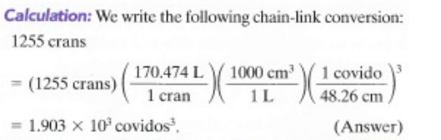

- Explain the difference between accuracy and precision of measurement. On what factors does precision depend? How can the accuracy be improved?
[3marks]

  - Accuracy is the ability of an instrument to show the exact reading.
  - Always related to the extent of the wrong reading/non accuracy.
- Defined as the capability of an instrument to show the same reading when used each time (reproducibility of the instrument).
- Precision of a measurement depends on what the number of significant figures.
- The accuracy can be improved upon by better calibration of the instrument

- Discuss the three types of systematic errors giving suitable examples. Explain the measures taken to minimise these errors. [9marks]
Instrumental Errors
- Due to inherent shortcoming in the instrument.
Example:- If the spring used in permanent magnet instrument has become weak then instrument will always read high. Errors may caused because of friction , hysteresis , or even gear backlash.
- Due to misuse of the instruments.
- Due to Loading effects of instruments.

Observational errors:-
-- Parallax, i.e. Apparent displacement when the line of vision is not normal to the scale.
-- Inaccurate estimate of average reading.
-- Wrong scale reading and wrong recording the data.
-- Incorrect conversion of units between consecutive reading.

- For the following given data, calculate

$x_{1}=$ 39.7; $x_{2}=40.1 ;{ x}_{3}=40.2;{ x}_{4}=39.6; x_{5}=39.8$
  - Arithmetic mean; [1mark]
  - Deviation of each value; [3marks]
  - Standard deviation [2marks]

- A voltmeter reading 70V on its 100V range and an ammeter reading 80mA on its 150mA range are used to determine the power dissipated in a resistor. Both these instruments are guaranteed to be accurate within $±1.5\%$ at full scale deflection. Determine the limiting error of the power. [3marks]

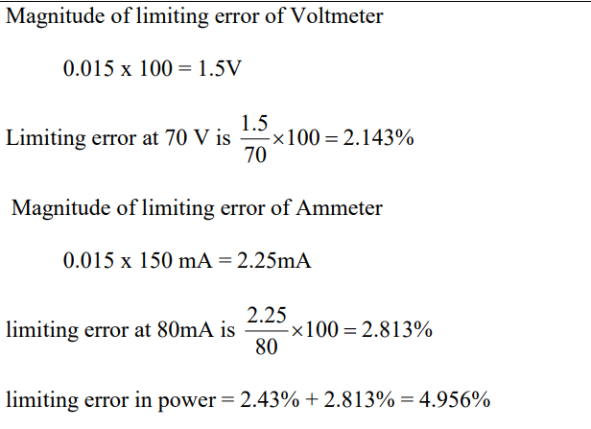

END OF TEST

