Course Code: CPEN 522: Robotics Modelling and Simulations

- In terms of robotic trajectory planning, define in detail the following terms
  - Manipulator
In robotic trajectory planning, a manipulator refers to the mechanical structure or arm of a robot designed to interact with its environment by manipulating objects, tools, or materials. It consists of multiple rigid links connected by joints, enabling motion and flexibility.

Trajectory planning for a manipulator involves determining a smooth, collision-free, and efficient path for its end-effector to move from an initial position to a desired target, accounting for:
- Joint limits and kinematics.
- Avoidance of obstacles.
- Dynamic constraints like speed and acceleration.
[2 marks]

  - Insertion device
An insertion device in robotic trajectory planning is a specialized tool or mechanism used to insert objects, tools, or materials into a designated environment or medium. It is often employed in precise, delicate, or constrained applications, such as medical surgeries, industrial assembly, or material handling.

Role in Trajectory Planning:
Trajectory planning for an insertion device focuses on:
- Path Planning:
  - Defining a precise trajectory to guide the device to the insertion site.
- Force Control:
  - Adjusting force to ensure proper insertion without excessive pressure.
- Collision Avoidance:
  - Ensuring the device avoids obstacles during insertion, especially in constrained environments.
- Orientation Control:
  - Maintaining a specific orientation to align correctly with the insertion site.

[2 marks]

- Actuators in robotic system basically consists of which elements. [4 marks]

Summary of Components
Element | Purpose
Energy Source | Supplies power for actuation.
Motor/Mechanism | Generates mechanical motion or force.
Transmission System | Transfers and modifies motion to achieve desired output.
Control System | Regulates the actuator’s operation.
Feedback Sensors | Monitor and provide real-time performance data.
Housing and Mounting | Protects and integrates the actuator into the robot.
Auxiliary Components | Enhance functionality and durability.
Actuators in robotic systems are an integration of these elements, working together to provide precise and controlled motion for tasks like moving joints, driving wheels, or manipulating end-effectors

- Draw a temperature sensor circuit and explain how it works. [4 marks]

  - applying a high voltage (5V) to P8 would generate a 2.5V drop across both resistors and the capacitor would be held at 2.5 volts above ground
  - applying a low to P8 would cause the charge on the capacitor to begin bleeding off and the voltage would drop below 2.5 volts
  - every 2.1 ms the ACD object reads the truth value of pin P9 (equal to the voltage across the capacitor)
  - since the duty cycle of the pulse is timed to allow some bleed off before the measurement is taken, if the LM34 is putting out zero volts, and all 255 samples would be zero

- Based on the source of input power actuators are classified into three groups, outline these groups, providing each group’s limitations.
[6 marks]
- Based on the source of Input Power actuators are classified in to three groups :
- Pneumatic Actuators.
These utilize pneumatic energy provided by the compressor and transforms it into mechanical energy by means of pistons or turbines. the fluid compressed is air. Pneumatic systems typically operate at about 100lb/in2
- Hydraulic Actuators.
These Transform the energy stored in reservoir into mechanical energy by means of suitable pumps. the fluid compressed is oil. Hydraulic systems at 1000 to 3000 lb/in2.
- Electric Actuators.
Electric actuators are simply electro-mechanical devices which allow movement through the use of an electrically controlled systems of gears

- For a rotary actuator, determine angular velocity, ω, [3 marks]

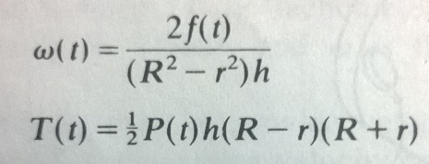 or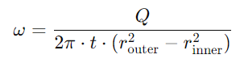
- R, outer radius of the vane., r, inner radius., h, thickness of the vane., ω, angular velocity
- Q flow rate

- Consider a simple 2 degree of freedom robot. We desire to move the robot from Point A to Point B, see Figure 1, below. Let’s assume that both joints of the robot can move at the maximum rate of 20 degree/sec. Initial angles α = 40º and β = 50^{ο}
[10 marks]
- Describe the robot arm movement in terms of links:
- Angular velocities
- Path and distances travelled
- Angles α and β at each point
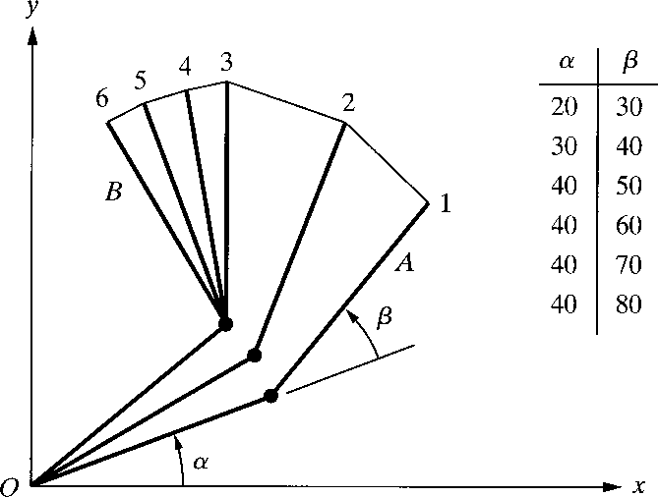
Figure 1: Joint-space nonnormalized movements of a robot with two degrees of freedom
Initial angles α = 40º and β = 50^{ο}
α = 60º and β = 70^{ο}
α = 80º and β = 90^{ο}
α = 100º and β = 110^{ο}
α = 120º and β = 130^{ο}

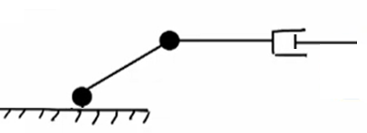

For the manipulator above

- Draw the Frame attachment for the figure above

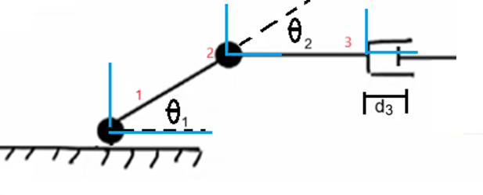(3 marks)
- For the manipulator shown in the figure above determine the DH parameters.
(8 marks)
The robot consists of two revolute joints and one prismatic joint. For DH parameter assignment:
- Joint 1 (Revolute): Base to first link.
- Joint 2 (Revolute): First link to second link.
- Joint 3 (Prismatic): Second link to the end-effector.

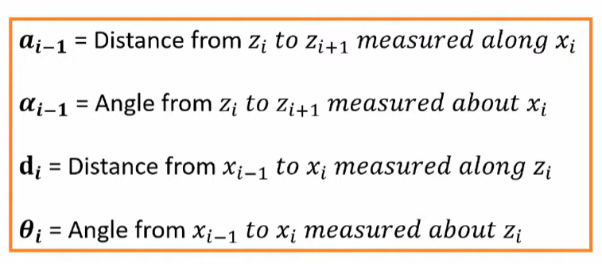

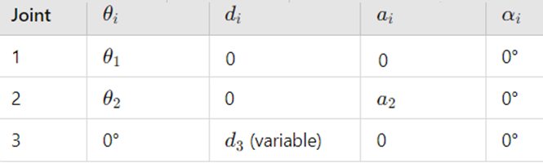

(8 marks)

- From the DH parameter table found in question 8, specify the homogeneous transform matrix for each adjacent link pair:
(10 marks)

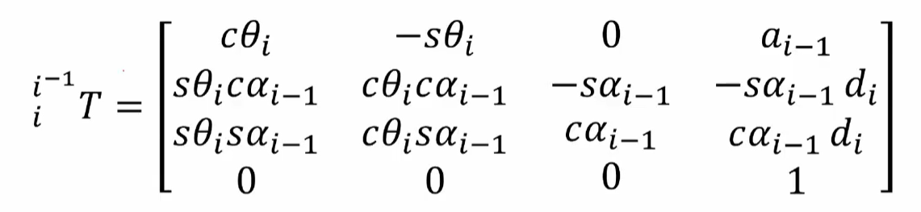
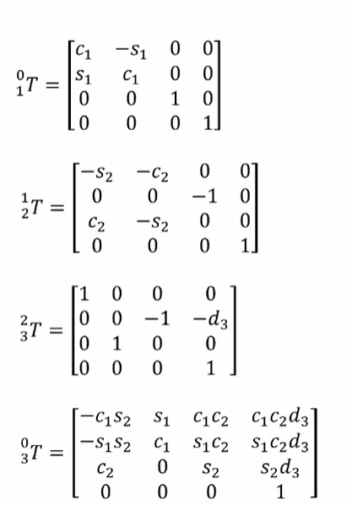
(3 marks each matrix)

Multiply 0 to 3 to get final matrix



(2 marks)

- Using the homogeneous transform matrix for each adjacent link pair for question 9, compute the angular and linear velocity of the “tool” frame relative to the base frame expressed in the “tool” frame.
(10 marks)

