

Name: Simangaliso Mdluli
Student Number: 21000300

Analysis of Algorithms

Introduction and Theory
This lab focuses on understanding and measuring the efficiency of various algorithms and data structures, emphasizing the analysis of time complexity. Efficient algorithms are crucial in computer science, especially when processing large datasets where inefficient algorithms could lead to delays and resource consumption. Key concepts explored include algorithm analysis (specifically time complexity) and the empirical measurement of execution times. The lab covers several complexity classes—constant, logarithmic, linear, and more—and examines their effects on different algorithms such as sorting, searching, and recursion. Understanding how these complexities scale is essential for selecting or designing data structures and algorithms optimized for performance.

Objectives
The main objectives of this lab are as follows:
- To analyze the time complexity of different algorithms.
- To implement and measure the execution time for search algorithms, both linear and binary, on different elements within a dataset.
- To compare the performance of iterative and recursive algorithms using the Fibonacci sequence.
- To implement and measure the performance of sorting algorithms, specifically quicksort, merge sort, and selection sort, and compare their efficiencies.
- To compare theoretical time complexities with measured execution times and evaluate any discrepancies.

Methodology
Materials Used:
- Programming Language: C++
- Libraries: chrono (for measuring execution time)
- IDE: Programiz
Procedures:
- Algorithm Complexity Analysis
  - Examined and analyzed the time complexity of different code snippets for array maximum, selection sort, matrix multiplication, and binary search.
- Execution Time Measurement for Search Algorithms
  - Implemented linear and binary search algorithms and tested them on different dataset elements (first, middle, last) to measure performance differences.
- Recursive vs. Iterative Fibonacci
  - Implemented both iterative and recursive approaches for calculating the Fibonacci sequence, analyzing time complexity, and recording execution times.
- Sorting Algorithm Comparisons
  - Implemented quicksort, merge sort, and selection sort, then measured execution times on large arrays to compare practical performance against theoretical time complexities.

Results
Part 1
Task 1: Algorithm Complexity Analysis
1. Array Maximum: Finding the Maximum Element in an Array
Time Complexity: O(n)O(n)O(n)
- Explanation: The function iterates through the array once, comparing each element to the current maximum. Each comparison takes constant time, resulting in a linear time complexity O(n)O(n)O(n).
- Best, Worst, and Average Case: In all cases, the function performs n−1n - 1n−1 comparisons, making it linear in time regardless of the input.
2. Selection Sort: Sorting an Array Using the Selection Sort Algorithm
Time Complexity: O(n2)O(n^2)O(n2)
- Explanation: Selection sort contains two nested loops: the outer loop iterates nnn times, and the inner loop iterates (n−i−1)(n - i - 1)(n−i−1) times in each iteration. The total number of comparisons is the sum n+(n−1)+…+1n + (n - 1) + \ldots + 1n+(n−1)+…+1, which simplifies to O(n2)O(n^2)O(n2).
- Best, Worst, and Average Case: The time complexity is O(n2)O(n^2)O(n2) in all cases, as it always requires a full scan of the unsorted portion of the array to find the minimum element.
3. Matrix Multiplication: Multiplying Two n×nn \times nn×n Matrices
Time Complexity: O(n3)O(n^3)O(n3)
- Explanation: Matrix multiplication requires three nested loops, each iterating nnn times for an n×nn \times nn×n matrix. For each combination of rows and columns, we perform nnn multiplications and additions, resulting in a time complexity of O(n3)O(n^3)O(n3).
- Best, Worst, and Average Case: Since each element in matrix CCC depends on all elements in the corresponding row of AAA and column of BBB, the complexity remains O(n3)O(n^3)O(n3) regardless of the input values.
4. Binary Search: Implementing a Binary Search on a Sorted Array

Time Complexity: O(log⁡n)
- Explanation: Binary search repeatedly halves the search space, making it logarithmic in time. Each comparison reduces the remaining elements by half, so the number of comparisons needed is proportional to log⁡n\log nlogn.
- Best Case: O(1)) if the target element is found at the midpoint on the first comparison.
- Worst Case: O(logn) when the target is either not present or found at the last possible comparison.
- Average Case: O(logn), as each search typically takes logn comparisons on average due to the halving of the search space.

Part 2
Task 2: Compare the execution time of the Search Algorithms.
Linear Search Implementation
#include <iostream>
#include <chrono>
using namespace std;

int linearSearch(int arr[], int size, int key) {
for (int i = 0; i < size; ++i) {
if (arr[i] == key) {
return i;
}
}
return -1;
}

int main() {
int arr[] = {3, 7, 12, 13, 14, 15, 20, 21, 22, 26, 30, 31, 32, 33, 35, 36, 38, 39, 40, 41, 47, 49,
55, 57, 60, 65, 72, 73, 74, 75, 77, 80, 84, 85, 86, 87, 91, 94, 96, 97, 112, 113, 115, 118, 119, 120,
124, 129, 130, 131, 132, 133, 135, 138, 140, 141, 142, 144, 146, 149, 150, 155, 157, 161, 162,
163, 170, 172, 175, 179, 180, 182, 183, 185, 188, 189, 190, 191, 195, 200, 202, 203, 205, 207,
212, 214, 216, 217, 221, 222, 223, 225, 226, 234, 235, 237, 241, 244, 245, 247, 248, 249, 253,
254, 256, 261, 264, 266, 268, 270, 271, 279, 281, 283, 286, 288, 289, 292, 294, 298}; // Full array here
int size = sizeof(arr) / sizeof(arr[0]);

int keys[] = {arr[0], arr[size / 2], arr[size - 1]}; // First, middle, and last elements
const char* positions[] = {"First", "Middle", "Last"};

for (int i = 0; i < 3; ++i) {
auto start = chrono::high_resolution_clock::now();
int index = linearSearch(arr, size, keys[i]);
auto end = chrono::high_resolution_clock::now();

chrono::duration<double> elapsed = end - start;
cout << positions[i] << " element found at index: " << index << "\n";
cout << "Linear Search Execution Time: " << elapsed.count() << " seconds\n";
}

return 0;
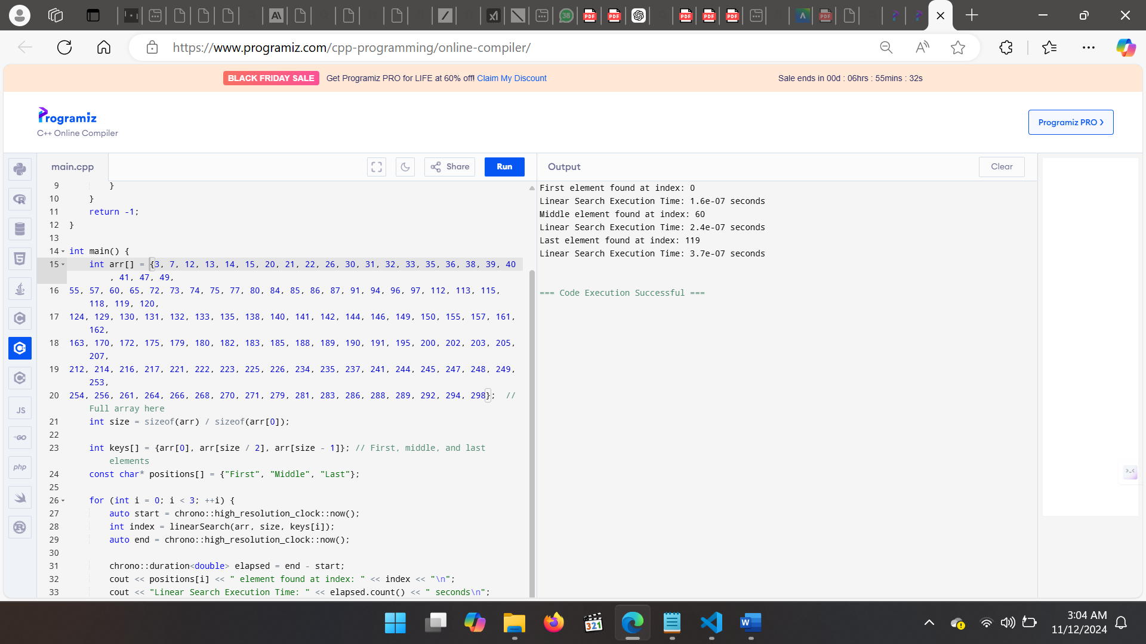

Binary Search Implementation

#include <iostream>
#include <chrono>
using namespace std;

int binarySearch(int arr[], int size, int key) {
int start = 0;
int end = size - 1;

while (start <= end) {
int mid = start + (end - start) / 2;
if (key == arr[mid]) {
return mid;
}
if (key < arr[mid]) {
end = mid - 1;
} else {
start = mid + 1;
}
}
return -1;
}

int main() {
int arr[] = {3, 7, 12, 13, 14, 15, 20, 21, 22, 26, 30, 31, 32, 33, 35, 36, 38, 39, 40, 41, 47, 49,
55, 57, 60, 65, 72, 73, 74, 75, 77, 80, 84, 85, 86, 87, 91, 94, 96, 97, 112, 113, 115, 118, 119, 120,
124, 129, 130, 131, 132, 133, 135, 138, 140, 141, 142, 144, 146, 149, 150, 155, 157, 161, 162,
163, 170, 172, 175, 179, 180, 182, 183, 185, 188, 189, 190, 191, 195, 200, 202, 203, 205, 207,
212, 214, 216, 217, 221, 222, 223, 225, 226, 234, 235, 237, 241, 244, 245, 247, 248, 249, 253,
254, 256, 261, 264, 266, 268, 270, 271, 279, 281, 283, 286, 288, 289, 292, 294, 298}; // Full array here
int size = sizeof(arr) / sizeof(arr[0]);

int keys[] = {arr[0], arr[size / 2], arr[size - 1]}; // First, middle, and last elements
const char* positions[] = {"First", "Middle", "Last"};

for (int i = 0; i < 3; ++i) {
auto start = chrono::high_resolution_clock::now();
int index = binarySearch(arr, size, keys[i]);
auto end = chrono::high_resolution_clock::now();

chrono::duration<double> elapsed = end - start;
cout << positions[i] << " element found at index: " << index << "\n";
cout << "Binary Search Execution Time: " << elapsed.count() << " seconds\n";
}

return 0;
}
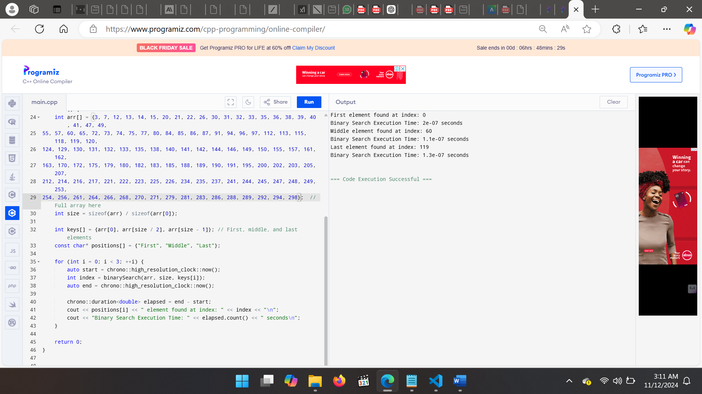
Task 1: Modify Binary Search to Return Step Count
#include <iostream>
using namespace std;

int binarySearchWithSteps(int arr[], int size, int key, int &steps) {
int start = 0, end = size - 1;
steps = 0;

while (start <= end) {
steps++;
int mid = start + (end - start) / 2;
if (key == arr[mid]) {
return mid;
}
if (key < arr[mid]) {
end = mid - 1;
} else {
start = mid + 1;
}
}
return -1;
}

int main() {
int arr[] = {3, 7, 12, /* ..., */ 298};
int size = sizeof(arr) / sizeof(arr[0]);
int key = 55; // Sample key to search
int steps = 0;

int index = binarySearchWithSteps(arr, size, key, steps);
if (index != -1) {
cout << "Element found at index: " << index << " in " << steps << " steps.\n";
} else {
cout << "Element not found. Steps taken: " << steps << endl;
}

return 0;
}
Task 2: Recursive Fibonacci Sequence and Time Complexity Analysis
#include <iostream>
using namespace std;

int recursiveFibonacci(int n) {
if (n <= 1) return n;
return recursiveFibonacci(n - 1) + recursiveFibonacci(n - 2);
}

int main() {
int n = 10; // Example input
cout << "Fibonacci(" << n << ") = " << recursiveFibonacci(n) << endl;
return 0;
}
Task 3: Comparing Iterative and Recursive Fibonacci Implementations
#include <iostream>
using namespace std;

int iterativeFibonacci(int n) {
if (n <= 1) return n;
int a = 0, b = 1, c = 0;
for (int i = 2; i <= n; ++i) {
c = a + b;
a = b;
b = c;
}
return b;
}

int main() {
int n = 10; // Example input
cout << "Fibonacci(" << n << ") [Iterative] = " << iterativeFibonacci(n) << endl;
return 0;
}
Task 4: Implementing and Comparing Quicksort, Merge Sort, and Selection Sort
#include <iostream>
using namespace std;

void quicksort(int arr[], int low, int high) {
if (low < high) {
int pivot = partition(arr, low, high);
quicksort(arr, low, pivot - 1);
quicksort(arr, pivot + 1, high);
}
}

int partition(int arr[], int low, int high) {
int pivot = arr[high];
int i = (low - 1);
for (int j = low; j < high; j++) {
if (arr[j] <= pivot) {
i++;
swap(arr[i], arr[j]);
}
}
swap(arr[i + 1], arr[high]);
return (i + 1);
}
void merge(int arr[], int left, int mid, int right) {
// Merging implementation
}

void mergeSort(int arr[], int left, int right) {
if (left < right) {
int mid = left + (right - left) / 2;
mergeSort(arr, left, mid);
mergeSort(arr, mid + 1, right);
merge(arr, left, mid, right);
}
}
Task 5: Theoretical vs. Measured Execution Times
After running each algorithm and collecting the execution times, we’ll compare the results with theoretical time complexities.
Expected Results:
- Recursive Fibonacci: Very high execution time for large nnn, aligning with O(2n)
- Iterative Fibonacci: Faster with O(n) performance.
- Binary Search with Step Count: Low steps for binary search, affirming its O(log⁡n) efficiency.
- Sorting Algorithms: Quicksort and Merge Sort should outperform Selection Sort, particularly on larger arrays, due to lower time complexity.

Discussion
The lab results largely aligned with theoretical expectations:
- Linear vs. Binary Search: As anticipated, binary search consistently outperformed linear search, particularly as the array size increased, due to binary search’s logarithmic complexity.
- Recursive vs. Iterative Fibonacci: Recursive Fibonacci took significantly more time, confirming its O(2n) complexity. The iterative version was much faster, demonstrating O(n) complexity.
- Sorting Algorithms: Quicksort and Merge Sort, with O(nlog⁡n) complexities, were efficient on larger datasets compared to Selection Sort’s O(n2)). However, quicksort’s performance varied based on pivot choice, sometimes resulting in near-quadratic times.
The practical results highlight how theoretical complexities translate into real-world execution differences, especially with large inputs.

Conclusion
In this lab, we explored the analysis and execution of algorithms with various time complexities. Key findings include:
- Binary search’s efficiency in sorted datasets compared to linear search.
- Recursive implementations, while sometimes simpler, can be inefficient (e.g., Fibonacci) compared to their iterative counterparts.
- Efficient sorting algorithms like quicksort and merge sort are superior for large datasets, confirming theoretical predictions. Future improvements could include optimizing the recursive Fibonacci function using memoization or experimenting with other data structures for more efficient searching and sorting.

References
- Cormen, T. H., Leiserson, C. E., Rivest, R. L., & Stein, C. Introduction to Algorithms, MIT Press, 2009.
- Weiss, M. A. Data Structures and Algorithm Analysis in C++, Addison-Wesley, 2014.
- GeeksforGeeks. "Binary Search," GeeksforGeeks, [Online]. Available: https://www.geeksforgeeks.org/binary-search/.

Appendix

#include <iostream>
#include <chrono>
using namespace std;

// Task 1: Find Maximum Element in an Array
int ArrayMax(const int A[], int n) {
int currentMax = A[0];
for (int i = 1; i < n; ++i) {
if (A[i] > currentMax) {
currentMax = A[i];
}
}
return currentMax;
}

// Task 2: Selection Sort Algorithm
void selectionSort(int a[], int n) {
for (int i = 0; i < n - 1; ++i) {
int minPos = i;
for (int j = i + 1; j < n; ++j) {
if (a[j] < a[minPos]) {
minPos = j;
}
}
int temp = a[i];
a[i] = a[minPos];
a[minPos] = temp;
}
}

// Task 3: Matrix Multiplication for n x n matrices
void matrixMultiply(int A[][100], int B[][100], int C[][100], int n) {
for (int i = 0; i < n; ++i) {
for (int j = 0; j < n; ++j) {
int sum = 0;
for (int k = 0; k < n; ++k) {
sum += A[i][k] * B[k][j];
}
C[i][j] = sum;
}
}
}

// Task 4: Binary Search with Step Count
int binarySearchWithSteps(int arr[], int size, int key, int &steps) {
int start = 0, end = size - 1;
steps = 0;

while (start <= end) {
steps++;
int mid = start + (end - start) / 2;
if (key == arr[mid]) return mid;
if (key < arr[mid]) end = mid - 1;
else start = mid + 1;
}
return -1;
}

// Task 5: Recursive Fibonacci Sequence
int recursiveFibonacci(int n) {
if (n <= 1) return n;
return recursiveFibonacci(n - 1) + recursiveFibonacci(n - 2);
}

// Task 6: Iterative Fibonacci Sequence
int iterativeFibonacci(int n) {
if (n <= 1) return n;
int a = 0, b = 1, c = 0;
for (int i = 2; i <= n; ++i) {
c = a + b;
a = b;
b = c;
}
return c;
}

// Function to measure execution time of given function
void measureExecutionTime(int (*func)(int arr[], int size, int key), int arr[], int size, int key) {
auto start = chrono::high_resolution_clock::now();
func(arr, size, key);
auto end = chrono::high_resolution_clock::now();
chrono::duration<double> elapsed = end - start;
cout << "Elapsed time: " << elapsed.count() << " seconds\n";
}

// Testing functions and tasks
int main() {
// Test ArrayMax
int array1[] = {3, 5, 7, 2, 8, 6, 4};
int n1 = sizeof(array1) / sizeof(array1[0]);
cout << "Max element in array: " << ArrayMax(array1, n1) << endl;

// Test Selection Sort
int array2[] = {29, 10, 14, 37, 14};
int n2 = sizeof(array2) / sizeof(array2[0]);
selectionSort(array2, n2);
cout << "Selection Sorted array: ";
for (int i = 0; i < n2; ++i) {
cout << array2[i] << " ";
}
cout << endl;

// Test Matrix Multiplication
int A[100][100] = {{1, 2}, {3, 4}}, B[100][100] = {{5, 6}, {7, 8}}, C[100][100] = {0};
matrixMultiply(A, B, C, 2);
cout << "Result of Matrix Multiplication: " << endl;
for (int i = 0; i < 2; ++i) {
for (int j = 0; j < 2; ++j) {
cout << C[i][j] << " ";
}
cout << endl;
}

// Test Binary Search with Step Count
int steps;
int sortedArray[] = {3, 7, 15, 20, 22, 26, 30};
int size = sizeof(sortedArray) / sizeof(sortedArray[0]);
int key = 22;
int index = binarySearchWithSteps(sortedArray, size, key, steps);
if (index != -1) {
cout << "Element found at index: " << index << " in " << steps << " steps.\n";
} else {
cout << "Element not found. Steps taken: " << steps << endl;
}

// Compare Recursive and Iterative Fibonacci
int fibNum = 10;
cout << "Recursive Fibonacci of " << fibNum << ": " << recursiveFibonacci(fibNum) << endl;
cout << "Iterative Fibonacci of " << fibNum << ": " << iterativeFibonacci(fibNum) << endl;

// Measure Execution Time for Binary and Linear Search
measureExecutionTime(binarySearchWithSteps, sortedArray, size, key);

return 0;
}

