Assignment #2

Sima Shafaei

March 19

**

* *For each recurrent cell the input is X(t)  which is a m*🞩*ninputs matrix where m is the number of instances in mini-batch and ninput is the number of input features.*
* *The output is Y(t) which is a m*🞩*nneurons and contains the layers' outputs at time step t for each instance in mini-batch. M is the number of instances in mini-batch and nneurons is the number of neurons*

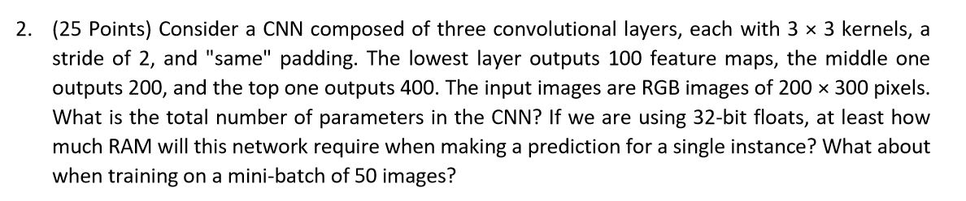

***Number of parameters for convolutional layer:***

$$(k×k×number of channel ×n_{in}+1)×n_{out}$$

$$where:$$

$$k=size of kernel$$

$$n_{in}=number of input feature maps$$

$$n_{out}=number of output feature maps$$

*We add 1 for term bias in each feature map.*

*Layer 1: $\left(3×3×3+1\right)×100=2800$*

*(memory=4*2800=0.112Mg)*

*Layer 2: $\left(3×3×3×100+1\right)×200=540200$*

$$(memory=4*540200 =2.1608Mg)$$

*Layer 3: $\left(3×3×3×200+1\right)×400=2160400$*

$$(memory=4*2160400=8.641Mg)$$

*Total number of parameters: $720400+ 180200+1000=901600$*

*For mini-batch =50:*

*Layer 1: $50×\left(3×3×3+1\right)×100=140000$*

*Layer 2: $50×\left(3×3×3×100+1\right)×200=27010000$*

*Layer 3: $50×\left(3×3×3×200+1\right)×400=108020000$*

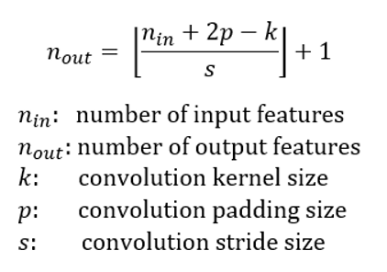

*For one image:*

*Required memory for input image: 3*200*300*4=720K =0.72 Mg*

*First Layer:*

|  |  |
| --- | --- |
| *k=3*3*  *p=same*  *s=2*2*  *nin= 3* 200 * 300=* | $n_{out}=$*3* 200/2 * 300/2* |
| *Output feature map= 100*  *Number of bytes: 4* | *Memory=3*100*150*100*4=18000000 = 18 Mg* |

*second Layer:*

|  |  |
| --- | --- |
| *k=3*3*  *p=same*  *s=2*2*  *nin* | *=3*100/2*150/2* |
| *Output feature map= 200*  *Number of bytes: 4* | *Memory=3*50*75*200*4=9000000 = 9 Mg* |

*third Layer:*

|  |  |
| --- | --- |
| *k=3*3*  *p=same*  *s=2*2*  *nin* | *3*50/2*75/2* |
| *Output feature map= 400*  *Number of bytes: 4* | *Memory=3*25*38*400*4=4560000 = 4.56Mg* |

*We can consider two different case:*

1. *After computing one layer the memory will release, so we can consider largest memory as required ram. In this case required RAM memory would be:*

*Required memory for input + Required memory for parameters + Required memory for the output= 0.72 +0.112+18 =18.83 Mg*

1. *All the layers' computations will remain in the ram memory. In this case required ram memory would be:*

*Required memory= size of image +*

*memory for parameter in first layer+ memory for result of first layer+*

*memory for parameter in second layer+ memory for result of second layer+*

*memory for parameter in third layer+ memory for result of third layer*

*0.72+0.112+18+2.16+9+8.64+4.56=43.192 Mg*

***For Mini-Bach:***

*To compute the total required memory for mini batch we need to compute memory required for a single instance and multiply it by 50 therefore:*

*In first case that after computing one layer the memory will release required memory would be: 18.83 * 50 = 941 Mg*

*And in second case that we suppose all computation will remain in the RAM, required memory would be:*

*43.192*50 $≅2160 Mg ≅2.2 Gig$*

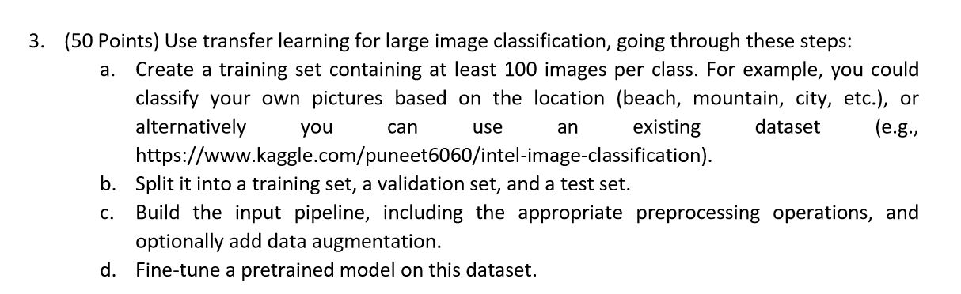

*Sima_Shafaei.ipynb*