Supplementary Materials

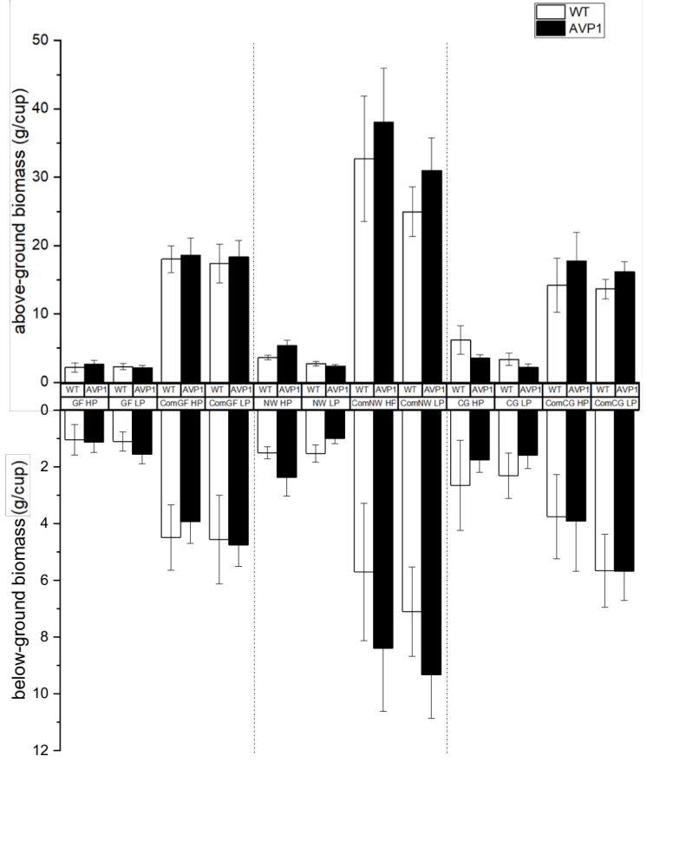
Figure S1. Above-ground and below-ground biomass in different biosolids and commercial fertilizer treatments comparing WT and AVP1 lettuce. The error bars indicate 95% confidence intervals. The two vertical dash lines separating the three sets of treatments (GF, NW, CG). Com: commercial fertilizer; HP & LP: high and low P; GF: Mesa Greenfield Water Reclamation Plant; NW: Mesa Northwest Water Reclamation Plant; and CG: Casa Grande Tolleson Wastewater Treatment Plant.

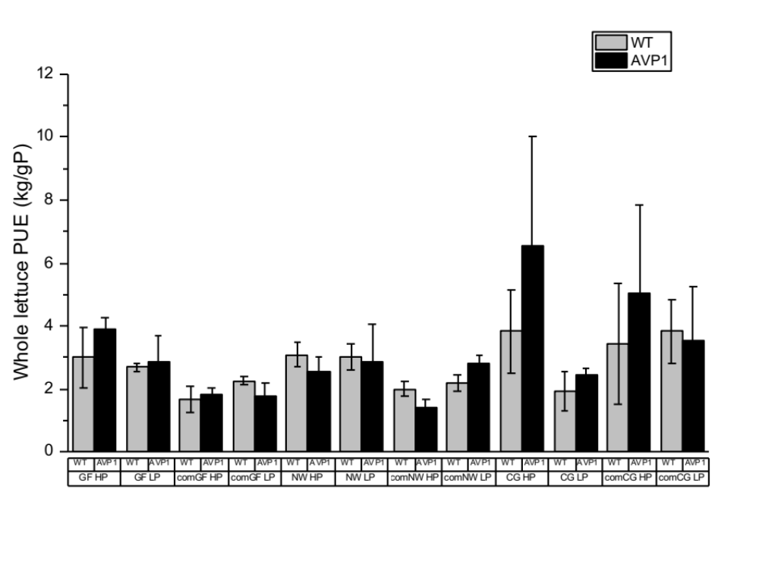
Figure S2. Whole-lettuce PUE with different biosolids and commercial-fertilizer treatments comparing WT and AVP1 lettuce. The error bars indicate 95% confidence intervals. Com: commercial fertilizer; HP & LP: high and low P; GF: Mesa Greenfield Water Reclamation Plant; NW: Mesa Northwest Water Reclamation Plant; CG: Casa Grande Tolleson Wastewater Treatment Plant.

Figure S2 shows the PUE of the whole lettuce. PUE was significantly higher in biosolid treatments than in commercial fertilizer treatments (p < 0.001). Higher PUE in biosolid treatments could imply that nutrients were less available for biosolids than for commercial fertilizers. Whole lettuce PUE was also higher under low fertilization rate than under high fertilization rate (p < 0.001). The blocking factor (source of biosolids) was significant as well (p < 0.001), in which the biosolid from Northwest Water Reclamation Plant was different from the others. Whole lettuce PUE was higher in AVP1 lettuce than in WT (p < 0.001) however there was no difference in whole lettuce PUE between WT and AVP1 lettuce in the commercial fertilizer treatment. However, under biosolid treatments, AVP1’s PUE was significantly higher than WT’s (p < 0.001).

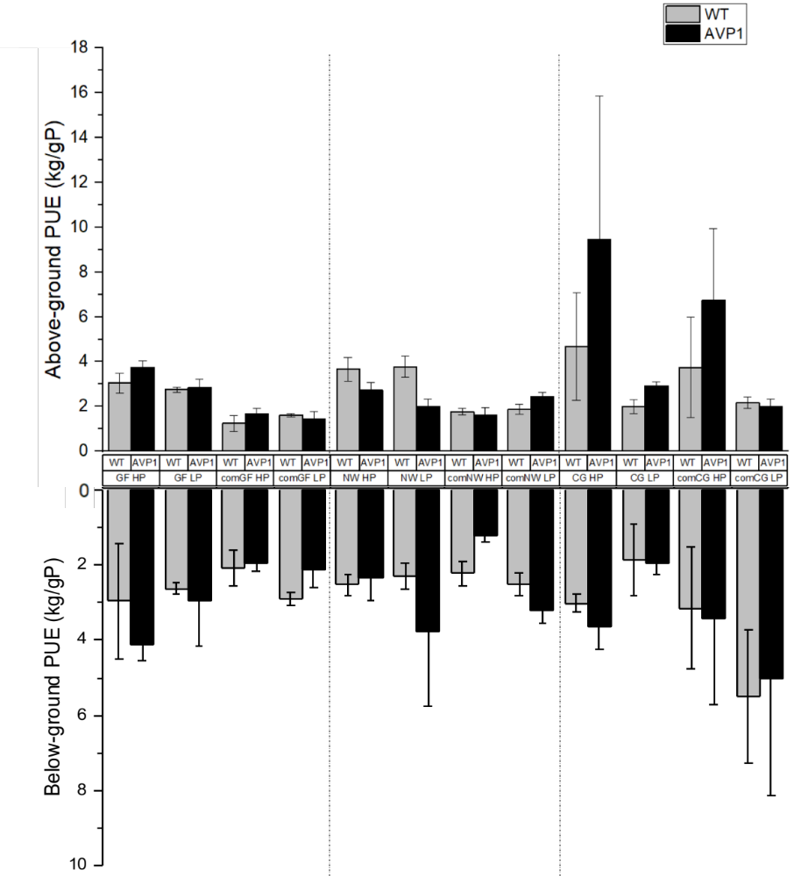
Figure S3. Above- and below-ground PUE in different biosolids and commercial fertilizer treatments comparing WT and AVP1 lettuce. Above-ground PUE of the two lettuce types did not differ, but below-ground PUE of AVP1 was higher than WT in biosolid treatments (p < 0.001). Low fertilizer level caused higher above- and below-ground PUE than high fertilizer level (p < 0.001, respectively). The error bars indicate 95% confidence intervals. Com: commercial fertilizer; HP & LP: high and low P; GF: Mesa Greenfield Water Reclamation Plant; NW: Mesa Northwest Water Reclamation Plant; CG: Casa Grande Tolleson Wastewater Treatment Plant.

Below-ground PUE (Fig. S3) of AVP1 was higher than below-ground PUE of WT (p < 0.001). Below-ground PUE (Fig. S3) of AVP1 was higher than below-ground PUE of WT in biosolid treatments (p < 0.001) but there was no difference in commercial fertilizer treatments. Below-ground PUE in biosolid treatments was better than in commercial fertilizer treatments (p < 0.001), and it was also higher in low fertilization rate than high fertilization rate (p < 0.001). Blocking effect was significant (p < 0.001), in which the biosolid from Northwest Water Reclamation Plant was different from the others. In summary, these results show that lettuce above- and below-ground PUE were affected by lettuce type, fertilizer type, fertilizer level, and block, as well as by various higher-level interactions.

It is interesting that the blocking effect is different in above- and below-ground PUE. The above-ground PUE was highest with the lowest N:P (CG) block, while the below-ground PUE was highest with the highest N:P (NW) block. In biosolid treatments, the above-ground PUE had no blocking effect. The blocking effect only appeared in the commercial fertilizer treatments. While the below-ground PUE had blocking effect in both biosolid and commercial fertilizer treatments. In conclusion, low N:P commercial fertilizer increased the above-ground PUE, while high N:P in both biosolids and commercial fertilizer increased the below-ground PUE.

Table S1. ANOVA table for above-ground biomass.
Source | Sum of Squares | df | Mean Square | F | Sigificance
Corrected Model | 21059 | 23 | 916 | 48.1 | 0.000
Intercept | 28817 | 1 | 28817 | 1515 | 0.000
Lettuce | 91.7 | 1 | 91.7 | 4.8 | 0.03
Block | 2432 | 2 | 1216 | 63.9 | 0.000
Fertilizer Type | 15858 | 1 | 15858 | 834 | 0.000
Fertilizer Level | 223 | 1 | 223 | 11.7 | 0.001
Lettuce x Block | 75.5 | 2 | 37.7 | 2 | 0.141
Lettuce x Fertilizer Type | 143 | 1 | 143 | 7.5 | 0.007
Lettuce x Fertilizer Level | 0.507 | 1 | 0.507 | 0.027 | 0.871
Block x Fertilizer Type | 2264 | 2 | 1132 | 59.5 | 0.000
Block x Fertilizer Level | 157 | 2 | 78.7 | 4.1 | 0.018
Fertilizer Type x Fertilizer Level | 28.6 | 1 | 28.6 | 1.5 | 0.222
Lettuce x Block x Fertilizer Type | 51 | 2 | 25.4 | 1.3 | 0.266
Lettuce x Block x Fertilizer Level | 1.6 | 2 | 0.822 | 0.043 | 0.958
Lettuce x Fertilizer Type x Fertilizer Level | 0.579 | 1 | 0.579 | 0.03 | 0.862
Block x Fertilizer Type x Fertilizer Level | 90.8 | 2 | 45.4 | 2.4 | 0.095
Lettuce x Block x Fertilizer type x Fertilizer Level | 13.8 | 2 | 6.9 | 0.362 | 0.697
Error | 3101 | 163 | 19
Total | 52593 | 187
Corrected Model | 24160 | 186

Table S2. ANOVA table for above-ground PUE.
Source | Sum of Squares | df | Mean Square | F | Sigificance
Corrected Model | 814 | 23 | 35.4 | 5.2 | 0.000
Intercept | 1667 | 1 | 1667 | 246 | 0.000
Lettuce | 17.2 | 1 | 17.1 | 2.5 | 0.113
Fertilizer Type | 75.3 | 1 | 75.3 | 11.1 | 0.001
Fertilizer Level | 85.7 | 1 | 85.7 | 12.7 | 0.000
Block | 128 | 2 | 64 | 9.5 | 0.000
Lettuce x Fertilizer Type | 0.026 | 1 | 0.026 | 0.004 | 0.951
Lettuce x Fertilizer Level | 22.6 | 1 | 22.6 | 3.3 | 0.069
Lettuce x Block | 58.6 | 2 | 29.3 | 4.3 | 0.014
Fertilizer Type x Fertilizer Level | 11 | 1 | 11 | 1.6 | 0.205
Block x Fertilizer Type | 2.5 | 2 | 1.2 | 0.181 | 0.834
Block x Fertilizer Level | 141 | 2 | 70.5 | 10.4 | 0.000
Lettuce x Fertilizer Type x Fertilizer Level | 1.6 | 1 | 1.6 | 0.241 | 0.624
Lettuce x Block x Fertilizer Type | 18.7 | 2 | 9.3 | 1.4 | 0.254
Lettuce x Block x Fertilizer Level | 25.5 | 2 | 12.7 | 1.9 | 0.155
Block x Fertilizer Type x Fertilizer Level | 1.3 | 2 | 0.671 | 0.099 | 0.906
Lettuce x Block x Fertilizer type x Fertilizer Level | 1.3 | 2 | 0.635 | 0.094 | 0.91
Error | 1414 | 209 | 6.8
Total | 4235 | 233
Corrected Model | 2228 | 232

