Fyp Assignment

Use case diagram
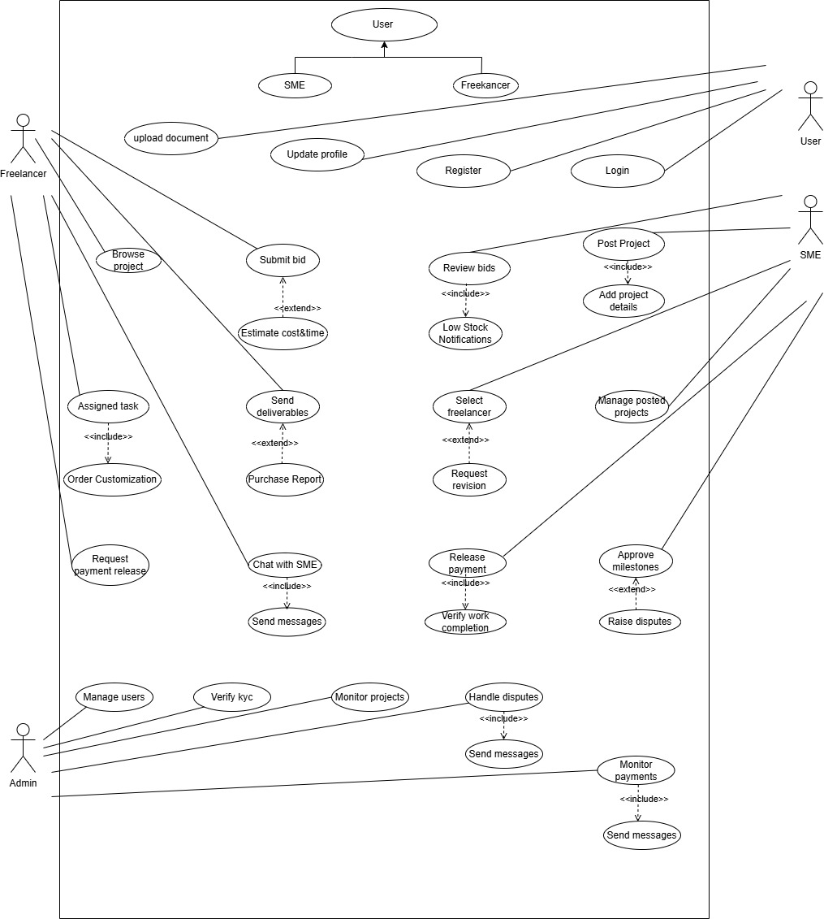
Figure 1: Use case diagram

Product Backlog

User registration and authentication
ID | User Story | Acceptance Criteria | Priority
PB1 | As a user, I want to create an account so I can start using the platform. | Correct input fields, phone/email verification, unique account check, KYC option available. | High
PB2 | As a user, I want to log in securely so I can access my dashboard. | Password encryption, proper session management, clear error handling. | High
PB3 | As a user, I want to update my profile whenever needed. | Editable details, profile image upload, data validation. | Medium
Table 1: Product Backlog

KYC Verification
ID | User Story | Acceptance Criteria | Priority
PB4 | As a user, I want to upload my KYC documents for verification. | Safe document upload, admin approval required. | High
PB5 | As an admin, I want to check and verify KYC submissions. | View files, accept or reject with remarks. | High
Table 2: Kyc verification product backlog

Project Posting(SMEs)
ID | User Story | Acceptance Criteria | Priority
PB6 | As an SME, I want to post a project so freelancers can apply. | Basic project details, skills, budget, file attachments. | High
PB7 | As an SME, I want to modify or close my posted project. | Editable information and option to archive the project. | Medium
Table 2: Product Backlog

Browse projects and bidding(freelancers)
ID | User Story | Acceptance Criteria | Priority
PB8 | As a freelancer, I want to browse available projects that match my skills. | Search and filter by skills, budget, or date. | High
PB9 | As a freelancer, I want to place a bid on projects I’m interested in. | Set bid amount, timeline, and a cover message. | High
PB10 | As a freelancer, I want to edit or cancel my bid before being hired. | Allowed prior to selection, confirmation message shown. | Medium
Table 3: Product Backlog

Freelancer Selection and contract
ID | User Story | Acceptance Criteria | Priority
PB11 | As an SME, I want to view and compare bids to choose the right freelancer. | Access profiles, reviews, and portfolios. | High
PB12 | As an SME, I want to officially hire a freelancer through the system. | Status updated, notifications sent. | High
Table 4: Product Backlog

Escrow Payment System (eSewa Integration)
ID | User Story | Acceptance Criteria | Priority
PB13 | As an SME, I want to deposit the project amount in escrow for security. | Integrated eSewa payment, confirmation receipt. | High
PB14 | As a freelancer, I want assurance that payment is reserved in escrow. | Visible escrow status and release terms. | High
PB15 | As an SME, I want to release the payment once the work is done. | Manual or automatic release, record kept in logs. | High
Table 5: Product Backlog

Messaging and File Sharing
ID | User Story | Acceptance Criteria | Priority
PB16 | As a user, I want to chat with my project partner for smooth communication. | Real-time messaging with timestamps. | High
PB17 | As a user, I want to share files safely during the project. | File size limit, basic security checks. | Medium
Table 6: Product Backlog

AI Estimation
ID | User Story | Acceptance Criteria | Priority
PB18 | As a freelancer, I want an AI tool that gives rough cost and time suggestions. | Basic machine-learning/rule-based outputs that can be adjusted. | Medium
Table 7: Product Backlog

Admin Dashboard
ID | User Story | Acceptance Criteria | Priority
PB19 | As an admin, I want a dashboard to supervise users, payments, and disputes. | Visual stats, tables, role controls. | High
Table 8: Product backlog

Dispute Handling
ID | User Story | Acceptance Criteria | Priority
PB20 | As a user, I want to submit disputes if problems arise. | Select issue type, upload evidence | High
PB21 | As an admin, I want to review complaints and settle disputes fairly. | Accept/reject decisions with justification. | High
Table 9: Product Backlog

Review and ratings
ID | User Story | Acceptance Criteria | Priority
PB22 | As an SME, I want to rate freelancers after a project is completed. | Rating scale plus written feedback. | Medium
PB33 | As a freelancer, I want to see my overall ratings. | Summary shown on profile. | Medium
Table 10: Product Backlog

Notification
ID | User story | Acceptance Criteria | Priority
PB24 | As a user, I want to receive alerts about bids, payments, chats, and disputes. | Real-time or email alerts. | Medium
Table 11: Product Backlog

Revised Gantt chart
A Gantt chart is a timeline that shows project tasks and milestones in a visual format. (ATLASSIAN, 2025)
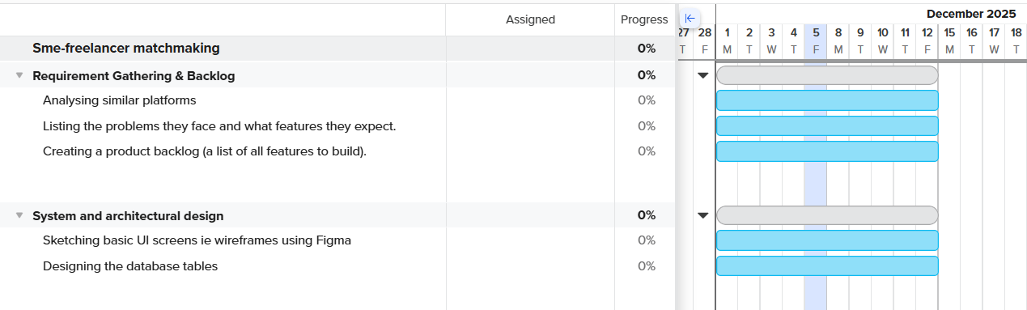
Figure 3: Gantt chart
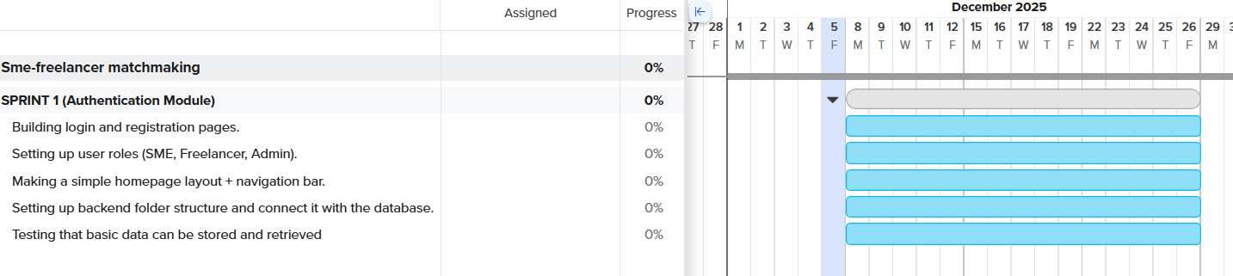
Figure 4: Gantt chart sprint 1
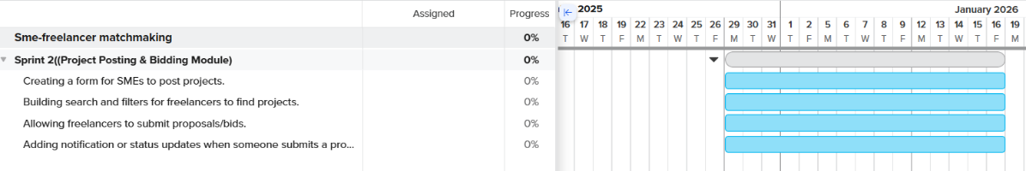
Figure 5: Gantt chart sprint 2
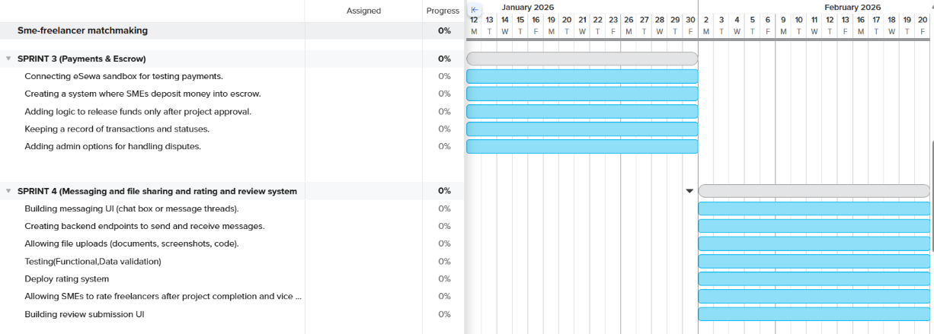
Figure 6: Gantt chart sprint 3 and 4
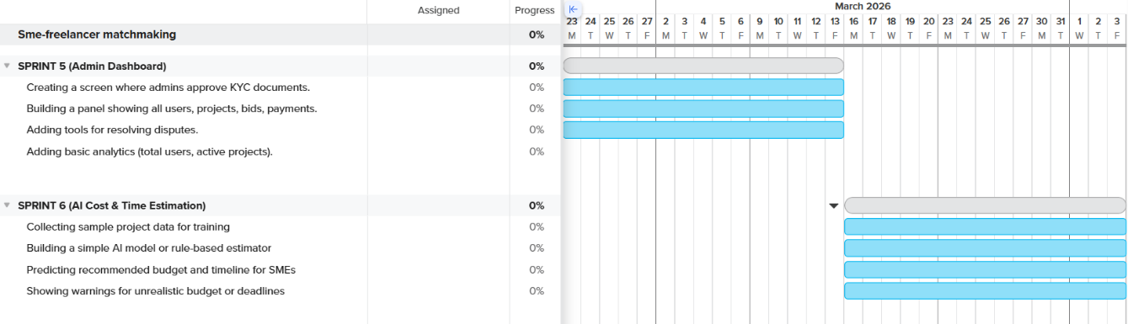
Figure 7: Gantt chart sprint 5 and 6
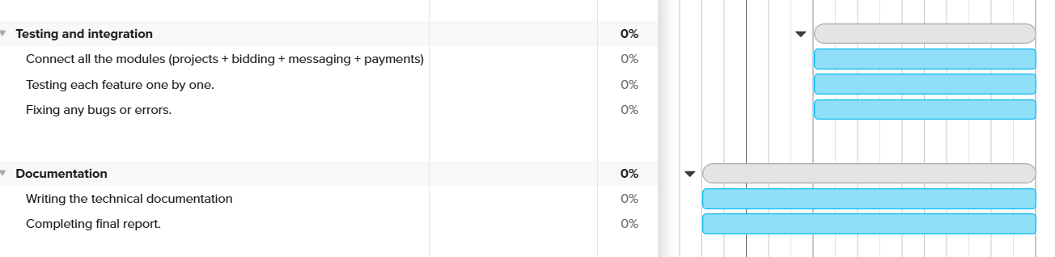
Figure 8: Gantt chart sprint 7, testing and documentation

Wireframe
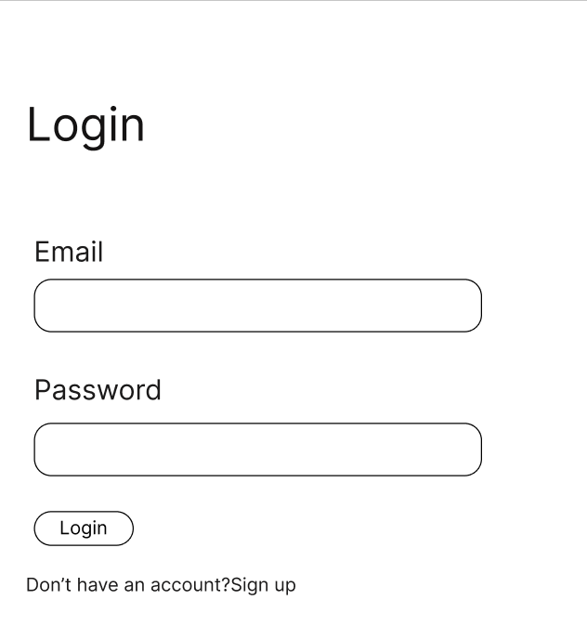
Figure 9: Wireframe of login
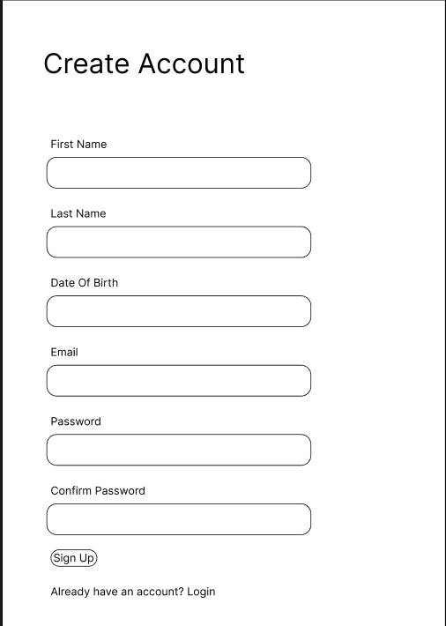
Figure 10: Registration wireframe

