Flight Reservation System helps the customer to reserve his/her air ticket using web site without any difficulty. The customer can reserve for air tickets and can pay online for their ticket confirmation by execution of online transaction. A customer can view his/her confirmation using login name and password provided during reservation for security purpose. There are various other facilities provided such as if a customer needed to cancel his/her reservation due to any reason, he/she may easily cancel out reservation with charges applied. Passenger can get information without visiting airport from their homes and offices like baggage, healthy travelling tips, luggage insurance etc.

* A Flight Reservation System is an application supporting the direct contact with the passenger through web site. This system make the life of passengers very easy as they don’t need to stand in queues for getting their seats reserved and they can easily make reservations on any airline just from a single system.
* User can choose Flight Reservation System to purchase air ticket of his choice that would be governed by whether he is a registered user or he is guest only who wants to search flights, check the availability of tickets or flight fare.
* User can register the system by signing up which will allow him to login after authentication. After login, user can avail facilities like view ticket, manage account and can also access his frequent flyer miles points which are awarded as per frequent purchase of tickets.
* For booking of flight, user will search the flight and select the seat of his choice, if required. After that user can review his itinerary details of travel. To confirm booking user have to do the payment. The mode of payment can be Debit Card, Credit Card or Online Banking. After payment validation by the bank, e-ticket for user is generated.
* After logging to system, user shall access View Reward Summary in which user can view their rewards points on booking of frequent air tickets which user can redeem during payment of air ticket reservation. In manage account, user can change his profile details like email id, contact number, user name, password etc. In view ticket, user can view his history of booked tickets. In ticket cancellation option, user can cancel his ticket which will result in the refund of user’s money after deduction of cancellation fees.
* In flight search, user will enter Route Search details i.e. origin city and destination city along with dates. After that system will then refer to the flight available along with fare followed by Passenger Details.
* Admin is the person who will manage the flight reservation system, he has the access to manage the flight schedule as per information. Admin will also be able to cancel the user’s ticket in case user is not able to login to the system.
* This system allows customers to buy tickets online from their home or anywhere from around the world. The customers can choose dates when they would like to travel as well as their departure and arrival location. The customers can even select their seats on the flight where they would like to reserve including the food and make their payment via debit card, credit card or online banking. The system also displays the available flights and seats forth desired location and dates, process the transaction and makes reservation.

# 

# **Use Cases**

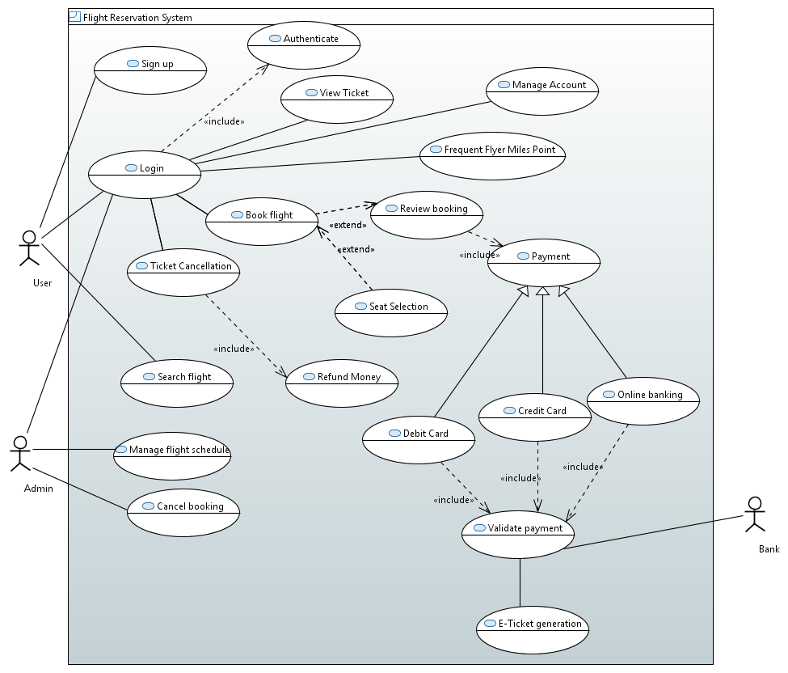

# **Use Cases Description**

|  |  |
| --- | --- |
| **Name** | **Sign-Up** |
| **Short Description** | Guest user sign up to register with system for future use. |
| **Precondition** | User must have access to Flight Reservation System |
| **Post-condition** | User get the unique credentials to login to Flight Reservation System |
| **Priority** | High |
| **Actors** | User |
| **Trigger** | User enters personal details |
| **Standard Process** | 1. User enters his person details like email-id, contact number, username and password. 2. User gets sign up with the system. |
| **Alternative Processes** | N.A. |

|  |  |
| --- | --- |
| **Name** | **Login** |
| **Short Description** | This use case describes the login page through which User/Admin can get into the system. |
| **Precondition** | 1. User is required to have a unique User-id and Password. 2. User should be a registered User. |
| **Post-condition** | User’s credentials are being authenticated. |
| **Priority** | High |
| **Actors** | User |
| **Trigger** | User enter his/her credentials to login. |
| **Standard Process** | 1. User/Admin enters his User-id and password. 2. User’s credentials is being authenticated. |
| **Alternative Processes** | Redirects to login page. |

|  |  |
| --- | --- |
| **Name** | **Authenticate** |
| **Short Description** | User would have to login with appropriate User-id and password which will be verified with the User-id and password in the User's account in database for successful login. |
| **Precondition** | User must login with valid credentials. |
| **Post-condition** | User’s login is successful. |
| **Priority** | High |
| **Actors** | System , User |
| **Trigger** | User is logging in the system. |
| **Standard Process** | 1. System verifies User’s credentials in database. 2. After verification is successful, User is redirected to their main page. |
| **Alternative Processes** | Login failed and appropriate error message should be displayed |

|  |  |
| --- | --- |
| **Name** | **View Ticket** |
| **Short Description** | User should be able to view his/her boarding pass/ticket after the successful booking. |
| **Precondition** | 1. User must be logged in successfully. 2. User must have purchased/booked a flight ticket. |
| **Post-condition** | Ticket/Boarding pass should be displayed on screen. |
| **Priority** | Medium |
| **Actors** | User |
| **Trigger** | User selected a boarding pass to view. |
| **Standard Process** | 1. User must be logged in successfully. 2. User clicked on ticket link/button to view in view ticked page. |
| **Alternative Processes** | User should be redirected to home page if their an error displaying ticket. |

|  |  |
| --- | --- |
| **Name** | **Manage Account** |
| **Short Description** | It helps Users to manage their profile in the system. For example, if User want to change their contact number or email id then can easily update their information in the system. |
| **Precondition** | User should be registered in the system. |
| **Post-condition** | User’s profile should be updated successfully. |
| **Priority** | Medium |
| **Actors** | User |
| **Trigger** | User proceeds to manage profile page after login. |
| **Standard Process** | 1. User logged in the system successfully. 2. User click on manage profile link to land on the page. 3. User updates his/her information successfully. |
| **Alternative Processes** | Appropriate error message is being displayed if User can’t edit his/her information successfully. |

|  |  |
| --- | --- |
| **Name** | **Frequent Flyer Miles Point** |
| **Short Description** | User can redeem the reward points in form of cash discount during payment. |
| **Precondition** | 1. User must login to system 2. User must have reward points, it should not be 0. |
| **Post-condition** | Reward points are redeemed. |
| **Priority** | Low |
| **Actors** | User |
| **Trigger** | User wants to book air ticket. |
| **Standard Process** | 1. User logins to the flight reservation system. 2. User selects frequent flyer miles points. 3. User can redeem reward points |
| **Alternative Processes** | N.A. |

|  |  |
| --- | --- |
| **Name** | **Search Flight** |
| **Short Description** | User can search flight route and fare. |
| **Precondition** | User should select travel dates and Departing and Returning Airports |
| **Post-condition** | Flight is searched. |
| **Priority** | High |
| **Actors** | User |
| **Trigger** | User wants to book air ticket. |
| **Standard Process** | 1. User logins to the flight reservation system. 2. User Enters Departing and Returning Airports. 3. User Enters Travel Dates. |
| **Alternative Processes** | N.A. |

|  |  |
| --- | --- |
| **Name** | **Book Flight** |
| **Short Description** | User can search flights and book air ticket. |
| **Precondition** | User should select travel dates and Departing and Returning Airports. |
| **Post-condition** | Flight ticket is booked. |
| **Priority** | High |
| **Actors** | User |
| **Trigger** | User wants to book air ticket. |
| **Standard Process** | 1. User logins to the flight reservation system. 2. User Enters Departing and Returning Airports. 3. User Enters Travel Date. 4. User review itinerary details. 5. User selects payment mode i.e. Credit Card, Debit Card or Online Banking. 6. After Payment verification by Bank side, e-ticket generates. |
| **Alternative Processes** | User can book flight through phone call or through travel agent. |

|  |  |
| --- | --- |
| **Name** | **Review Booking** |
| **Short Description** | User can review itinerary booking details. |
| **Precondition** | User selects flight for reservation. |
| **Post-condition** | Itinerary is reviewed. |
| **Priority** | Medium |
| **Actors** | User |
| **Trigger** | User wants to book air ticket. |
| **Standard Process** | 1. User logins to the flight reservation system. 2. User Enters Departing and Returning Airports. 3. User Enters Travel Date. 4. User can select seat, if required. |
| **Alternative Processes** | N.A. |

|  |  |
| --- | --- |
| **Name** | **Seat Selection** |
| **Short Description** | User can select seats as per his convenience. |
| **Precondition** | 1. User has to search flights. 2. One Flight needs to be selected. 3. Seats need to be available. |
| **Post-condition** | 1. Seats should be selected. |
| **Priority** | Medium |
| **Actors** | User |
| **Trigger** | User wants to select seats. |
| **Standard Process** | 1. User search the flights. 2. User try to book the flights as per his/her convenience. 3. After selecting flight User has to select seats of his choice. |
| **Alternative Processes** | 1. Seats are not available. 2. User search for other flight with available seats. |

|  |  |
| --- | --- |
| **Name** | **Payment** |
| **Short Description** | Use case describe the payment process to confirm reservation once the the flight is confirmed. Payment can be done through the differents option available. |
| **Precondition** | 1. Flight needs to be selected. 2. Confirmation needs to be done after reviewing whole information. |
| **Post-condition** | Payments should be accepted and tickets needs to be generated. |
| **Priority** | High |
| **Actors** | User |
| **Trigger** | User give confirmation for payment. |
| **Standard Process** | 1. User select the flight. 2. User give confirmation of payment. 3. User pay the fare through secure gateway by choosing one from credit card,master card and online banking. 4. Payment is accepted by bank. 5. Ticket is generated. |
| **Alternative Processes** | 1. Payment fails due to some reason. 2. User is redirected back to book flight page. |

|  |  |
| --- | --- |
| **Name** | **Validate Payment** |
| **Short Description** | Use case describe that the bank accepted the payment via the modes provide and redirect User back to the flight reservation page. |
| **Precondition** | 1. Payment need to be done through the modes provided. 2. User should have balance in the account for fare payment. |
| **Post-condition** | Payments should be accepted and tickets needs to be generated. |
| **Priority** | High |
| **Actors** | Bank |
| **Trigger** | User pay fare through the options available. |
| **Standard Process** | 1. User pay after selection of ticket. 2. User choose one of the option for payment. 3. Payment is validated by the bank. |
| **Alternative Processes** | 1. Validation fails due to some reason. 2. User is redirected again to payment platform. |

|  |  |
| --- | --- |
| **Name** | **E-Ticket generation** |
| **Short Description** | Use case describe the generation of ticket once the payment is done successful. |
| **Precondition** | 1. User needs to have proper balance in account. 2. Bank should accept payment. |
| **Post-condition** | Ticket is generated. |
| **Priority** | High |
| **Actors** | User,Bank |
| **Trigger** | User do the payment for reservation. |
| **Standard Process** | 1. User tried to make payment. 2. User select mode of payment. 3. Bank validated the payment. |
| **Alternative Processes** | 1. Ticket is not generated to to payment failure. 2. User try to pay with different mode. |

|  |  |
| --- | --- |
| **Name** | **Ticket Cancellation** |
| **Short Description** | A customer wishes to cancel a reservation. |
| **Precondition** | 1. A reservation has already been made. 2. Actor has successfully navigated to the main options screen. |
| **Post-condition** | 1. User should be logged in. 2. The selected reservation has been cancelled. 3. The selected reservation has NOT been cancelled. |
| **Priority** | Medium |
| **Actors** | Customer |
| **Trigger** | Selects the "Cancel Reservation" option |
| **Standard Process** | 1. User login: System verifies him from database. 2. User select cancel option: System will give him a warning message. 3. User cancel the reservation: System updates the database and shows a massage. |
| **Alternative Processes** | 1. In case of database connectivity error, system should show an error. 2. In case of log out the customer should be log in again and then perform again each step. |

|  |  |
| --- | --- |
| **Name** | **Refund Money** |
| **Short Description** | This use case describes how the user will request a refund on Ticket cancellation. |
| **Precondition** | 1. User should be registered. 2. A reservation has already been made. 3. User requests ticket cancellation. 4. The selected reservation should have NOT been cancelled before. |
| **Post-condition** | 1. The user will receive full refund. 2. The user will receive partial refund. 3. The user will receive no refund. |
| **Priority** | High |
| **Actors** | User |
| **Trigger** | 1. User requests Ticket cancellation. 2. Ticket cancellation is approved by the Admin. |
| **Standard Process** | 1. User login: System verifies him from database. 2. User select ticket cancel option: System will give him a warning message. 3. User cancel the reservation: System updates the database and shows a message. 4. User selects Refund money option. 5. Admin looks at the case and based upon the criteria for refund, he approves or denies a refund. |
| **Alternative Processes** | 1. In case of database connectivity error, system should show an error. 2. In case of logout the customer should be log in again and then perform again each step. 3. In case the user writes a request after the deadline. |

|  |  |
| --- | --- |
| **Name** | **Manage Flight Schedule** |
| **Short Description** | This use case describes how the administrator of the system can add and delete flight details from the portal. |
| **Precondition** | 1. The portal is pre-loaded with details such as text and images. 2. The administrator is logged into the system. |
| **Post-condition** | The Admin successfully manages the details. |
| **Priority** | High |
| **Actors** | Administrator |
| **Trigger** | 1. Administrator wants to add/modify flight information. 2. User wants updated flight information. |
| **Standard Process** | Admin selects the “Manage Flights” option, the system prompts the user to select one of the following two options:   1. Add new flight details 2. Modify existing information, i.e., update or remove. |
| **Alternative Processes** | Incomplete Flight Information: If the Admin fails to enter any of the mandatory flight information like flight Name, Availability and Price then the system displays an appropriate error message to the Admin. |

|  |  |
| --- | --- |
| **Name** | **Cancel Booking** |
| **Short Description** | The Administrator has to remove the reservation from the back end when the customer wishes to cancel the reservation. |
| **Precondition** | 1. User should be registered. 2. A reservation has already been made. 3. User requests ticket cancellation. 4. The selected reservation should have NOT been cancelled before. |
| **Post-condition** | 1. Ticket is cancelled. 2. Money is refunded. |
| **Priority** | Medium |
| **Actors** | Administrator |
| **Trigger** | A customer wishes to cancel a reservation. |
| **Standard Process** | 1. The Admin logs in. 2. The application authenticates the administrator and then displays the page where the administrator looks up the id of the customer who has requested cancellation of reservation. 3. After canceling the reservation, the administrator then sends a confirmation e-mail to the customer. |
| **Alternative Processes** | 1. The Admin fails to Log in. 2. User decides not to cancel the reservation. |

**Functional Requirement** :- The system shall provide given services. Users need these facilities and functions:

* **Sign Up :** Guest user can register with flight reservation system by signing up. User will gets login credentials after signing up.
* **Authenticated Login :** The system must provide Users a valid access. Registered Users should be able to logged in conveniently and unauthorised Users must be prevented the access of whole system as of security concerns. Their will be different privileges allocated to type of Users such as guest User , registered User/User , Admin etc.
* **View boarding pass/ticket :** Registered Users must be able to view their boarding pass after a successful login to check flight details or take a printout of ticket.
* **Manage User’s account :** User should be given privilege to create and update their profiles containing basic information.
* **Frequent Flyer Miles Point :** User can redeem the reward points gained from previous flight tickets booking in the form of cash discount on the latest ticket booking. This helps the user to remain loyal to particular website.
* **Search Flight :** User can search flights with fares and select flights accordingly or can only use the same for fares comparisons from other flight reservation system.
* **Book Flight :** User can search flight by giving details like travel dates, departing and returning airport. After select particular flight, user can select seat and then review itinerary details. After this user can do the payment through either credit card, debit card or online banking. Once verification of payment through bank is done, e-ticket gets generated.
* **Review Booking :** User can review itinerary details before confirming the booking. The payment mode for reservation of flight is enabled after review booking.
* **Seat selection :** User has option to select the seats as per his/her convenience. It is not mandatory but User can take benefit of this feature.
* **Payment/Validate payment :** User has to pay fare after the selection of flight and seats.Payment can be done through the different modes provided( Debit card, Credit card and Online banking ) which is later validated by bank.
* **E-ticket generation :** Ticket is provided to the User once the payment is accepted by the bank.
* **Ticket Cancellation :** The application authenticates the user and then displays the page where the user can cancel the booked ticket. User select cancel option and system will give him a warning message. User cancels the reservation and system updates the database and shows a confirmation message.
* **Refund Money :** Ticket cancellation is approved by the Admin. Admin looks at the case and based upon the criteria for refund, he approves or denies a refund.
* **Manage Flight Schedule :** The updated information is reflected on the front end for the user to browse through by Admin.
* **Cancel Booking :** The application authenticates the administrator and then displays the page where the administrator looks up the id of the customer who has requested cancellation of reservation. After canceling the reservation, the administrator then sends a confirmation e-mail to the customer.

**Non-functional requirements :** The system must adhere to the following non-functional requirements in order meet quality criteria and provide quality service.

* **Integrity :** Degree to which a system, product or component prevents unauthorized access to, or modification of, computer programs or data.

Login will do the authentication of the users, to avoid unauthorized/malicious access of the system.

* **Usability :** Degree to which a product or system can be used by specified Users to achieve specified goals with effectiveness, efficiency and satisfaction in a specified context of use.

Novice users can perform task X & Y in 10 mins while experience use can perform in 3 mins

* **Reliability :** Degree to which a system, product or component performs specified functions under specified conditions for a specified period of time.

No more than 1 per 1000 transactions shall result in a failure requiring a user to buy ticket again. But user won’t be charge for failure booking.

* **Performance efficiency :** This characteristic represents the performance relative to the amount of resources used under stated conditions.

Performance efficiency of the system is high as user can buy ticket within 10 seconds for 95% of cases.

* **Maintainability :** This characteristic represents the degree of effectiveness and efficiency with which a product or system can be modified to improve it, correct it or adapt it to changes in environment, and in requirements.

The Cyclomatic Complexity of code will not exceed 10 and no method will exceed 100 lines of code.

* **Portability :** Degree of effectiveness and efficiency with which a system, product or component can be transferred from one hardware, software or other operational or usage environment to another.

Not more than 10 % of the system implementation will be specific to the operating system.

* **Testability :** Degree of effectiveness and efficiency with which test criteria can be established for a system, product or component and tests can be performed to determine whether those criteria have been met.

90 - 95% of branch coverage will be included in the delivered system.

* **Reusability :** Degree to which an asset can be used in more than one system, or in building other assets.

The system code will be reusable which will help in achieving scalability.

* **Security :** degree to which a product or system protects information and data so that persons or other products or systems have the degree of data access appropriate to their types and levels of authorization.

Any intrusion will be detected and avoided by the system within few seconds.

* **Robustness :** Ability of system to cope with unexpected input or situation.

System will be able to handle up to 1000 users concurrently.

**References :**

1 ) ISO/IEC 25010