BookFlight:

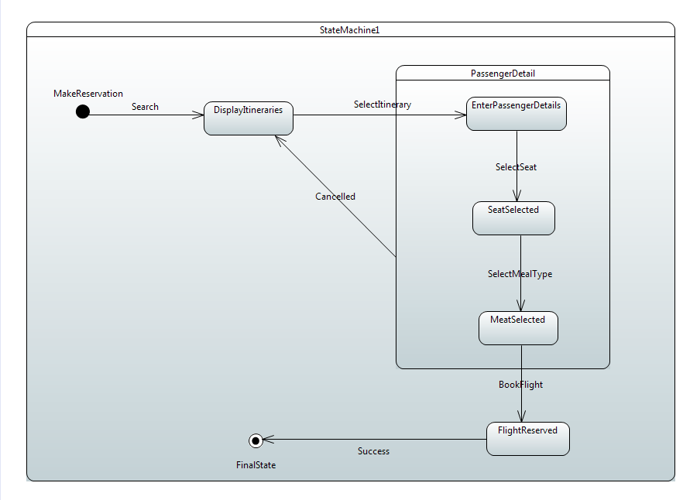

Payment

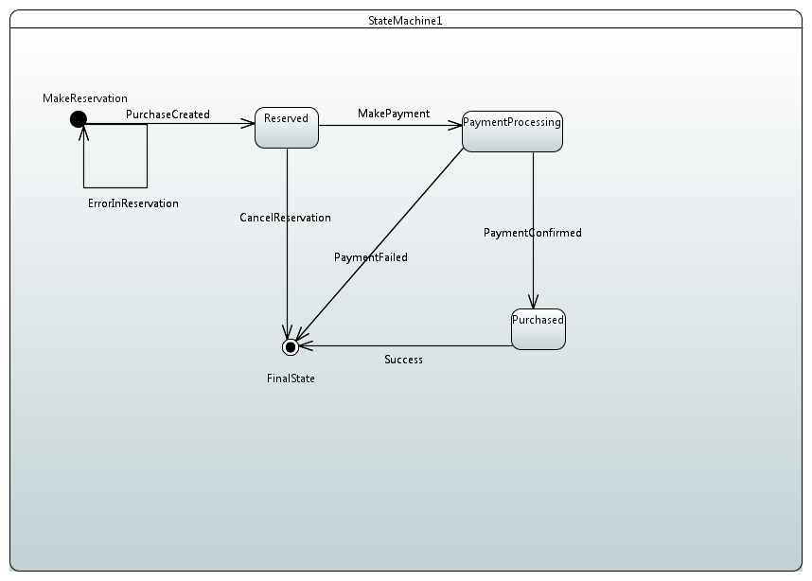

User Registration

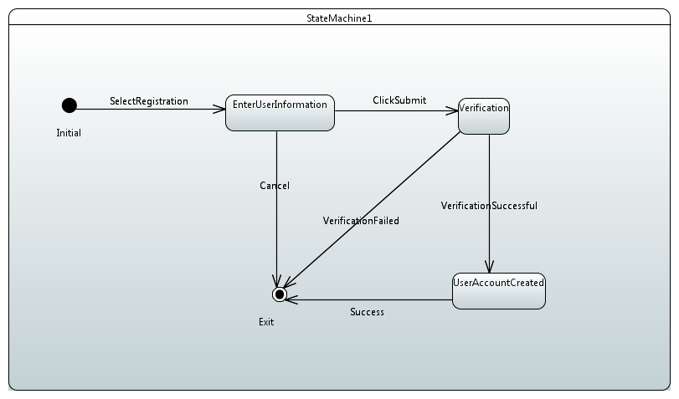

Action specification language

:searchFlight(arrival_date,departure_date,departure_city,No_of_passenger,arival_city)

If This.arrival_date>=this.departure_date and This.arival_city!=this.departure_city and

No_of_passenger!=null and trip!=null

Then

This.viewFlightInformation();

Else

Alert:= [Alert] = A1 : generateAlert[] on searchFlight

generateAlert()

endif

:bookingFlight(passenger_name, seat_preference, meal_preference, phone_number, email_id)

If This.passenger_name!=null and This. seat_preference!=null and this.meal_preference!=null and this.phone_number!=null and this.email_id!=null

Then

this.makePayment();

Else

Alert:= [Alert] = A1 : generateAlert [] on bookingFlight

generateAlert()

endif;

:makePayment(amount, payment_status ,card_number,card_hoder_name)

If this.validateCard(card_number,card_hoder_name)==true and this.sufficientAmount(amount)==true

ThenThis.payment_status=This.paymentConfirm()

Alert(payment_status);

endif;

:cancelFlight(booking_id,cancel_status)

If this.booking_id!=null

Then this.cancel_status=this.

flightCancellationConfirmation()

Alert(cancel_status);

endif;

**public** **class** RegisterUser {

**public** **static** **void** SaveUser(String user_name, **int** password,String first_name,String last_name,//others)

{

//code to register user by using all the parameters

}

}

**public** **class** Flight{

Public **static** **void** searchFlight(String arrival_city,departure_city,arrival_date,departure_date

number_of_passenger)

{

**if**(arrival_city!=**null** and departure_city!=**null** and arrival_date!=**null** and departure_date!=**null**)

{// here we code for search flights

// String result is local vairable to store search result.

ViewFlightInformation( result); // this is for displaying search result

}

**else**

generateAlert() // display error message

}

}

public **static** ViewFlightInformation(String result)

{ // display search result

// System.out.print(result) to display search}

}

}

**public** **class** BookFlight

{

**public** **static** bookFlight(String member_name,passenger_name,phone_number//others)

{

**if**(member_name!=**null** and passenger_name!=**null** and phone_number!=**null**)

{

//here we code to book flights.

bookingDetails(details);//// this is to display booking details like displaying id

}

**else**

generateAlert() // display error message

}

**public** **static** bookingDetails(String details)

{

//display the ticket details once the flight is booked

}

}

**public** **class** Payment

{

String payment_status;

**public** **static** makePayment(**int** amount,**int** card_number, String card_holder_name)

{

**if** (validateDetails(card_number,card_holder_name)==**true**

and sufficientAmount(amount)==**true**)

{

payment_status=paymentConfirm();//display the status about payment

System.out.println(payment_status)

}

**else** generateAlert() // display error message

}

**public** String validateDetails(**int** card_number, String card_holder_name )

{

//validate card information

**return** status;// status will be local variable which confirm the card details

}

**public** **int** sufficientAmount(**int** amount )

{

//validate sufficient balance

**return** status;// status will be local variable which display the sufficient amount

}

**public** String paymentConfirm()

{

//display message

**return** status;// status will be local variable which display the payment status

}

}

**public** **class** Cancellation

{

String cancel_status;

**public** String cancelFlight(Long booking_id)

{

If (booking_id!=**null**)

{

cancel_status=flightCancellationConfirmation(booking_id)//code for canceling flight

**return**(cancel_status);

}

**else** generateAlert() // display error message

**return** (message);

}

**public** string flightCancellationConfirmation(Long booking_id)

{

**return**(status);//code for cancellation of flight

}

}