Machine Learning Classification Report
Online Purchase Risk Prediction
AIGC 5005 — Midterm Project | March 2026
Simardeep Kullar - n10008693
Pravdeep Kullar - n01430968
Udeme Akpausoh - n01495603
Istikbal Turut - n01404444

Table of Contents
1. Introduction 3
2. Dataset Overview and Preprocessing 3
2.1 – Dataset Overview 3
2.2 – Data Preprocessing Steps 4
Step 1 – Drop Columns 4
Step 2 – Binary Encoding 4
Step 3 – Feature Engineering 4
Step 4 – One-hot Encode Categorical Variables 4
Step 5 – Median Imputation 5
2.3 – Model Selection 5
3. Results and Findings 5
3.1 – Feature Analysis 5
3.2 – Threshold Selection 7
3.3 – Test Set Performance 8
3.4 – Confusion Matrix 8
3.5 – ROC Curve 9
4. Interpretation and Discussion 10
4.1 – Interpretation of Results 10
4.2 – Discussion – Why the 70% F1 Target Was Not Reached 11
5. Conclusion 11
6. References 11

1. Introduction
In e-commerce, accepting an order that defaults on payment represents a direct financial loss, while falsely rejecting a legitimate order, leads to loss in revenue as well as ruining a customer’s experience. Identifying high-risk orders before fulfilment is therefore a problem of practical commercial importance.
This report presents a Logistic Regression classification model built to predict whether an online purchase order will result in a payment default (labelled “yes” for high risk) or not (labelled "no” for low risk). The dataset contains 30,000 online purchase orders from an online retailer, described by 44 features which include customer demographics, payment method, address validation flags, and historical purchasing behaviour. The challenge for this model is to maximize the F1-Score for the “yes” class and aim for 70%.

2. Dataset Overview and Preprocessing

2.1 – Dataset Overview
The dataset (risk-train.txt) is a tab-separated file containing 30,000 rows and 44 columns. Each row represents a single online purchase order. The target variable CLASS is binary with “yes” indicating a high-risk order and “no” indicating a low-risk order.
Class Distribution:
Class | Count | Proportion
No (Low-risk) | 28,254 | 94.2%
Yes (High-risk) | 1,746 | 5.8%
Total | 30,000 | 100%
Table 1 – Class distribution in the full dataset
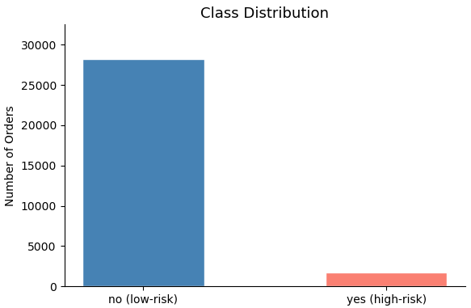
Figure 1 - Class distribution visualization
The dataset contains 16 columns with missing values, ranging from 0.1% (TIME_ORDER) to 100% (ANUMBER_10). There are several columns () with a large amounts of missing values which are
Column | Missing % | Handling
ANUMBER_02 - 10 | 73.8 – 100% | Dropped
Z_CARD_ART | 62.2% | Dropped
MAHN_AKT | 52.9% | Kept – Filled with 0
DATE_LORDER | 52.9% | Kept – Engineered to recency
MAHN_HOECHST | 52.9% | Kept – Filled with 0
Z_LAST_NAME | 49.4% | Kept – Filled with median
B_BIRTHDATE | 9.8% | Kept – Engineered to AGE
TIME_ORDER | 0.1% | Kept – Filled with median
Table 2 – Columns with missing values and their handling

2.2 – Data Preprocessing Steps
The preprocessing of this dataset followed a specific strategy to keep as much relevant information as possible, rather than simply dropping columns because they contained missing values. The steps are outlined below:

Step 1 – Drop Columns
ORDER_ID is a row identifier with not predictive value and was removed.
ANUMBER02-10 are product code fields with a high percentage of missing values (73.8-100%) with no predictive value and were removed.
Z_CARD_ART contained the card type as a string and was also dropped as it had no predictive value, was missing 62.2% and cannot be used directly in a numeric model.

Step 2 – Binary Encoding
There are 19 columns containing yes/no text, which were all mapped to 1/0 integer values so the logistic model could process them numerically.

Step 3 – Feature Engineering
TIME_ORDER was parsed from a HH:MM string into an integer hour (0-23).
B_BIRTHDATE was converted to AGE by subtracting the birth year from 2026, and the original B_BIRTHDATE column was dropped.
MAHN_AKT and MAHN_HOECHST contain the stage of reminder for the customer, and the highest stage of reminder respectively. A missing value means the customer has never received a notice, so both columns are kept and their missing values are imputed with 0 to represent “no reminder history”.
DATE_LORDER was kept and engineered into two new features.
DAYS_SINCE_LAST_ORDER which is calculated as the number of days between the order and last recorded order date in the dataset (used as reference point as it is most recent) and HAS_PRIOR_ORDER_DATE is a binary flag indicating whether a prior order date was recorded at all. The original DATE_LORDER column is then dropped and the remaining missing values in DAYS_SINCE_LAST_ORDER were filled with the column median.

Step 4 – One-hot Encode Categorical Variables
WEEKDAY_ORDER and Z_METHODE were one-hot encoded with drop_first=True which drops one dummy variable per group to avoid multicollinearity in the model.

Step 5 – Median Imputation
Any remaining missing values across all columns were filled with the column median, which is not affected by outliers.
After preprocessing, the dataset contained 30,000 rows and 41 columns (40 features plus the target CLASS), with zero missing values.

2.3 – Model Selection
Logistic Regression was selected as the classification algorithm due to its interpretability and suitability for binary classification. It models the log-odds of the positive class as a linear combination of the input features and outputs a probability between 0 and 1 for each set (Tripepi et al., 2008). The probabilities can then be converted into a class label using a decision threshold.
Since the dataset is very imbalanced, with only 5.8% of orders labelled as high risk, it needs to be addressed properly so that the model can better predict on unseen data. By setting the parameter class_weight=”balanced”, the model can automatically weigh each class inversely proportional to its frequency in the training data (Scikit-learn developers, n.d. -a). This will then penalize the model more heavily for missing a high-risk order, since in this business case missing a high-risk order is more dangerous than missing a low-risk order.
Features were then standardized using StandardScalar(), and fit on the training set only and then applied to the test set. The reason standardizing was needed was because this dataset contains features on many different scales. For example, there are binary scales (0 or 1) in features such as B_EMAIL, while other features such as VALUE_ORDER span much larger ranges. Standardization thus, rescales each feature to ensure that no single feature dominates the model due to its larger values, as compared to its predictive value (how important it is), this then allows the optimization algorithm to converge reliably (Scikit-learn developers, n.d. -b).
The data was split 80% (24,000 samples) for the training set and 20% (6,000 samples) for the testing set using stratified sampling to preserve the class imbalance in both partitions.

3. Results and Findings

3.1 – Feature Analysis
Figure 2 shows the top 10 features by absolute correlation with the target CLASS, with NEUKUNDE (new customer flag), HAS_PRIOR_ORDER_DATE (customer has ordered before), and B_EMAIL (customer has email on file) coming out as the strongest predictors. This visualization shows a weak correlation (max ≈ 0.10), indicating that there is no strong individual predictors. While new customers exhibit higher risk, most features show inconsistent or non-linear patterns. This suggests that default risk depends on complex feature interactions rather than single variables.
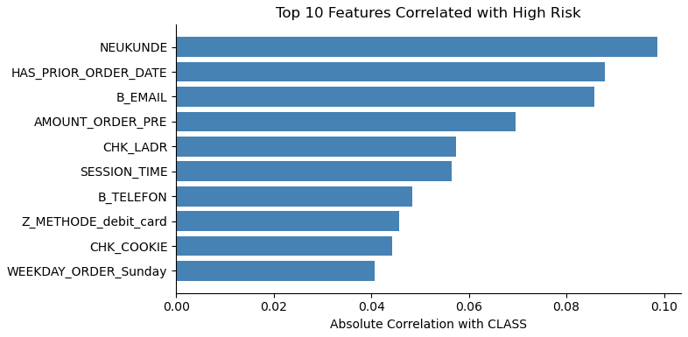
Figure 2 – Top 10 Features Associated with High-Risk
Figure 3 illustrates the high-risk rate broken down by each of the three most correlated features. NEUKUNDE shows that a new customer have almost double the default rate of existing customers, which is naturally expected as customers with no purchase history have more uncertainty about their payment behaviour. Aligned with NEUKUNDE, HAS_PRIOR_ORDER_DATE also has roughly double the default rate as compared to customers with a previous order date. Both these features capture whether a customer is a first-time customer with no history or they are a returning customer. Lastly, B_EMAIL shows that orders with no email addresses on file also have double the default rate as compared to customers with emails on file.
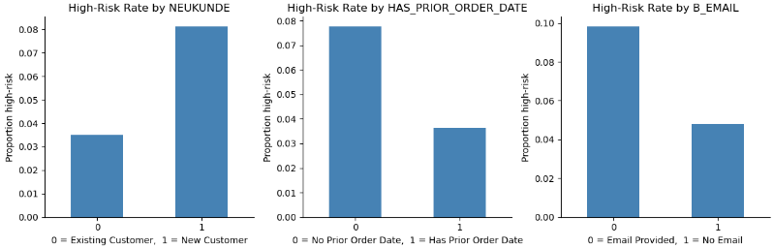
Figure 3 – Top 3 Features Associated with High-Risk Detailed
Referring back to Figure 1, the class distribution confirms that the dataset is highly imbalanced, with only ~5–6% high-risk cases, suggesting that payment default is a rare event. This underlines the need for careful handling of class imbalance during modelling as a standard classifier trained without any adjustment would more inclined to predict “no” for every order and still achieve at least an accuracy of 94% while failing to predict any high-risk cases.

3.2 – Threshold Selection
Originally the default threshold of 0.5 was used to predict the classification of the test data which resulted in an F1-score of 0.19. However, since it was unable to achieve the goal of obtaining a F1-score of 70%, threshold tuning was used to search which threshold was optimal for increasing the F1-score.
Figure 4 shows the predicted probability distributions for the true low-risk and true high-risk orders on the test set. From this plot it is clear that the low-risk order distribution extends well past 0.5, meaning a large amount of low-risk orders score above the default threshold and would be incorrectly identified as high-risk. At the same time, the opposite is true with high-risk orders below the default threshold being incorrectly identified as low-risk. The two distributions are also seen to be overlapping around 0.45 to 0.6 which places the default threshold in the center of the distribution where the model is most uncertain. Both of these observations, are the result of class_weight=”balanced” which pushes the predicted probabilities upward and shifts the high-risk distribution towards 0.6 to roughly 0.9. Thus, looking for the optimal threshold to achieve the highest F1-score is required for the goal of this project.
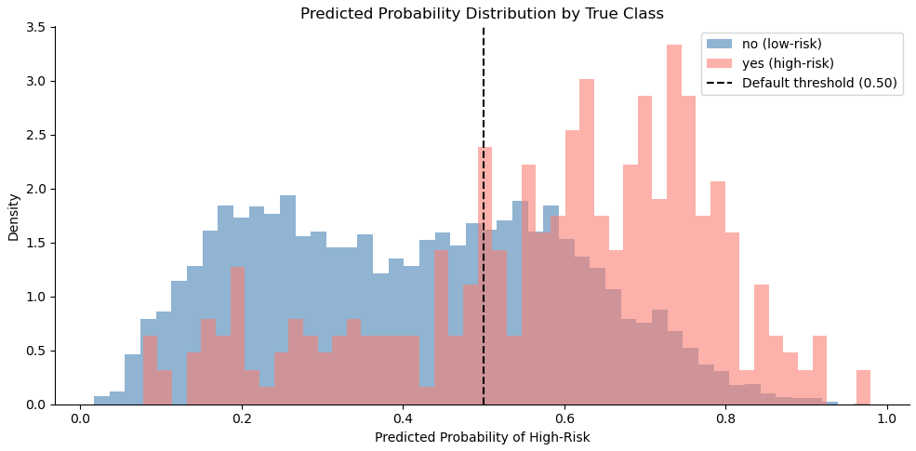
Figure 4 – Predicted Probability Distribution of Each Class
Figure 5 shows the F1-score for the high-risk “yes” class across all thresholds. The curve peaks at a threshold of 0.68, which is selected as the optimal decision boundary to maximize the F1-score.
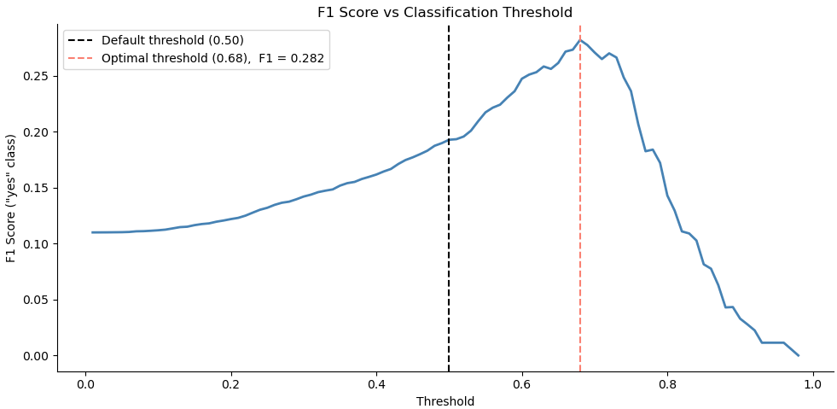
Figure 5 – F1-Score vs Thresholds

3.3 – Test Set Performance
Figure 6 presents the full classification report on the 6,000 sample test set with the default threshold of 0.5.
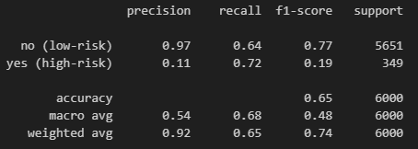
Figure 6 – Classification Report on Test Set (Threshold = 0.5)
Without any threshold tuning, with the default threshold of 0.5, the model performs moderately on the low-risk class with an F1-score of 0.77, while the high-risk class achieves an F1-scoer of only 0.19. The recall of 0.72 for the high-risk class means that the model is able to correctly identify 72% of all actual high-risk orders. However a precision of 0.11 means that of all orders flagged as high-risk orders, only 11% are real.
Figure 7 presents the full classification report on the 6,000 sample test set using the optimal threshold of 0.68.
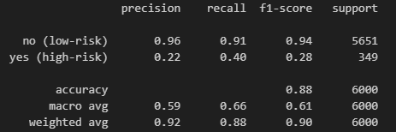
Figure 7 – Classification Report on Test Set (Threshold = 0.68)
The model performs much more strongly on the low-risk class, achieving an F1-score of 0.93, while performance on the high-risk class is much lower at 0.28. The recall of 0.40 for the high-risk class means the model correctly identifies 40% of all actual high-risk orders, while a precision of 0.21 means that of all orders flagged as high-risk, 21% of them are actually true. The overall accuracy of 88% is largely due to the high number of low-risk cases and it is not a meaningful indicator of performance in this case.

3.4 – Confusion Matrix
Figure 8 breaks down the test set predictions into the four categories of, True Negative (low-risk correctly identified), False Positive (low-risk incorrectly flagged as high-risk), False Negative (high-risk orders missed) and True Positive (high-risk correctly identified) for the model with default threshold of 0.5.
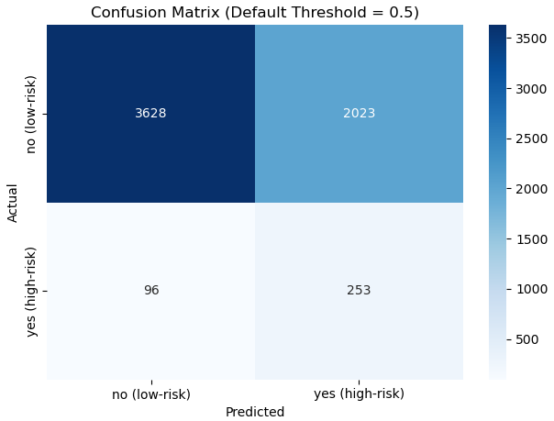
Figure 8 – Confusion Matrix (Default Threshold = 0.5)
Figure 9 breaks down the test set predictions for the tuned model with threshold of 0.68.
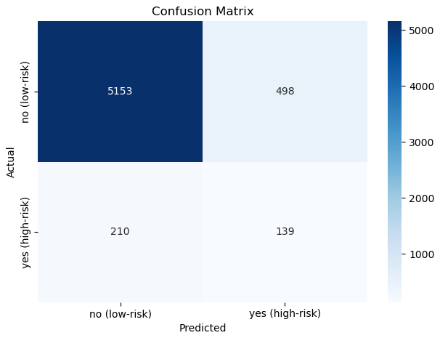
Figure 9 – Confusion Matrix (Threshold = 0.68)

3.5 – ROC Curve
Figure 10 illustrates the ROC curve which plots the true positive rate against the false positive rate across all possible thresholds, as well as the area under the curve (AUC) which helps summarize the model’s overall ability to discriminate between the two classes regardless of threshold (Yang & Berdine, 2017). An AUC of 1.0 indicates perfect separation and 0.5 is equivalent to “randomly flipping a coin” (Yang & Berdine, 2017).
The model achieves an AUC of 0.74, which indicates an acceptable discriminative ability despite the class imbalance. The curve rising steeply in the beginning means the model is able to identify a good portion of high-risk orders while generating few false alarm. After a false positive rate of roughly 0.2, the curve begins to flatten, which suggests that catching additional high-risk orders comes at a cost of increasing false positives.
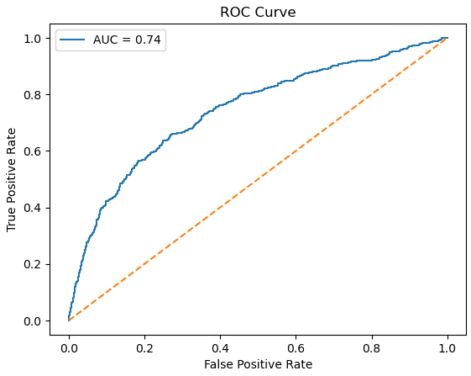
Figure 10 – ROC Curve

4. Interpretation and Discussion

4.1 – Interpretation of Results
The model achieves an F1-score of 0.28 for the high-risk class, with an overall accuracy of 88% and an AUC of 0.74. While the accuracy and low-risk f1-score appear strong, they are largely due to the dominant low-risk class and do not accurately reflect the model’s performance.
Looking at the high-risk class specifically, the model is able to correctly predict 140 out of 349 high-risk orders, but misses 209 entirely. Of all the orders flagged as high-risk the model is only able to identify 22% genuine cases which means that roughly every 4 out of 5 orders flagged are false alarms.
The AUC of 0.74 indicates that the model has moderate discriminative ability overall, performing much better than randomly guessing but also reflecting difficulty in separating the two classes where no single feature provides strong separation.
The threshold tuning improved the F1-score from 0.19 to 0.28 by raising the decision threshold from 0.5 to 0.68. However, threshold tuning came at the cost of recall dropping from 0.72 to 0.40, which means the tuned model misses more high-risk orders than the untuned version. This is a direct trade-off for optimizing for F1 which treats precision and recall equally as important, even when in situations where one or the other can be more important, which in this business case would be recall, since missing a high-risk order results in a direct financial loss.

4.2 – Discussion – Why the 70% F1 Target Was Not Reached
The model was able to achieve an F1-score of 0.28 after threshold tuning for the high-risk class, however it falls significantly short of the 0.70 target for this project. Without threshold tuning the model was only able to achieve an F1-score of 0.19. This gap is not a result of a single issue but rather a combination of limitations that constrain what logistic regression classification can achieve on this dataset.
The first limitation is the weakness of the features in the dataset. As shown from Figure 2, the maximum absolute correlation between any single feature and the target class is about 0.10. This means that the model has no strong signal to work with but rather several faint indicators of risk which the logistic regression model must combiner into a singular decision. If the underlying features are unable to cleanly differentiate between what is low-risk and what is high-risk, regardless of how much feature engineering is done the performance will still fall short of the 0.70 F1-score.
The second limitation is logistic regression itself as it can only draw a straight line between two classes when making predictions and it cannot capture curved or complex patterns. This would work well when the high-risk and low-risk orders are clearly separable by a straight line, however given the weak correlations observed across all the features it is unlikely that a linear boundary is sufficient in separating the two classes in the dataset.
The third limitation and arguably the most significant is the severe class imbalance. With only 5.8% of orders labelled high-risk, there are 349 positive examples in the test set compared to 5,651 negative examples. Even after using the parameter class_weight=”balanced” and threshold tuning, the model has far fewer high-risk examples to learn from during training. This makes it extremely difficult for logistic regression to learn what a reliable high-risk order looks like, even more specifically when the features themselves are weak at distinguishing the classes.

5. Conclusion
This project applied logistic regression to a binary payment default classification problem using a dataset of 30,000 online purchase orders. One of the biggest challenges of this dataset was the severe class imbalance, as only 5.8% of the orders were labelled as high-risk, which is why careful data preprocessing and feature engineering was required to prevent the model from defaulting to predicting “no” for every observation. The primary objective was to aim to achieve an F1-sccore of 70% for the high-risk “yes” class, however due to the class imbalance, weak feature correlations and limitations of logistic regression, it was proven difficult and the model only achieved an F1-score of 0.28.

6. References
Pourmodheji, H. (n.d.). 03 – classification [Jupyter notebook]. GitHub. https://github.com/pmodheji/ml-basics/blob/main/03%20-%20Classification.ipynb
Pourmodheji, H. (n.d.). Lecture notes of AI capstone project prep (AIGC-5005-RNA) [Lecture notes]. Humber College.
Scikit-learn developers. (n.d.-a). sklearn.linear_model.LogisticRegression. Scikit-learn. https://scikit-learn.org/stable/modules/generated/sklearn.linear_model.LogisticRegression.html
Scikit-learn developers. (n.d.-b). sklearn.preprocessing.StandardScaler. Scikit-learn. https://scikit-learn.org/stable/modules/generated/sklearn.preprocessing.StandardScaler.html
Tamim, I. (n.d.). Lecture notes of machine learning & deep learning (AIGC-5002-RNA) [Lecture notes]. Humber College.
Tripepi, G., Jager, K. J., Dekker, F. W., & Zoccali, C. (2008). Linear and logistic regression analysis. Kidney international, 73(7), 806-810.
Yang, S., & Berdine, G. (2017). The receiver operating characteristic (ROC) curve. The Southwest Respiratory and Critical Care Chronicles, 5(19), 34-36.

