**Style:**

**Are you sure it is comfortable to use capital letters in every sentence.**

**DATA SOURCES & PRE-PROCESSING**

Change:

COMBINED DATASETS:

ADD “Get age of every sample according to pre-result on Mastersheet.”

**Analysis Completed about q2:**

**1 CHOSEN DATA:**

all samples but divided by age;

**2 Feature engineer:**

Choosing features from all features for every bins divided by age according to Standard deviation.

**3 MODLE and OPTIMIZATION:**

**Gaussian mixture model optimized by AIC**



**4 result:**

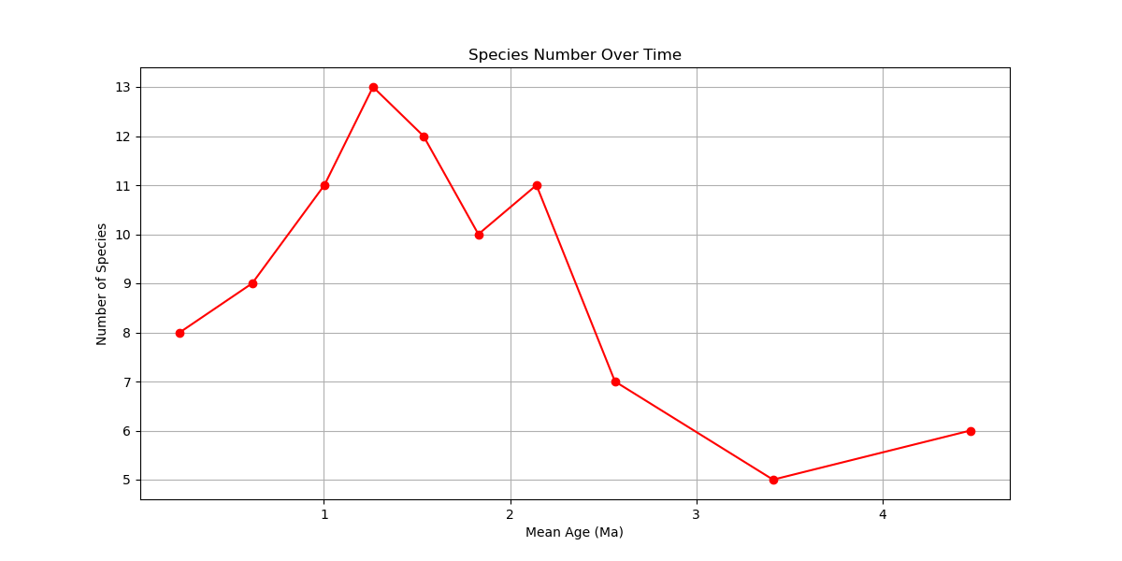

**NEXT PLANNED STEPS(**This part I give more because I see there is a little on ppt. If you think they are too much, you can decrease the reason why we make it(RED)):

1 Add Correlation analysis on feature engineer of q2. When we make Feature engineer, we ignore correlation between features because the number of feature is enough small.