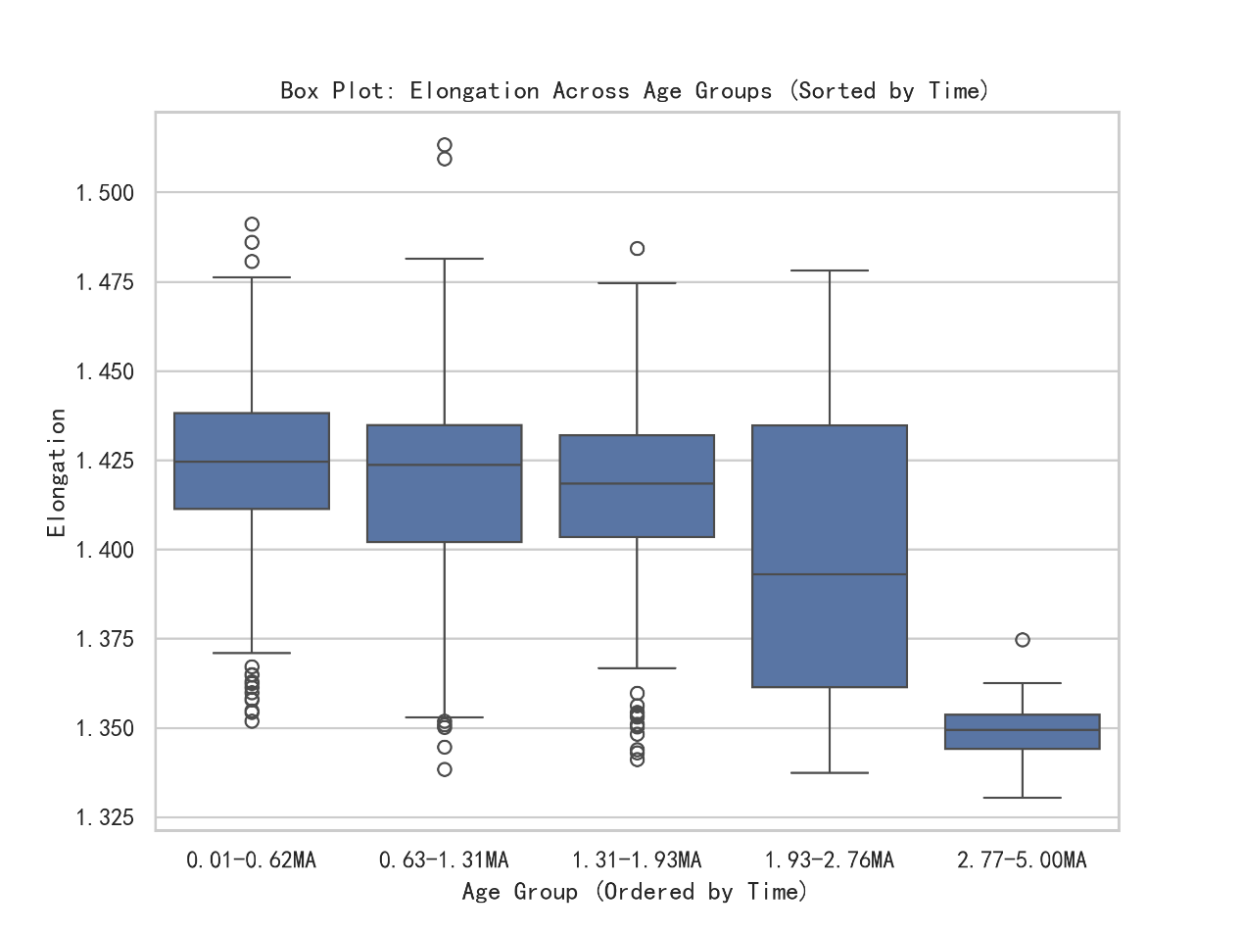The code reads the data and performs preliminary checks, including data shape, missing values, repeated row statistics, and basic descriptive statistics. Next, we preprocess the data, rename some columns, and divide the data into five age groups (age_groups) based on the quantile of the "Age_Ma" column, and calculate the time intervals for each group. Next, the code analyzes the distribution of Max_Diameter, Min_Diameter, and Elongation by drawing histograms, and uses the IQR (interquartile range) method to detect and remove outliers to improve data quality. After removing the outliers, box plots, scatter plots and line plots were drawn to observe the trend of each feature over time. Finally, the correlation matrix between Age_Ma and each feature is calculated and visualized using a heat map to help identify the relationship between variables.

This box plot shows how Elongation changes over time (age groups). It can be seen from the figure that the elongation rate is relatively stable in most of the time periods, approximately between 1.40 and 1.45. However, during the period of 1.93-2.76MA, the data fluctuates greatly, and some values are particularly high or low, indicating that some changes may have occurred during this period, such as the influence of environmental conditions or changes in material properties. However, the data from 2.77 to 5.00MA are very concentrated and hardly change much, which may mean that the biological or material morphology is relatively stable during this period. In addition, some time periods have some outliers (outliers), possibly due to individual special circumstances.

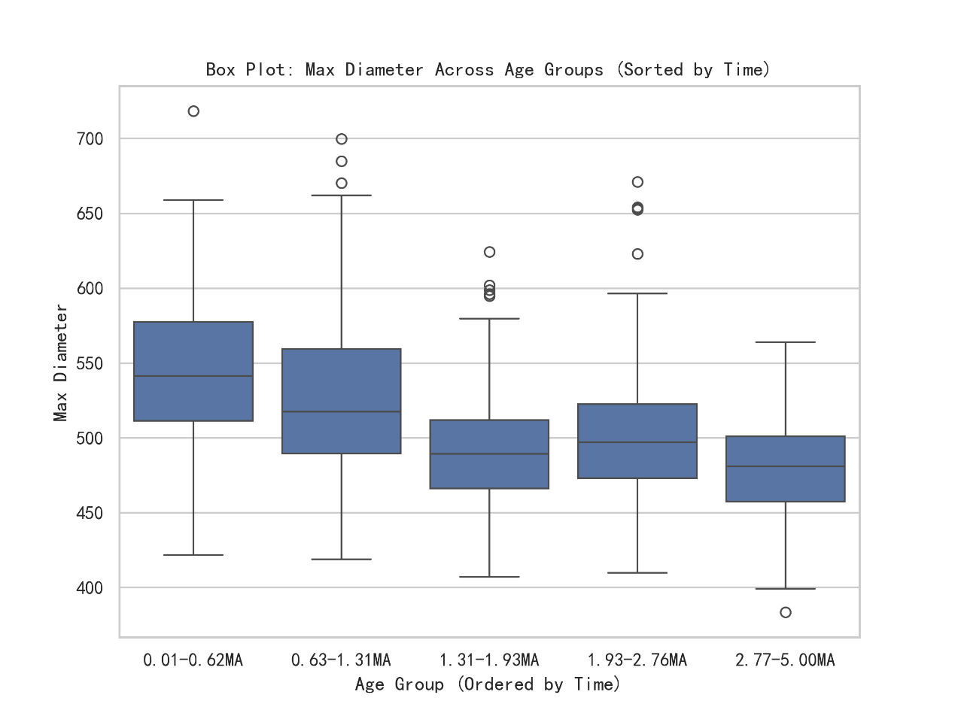

The box plot shows the trend of Max Diameter over time (age groups). It can be seen from the figure that the maximum diameter of the earlier time period (0.01-0.62MA and 0.63-1.31MA) is larger on the whole, and the median is about 520-550, and the data distribution is wide, indicating that the particle size difference is large in this period. However, after 1.31-1.93MA, the overall level of the maximum diameter decreased, the median tended to be about 480-500, and the fluctuation range of the data was relatively small, indicating that the particle size was relatively stable in this period. In addition, more outliers (outliers) can be seen in the first two time periods, especially 0.63-1.31MA, which may mean that some particles are particularly large in size, possibly due to a specific sedimentary environment or formation mechanism. From 2.77-5.00MA, the data distribution is more concentrated, and the overall diameter is smaller, indicating that the particles in this period tend to be uniform in size.

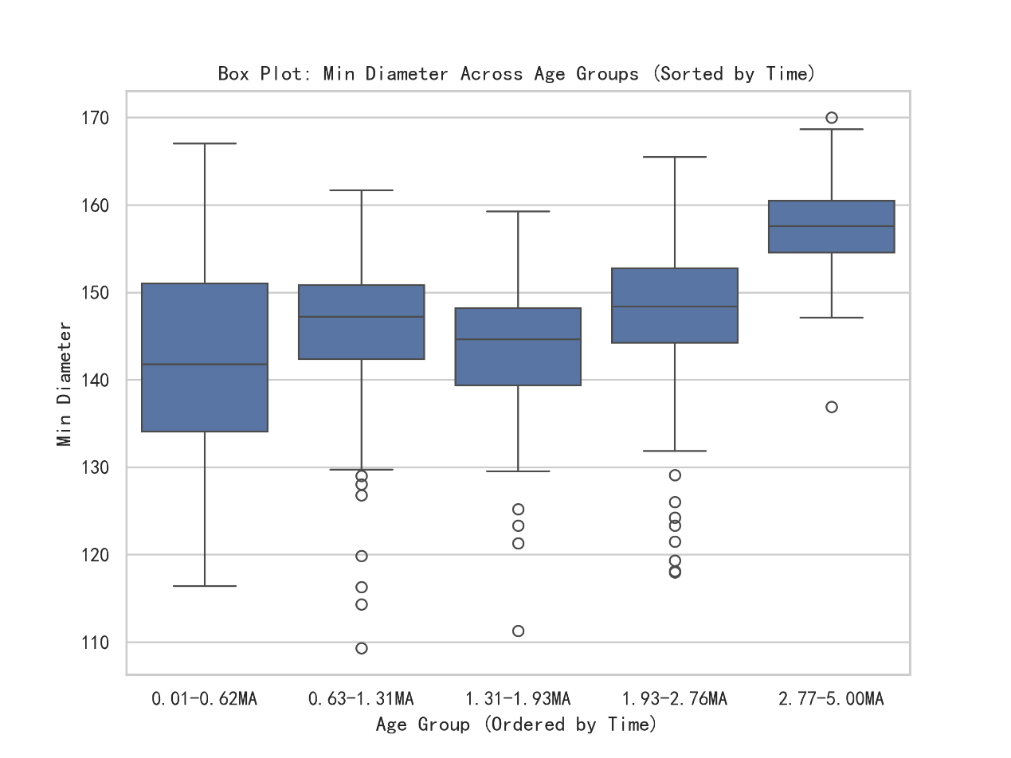The box plot shows how the Min Diameter changes over time. As can be seen from the figure, the minimum diameter shows an overall upward trend over time. In the earliest time period (0.01-0.62MA), the distribution range of the data is wide, the median is about 140, but the lower edge is low, indicating that there are small particles in this period, and there are many abnormal points with low values. At 0.63-1.31MA and 1.31-1.93MA, the median of the data is slightly higher and more concentrated, and the low value outliers are still present, but the number is reduced.

At the stage of 1.93-2.76MA, the median of the minimum diameter further rises to about 150, and the data range also stabilizes. At the stage of 2.77-5.00MA, the minimum diameter reached the highest level, and the median was about 160. The data distribution was relatively concentrated, and there were almost no low-value outliers, indicating that the particle size was more uniform in this period, and the proportion of smaller particles was reduced.

Overall trend: The minimum diameter of particles gradually increases over time, possibly implying a change in the way material particles are deposited or grown.

The early data fluctuated greatly, indicating that the change of particle size was unstable, while the late data (especially 2.77-5.00MA) were more concentrated, indicating that the particle size tended to be consistent.

There are many small diameter outliers in the interval of 0.01-1.93MA, which may be caused by the special properties of individual samples or external environmental changes, while there are almost no low value outliers in the late period (2.77-5.00MA), indicating that the particle distribution is more uniform.

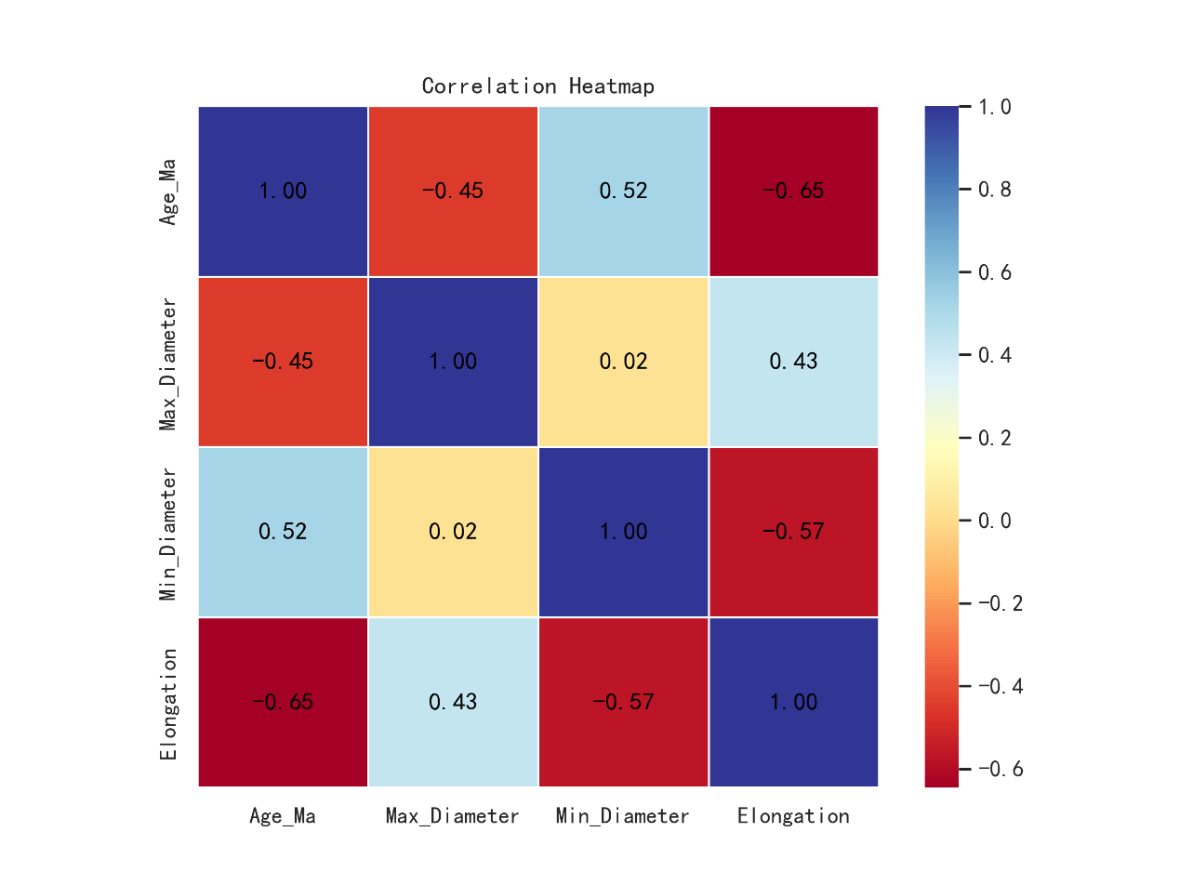This correlation heatmap shows the correlation between Age_Ma, Max_Diameter, Min_Diameter, and Elongation, with the colors representing the magnitude of the correlation coefficient (ranging from -1 to 1). Values closer to 1 indicate a positive correlation, and values closer to -1 indicate a negative correlation. It can be seen from the figure that there is a strong negative correlation between Age_Ma and Elongation (-0.65), indicating that the elongation rate of particles gradually decreases with time, and particles in earlier periods may be longer, while the morphology of particles in newer periods tends to be shorter. At the same time, Age_Ma and Max_Diameter have a moderate negative correlation (-0.45), which means that the maximum diameter of particles gradually decreases in the process of time, which may be affected by the change of deposition environment or the decomposition of particles. However, a moderate positive correlation between Age_Ma and Min_Diameter (0.52) indicates that the minimum diameter of the particles has increased over time, indicating that the particles may be more homogeneous or have an increased proportion of smaller particles in newer formations.

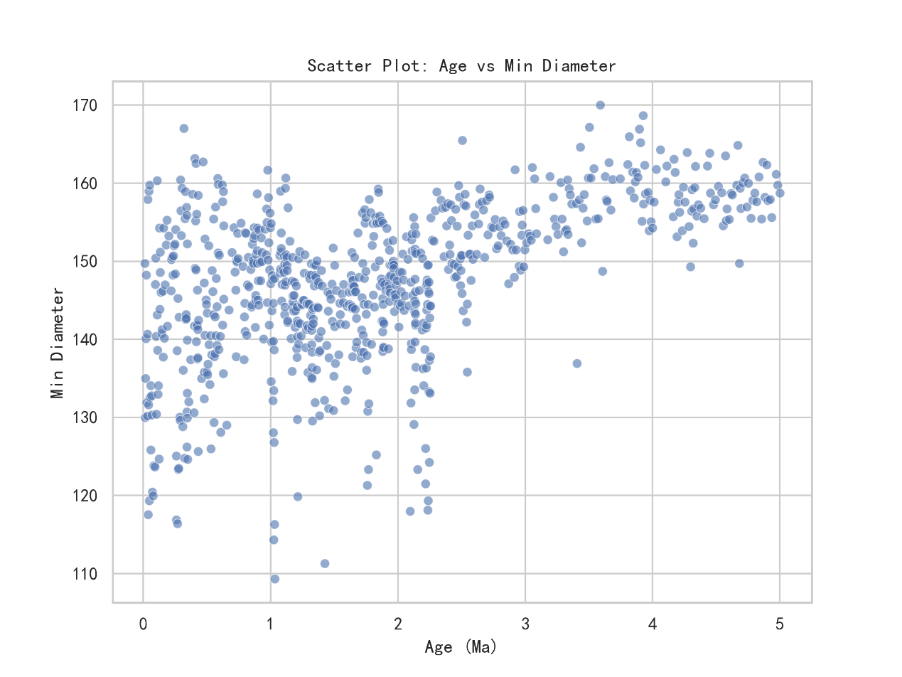

This correlation heatmap shows the correlation between Age_Ma, Max_Diameter, Min_Diameter, and Elongation, with the colors representing the magnitude of the correlation coefficient (ranging from -1 to 1). Values closer to 1 indicate a positive correlation, and values closer to -1 indicate a negative correlation. It can be seen from the figure that there is a strong negative correlation between Age_Ma and Elongation (-0.65), indicating that the elongation rate of particles gradually decreases with time, and particles in earlier periods may be longer, while the morphology of particles in newer periods tends to be shorter. At the same time, Age_Ma and Max_Diameter have a moderate negative correlation (-0.45), which means that the maximum diameter of particles gradually decreases in the process of time, which may be affected by the change of deposition environment or the decomposition of particles. However, a moderate positive correlation between Age_Ma and Min_Diameter (0.52) indicates that the minimum diameter of the particles has increased over time, indicating that the particles may be more homogeneous or have an increased proportion of smaller particles in newer formations.

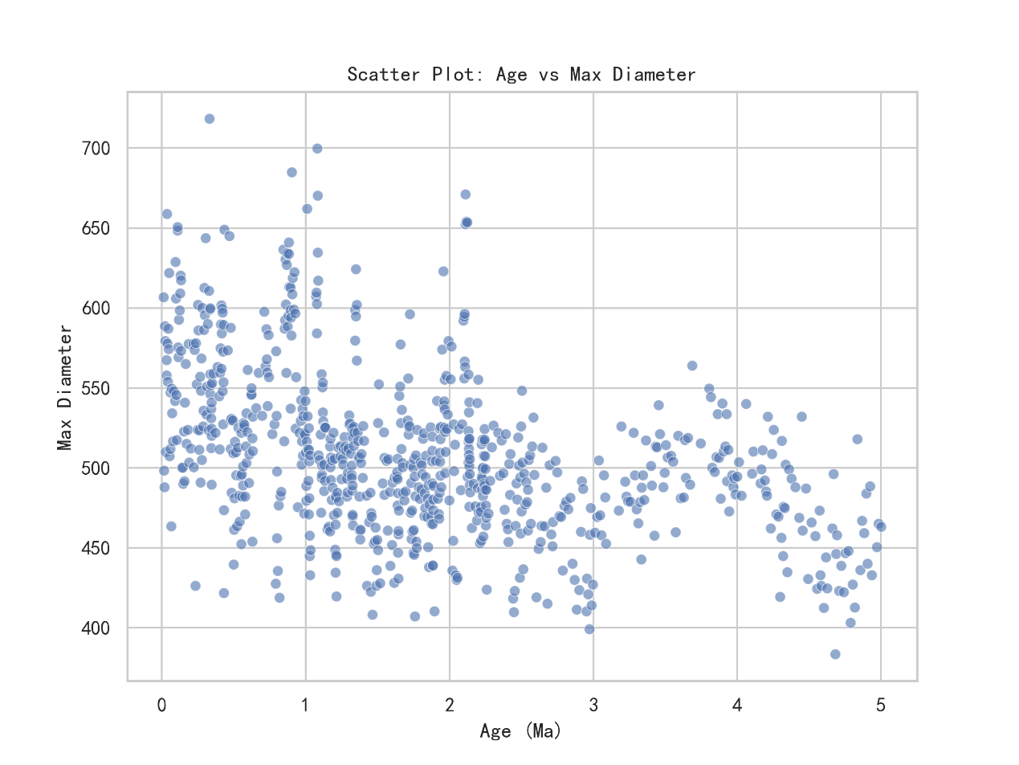This scatter plot shows the relationship between Age_Ma and Max_Diameter. It can be seen that the maximum diameter is generally decreasing over time, with newer samples (smaller Age_Ma) having larger maximum diameters. Older samples (larger Age_Ma) have smaller maximum diameters. This is consistent with the negative correlation (-0.45) between Age_Ma and Max_Diameter in the correlation heatmap. In the range of 0-2 Ma, the maximum diameter value is relatively high and the distribution is relatively dispersed, ranging from about 400 to 700, indicating that the particle size changes greatly in this period, which may be strongly affected by the sedimentary environment or transport process. However, between 2-5 Ma, the distribution of data points becomes more concentrated, with maximum diameters mostly below 500, indicating a stabilization of particle sizes during this period and a significant decrease in the number of large particles from earlier periods. This trend may be related to grain weathering, increased transport distance, sedimentary environment evolution, or long-term diagenesis, reflecting the grain refinement process on geological time scales. In general, the particle size in the newer stratum is larger, while the particle size in the older stratum is smaller, showing a trend of decreasing particle diameter over time.

This scatter plot shows the relationship between Age_Ma and Elongation. Overall, elongation tends to decrease over time, that is, newer samples (with smaller Age_Ma) have higher elongation and older samples (with larger Age_Ma) have lower elongation. It is consistent with the negative correlation between Age_Ma and Elongation (-0.65) in the correlation heatmap. Between 0-2 Ma, the elongation distribution is relatively dispersed, ranging from about 1.35 to 1.50, indicating that the particles in this period have diverse morphology, which may be greatly affected by the deposition environment, transport process or particle composition. However, between 2 and 5 Ma, the data points gradually converged, and the elongation was mostly lower than 1.38, indicating that the grain morphology in this period was more uniform and tended to be short and equiaxed, which may be affected by long-term diagenesis, compaction process or stabilization of the sedimentary environment. This trend reflects changes in grain morphology during geological evolution and may be driven by sedimentary dynamics, physical compaction, or mineral composition evolution, further supporting the negative relationship between age and elongation.