Regression Test for Subscriber Transactions:

Steps:

1. Open “tests/subscriberTransactions.jmx” file in jmeter.
2. Change the BASEDIR value to match the directory path in your system where regression test directories are downloaded.

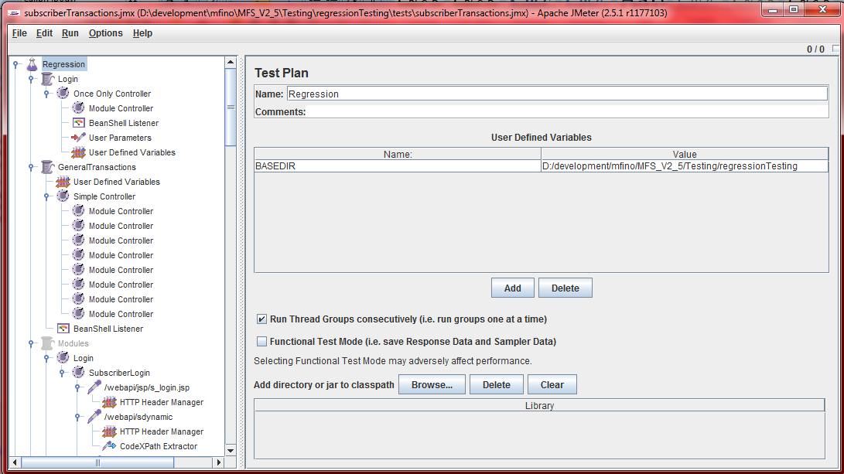

1. Update “inputData.csv” file in the input folder with a set of values existing in your system. The values to be changed in each of the cells are A1: Source MDN, B1: Destination MDN, C1: Agent Code, D1: Merchant Code and E1: Biller Code respectively as illustrated below.

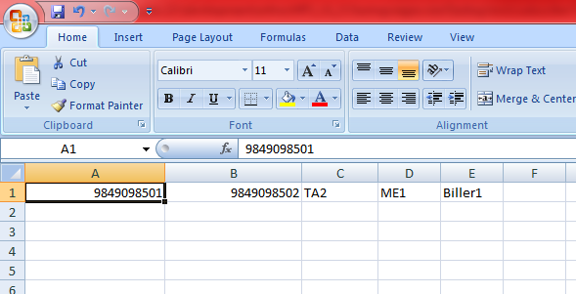

1. Now press Run->Start (or ctrl+R) in Jmeter.
2. The square box in the top right corner glows in green and stops, after which the result will be available in “output /out.txt” file.

Regression Test for Agent Transactions:

Steps:

1. Open “tests/agentTransactions.jmx” file in jmeter.
2. Change the BASEDIR value to match the directory path in your system where regression test directories are downloaded. (Same as Subscriber Transactions illustrated above)
3. Update “agentInputData.csv” file in the input folder with a set of values existing in your system. The values to be changed in each of the cells are A1: Source Agent MDN, B1: Destination Agent Code (for agent to agent transfer) C1: Existing Subscriber Mdn (for agent cash in) D1: New Subscriber MDN (for subscriber registration by agent) respectively.
4. Now press Run->Start (or ctrl+R) in Jmeter.
5. The square box in the top right corner glows in green and stops, after which the result will be available in “output /out.txt” file.

Regression Test for Activations:

Steps:

1. Open “tests/activations.jmx” file in jmeter.
2. Change the BASEDIR value to match the directory path in your system where regression test directories are downloaded. (Same as Subscriber Transactions illustrated above)
3. Update “activationInputData.csv” file in the input folder with a set of values existing in your system. The values to be changed in each of the cells are A1: New Subscriber MDN, B1: New Subscriber OTP, C1: New Agent MDN and D1: New Agent OTP respectively.
4. Now press Run->Start (or ctrl+R) in Jmeter.
5. The square box in the top right corner glows in green and stops, after which the result will be available in “output /out.txt” file.

Note: To test for different ip address:

1. Click “HttpRequestDefaults”
2. Change Server Name or IP value to the respective ip in place of local host. e.g. 192.168.1.105

