1. Machine Learning System – Blocks & Learning Types
Technique: Hierarchical (tree) map – left-to-right
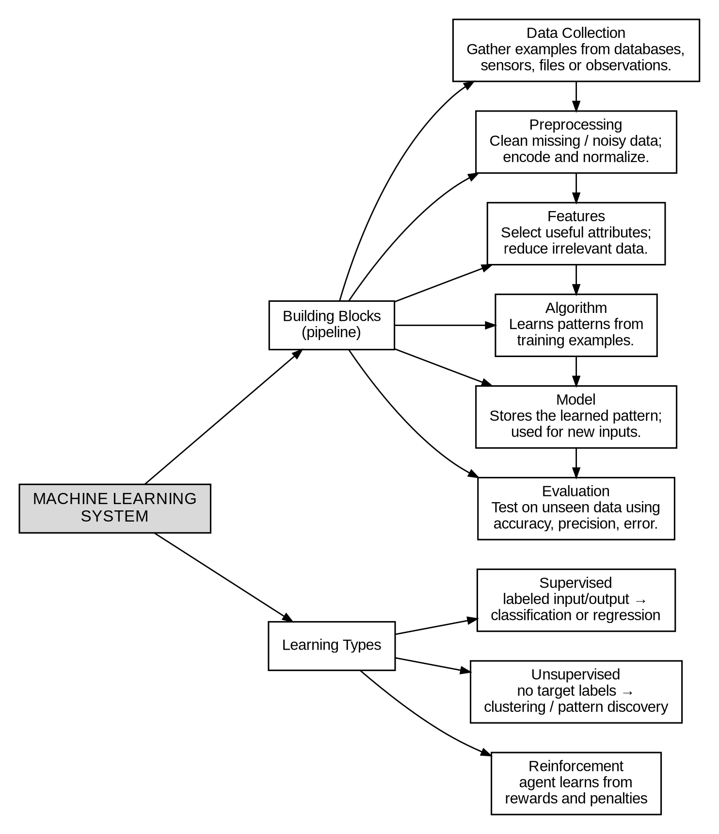

2. Disaster Management Prediction
Technique: Flowchart map – merging data sources into a life-cycle
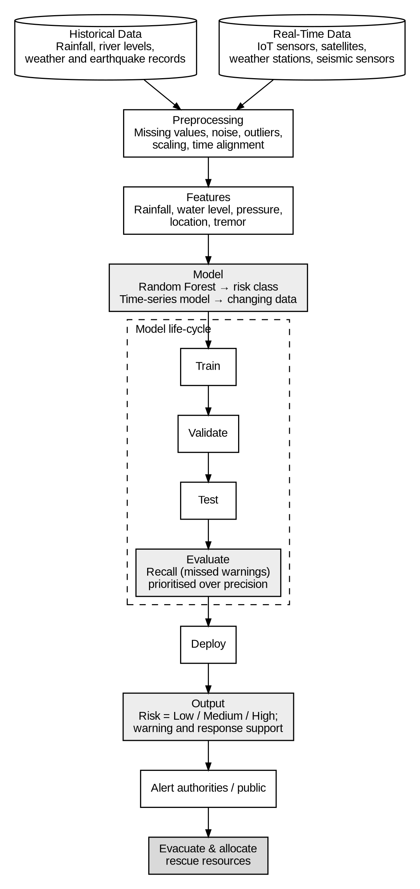

3. Find-S – Play Tennis
Technique: Timeline (sequence) map
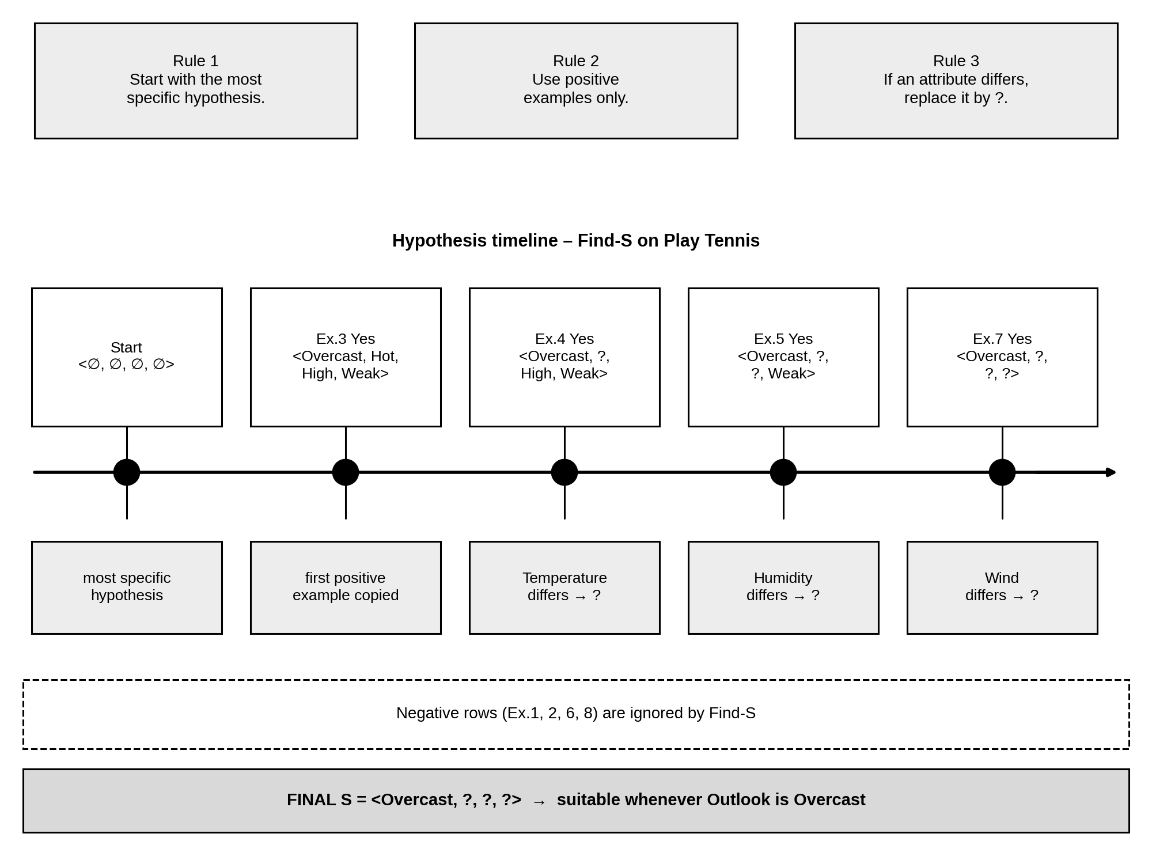

4. Candidate Elimination – Enjoy Sport
Technique: Decision-flow (algorithm) map
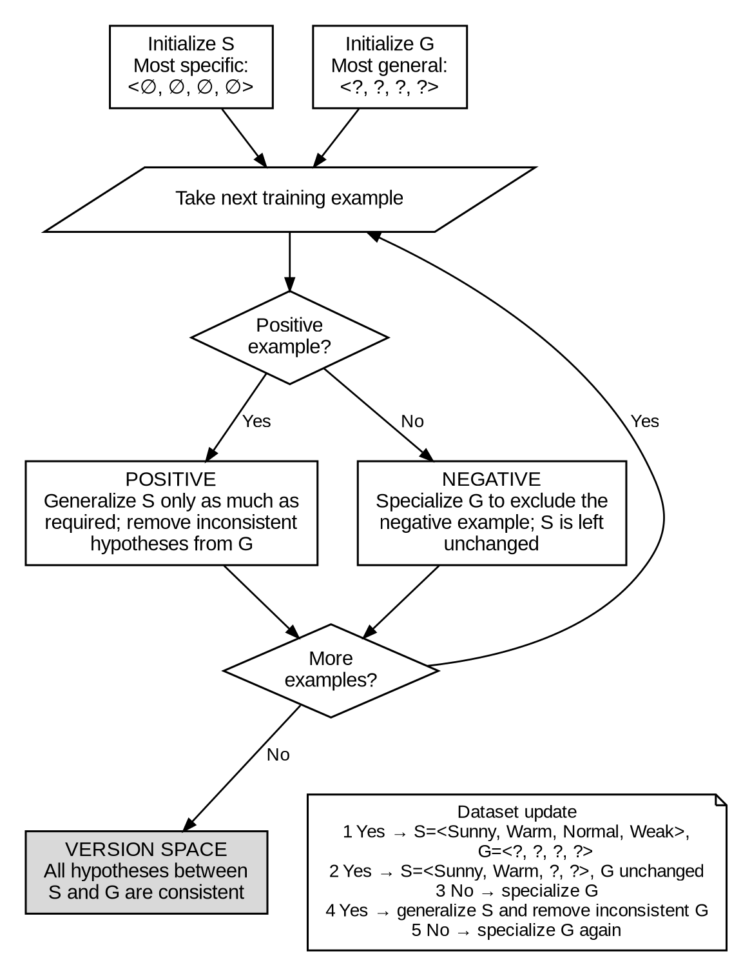

5. Find-S – Customer Buys Product
Technique: Double-bubble (compare & contrast) map
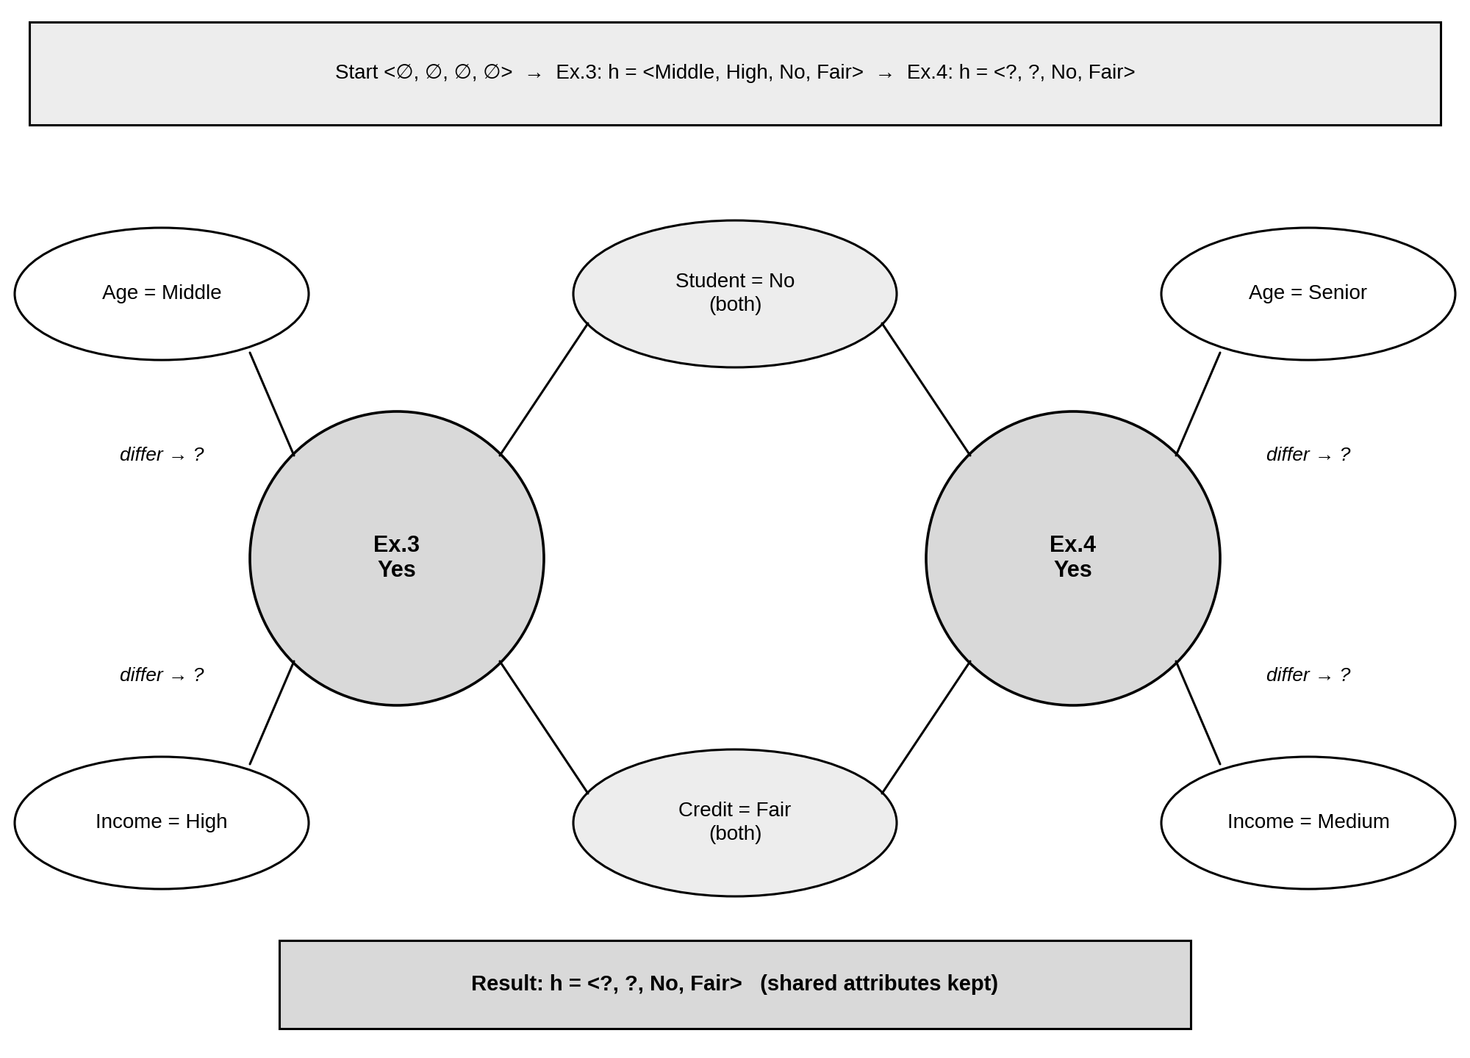

6. Find-S – Workout
Technique: Fishbone (cause-and-effect) map
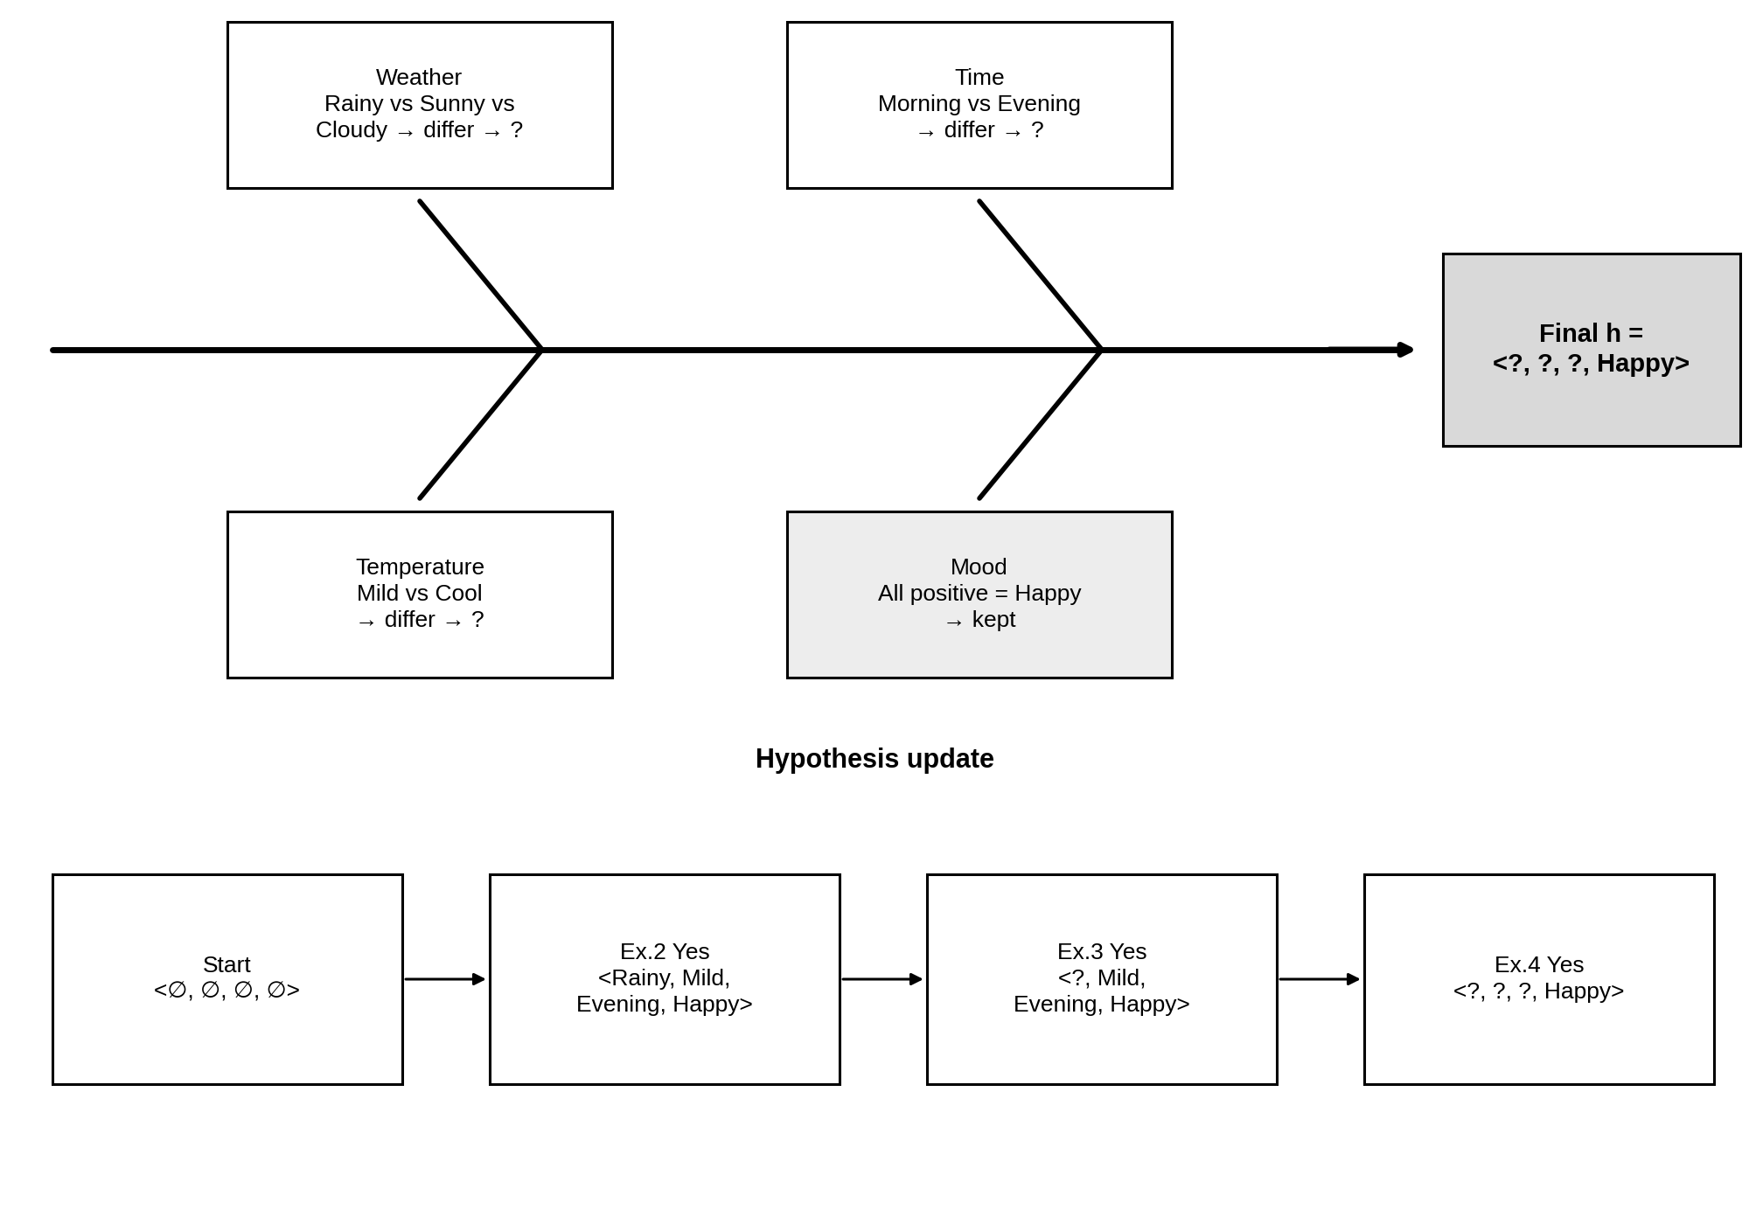
Key note: Therefore, Mood is the only attribute that is common to every positive workout example.

7. Find-S – Loan Approval
Technique: Fan-out / fan-in (convergent) map
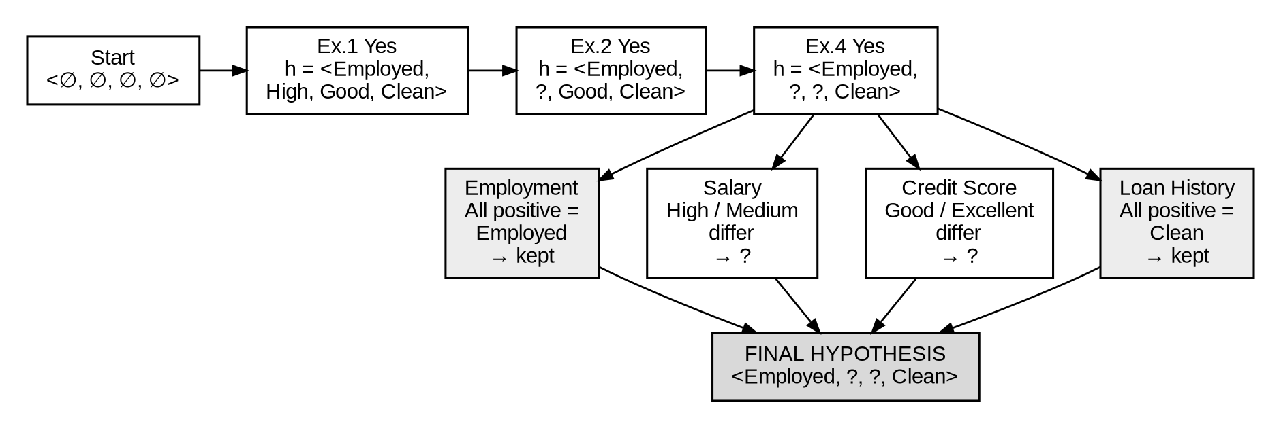
Key note: Interpretation: the positive training examples agree on Employment Status and Clean Loan History.

8. Candidate Elimination – Service Subscription
Technique: Branching (decision-tree) map
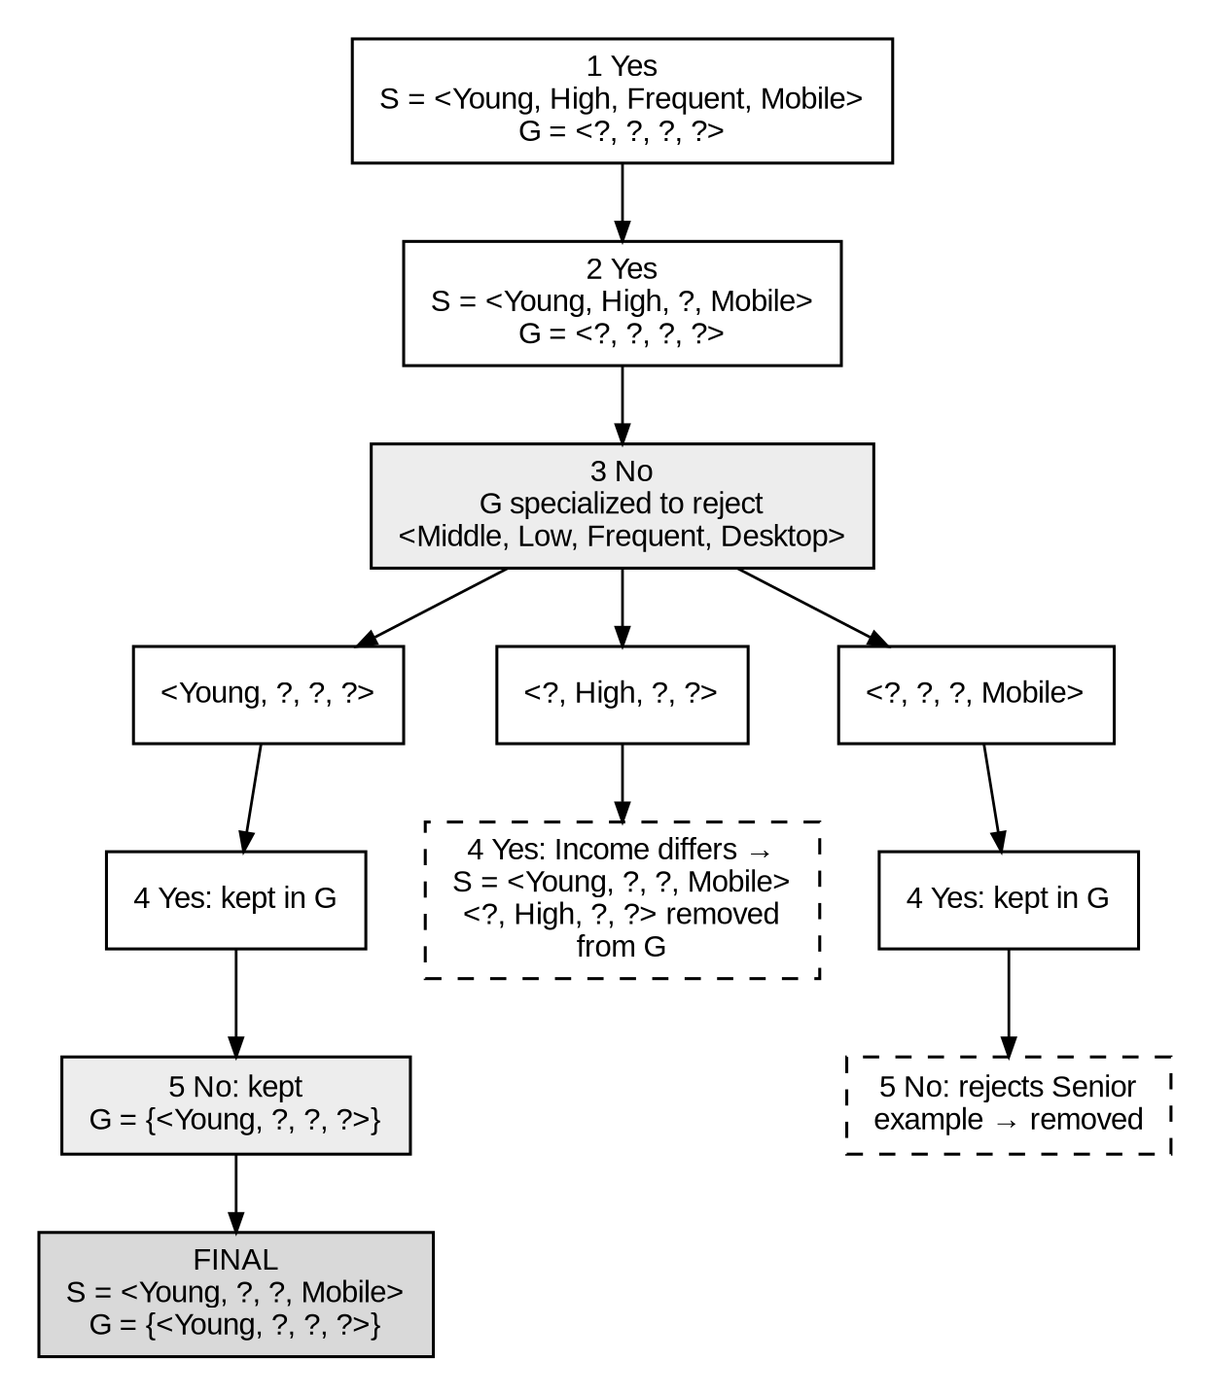
Key note: The version space contains S, G and every hypothesis that lies between them.

9. Candidate Elimination – Healthy Lifestyle
Technique: Swim-lane (two-track) map
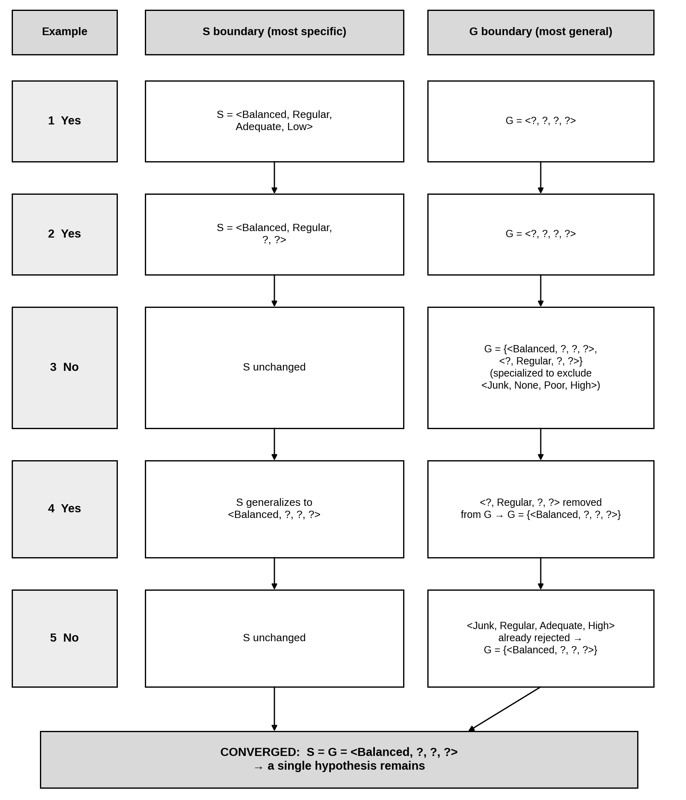
Key note: S is the most specific and G the most general consistent hypothesis. Here they meet, so the version space has converged to a single hypothesis.

10. Health Analysis – Disease Prediction
Technique: Mind map (radial layout)
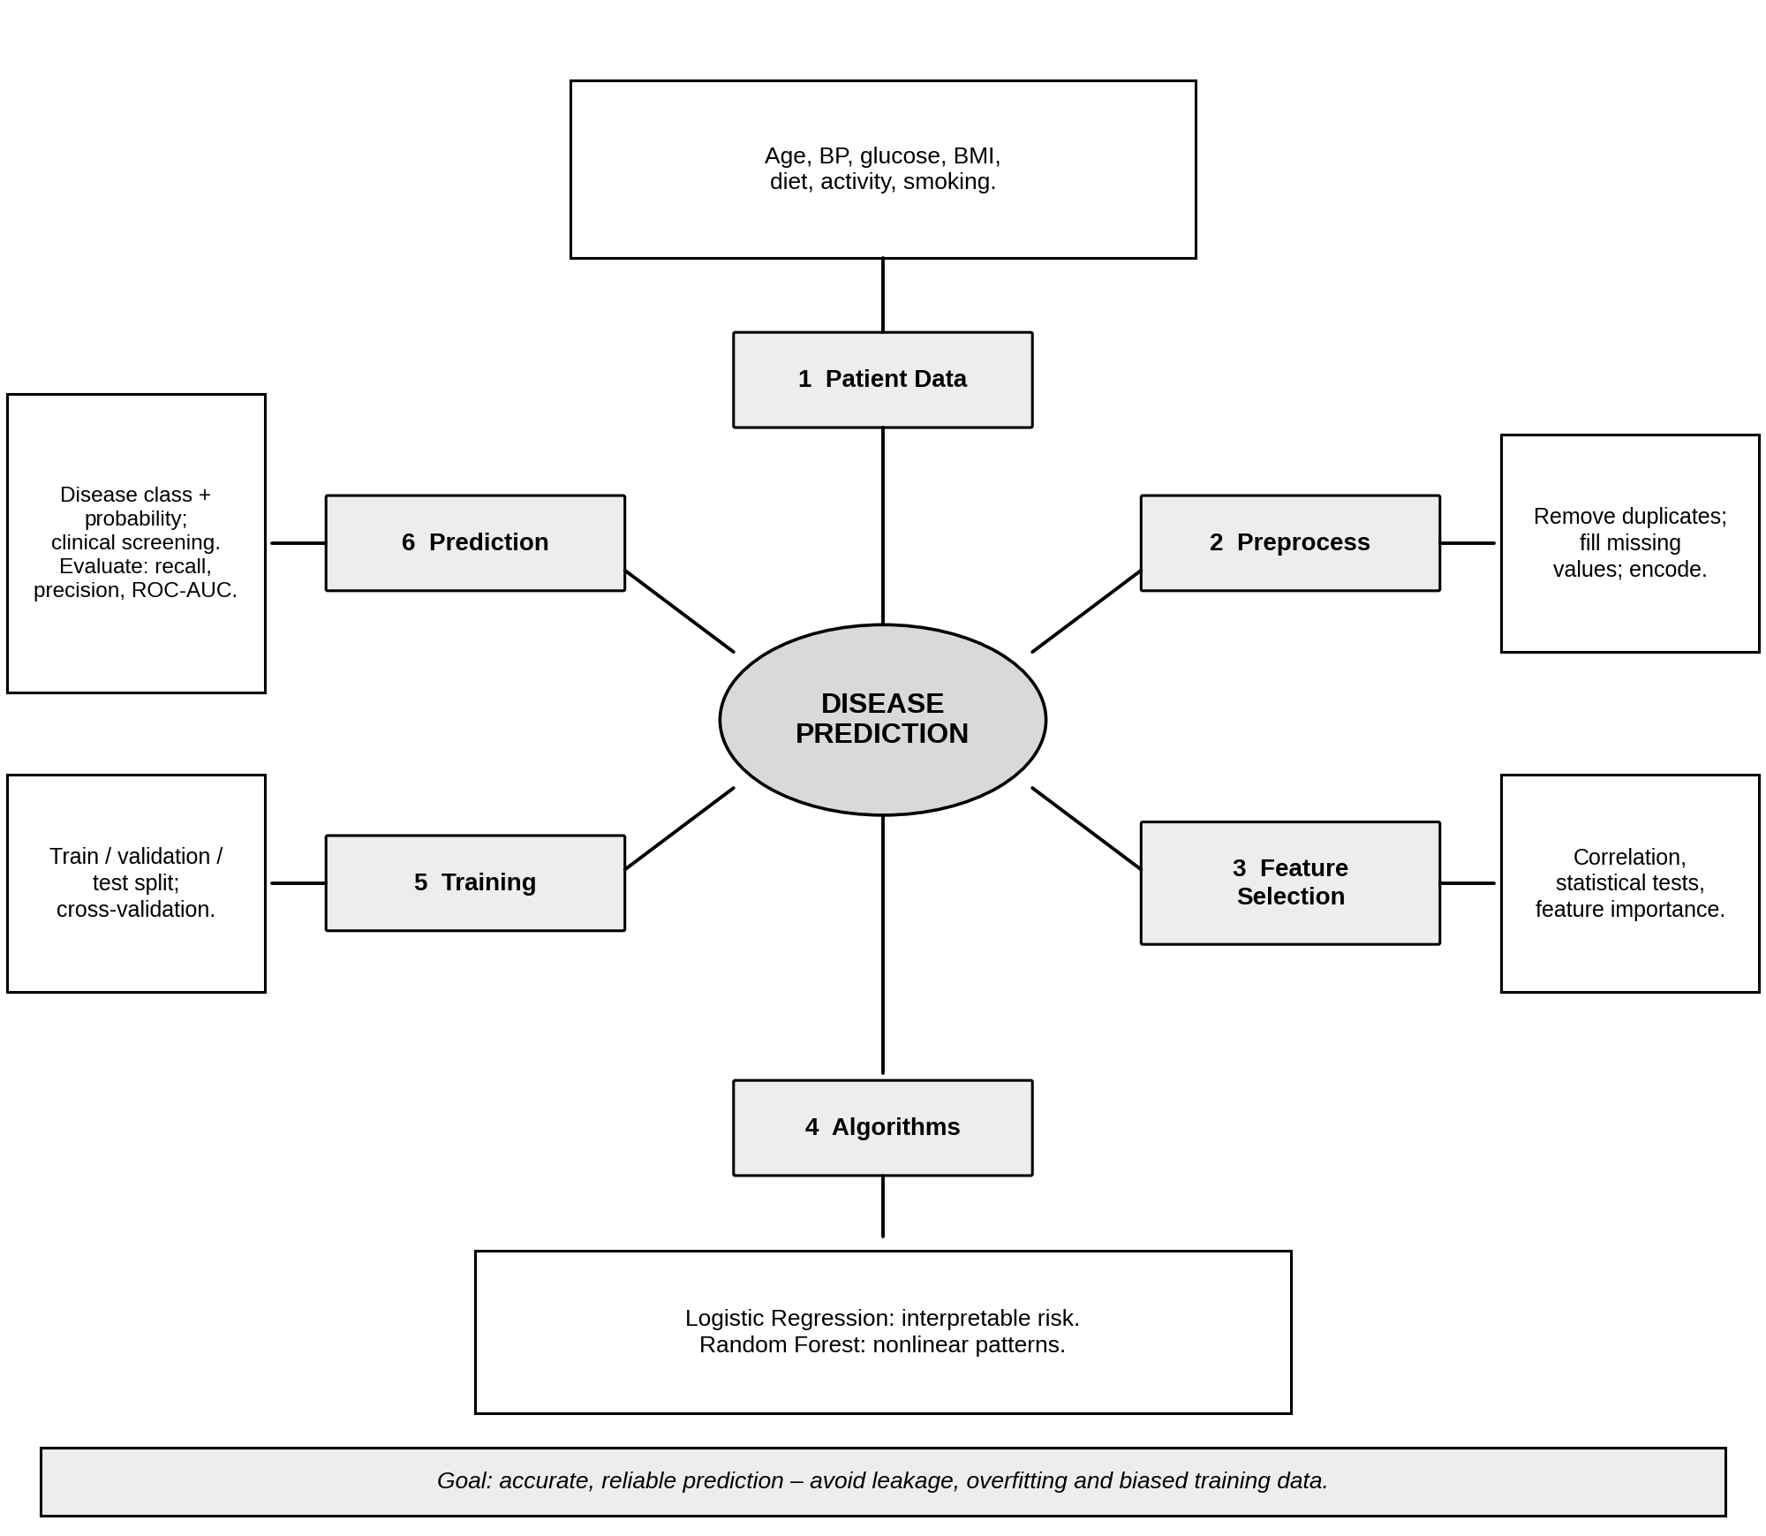

11. Machine Learning Pipeline Architecture
Technique: Cycle (circular) map with central concept
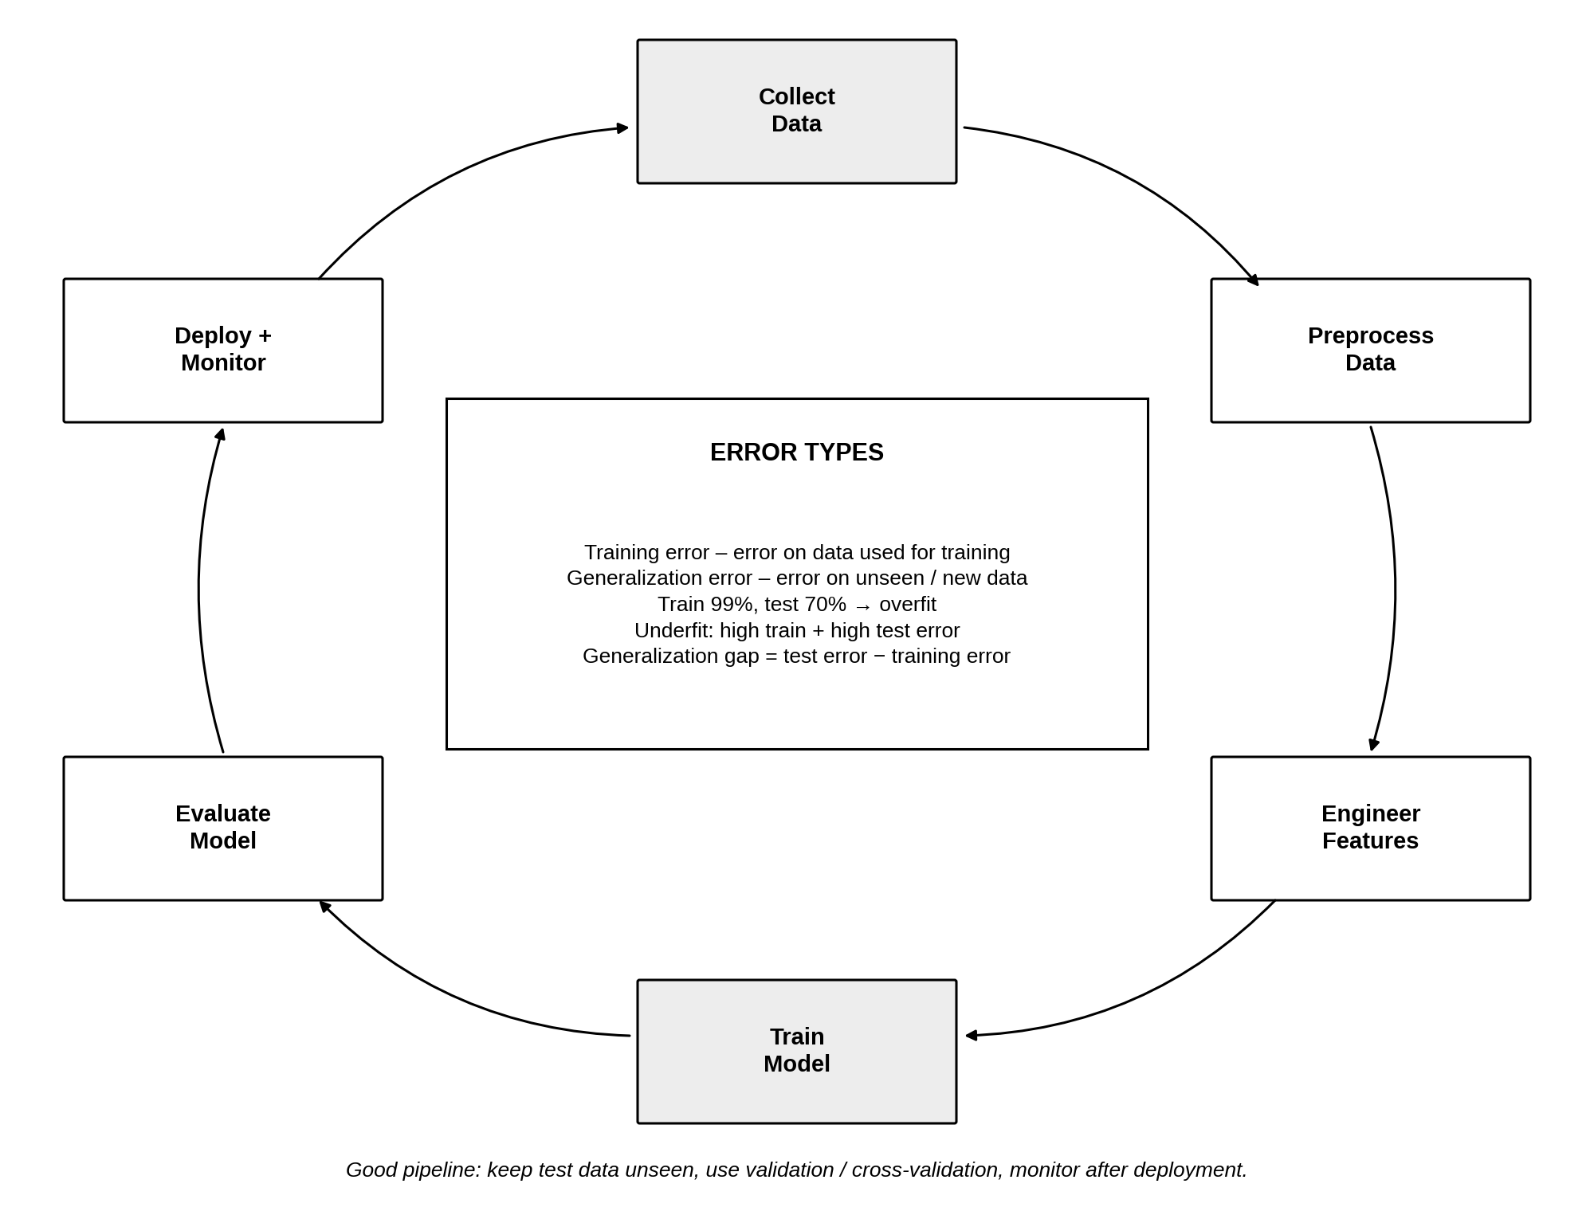

12. Spam Email Classification
Technique: Vertical flowchart with split and merge
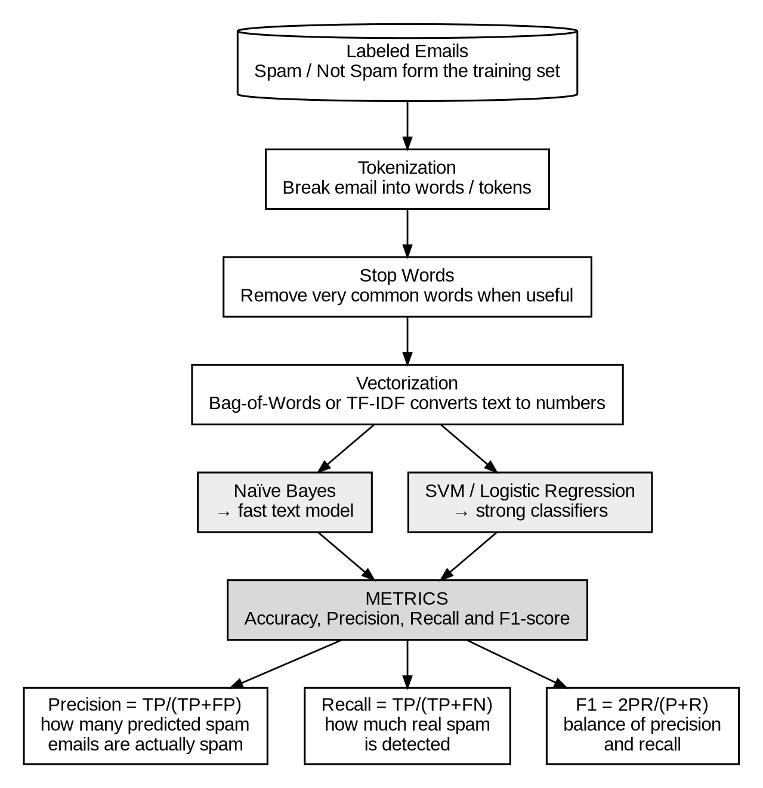

13. Candidate Elimination – EnjoySport
Technique: Stage-by-stage boundary map (S and G tracks)
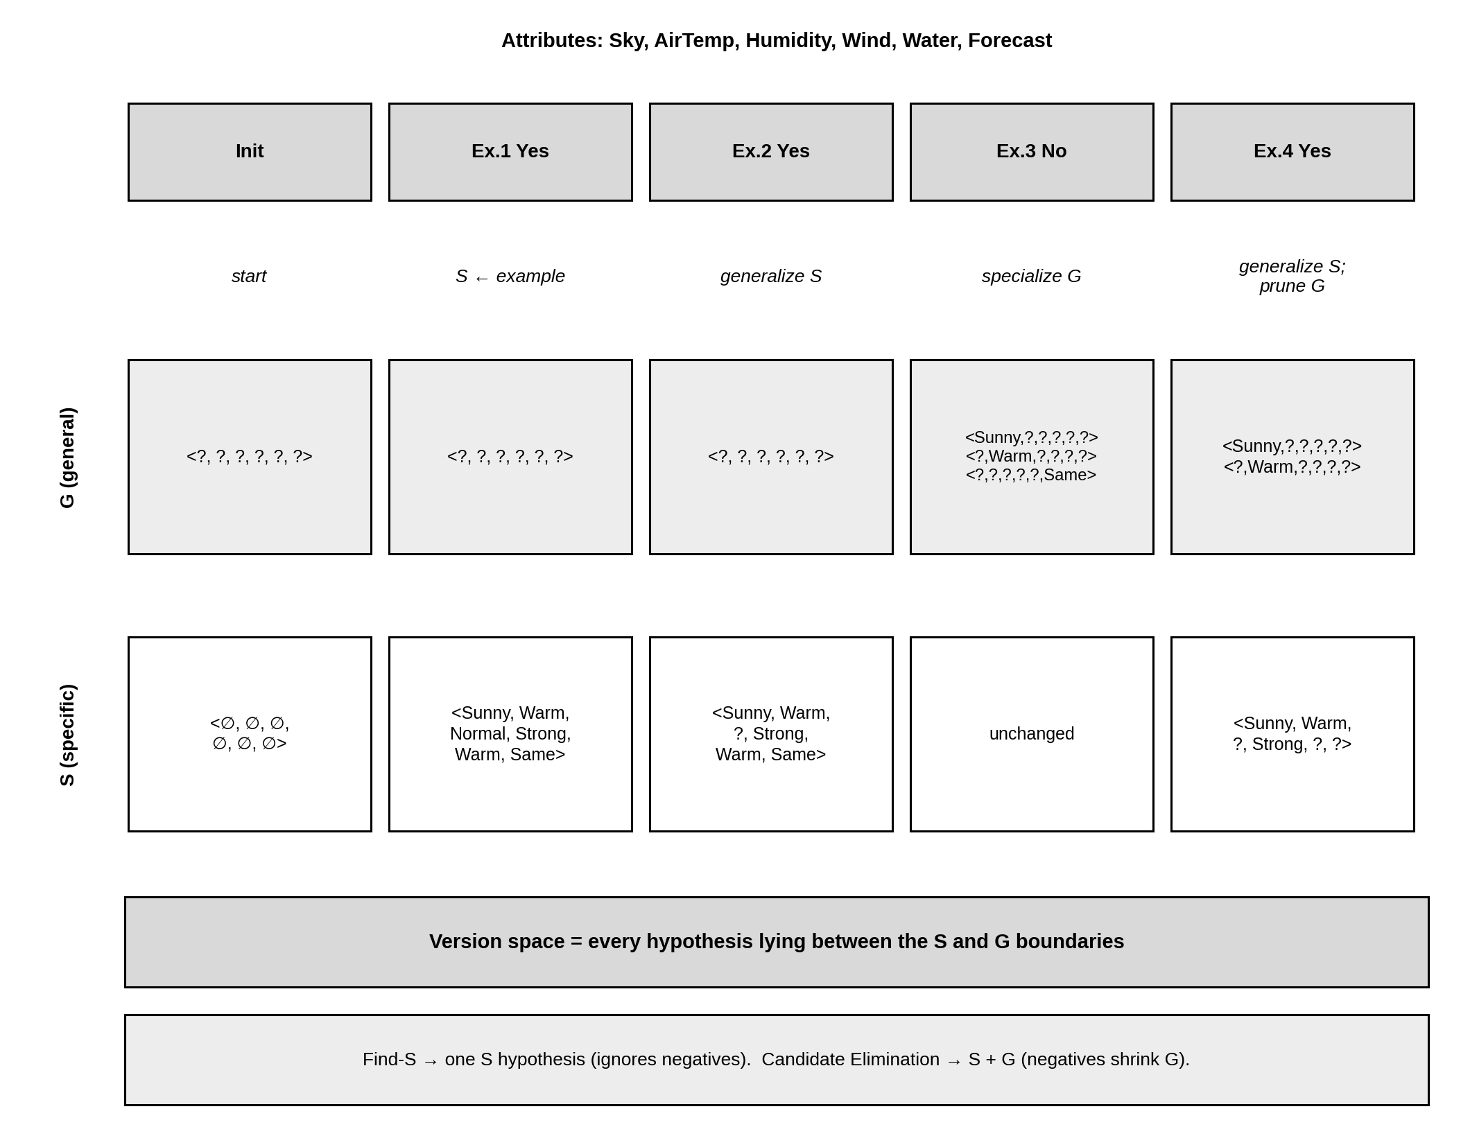

14. House Price Prediction
Technique: Labelled (propositional) concept map
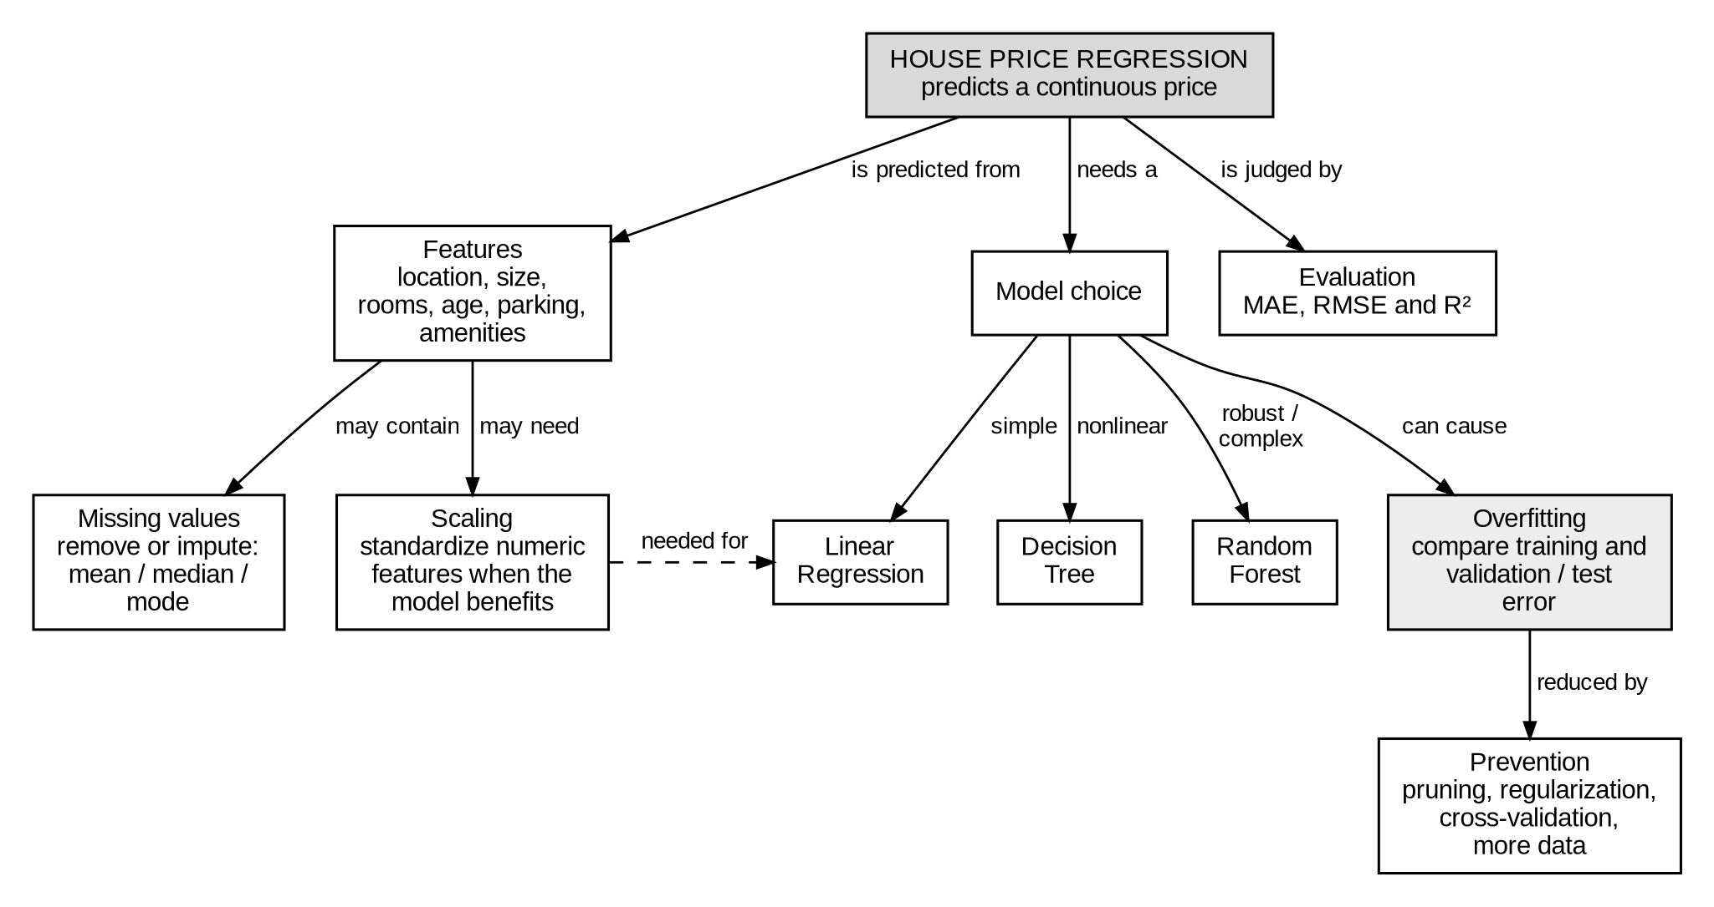
Key note: Output: the predicted continuous house price. Random Forest is often suitable when the relationships are nonlinear and several features interact. Evaluate with MAE, RMSE and R². Scaling matters for linear regression but not for tree-based models.

15. Clustering – K-Means & Hierarchical
Technique: Venn diagram (compare & contrast)
