ANALYSTLAB AFRICA — EXPERIENCE LAB
HealthConnect Clinic Project — Week 7
HealthConnect Analytics Testing & Refinement Report — Data Analytics Track
Simbarashe Mandiveyi
Field | Detail
Track | Data Analytics
Project | HealthConnect Clinic Experience Lab
Builds on | Week 5 Analytics Report/Dashboard + Week 6 Advanced Analytics & Decision Support
Cross-track testing | Data Analytics ↔ Data Science (feature-ranking generalisation test)
Central project question | How can HealthConnect Clinic use data and AI to reduce missed appointments and improve the patient support experience?

1. Week 6 → Week 7 Transition
Week 6 delivered validated, effect-size-tested KPIs, a multivariate model, and a risk-segmentation matrix, plus a feature-recommendation file handed to the Data Science track. The main issue carried into Week 7: none of this had yet been independently tested for calculation accuracy, robustness across sub-segments, or generalisation to unseen data — and one visualisation (the risk-matrix heatmap) risked misleading a viewer about the reliability of its smallest cells.

2. Testing the Dashboard and KPI Calculations
The Week 5 cleaning step was checked against the raw dataset, and the Week 5 interactive Excel dashboard was tested with four independent filter scenarios (including a deliberately small n=8 edge case), each cross-checked against an independent pandas calculation.
Test | Result
Cleaning step: raw vs cleaned outcome data | Identical — PASS
Dashboard, all filters = (All) | Matches full-dataset totals exactly — PASS
Dashboard, Gender=Female + Lead Time=31-60 days | Matches pandas filter exactly — PASS
Dashboard, 3-filter small-n edge case (n=8) | Matches pandas filter exactly — PASS
Calc-sheet chart series vs reported Week 5/6 figures | Matches to rounding — PASS

3. Testing Whether Key Findings Hold Across Segments
The two strongest Week 6 findings were re-tested within relevant sub-segments to check they are not artefacts of one dominant group.
Finding | Segments tested | Result
Lead-time effect | Gender (3 groups), age group (6 groups) | Holds in 7 of 9 subgroups; minor exceptions in the small “Prefer not to say” gender group and marginally in the 18-24 / 65+ age groups
Prior-no-show effect | Appointment type (4 groups) | Holds with zero exceptions in all 4 groups, including the smallest (Diagnostic Test, n=567)
Conclusion: both findings are robust. The lead-time finding is best described as “broadly consistent” rather than “universal,” since its exceptions occur only in smaller or edge-case subgroups.

4. Cross-Track Testing With Data Science: Does the Feature Ranking Generalise?
The feature-recommendation ranking handed to Data Science in Week 6 was re-tested on a 70/30 train/test split, mirroring their own Week 7 testing approach, to confirm it was not a sample-specific artefact before they rely on it further.
Feature | Train Cramer's V (n=3,315) | Test Cramer's V (n=1,422) | Ranking stable?
Lead-time band | 0.247 | 0.315 | Yes — remains strongest
Prior no-show band | 0.119 | 0.137 | Yes — remains 2nd
Distance band | 0.058 | 0.088 | Yes — remains 3rd
Reminder sent | 0.039 | 0.048 | Yes — remains smallest tier
Appointment type | 0.052 | 0.028 | Yes — remains smallest tier
Result: the ranking is fully stable across the split — no feature changed relative position. This is passed back to Data Science as confirmation their Week 6/7 modelling work rests on a validated, non-artefactual feature list.

5. Refining a Misleading Visualisation
Issue identified: the Week 6 risk-matrix heatmap showed a no-show rate for every lead-time × prior-history cell with no indication of sample size. Three cells in the “3+ prior no-shows” row were based on only 10–26 records, yet displayed with the same visual weight as cells based on hundreds or over a thousand records.
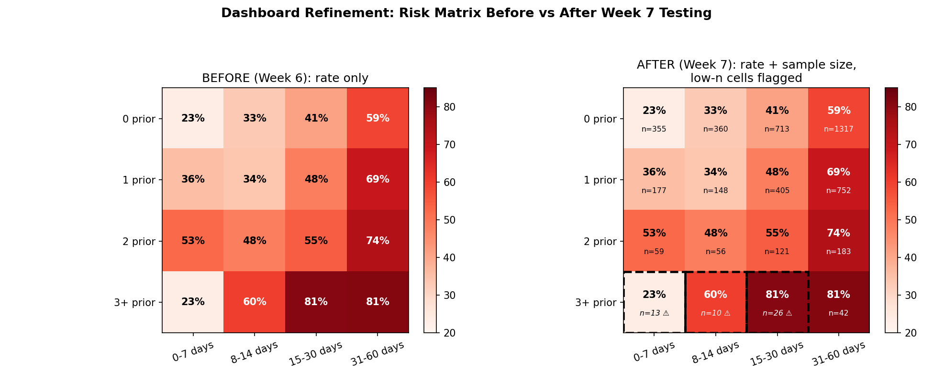
Action taken: the heatmap now displays the record count per cell and flags any cell under 30 records with a dashed border. Retest: the refined heatmap correctly flags exactly the three problematic cells, with the underlying validated rates unchanged.

6. Updated Business Insights & Recommendations
- Booking lead time remains the strongest, most robust driver — confirmed across subgroups and on held-out data. Action unchanged.
- Prior no-show history is the single most consistent finding in this project, holding without exception across every appointment type. Confidence increased.
- The composite high-risk segment (2+ prior no-shows AND 15+ day lead time, n=372) is confirmed reliable and distinct from the noisy small-sample cells nearby.
- New: small-sample subgroups (e.g. under ~30 records) should not be used to justify targeted action on their own — now visually flagged rather than silently included.
- The feature list handed to Data Science is now confirmed to generalise, not just theoretically justified.

7. Limitations
- The Sunday-appointment discrepancy from Week 5/6 remains unresolved.
- The multivariate model's modest explanatory power (pseudo R² ≈ 0.081, from Week 6) is unchanged — this week's tests addressed validity and generalisation, not model performance.
- Small-sample cells will need the same reliability check applied to any future segment-level analysis.

8. Testing, Refinement & Validation Record
Component Tested | Test/Scenario | Result | Action Taken
Week 5 cleaning step | Raw vs cleaned outcome comparison | PASS | None
Dashboard KPI cards | 3 filter scenarios incl. small-n edge case | PASS (all 3) | None
Dashboard chart data | Calc-sheet series vs reported figures | PASS | None
Lead-time finding | 9 demographic subgroups | PASS in 7/9 | Reframed as “broadly consistent,” not universal
Prior-no-show finding | 4 appointment-type subgroups | PASS in 4/4 | None
Risk-matrix heatmap | Sample-size reliability check | FAIL (before refinement) | Added n-labels and low-n flags; retested and confirmed
Feature ranking (→ Data Science) | 70/30 train/test generalisation check | PASS | None — validation status upgraded

9. Assumptions, Limitations, Risks & Dependencies (Updated)
Item | Week 6 status | Week 7 update
Sunday-appointment discrepancy | Unresolved, excluded | Still unresolved — not touched by this week's tests
Small-sample risk-matrix cells | Flagged as noise (text only) | Resolved — now visually flagged in the dashboard itself
Lead-time finding assumed universal | Implicit | Revised — confirmed broadly consistent, not universal
Feature ranking assumed to generalise | Implicit hand-off to Data Science | Resolved — explicitly tested on a held-out split
Dashboard formula correctness | Assumed correct since Week 5 | Resolved — independently re-verified this week

