PAGE 1 RESULTS This is an example of the adult flow. Use this as the foundation for all of the results.

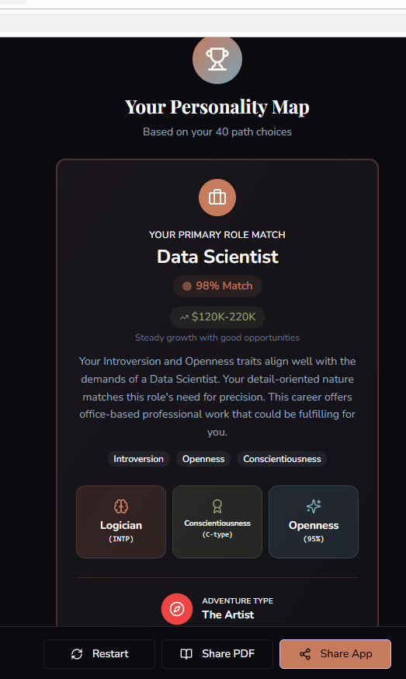
This should be the first page of results. The 3 buttons at the bottom should be restart, share results, and the right button should say ‘more details’

PAGE 2 RESULTS This is an example of the adult flow FOR PAGE 2 RESULTS.. Use this as the foundation for all of the results FORMATS.
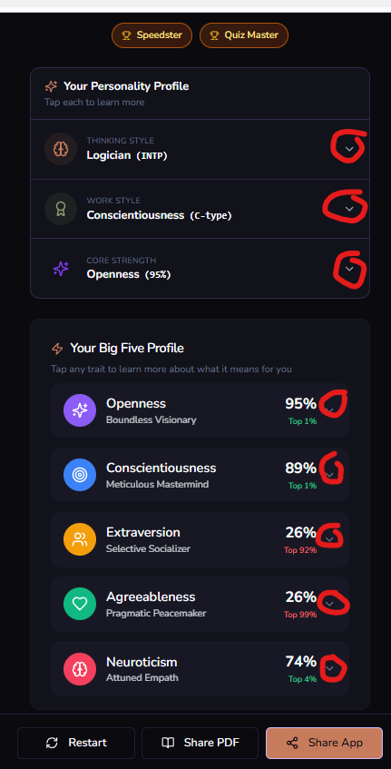
This page 2 will have more detail where the user can tap the carrot on the right of each section to expandthe section for more detail on each part of this. This will conclude the free section. The 3 buttons on the bottom should be restart, share results, and the right button should change to Learn More!. The learn more button will be the gateway to the “premium section”. Maybe add a 4th button that lests them go back a page so see the 1st page of results.

The learn more button will launchinto this window (image attached below).
The message on this window should be
“Premium is Free!
We’re testing. Help us build something useful by providing feedback or donating.”
the two buttons will stay the same as below
“Proceed to Results” and “
“Donate (Help us build)” which links to the stripe options

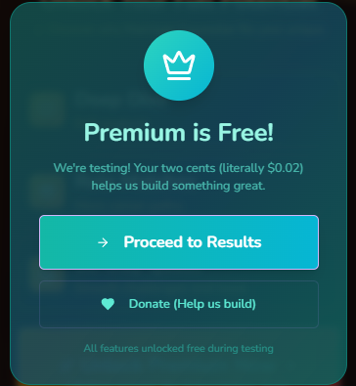

When they click on proceed to results, this is what they will see:
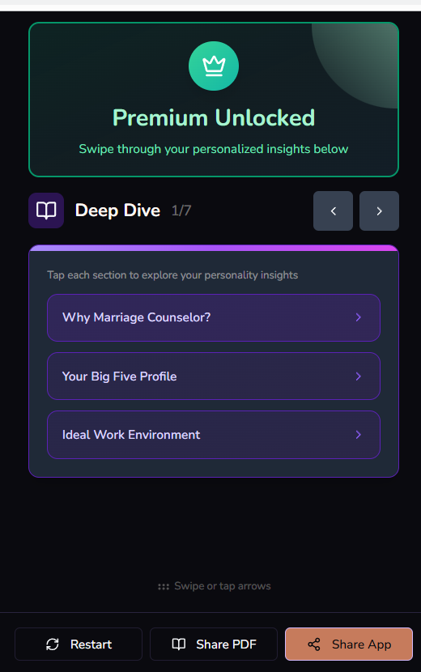

The bottom 3 buttons saying, retart, share results (which still shares the basic results) or the 3rd button that say go back. There should be a way for people to go back and forth between the 1st second and 3rd page or results. For now, they are all free. Yes, a person can donate but they are all free whether they donate or not. In the future their will be a paywall to get to the 3rd page of results.

