
Submitted By

Danala 3 – Theme 2
Abir - 382198
Sakeeb - 393942
Ahmad - 393516
Mutyambizi – 385833
Ikegbunam – 390803

Unit: Data Science Practice(PRT661)
(HIT234)
Assessment 1

Submitted To

Dr. Selvarajah
Lecturer, School of Engineering and Information Technology, CDU

Deadline: 12th August 2026

Contents
Project overview 2
Problem statement 2
Dataset description 2
Project Objectives: 3
Theme justification 3
Initial architecture diagram 3
Workflow plan 4
Task allocation and team structure 5
Initial risk analysis 6
Ethics, privacy and security considerations 7
Ethics 7
Privacy 7
GITHUB & JIRA Links 7

Project overview
Our project lies in the domain of Biomedical data, with the goal of building a predictive tool that can ingest various cultural, linguistic and biodata.

Problem statement
The first step to our project was to select a meaningful and impactful project in the domain of Biomedical /CVD data. We decided to a narrow our scope of the project to common health problems faced in Australia.
After analyzing multiple articles and online journals such as ABC’s NT's high rates of diabetes and amputations highlighted by territory health professionals on World Diabetes Day and Skin cancer in Australia from AIHW (2026), we decide to narrow our focus towards discovering what factors contribute towards certain health conditions occurring amongst Australian citizens/residents. This project's inspiration became our problem statement and was also based on the intriguing diversity of culture and ethnicities in Australia, with the goal to understand how this diversity contributes towards this analysis.

Dataset description
We have collected data from the Australian Institute of Health and Welfare (AIHW) which consisted of Chronic health conditions among culturally and linguistically diverse Australians from the census year of 2021.
The following is a description of the different variables from the dataset:
- Long-term health conditions (LTHCs): measures the number of people who reported that they have been told by a doctor or nurse that they have any long-term health conditions. Long-term health conditions (LTHCs) include health conditions that have lasted or are expected to last six months or more, may occur from time to time, are controlled by medication or are in remission.
- Country of birth of person: Contains records of the country of birth of that individual, according to the Standard Australian Classification of Countries (SACC), 2016. Names, date of births or other identifiable variables have not been included in this dataset.
- Language used at home: Classified according to the Australian Standard Classification of Languages (ASCL), 2016.
- Years spent in Australia: Specified how long that person has been in Australia.
- Proficiency in spoken English: Categorized into two groups of “very well” and “not well at all”.
- Country of birth.
- Age group: Age groups classified between “0 to 44”, “44 to 64” and “64 to above”
- Sex: Categorized between “Male”, “Female” and “Persons”.
- Number of people reporting with LTHC.
- Population: The total recorded population from the census, including those with and without LTHCs.
- Age specific percentage population of people with LTHC: Percentage calculated by dividing the number of people with LTHC by population.

Project Objectives:
- Train a prediction machine learning algorithm to determine the likelihood of an individual developing a long-term health condition based on features to be stated in the sections below.
- Create a dashboard that provides key findings from our exploratory analysis.
- Store the data in a structured and reusable manner that allows for easy retrieval, analysis, manipulation, recovery of raw data, and syncing with dashboard functionalities.
- Host the dashboard and machine learning scripts on Cloud hosting servers.
- Provide a detailed report of the project from the project plan to its conclusion.
Our target users for this project includes members of the public in Australia who’re interested in determining the most likely diseases they might suffer from based on our findings, health professional and institutions as it can be used when conducting prognosis on clients, alongside other personal records of their client.

Theme justification
The theme for this project is classified under Theme 2 (Predictive/Forecasting analytics) due to the following reasons:
- Consists of historical data.
- We have continuous and categorical data that can be used to predict our goal.
- The data only changes after a set timeline due to it being census data, hence the velocity of the data changes after 5 years, hence it would be under Real time or Anomaly detection themes.
- Data is collected in batches which is suitable for Predictive/Forecasting analytics.

Initial architecture diagram
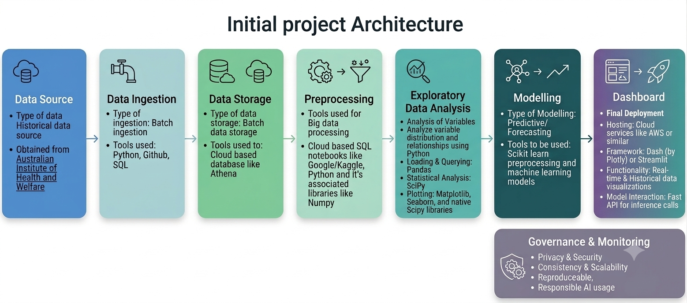
Figure 1: Initial project architecture
From reviewing Architecting Data Solutions: A High-Level Overview, we have understood that data architecture refers to the different stages necessary to the core structure of a data science project. Hence, we used this information to design our initial architecture, including the different tools and technologies for each stage.
We also considered this project to be a data science project and not just merely a machine learning project because the results of the analysis are an important part of this project. We will be capable of identifying variance in social constructs and how these behaviors lead to varying LTHC and provide a dashboard that will reflect these changes. This project will also be reproducible to reflect updated census data as the years go by, serving more than just machine learning endeavor.

Workflow plan
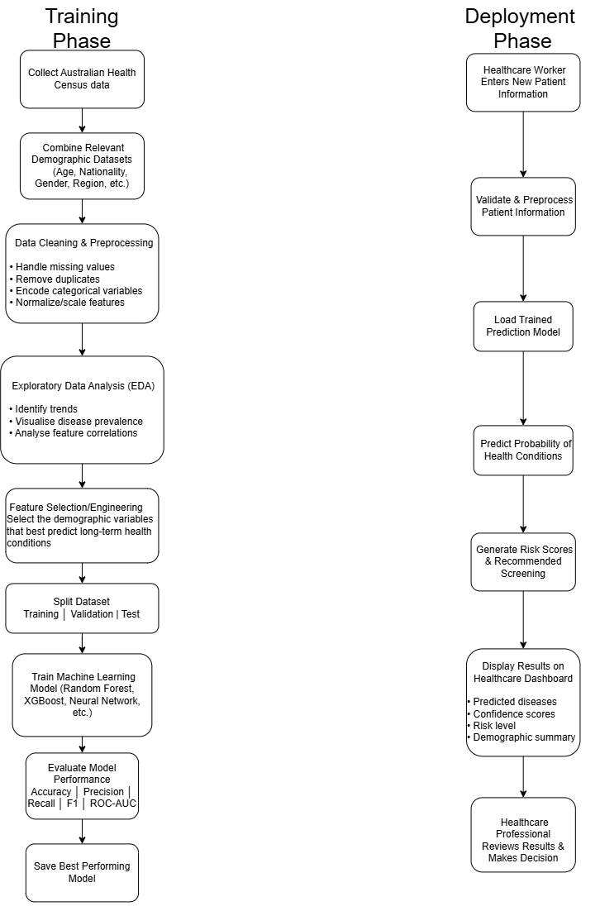
Figure 2: The workflow plan showing the training and the deployment phase of the project

Milestone | Deliverable | Week Deadline
M1 | Project approved | Week 3
M2 | Dataset collected | Week 4
M3 | Data preprocessing completed | Week 5
M4 | Baseline model trained | Week 6
M5 | Best model selected | Week 7
M6 | Dashboard prototype completed | Week 8
M7 | Integrated system tested | Week 10
M8 | Final report submitted | Week 12
Table 1: Milestone alongside the appropriate deliverable and week deadline

Task allocation and team structure

Communication Agreements
We are communicating over teams where we are talking about what the work allocation is and what the progress is.
We are also communicating over WhatsApp if something urgent that we need to discuss and we can’t get to someone over teams.
We are going to meet during the class and discuss how the current lectures meet what we going to do in the report and presentation.
If we really need to have a face-to-face meeting, then we will try to book a venue on campus and meet there.
Table 2: Communication agreements between team members to ensure a successful project

Task | Simba | Haroon | Adnan | Sakeeb | Cynthia
Training Phase
Collecting the Australian Census Data | R | A | C | C | I
Combine the relevant datasets into certain demographics | R | R | I | I | R
Data cleaning and preprocessing | A | R | R | C | A
Exploratory Data Analysis | R | R | C | A | R
Feature Selection/Engineering | R | C | I | A | C
Split the dataset into train | validation | test | C | A | I | R | A
Train Machine Learning Model (Random Forest, XGBoost, Neural Network, etc.) | C | A | R | I | C
Evaluate Model Performance and save best model | R | A | C | I | A
Dashboard Phase
Design dashboard GUI for patients to use | A | R | C | R | I
Upload the trained model to a decided cloud hosting service | C | R | A | I | R
Testing dashboard with medical professional | A | C | R | A | I
Integrate within the healthcare system | R | A | I | C | A

R | Responsible
A | Accountable
C | Consulted
I | Informed
Table 3: The RACI matrix with task allocation

Initial risk analysis
Risk | Likelihood | Impact | Mitigation
Poor data quality | High | High | Perform extensive preprocessing and validation
Missing values | High | Medium | Use imputation techniques
Low model accuracy | Medium | High | Compare multiple algorithms and tune hyperparameters
Dataset bias | Medium | High | Analyze class balance and demographic representation
Delays | Medium | Medium | Weekly milestones and buffer time
Dashboard integration issues | Low | High | Build prototypes early and test frequently
Team member unavailable | Low | Medium | Crosstrain team members and maintain documentation
Table 4: Risk analysis table with likelihood, impact, and mitigation strategy.

Ethics, privacy and security considerations

Ethics
The AI model should be trained not to be biased (IBM, “AI bias”) with certain cultural groups, age groups, urban/rural, etc. Certain diseases may be more present in a certain demographic than others. To mitigate against this, it is important to ensure that balanced sampling techniques are used, models are trained across various demographics to examine differences, and models are regularly retrained on new data.
The AI model needs to be transparent with the health professionals in how it reached the prediction. As an example, it could output: this patient has an 80% likelihood of Diabetes. However, more than this, it needs to provide the underlying contributing risk factors such as age, geographic region, previous health conditions, etc.
Another important ethical consideration would be to still value human oversight (Obuchowicz et al., “Will AI Replace Physicians in the Near Future? AI Adoption Barriers in Medicine”) over the AI model’s output. It is important to understand that a medical professional is not replaced by this AI model. The medical professional should take the model’s output but still use their own professional diagnosis for the final outcome for the patient.

Privacy
It is very important to make sure that the medical data needs to be anonymized. This means we need to remove information regarding names, addresses, phone numbers, birth dates, etc. These pieces of information need to be transformed into a more appropriate format such as age group, gender, region, health indicators, etc. Whatever is necessary to ensure that the individuals in the dataset can’t be recognized.
It is important to ensure that the patients are aware of what is being done with their data. This includes what information is being collected from them, who can access it, for how long the data will be stored, how it will be used, etc. According to what the data will be used for, the patients need to be aware. If that use changes from research/analysis to commercial, the patients’ needs to be notified and ethical approvals need to be undertaken.
Another important privacy related consideration is to make sure that the healthcare systems are compliant to Australian law. The Privacy Act 1988 (Commonwealth of Australia, Privacy Act 1988 (Cth)) which is responsible for how personal data is handled by organizations. The healthcare systems follow certain Australian Privacy Principles (APPs) which govern the laws over how data can be collected, used, disclosed, stored, etc. This will ensure that data is handled lawfully and transparently.

GITHUB & JIRA Links

- Github
  - https://github.com/Simbarashe-Mutyambizi/DATA-VISUALIZATION-GROUP-11
- Jira
  - https://vongngocloi.atlassian.net/?continue=https%3A%2F%2Fvongngocloi.atlassian.net%2Fwelcome%2Fsoftware%3FprojectId%3D10040&atlOrigin=eyJpIjoiNzM1ZjhiZTEwOGI1NDU4Yjk4NzJkMDI1OGRhODY2OGMiLCJwIjoiamlyYS1jb3JlIn0

References
- A. Ahmed, "Architecting Data Solutions: A High-Level Overview" 2025. [Online]. Available: https://awadrahman.medium.com/architecting-data-solutions-a-high-level-overview-3357414ac679 [Accessed: 06-Aug-2026].
- Commonwealth of Australia, Privacy Act 1988 (Cth). [Online]. Available: https://www.legislation.gov.au/C2004A03712/latest. [Accessed: 05-Aug-2026].
- T. Colling, " NT's high rates of diabetes and amputations highlighted by territory health professionals on World Diabetes Day", 2026. [Online]. Available: https://www.abc.net.au/news/2025-11-15/nt-high-rates-of-diabetes-flagged-world-diabetes-day/106009950 [Accessed: 06-Aug-2026].
- IBM, “AI bias,” IBM Think. [Online]. Available: https://www.ibm.com/think/topics/ai-bias. [Accessed: 14-Mar-2026].
- R. Obuchowicz et al., “Will AI Replace Physicians in the Near Future? AI Adoption Barriers in Medicine,” Diagnostics, 2026. [Online]. Available: https://pmc.ncbi.nlm.nih.gov/articles/PMC12897247/. [Accessed: 05-Aug-2026].
- Australian Institute of Health and Welfare, "Skin cancer in Australia". [Online]. Available: https://www.aihw.gov.au/reports/cancer/skin-cancer-in-australia/summary [Accessed: 06-Aug-2026].

