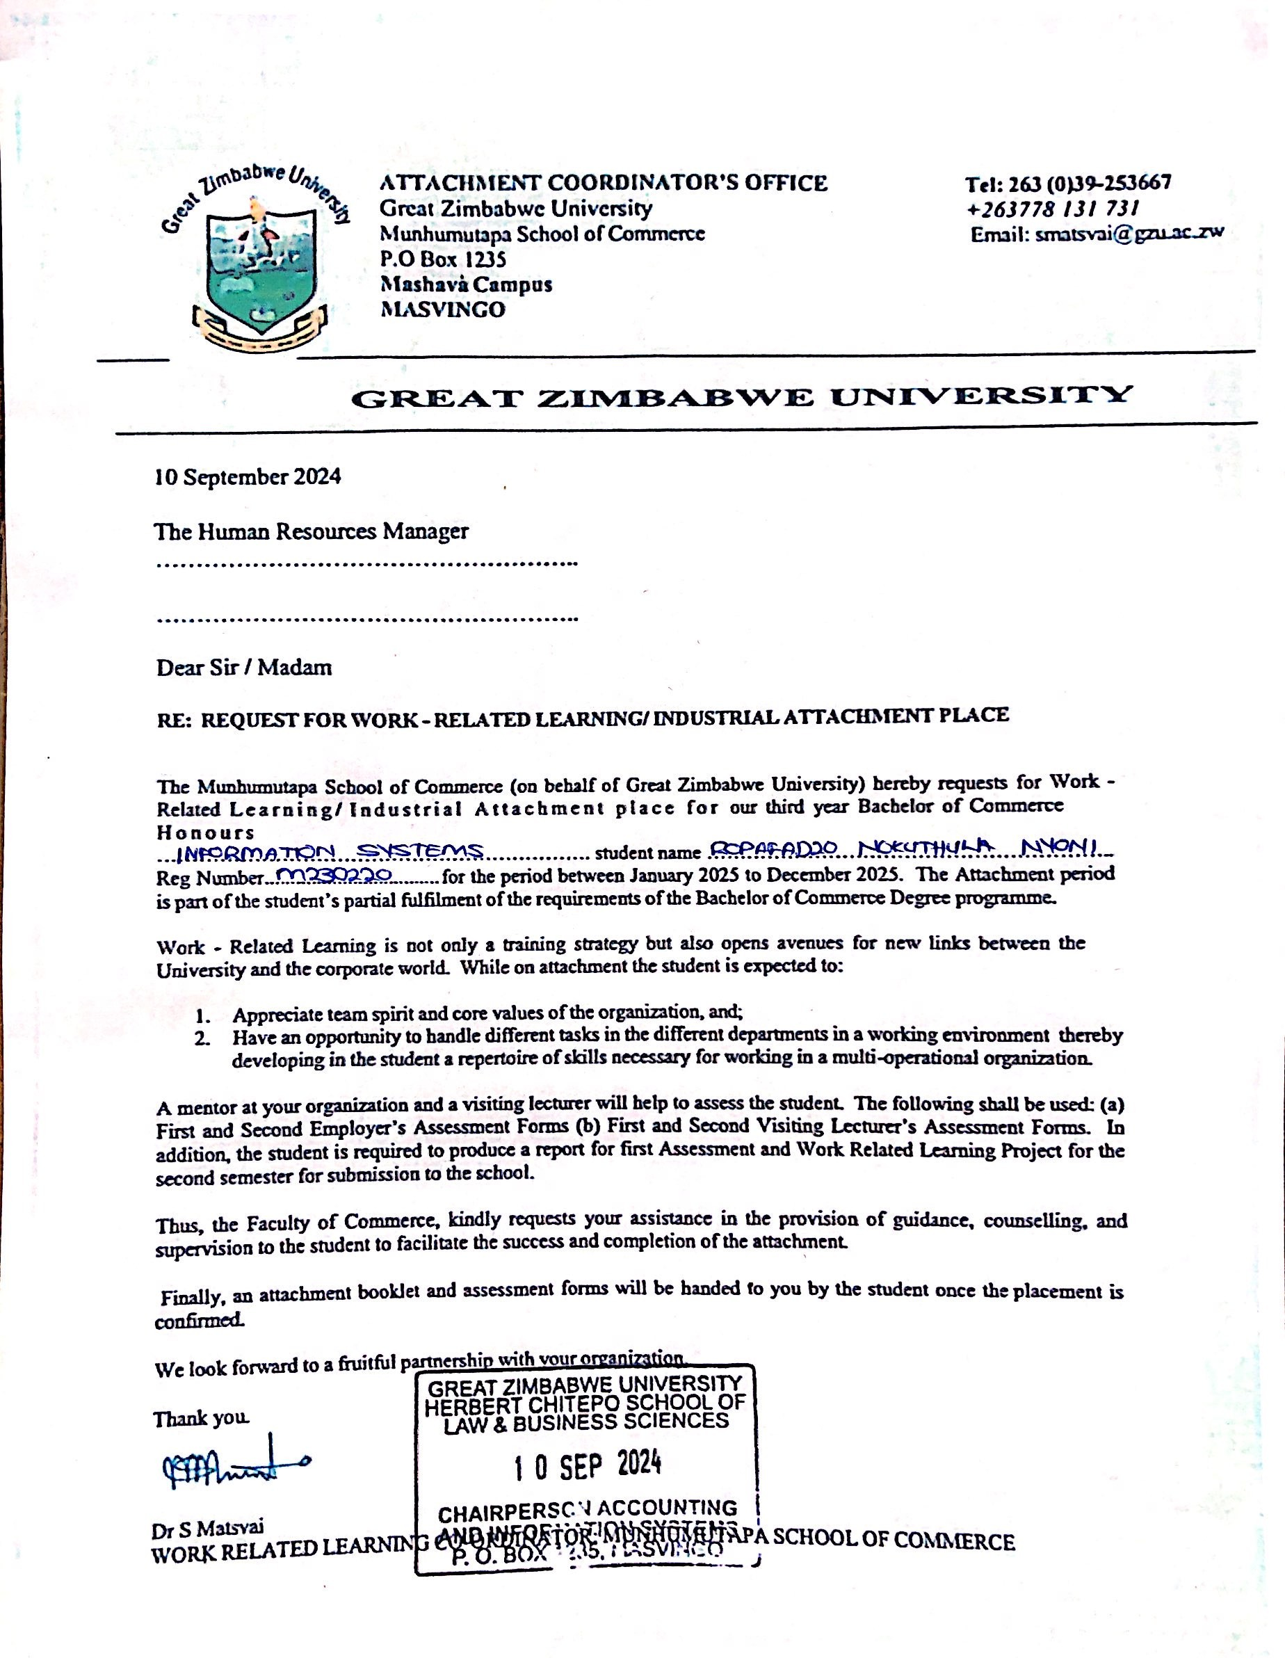

125 Mukonono Road
Marimba Park
125 Mokonono Road
Marimba Park
Harare
Zimbabwe

22 January 2025

The Human Resource Manager

Dear Sir/Madam

Re: Application for Work-Related Learning / Industrial Attachment in the IT Department

I am a young, energetic lady aged 21 and currently in my third year of study at Great Zimbabwe University, pursuing a Bachelor of Commerce Honors Degree in Information Systems. I am writing to kindly request an internship opportunity within your esteemed organization.

I am a disciplined and highly motivated individual, eager to learn and contribute to your team. I am confident that my academic background, combined with my enthusiasm for gaining practical experience, will allow me to make a valuable contribution to your organization. Furthermore, I am committed to sharing the knowledge and skills I have acquired over the past two years at university.

Please find attached my curriculum vitae, university transcript, academic certificates, and a letter from my institution.

Thank you for considering my application. I look forward to the possibility of contributing to your organization and learning from your team.

Yours faithfully

Ropafadzo Nokuthula Nyoni

Ropafadzo Nokuthula Nyoni
- 125 Mukonono Road
Marimba Park Harare
Zimbabwe • ropafadzonyoni0@gmail.com • +263780408095

Education

Ordinary Level Mufakose 2 Secondary School 2016 – 2019
Advanced Level Kambarami High School
2020 - 2021
Undergraduate Bachelor Honors Degree Information Systems
Great Zimbabwe University 2023-2026

Objective
Motivated student at Great Zimbabwe, seeking an internship to apply my knowledge in systems analysis, data management and programming.
Passionate about applying theoretical knowledge in real world settings.
Eager to contribute in innovative projects and gain hands on experience that will enhance my skills and support my career growth in IT.

Skills
Technical skills :
Programming Languages : Python, Java, C#
Flutter Mobile Programming
Microsoft Office Packages
Linux Administration
Web Development : HTML, CSS

Soft skills :
Problem solving
Time management
Effective communication
Team collaboration
Honest and trustworthy

Projects

School Management System
- Purpose: Built to help a school manage student records, track attendance, and handle grades more easily.
- Tools Used: Java, MySQL, NetBeans.
- Outcome: Created a system that made it easier for staff to keep track of student information.
- Users found it easy to use and helpful for reducing paperwork.

Coffee Shop Website
- Purpose: Made a website for a coffee shop to show their menu, location, and let customers order online.
- Tools Used: HTML, CSS, JavaScript, Bootstrap.
- Outcome: Developed a nice-looking, easy-to-use website that helped the coffee shop attract more customers online.

Self Checkout System for Restaurant

- Purpose: Created an app for customers to scan items and pay on their own, making shopping faster and easier.
- Tools Used: Flutter, Android Studio.
- Outcome: The app helped reduce waiting times and made shopping more convenient for customers. It also showed my skills in designing simple and useful user interfaces.

References
Great Zimbabwe University
+263 392 266 648/60/68
information@gzu.ac.zw
Mr Chibidi Project Co-ordinator Information Systems
+263 77 389 3975

Mr Nyamubaya- Provincial Accountant- Mash Central Ministry of Mines and Mining Development
1128 Fleetwood Dr Bindura
+263773180745
+263717516732

Mr Pasi
+263 77 406 2476

