Simen Bekkhus

NITH | Schweigaardsgate 14 | 0185 Oslo

BU5100-13 Entrepreneurship

Assignment 2

October 27, 2013



**FORSIDE FOR INNLEVERING**

**TILGJENGELIGHET**

|  |  |  |  |
| --- | --- | --- | --- |
|  | **Fri** | **x** | **Begrenset** |

|  |  |  |
| --- | --- | --- |
| **Emnekode og emnenavn:** | BU5100-13 Entreprenørskap | |
| **Tittel norsk:** | Innleveringsoppgave 2 | |
| **Tittel engelsk (Hovedprosjekt):** | Assignment 2 | |
| **Eventuell oppdragsgiver:** |  | |
| **Utleveringsdato:** | 07.10.2013 | |
| **Innleveringsdato:** | 27.10.2013 | |
| **Antall sider:** | 3.65 (8385 characters including spaces / 2300) | |
| **Antall ord:** | 1380 | |
| An analysis of WeVideo’s business model, its strategy, including whether or not it is a “Blue Ocean Strategy” and some advice on how WeVideo could improve its business model/strategy to improve its chance of success. | | |
| **Studentnavn:** | **Studentnummer:** | **Signatur:** |
| Simen Bekkhus | 700532 |  |

# Table of Contents

1. Subtask A – The Business Model 3

1.1 Quick summary of WeVideo’s features 3

1.2 How WeVideo makes its money 3

1.3 How WeVideo spends its money 4

2. Subtask B – The Strategy 5

2.1 The Strategy Canvas 5

2.1.1 Reasons behind weighting 5

2.1.2 Comments to the strategy 6

2.2 Is the strategy in the “Blue Ocean”? 7

3. Subtask C – Advice on WeVideo’s strategy 8

# 1. Subtask A – The Business Model

## 1.1 Quick summary of WeVideo’s features

WeVideo is a company, a platform and a product, delivered as a Software as a Service (SaaS), providing cloud-based, collaborative video editing in the browser, geared towards private and enterprise markets, as well as schools.

WeVideo provides simple integration with existing tools and services, such as Dropbox and YouTube, as well as a simple and intuitive user-interface and tooling. This enables the user to create big and advanced, or small and simple, videos; and quickly and easily share it with others, either via simply exporting it, uploading it to other sites, such as YouTube, or just sharing it with others through the WeVideo-platform. The integration with e.g. Dropbox allows users to, quickly and easily, use their already online assets, such as video or images, so the threshold to get started with WeVideo is low.

## 1.2 How WeVideo makes its money

WeVideo is a SaaS (Software as a Service), meaning it does not sell something once, or license its software, but provides a service based on subscription fees. It is also possible to subscribe to a free model, but paying allows the user to have more of everything the service offers. More exports, more storage, higher resolution, more music and access to the full feature-set of the editor, as well as removing WeVideo’s watermark from the exported video. WeVideo offers subscriptions both to private persons (free or Premium), as well as Business-, and Education-licenses.

The subscriptions can be either on a monthly basis, or on a yearly one, with the yearly one providing the best value for money (typically getting a few months’ worth of subscription as an incentive for the higher fee).

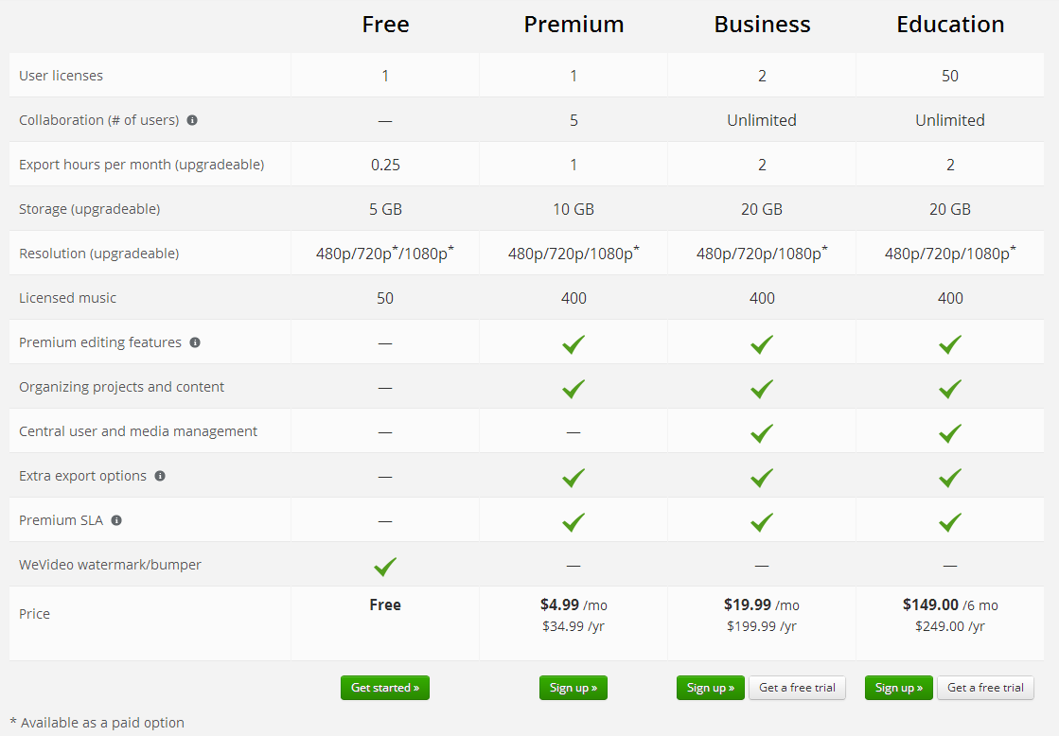

Figure 1The subscription-models WeVideo provides (<https://www.wevideo.com/sign-up>)

WeVideo also has, or has had, larger enterprise-partnerships, such as with Disney (*The Avengers*) (About Us, n.d.) and Sony (*One Direction: This Is Us*) (Tchaouchev, 2013), as well as bands, such as Coheed and Cambria (*The Afterman: Descension*) (Jacobson, 2013). This generates income, but more importantly, generate PR, and is a big incentive for fans of the film/band to register at the site and try it out.

## 1.3 How WeVideo spends its money

WeVideo’s expenditures are the typical ones for a SaaS, hosting, development and marketing. Because it also renders video, which requires a lot of computer-power, they also pay for cloud computing (through Amazon).

# 2. Subtask B – The Strategy

## 2.1 The Strategy Canvas

*Disclaimer: I have absolutely no experience in video editing, and this graph is thusly mostly a figment of my imagination, and based on the few forum-threads I have read on the various offerings, and from WeVideo’s own presentation at NITH.*

I created the Strategy Canvas on <http://strategycanvas.org/>. Link to mine: <http://strategycanvas.org/#/D4swJ>. 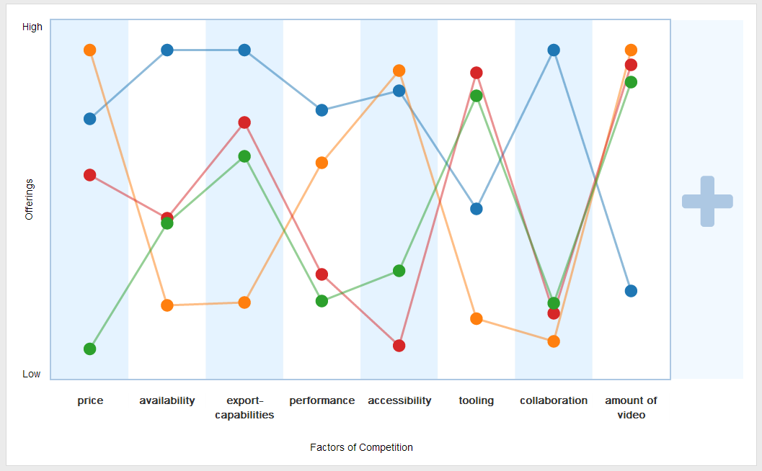

Figure 2The Strategy Canvas



Figure 3The different products

### 2.1.1 Reasons behind weighting

**Price:** WMM is free, while both WV and AP offer subscription based services. SV has a one-time price.

**Availability:** WMM is only available on Windows. Both AP and SV are available on both Windows and OSX. WeVideo does a knockout by being browser-based, meaning it is available on all platforms (including Linux and smart-phones).

**Export-capabilities:** WMM is a little bit limited, while both AP and SV offers the possibility to export to practically any format. However, WV allows direct exportation to video-sites, such as YouTube, and sharing in the cloud, through Dropbox.

**Performance:** Both WMM and WV are lightweight, while AP and SV are more full-featured, and thusly takes more computer-power. WV using cloud-computing makes it possible to render large videos also for people without the best hardware.

**Accessibility:** Same as above, WMM and WV are lightweight, while AP and SV are "heavier". In practice this make it easier to start using it, in comparison to the more advanced programs.

**Tooling:** WMM has very basic tooling. WV is more powerful, but pales in comparison to AP and SV.

**Collaboration:** WV does a complete knockout by being able to collaborate live, at the same time, as well as easily saving the files and continuing somewhere else.

**Amount of video:** The browser/cloud based WV naturally has limitations to the amount of assets it can handle and export. The costs increases if you want more.  
This is not a limitation of the desktop-applications.

### 2.1.2 Comments to the strategy

WeVideo differentiates itself from its competition mainly by being browser-based, and geared towards social media and interaction, while the other products focuses on the video-editing part. Another advantage of WeVideo is that by being cloud-based, it enables collaboration like no other tool. By being able to pick up your project whenever you feel like it, as long as you have internet available, on any device, OS or platform, and render the video independent from you own computer’s specs, makes it an awesome alternative to other “simple” editors.

Its only real weakness compared to its competition is if the customer is interested in very advanced tooling, or has to be able to produce large amounts of video.

## 2.2 Is the strategy in the “Blue Ocean”?

I would definitely say that WeVideo is in the Blue Ocean. While there are many video-editing tools out there, no one combines a browser-based editor with a focus on the social aspect of it as WeVideo does.

Looking at the Six Paths (Six Paths, 2013), which are ‘Industry’, ‘Strategic Groups’, ‘Buyer Group’, ‘Scope of Product or Service Offering’, ‘Functional-emotional Orientation’ and ‘Time’, several of them applies to WeVideo’s strategy. In general, all the points refer to “thinking outside the box” and looking at trends.

WeVideo’s winning strategy was looking at the explosion of social media, and how popular cloud-storage services such as Dropbox and Google Drive has become. The movement towards using tablets and smaller notebooks as opposed to large desktop-machines also work in WeVideo’s favour. To not have to use $1000 on hardware, and then spend another $200 on software, and having an easy way of sharing your videos with friends, or the internet at large, in something other than a raw, unedited format, is something that doesn’t really exist on the market today (besides WeVideo, of course). In addition, the ease of entry, with many people already having videos on services like Dropbox, gives WeVideo a large advantage in acquiring customers. Lastly, the ability to collaborate, at the same time, on the same video/project, is something no other tool provides today.

# 3. Subtask C – Advice on WeVideo’s strategy

In my opinion, there is not much WeVideo can do to increase its appeal. Therefore, I will just list out some ideas that might make it an even bigger success.

Concrete things I can think of would include striking up a more formal partnership with content-hosts (e.g. Dropbox or Google Drive), to have them advertise for WeVideo to user with many pictures or videos on their account. This would just be to increase awareness of the service.

It might also help to state, on i.e. the signup-page, that it is possible to use micro-transactions to get higher resolution, or more video-output without having to subscribe.

Samples of videos made with the tool on the first page of the website, along with maybe a small window showing how a video was actually created using WeVideo, to illustrate how easy it is, might also be a good idea.

Emphasising that it is browser-based, and thus independent of the platform a user is using, and driven by cloud-computing, so that the hardware of the user is irrelevant, could also be a way to get new users.

Being able to try it out (with pre-existing content) without having to sign up for an account, could also be a way to get new customers to give it a go.

Lastly, having some sort of reward for greatest videos made using WeVideo (in the form of e.g. more storage-space for a month), could be a way to bring users back to the service, or attract people making videos with high visibility. Alternatively, just asking “famous YouTubers” if they would be willing to give WeVideo a go, and having them say in their video that they used it, or state it in some sort of credits section. This might increase awareness amongst those thinking of making a cool video and sharing it, but not having the tools/skills/computer to actually achieve it.

# References

*About Us*. (n.d.). Retrieved from WeVideo: http://www.wevideo.com/about-us

Jacobson, J. (2013, February 4). *WeVideo Dives Into Music Promotion with Coheed and Cambria's "Dark Side of Me"*. Retrieved from WeVideo Blog: http://blog.wevideo.com/bid/265962/WeVideo-Dives-Into-Music-Promotion-with-Coheed-and-Cambria-s-Dark-Side-of-Me

*Six Paths*. (2013). Retrieved from Blue Ocean Strategy: http://www.blueoceanstrategy.com/concepts/bos-tools/six-paths/

Tchaouchev, N. (2013, August 2). *WeVideo and Sony Pictures Spotlight One Direction with Online Video Experience for Fans*. Retrieved from WeVideo Blog: http://blog.wevideo.com/bid/307456/WeVideo-and-Sony-Pictures-Spotlight-One-Direction-with-Online-Video-Experience-for-Fans