Table of Contents
Introduction 2
Background 2
Entity Relationship Diagram 2
3
Normalization of my database 4
Objects in my database 4
Tables 4
Triggers 4
Other Objects 4
Questions that can be answered with the database. 5
Login 7
Questions Answers 7

Introduction and Background
Nestled within the vibrant cityscape of Pretoria, South Africa, Golden Gate Dental Clinic stands out as a shining example of top-tier oral healthcare. From the very beginning, the clinic has remained steadfast in its commitment to providing comprehensive dental services to the local community. This dedication stems from the leadership of Dr. John Doe.
Guided by Dr. Doe's expertise, a dedicated team of dental professionals including seasoned associate dentists, committed hygienists, attentive assistants, and proficient administrative staff work tirelessly to uphold the clinic's unwavering commitment to exceptional patient care.
Despite their dedication, Golden Gate Dental Clinic faces challenges in effectively managing billing, inventory, and regulatory compliance. Manual billing processes are time-consuming and prone to errors, while inventory management issues can disrupt operations. Additionally, maintaining compliance with patient privacy laws demands rigorous security measures and meticulous record-keeping practices.
To overcome these challenges and enhance efficiency, the clinic asked us to implement an relational database . This technological advancement will automate billing, monitor inventory levels, and ensure regulatory compliance, ultimately streamlining operations and improving patient care outcomes.

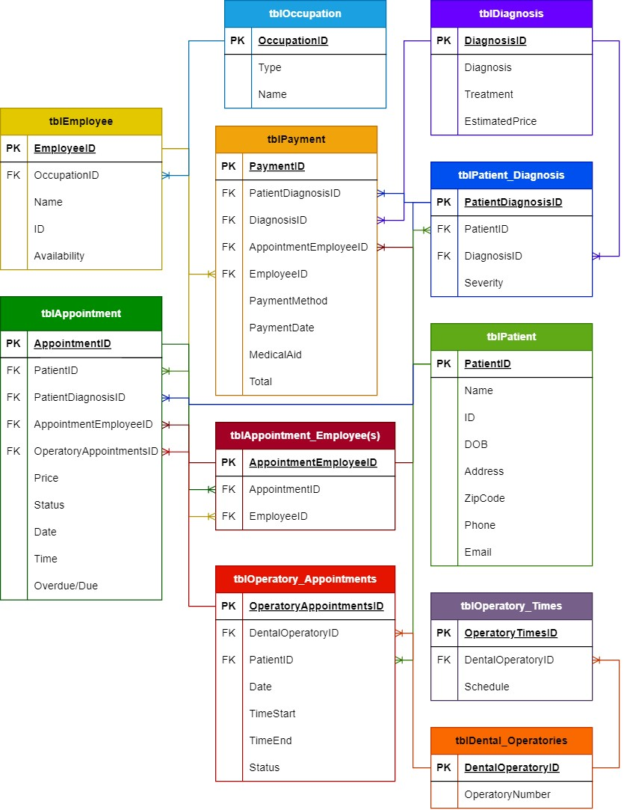
ERD
PK = Primary Key
FK = Foreign Key

Normalization of my database
Normalization is the process of organizing data in a database to reduce redundancy of data. There are several normal forms that can be achieved in a database, but Third Normal Form (3NF) is the most desired form. To achieve 3NF the database first needs to be in Second Normal Form (2NF) and then no transitive dependencies should exist for the database to be in 3NF. Before we can look at 2NF and 3NF we first needed to achieve First Normal Form (1NF).
First Normal Form (1NF):
This is when the data is organized in a table with each cell containing a single value, avoiding repeating groups of data. Columns have unique names, rows represent unique records, and the order of rows and columns is insignificant. After we achieve NF1 in the Dentist Database we can move forward to 2NF.

Second Normal Form (2NF):
Requires that every non-prime attribute of a table is fully functionally dependent on the entire primary key. This means that each attribute should depend on the whole primary key, not just part of it. We can see this looking at the tables in the dentist database. That all tables have a primary key and there is no partial dependencies meaning we can move on to achieve 3NF.

Third Normal Form (3NF):
Third Normal Form (3NF) eliminates transitive dependencies, which means that no nonprime attribute should be functionally dependent on another non-prime attribute. For example, let's consider the Employees table. The IsAvailable attribute is only dependent on the Employee_ID, which is the primary key. There are no apparent transitive dependencies in this table. Meaning we achieve 3NF in our Dentist database because we meet the criteria for 2NF and there is no transitive dependencies

Objects in my database

Tables
- Employee_Types
- Employees
- Patients
- Rooms
- Room_Breaks
- Room_Bookings
- Appontment_Workers
- Treatments
- Patient_Treatments
- Appointments
- Payment

Stored procedures
--Stored procedures
GO
-- Parameterized query to find a patient by their ID, also prevents SQL injection:
CREATE PROCEDURE GetPatientByID @PatientID INT
AS
BEGIN
SELECT *
FROM Patients
WHERE Patient_ID = @PatientID;
END;
-- EXECUTE GetPatientByID @PatientID = 1;
GO
-- Stored procedure to update patient information
CREATE PROCEDURE UpdatePatientInfo
@PatientID INT,
@NewCity VARCHAR(50)
AS
BEGIN
UPDATE Patients
SET City = @NewCity
WHERE Patient_ID = @PatientID;
END;
-- Execute UpdatePatientInfo stored procedure
EXECUTE UpdatePatientInfo @PatientID = 123, @NewCity = 'New York';
-- Replace 123 with the actual Patient_ID and 'New York' with the new city value
GO
-- Stored procedure to calculate total revenue for a specific date range
CREATE PROCEDURE CalculateRevenue
@StartDate DATE,
@EndDate DATE
AS
BEGIN
SELECT SUM(p.Total) AS TotalRevenue
FROM Payment p
WHERE p.Payment_Date BETWEEN @StartDate AND @EndDate;
END;

-- Execute CalculateRevenue stored procedure
DECLARE @StartDate DATE = '2024-01-01';
DECLARE @EndDate DATE = '2024-12-31';
EXECUTE CalculateRevenue @StartDate, @EndDate;
GO
-- Stored procedure to delete a patient and all related records
CREATE PROCEDURE DeletePatientCascade
@PatientID INT
AS
BEGIN
DELETE FROM Appointments WHERE Patient_ID = @PatientID;
DELETE FROM Patients WHERE Patient_ID = @PatientID;
END;

-- Execute DeletePatientCascade stored procedure
EXECUTE DeletePatientCascade @PatientID = 123;
-- Replace 123 with the actual Patient_ID to be deleted

Views
--Views
GO
--View for patient appointments and treatments with employee details:
CREATE VIEW PatientAppointmentDetails AS
SELECT a.Appointment_ID, a.Appointment_Date, a.Appointment_time,
p.Patient_FirstName, p.Patient_LastName, p.City,
t.Treatment, py.Payment_Method
FROM Appointments a
INNER JOIN Patients p ON a.Patient_ID = p.Patient_ID
INNER JOIN Patient_Treatments pt ON a.PatientTreatment_ID = pt.PatientTreatment_ID
INNER JOIN Treatments t ON pt.Treatment_ID = t.Treatment_ID
INNER JOIN Payment py ON pt.PatientTreatment_ID = py.PatientTreatment_ID;
GO
-- View to look at employee performance like how many patients, revenue and avg duration per patient:
CREATE VIEW EmployeePerformance
AS
SELECT CONCAT(E.Employee_FirstName,' ' ,E.Employee_LastName) 'EmployeeFullName', COUNT(A.Patient_ID) 'TotalAppointments',
SUM(A.Price) 'TotalRevenue', AVG(RB.Duration) 'AverageDuration'
FROM Appointments A
LEFT JOIN Appointment_Workers AW ON A.Appointment_WorkerID = AW.Appointment_WorkerID
LEFT JOIN Employees E ON AW.Employee_ID = E.Employee_ID
LEFT JOIN Room_Bookings RB ON A.RoomBooking_ID = RB.RoomBooking_ID
GROUP BY CONCAT(E.Employee_FirstName,' ' ,E.Employee_LastName);
GO
--View for appointments with patient details:
CREATE VIEW AppointmentDetails AS
SELECT A.*, P.Patient_FirstName, P.Patient_LastName, P.City
FROM Appointments A
INNER JOIN Patients P ON A.Patient_ID = P.Patient_ID;
GO
--View for room utilization:
CREATE VIEW RoomUtilization AS
SELECT R.Room_ID, R.RoomName, COUNT(RB.RoomBooking_ID) AS Bookings
FROM Rooms R
LEFT JOIN Room_Bookings RB ON R.Room_ID = RB.Room_ID
GROUP BY R.Room_ID, R.RoomName;
GO
--View for patient treatments and payments:
CREATE VIEW PatientPayments AS
SELECT P.Patient_ID, P.Patient_FirstName, P.Patient_LastName, T.Treatment, Py.Payment_Method, Py.Total
FROM Patients P
INNER JOIN Patient_Treatments PT ON P.Patient_ID = PT.Patient_ID
INNER JOIN Treatments T ON PT.Treatment_ID = T.Treatment_ID
INNER JOIN Payment Py ON PT.PatientTreatment_ID = Py.PatientTreatment_ID;
GO
--View for appointment statuses:
CREATE VIEW AppointmentStatus AS
SELECT Patient_ID, Status, COUNT(*) AS Status_Count
FROM Appointments
GROUP BY Patient_ID, Status;
GO
-- appointment details with revenue:
CREATE VIEW AppointmentRevenueDetails AS
SELECT A.Appointment_ID, A.Appointment_Date, A.Appointment_time,
P.Patient_FirstName, P.Patient_LastName, P.City,
T.Treatment, Py.Payment_Method, Py.Total AS Revenue
FROM Appointments A
INNER JOIN Patients P ON A.Patient_ID = P.Patient_ID
INNER JOIN Patient_Treatments PT ON A.PatientTreatment_ID = PT.PatientTreatment_ID
INNER JOIN Treatments T ON PT.Treatment_ID = T.Treatment_ID
INNER JOIN Payment Py ON PT.PatientTreatment_ID = Py.PatientTreatment_ID;
Go
--Appointment Statistics by Employee
CREATE VIEW AppointmentStatisticsByEmployee AS
SELECT CONCAT(E.Employee_FirstName, ' ', E.Employee_LastName) AS EmployeeName,
COUNT(A.Appointment_ID) AS TotalAppointments,
SUM(P.Total) AS TotalRevenue
FROM Employees E
INNER JOIN Appointment_Workers AW ON E.Employee_ID = AW.Employee_ID
INNER JOIN Appointments A ON AW.Appointment_WorkerID = A.Appointment_WorkerID
INNER JOIN Patient_Treatments PT ON A.PatientTreatment_ID = PT.PatientTreatment_ID
INNER JOIN Payment P ON PT.PatientTreatment_ID = P.PatientTreatment_ID
GROUP BY E.Employee_ID, E.Employee_FirstName, E.Employee_LastName;

Triggers
--Triggers
GO
-- Trigger to log patient deletions
CREATE TRIGGER LogPatientDeletions
ON Patients
INSTEAD OF DELETE
AS
BEGIN
INSERT INTO DeletedPatientsLog (PatientID, DeletionDate)
SELECT Patient_ID, GETDATE()
FROM deleted;

DELETE FROM Patients WHERE Patient_ID IN (SELECT Patient_ID FROM deleted);
END;
GO
-- Trigger to enforce unique emails for patients
CREATE TRIGGER EnforceUniqueEmail
ON Patients
AFTER INSERT, UPDATE
AS
BEGIN
IF EXISTS (SELECT 1 FROM inserted GROUP BY Email HAVING COUNT(*) > 1)
BEGIN
RAISERROR ('Email must be unique.', 16, 1);
ROLLBACK TRANSACTION;
END;
END;

Other Objects
--other objects (indexes,views, and constraints)
--index
CREATE INDEX IX_Appointment_Date ON Appointments (Appointment_Date);
CREATE INDEX IX_Patient_LastName ON Patients (Patient_LastName);

--views
CREATE VIEW AppointmentDetails AS
SELECT A.Appointment_ID, A.Appointment_Date, A.Appointment_time,
P.Patient_FirstName, P.Patient_LastName, P.City,
T.Treatment, Py.Payment_Method
FROM Appointments A
INNER JOIN Patients P ON A.Patient_ID = P.Patient_ID
INNER JOIN Patient_Treatments PT ON A.PatientTreatment_ID = PT.PatientTreatment_ID
INNER JOIN Treatments T ON PT.Treatment_ID = T.Treatment_ID
INNER JOIN Payment Py ON PT.PatientTreatment_ID = Py.PatientTreatment_ID;

/*if the object exists, rename and drop:
CREATE VIEW NewAppointmentDetails AS
SELECT A.Appointment_ID, A.Appointment_Date, A.Appointment_time,
P.Patient_FirstName, P.Patient_LastName, P.City,
T.Treatment, Py.Payment_Method
FROM Appointments A
INNER JOIN Patients P ON A.Patient_ID = P.Patient_ID
INNER JOIN Patient_Treatments PT ON A.PatientTreatment_ID = PT.PatientTreatment_ID
INNER JOIN Treatments T ON PT.Treatment_ID = T.Treatment_ID
INNER JOIN Payment Py ON PT.PatientTreatment_ID = Py.PatientTreatment_ID;

DROP VIEW AppointmentDetails;

and thern continute to run the code
*/

CREATE VIEW RoomUtilization AS
SELECT R.Room_ID, R.RoomName, COUNT(RB.RoomBooking_ID) AS Bookings
FROM Rooms R
LEFT JOIN Room_Bookings RB ON R.Room_ID = RB.Room_ID
GROUP BY R.Room_ID, R.RoomName;

/*if the object exists, rename and drop:
CREATE VIEW NewRoomUtilization AS
SELECT R.Room_ID, R.RoomName, COUNT(RB.RoomBooking_ID) AS Bookings
FROM Rooms R
LEFT JOIN Room_Bookings RB ON R.Room_ID = RB.Room_ID
GROUP BY R.Room_ID, R.RoomName;

DROP VIEW RoomUtilization;

and thern continute to run the code
*/

--constraints
ALTER TABLE Patients
ADD Age INT;

ALTER TABLE Patients
ADD CONSTRAINT CHK_Age CHECK (Age >= 0 AND Age < 120);

ALTER TABLE Appointments
ADD CONSTRAINT FK_Appointments_Patients FOREIGN KEY (Patient_ID) REFERENCES Patients(Patient_ID);

Login
You may Login to the database with the following created Login:
-- logins
CREATE LOGIN SampleLogin WITH PASSWORD = 'DentistStrongPassword';
CREATE USER SampleUser FOR LOGIN SampleLogin;
CREATE ROLE DataEntryRole;
CREATE ROLE DoctorRole;
CREATE ROLE AdministratorRole;

--assigning the permissions to the roles
GRANT SELECT, INSERT, UPDATE, DELETE ON dbo.Appointments TO DataEntryRole;
GRANT SELECT, INSERT, UPDATE, DELETE ON dbo.Patients TO DataEntryRole;
GRANT SELECT, INSERT, UPDATE, DELETE ON dbo.Appointments TO DoctorRole;
GRANT SELECT, INSERT, UPDATE, DELETE ON dbo.Patient_Treatments TO DoctorRole;
GRANT SELECT, INSERT, UPDATE, DELETE ON dbo.Appointments TO AdministratorRole;
GRANT SELECT, INSERT, UPDATE, DELETE ON dbo.Patients TO AdministratorRole;
GRANT SELECT, INSERT, UPDATE, DELETE ON dbo.Patient_Treatments TO AdministratorRole;
GRANT SELECT, INSERT, UPDATE, DELETE ON dbo.Payment TO AdministratorRole;
GRANT SELECT, INSERT, UPDATE, DELETE ON dbo.Treatments TO AdministratorRole;
GRANT SELECT, INSERT, UPDATE, DELETE ON dbo.Rooms TO AdministratorRole;
GRANT SELECT, INSERT, UPDATE, DELETE ON dbo.Room_Bookings TO AdministratorRole;
GRANT SELECT, INSERT, UPDATE, DELETE ON dbo.Employee_Types TO AdministratorRole;
GRANT SELECT, INSERT, UPDATE, DELETE ON dbo.Employees TO AdministratorRole;

Physical design – database environment, hardware, software ,security, performance requirements

Questions that can be answered with the database.
- Find the average revenue per appointment for each employee type.
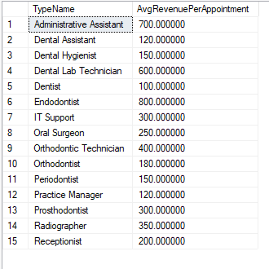
SELECT et.TypeName,ROUND(AVG(p.Total), 2) AS AvgRevenuePerAppointment
FROM Employees e
INNER JOIN Employee_Types et ON e.Employee_TypeID = et.Employee_TypeID
INNER JOIN Appointment_Workers aw ON e.Employee_ID = aw.Employee_ID
INNER JOIN Appointments a ON aw.Appointment_WorkerID = a.Appointment_WorkerID
INNER JOIN Patient_Treatments pt ON a.PatientTreatment_ID = pt.PatientTreatment_ID
INNER JOIN Payment p ON pt.PatientTreatment_ID = p.PatientTreatment_ID
GROUP BY et.TypeName;
- Show all details about all appointments along with patient, employee, room, and treatment information.
SELECT A.Appointment_ID, A.Appointment_Date, A.Appointment_time, P.Patient_ID,P.Patient_FirstName, P.Patient_LastName, E.Employee_ID, E.Employee_FirstName, E.Employee_LastName, R.Room_ID, R.RoomName, T.Treatment_ID, T.Treatment, T.Price
FROM Appointments A
INNER JOIN Patients P ON A.Patient_ID = P.Patient_ID
INNER JOIN Appointment_Workers AW ON A.Appointment_WorkerID = AW.Appointment_WorkerID
INNER JOIN Employees E ON AW.Employee_ID = E.Employee_ID
INNER JOIN Room_Bookings RB ON A.RoomBooking_ID = RB.RoomBooking_ID
INNER JOIN Rooms R ON RB.Room_ID = R.Room_ID
INNER JOIN Patient_Treatments PT ON A.PatientTreatment_ID = PT.PatientTreatment_ID
INNER JOIN Treatments T ON PT.Treatment_ID = T.Treatment_ID;
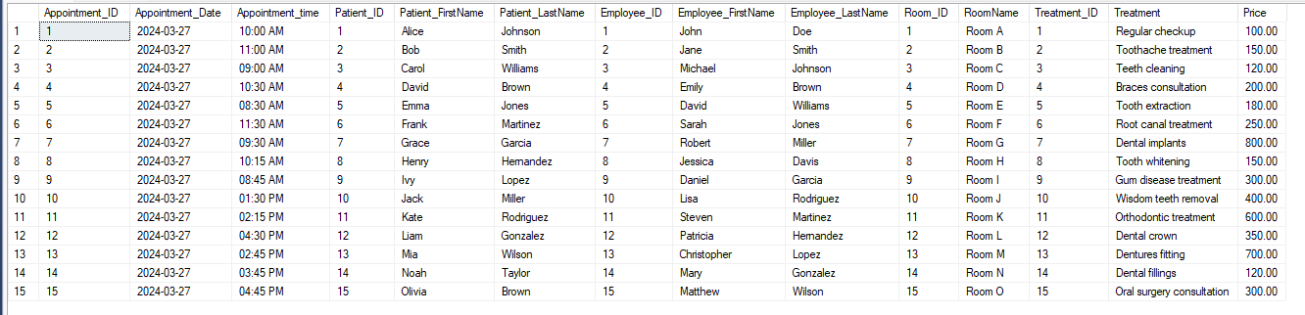

- Stored Procedure: Update Patient Information.Write a stored method named UpdatePatientInfo that updates the records of a patient based on their affected person ID. The stored manner should accept the affected person ID, new first name, new last name, new email, and new phone quantity as parameters and replace the corresponding affected person's information inside the Patients desk.

CREATE PROCEDURE UpdatePatientInfo @PatientID INT,@NewCity VARCHAR(50)
AS
BEGIN
UPDATE Patients
SET City = @NewCity
WHERE Patient_ID = @PatientID;
END;
-- Execute UpdatePatientInfo stored procedure
EXECUTE UpdatePatientInfo @PatientID = 123, @NewCity = 'New York';
-- Replace 123 with the actual Patient_ID and 'New York' with the new city value
GO

