**Git tutorial**

1. **Text

   Description automatically generatedIntroduce yourself:**

**Write your email**

**Write your name**

1. 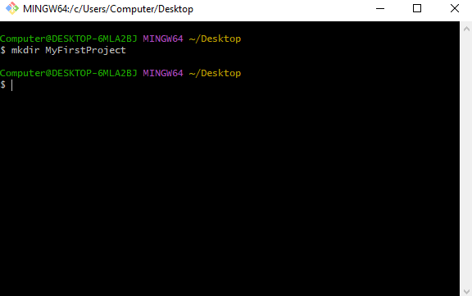 **Creating a new directory:**

**Write the directory’s name**

1. 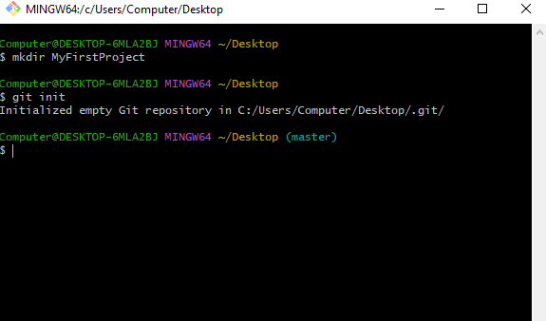**Creating a Git repository:**
2. 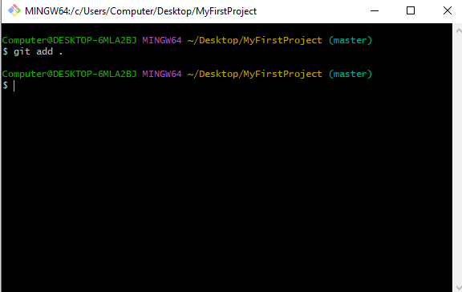**How to add files**

**Adds everything**

1. **How to check the state(changes) of your repository:**

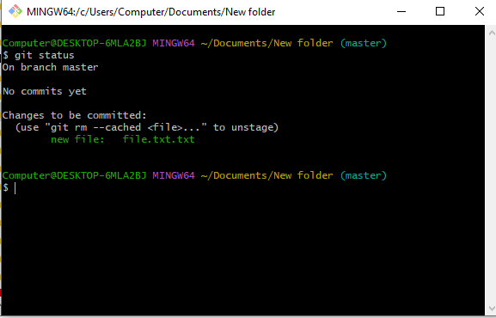

1. **How to commit the changes to your repository:**

**Type in your message**

1. **Displaying records of commits in the Git repository:**

1. **How to create a new, empty Git repository on your remote server:**

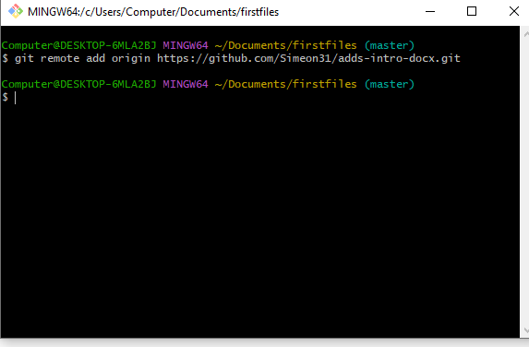

**A remote URL**

**A remote name**

1. **Text

   Description automatically generatedHow to push the changes to your remote repository:**