This database is a curbside pickup system of a local supermarket. The idea of the system is that the customer will be able to make an order online and send the order to the store through. The employees of the specific store that the order was sent to will collect those items for the customer and bring the items to the customer upon arrival. This assumes that the customer will be alerted whenever the order is ready and they will have time to pick up their order.

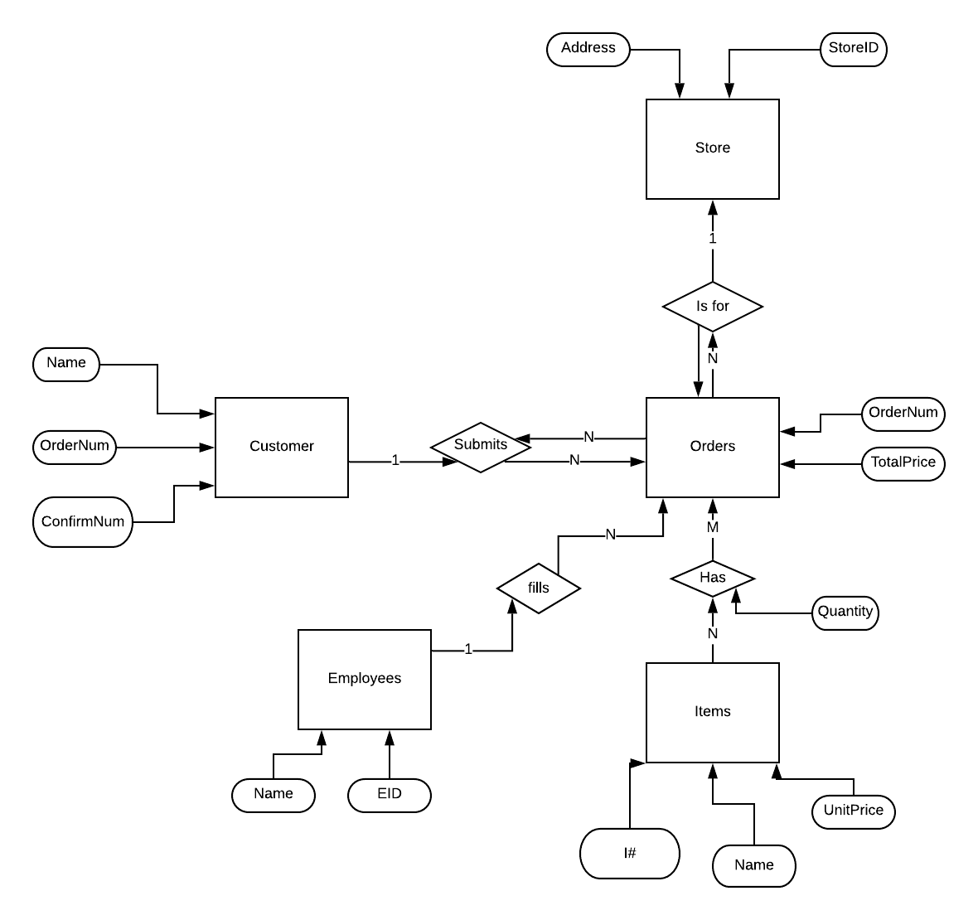

Relational Schema:

Superstore(Address, *StoreID*)

Customer(Name, *OrderNum*, ConfirmNum)

Orders(*OrderNum*, TotalPrice)

Employees(Name, *EID*)

Items*(I#*, *Name*, UnitPrice)

Populated database:

drop table superstore cascade constraints;

create table superstore(

address varchar2(50),

storeID number(3),

primary key (storeID));

drop table customer cascade constraints;

create table customer(

name varchar2(60),

ordernum number(13),

confirmnum number(20),

primary key (ordernum));

drop table orders cascade constraints;

create table orders(

ordernum number(13),

totalPrice number (5));

drop table employee cascade constraints;

create table employee(

name varchar2(60),

EID number(6));

drop table items cascade constraints;

create table items(

i# number(12),

name varchar2(60),

UnitPrice number(5));