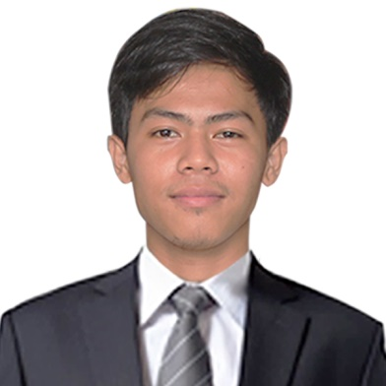**Anunciado Simeon Jr, B.**

Blk233 lot7 Arsenio St. Anne Phase

Deca Homes Brgy Loma de Gato Marilao Bul.

Email: [junsimeonanunciado@gmail.com](mailto:junsimeonanunciado@gmail.com)

Contact #**:** 09556158563

**OBJECTIVE**

To seek job that will help me improve my skills, skills that will help me to become a better person that will lead me to a better person tomorrow

**PERSONAL INFORMATION**

**NAME:** Anunciado, Simeon Jr. B,

**AGE:**  23

**BIRTH PLACE:**  Caloocan City

**BIRTH DATE:**  July 20, 1997

**HEGHT:** 5’6

**RELIGION:**  Roman Catholic

**CITIZENSHIP:**  Filipino

**SKILL:** With a Bachelor’s degree in Information of Technology.

Basic knowledge in troubleshooting computer hardware and also know Basic Web development PHP, MYSQL, CSS, BOOTSRAP, AJAX, JSON, CODEIGNITER, LARAVEL,JAVASCRIPT, VUE JS, ADONIS JS , IONICs AND GIT Version Control

**EDUCATIONAL BACKGROUND**

**TERTIARY:** Access Computer College Caloocan City (Camarin Branch) 2014

**SECONDARY:** Sampaguita High School Caloocan City 2010- 2014

**PRIMARY:** FSS Elementary School Marilao Mulacan 2004-2010

**WORK EXPERIENCE** VCM Technician Technical Support at ComElect Halalan 2016

Web Developer ( Wordpress ) at GC Web Experts (OJT)

* Computer Programmer (Diverse IT Innovation) 2018-2019
* Computer Programmer (San Roque Supermarket) 2019-2021

**GITHUB PROFILE:**  <https://simeonanunciado.github.io/>

**PROJECTS** <http://skyaerotrade.ph/>

<https://www.membership.aimforlevel1.com/membership/page/login.php>

<https://collectorshive.com/>

<http://vua.uniorient.net/>

<http://connectified.ph/>

<https://bringiton.ph/>

https://bioskincoco.com/

**OTHER WORKS** Recently I did some Mobile Development using angular and ionics with Laravel Backend and also I used wordpress and woocommerce for my extra projects**.** My other projects on my previouse job was an inhouse company I created and maintenance some system for retail company**.**

**CHARACTER REFERENCE Florante, Macaspag - Accountant** Senior (09505978165)

**Celo Sioson Batiduan III -** Professor

**John Ravida –** Web Master / Developer

**Johnny Balderama –** Web Develeper

**Dan Kevin Olea –** Graphic Artist