Ladder Editor for ARM PLC v6:

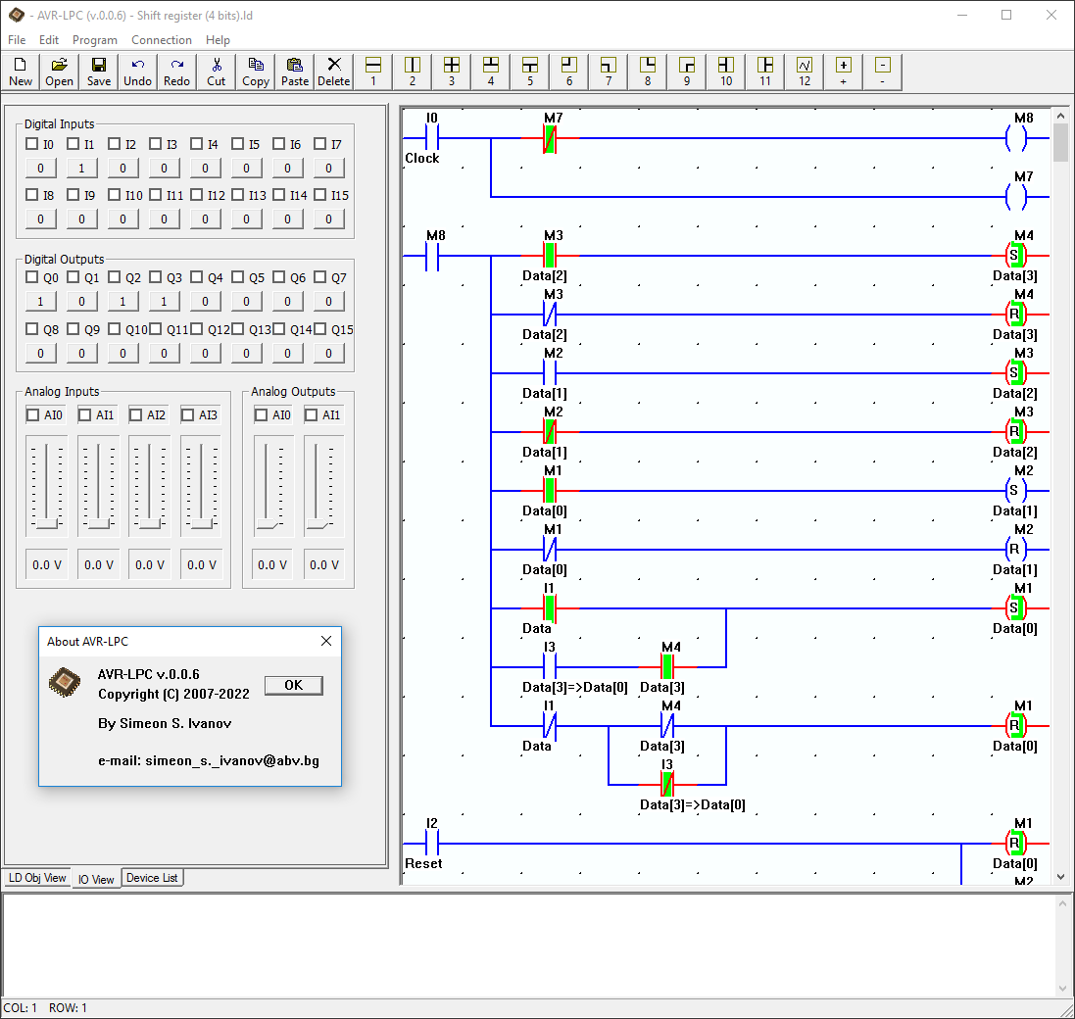

Ladder Editor for AVR/ARM PLC v5:

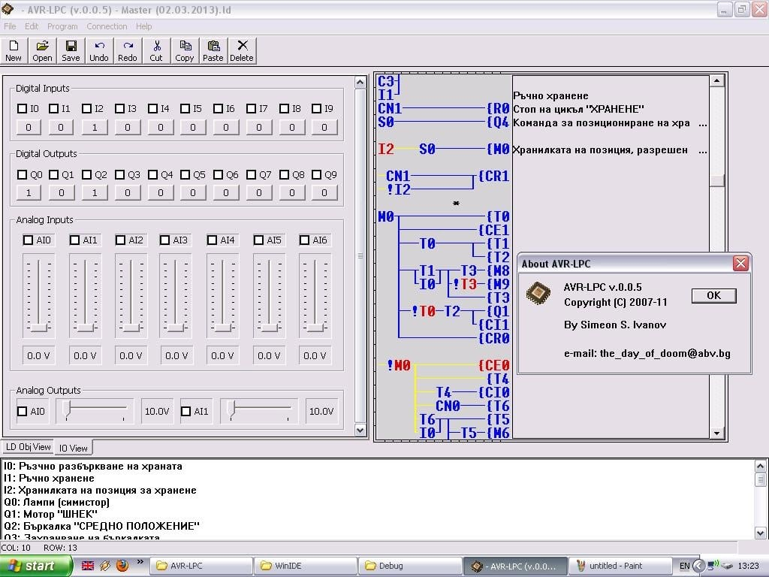

**DOS Version:**

