JS Arrays and Strings – Lab
Submit your solutions in the SoftUni judge system at: https://alpha.judge.softuni.org/contests/js-arrays-and-strings-lab/5053

Sum First and Last Array Elements
Write a function that receives an array of numbers and prints the sum of the first and last element in that array.

Examples
Input | Output
[20, 30, 40] | 60
[10, 17, 22, 33] | 43
[11, 58, 69] | 80

Hints
- You can access the last element in an array by subtracting 1 from its length:
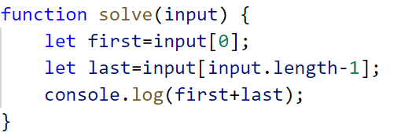

Reverse an Array of Numbers
Write a program, which receives a number n and an array of elements. Your task is to create a new array with n numbers from the original array, reverse it and print its elements on a single line, space-separated.

Examples
Input | Output
3, [10, 20, 30, 40, 50] | 30 20 10
4, [-1, 20, 99, 5] | 5 99 20 -1
2, [66, 43, 75, 89, 47] | 43 66

Hints
- Use push() to add elements inside the new array
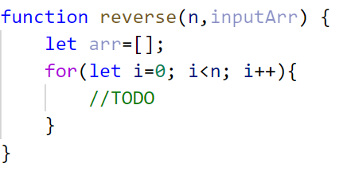
- Use string interpolation for the output
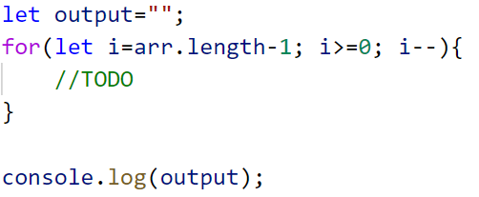

Even and Odd Subtraction
Write a program that calculates the difference between the sum of the even and the sum of the odd numbers in an array.

Examples
Input | Output | Comments
[1,2,3,4,5,6] | 3 | 2 + 4 + 6 = 12, 1 + 3 + 5 = 9, 12 - 9 = 3
[3,5,7,9] | -24
[2,4,6,8,10] | 30

Hints
- Parse each string to number
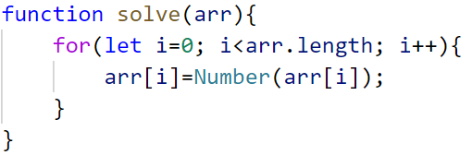
- Create two variables - for even and odd sum
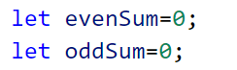
- Iterate through all elements in the array with a loop and check if the number is odd or even
- Print the difference

Substring
Write a function that receives a string and two numbers. The numbers will be a starting index and count of elements to substring. Print the result.

Input / Output
Input | Output
'ASentence', 1, 8 | Sentence
'SkipWord', 4, 7 | Word

Hints
Create a new string that takes the needed amount of elements from the given string.
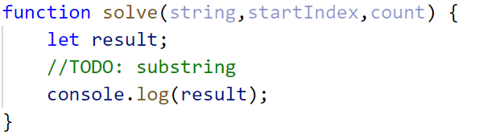

Censored Words
Write a function that receives a text as a first parameter and a single word as a second. Find all occurrences of that word in the text and replace them with the corresponding count of '*'.

Input / Output
Input | Output
'A small sentence with some words', 'small' | A ***** sentence with some words
'Find the hidden word', 'hidden' | Find the ****** word

Hints
Save the new text in a new variable.
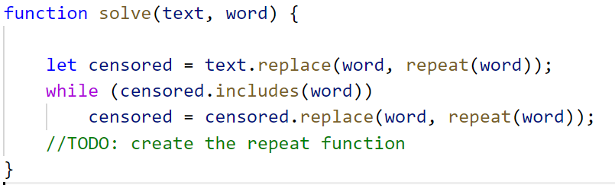
The repeat() function should take the length of the word and return that amount of stars '*'.

Count String Occurrences
Write a function that receives a text and a single word that you need to search. Print the number of all occurrences of this word in the text.

Input / Output
Input | Output
'This is a word and it also is a sentence',  'is' | 2
'softuni is great place for learning new programming languages',  'softuni' | 1

Hints
Split the sentence into words and create a counter that stores how many times the searched word occurs.


