Lab: Modules
The following problem descriptions do not require submissions to the Judge System.

Calculate Logarithm
Write a program that prints the calculated logarithm of any given number

Input
- On the first line, you will receive the number (an integer)
- On the second line, you will receive a number, which is the logarithm base. It can be either a number or the word "natural"
The output should be formatted to the 2nd decimal digit

Examples
Input | Output
10  natural | 2.30
10  10 | 1.00

Hints
Use the math module. You can read more about it here
- Import the module:
- Read the variables:
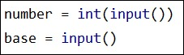
- Implement the logic:
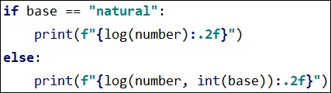

ASCII Art
Write a program that encrypts given words by using the characters: "-|_/\()" to structure the word. Use the pyfiglet module. You can read more about it here

Directions
- First you need to install the module that we will be using. To install it go to Setting --> Project <your_project_name> --> Project Interpreter --> + --> search for pyfiglet --> install package.
- Import the module
- Implement the logic. We will be using the figlet_format method

Examples
Input | Output
Hello World! | 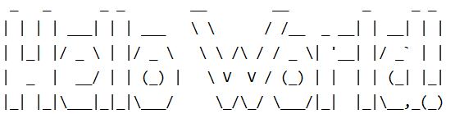
Python 3.8 | 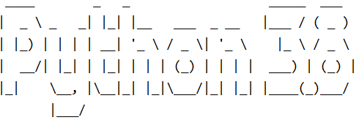

Hints
- First, we need to import the module:
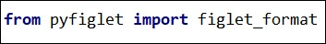
- Then we implement the logic:
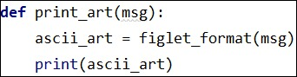
- Lastly, we print the message.

Triangle
Create a module for printing a triangle. You will receive an integer number which is the size of the triangle.

Examples
Input | Output
3 | 1  1 2  1 2 3  1 2  1
4 | 1  1 2  1 2 3  1 2 3 4  1 2 3  1 2  1

Hints
- We'll start with creating a package called a triangle
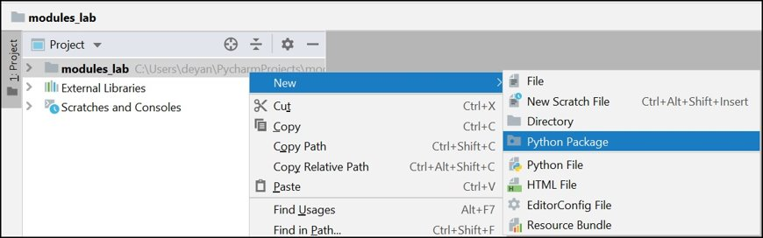
- Then we implement the logic. You can use 2 nested loops, one starting from 1 and another starting from our limit, each printing a line per cycle
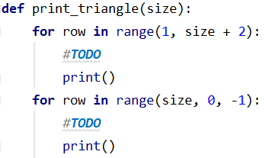
- And finally, import the module:
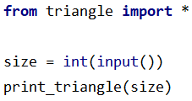

Mathematical Operations
Create a module that does basic calculations. You will receive 2 numbers and a sign between them all in one string

Input
You will receive a single string in the following format
"{number1} {sign} {number2}"
- number1 - a float number in the range (0.0, 1000.0)
- sign - a char that can be
'/' - divide the first number by the second
'*' - multiply the 2 numbers
'-' - subtract the first number from the second
'+' - add the 2 numbers
'^' - raise the first number to the second
- number2 - an integer number in the range (0, 1000)

Output
Print only the result of the operation
The result should be formatted to the second decimal point

Examples
Input | Output
2.5 * 2 | 5.00
6.66 ^ 2 | 44.35
36.66 / 6 | 6.11

Fibonacci Sequence
Create a module that can create a Fibonacci sequence up to a number (count of numbers in the sequence) and print them, separating them with a single space. The module should also be able to locate a specific number in the sequence. You can read more about the Fibonacci sequence here.
You will be receiving commands until the "Stop" command. The commands are:
- "Create Sequence {count}". Create a series of numbers up to a specific count and print them in the following format:
"{n1} {n2} … {n}"
- "Locate {number}"
Check if the sequence contains the number. If it finds the number, it should print:
"The number - {number} is at index {index}"
And if it doesn't find it:
"The number {number} is not in the sequence"

Input
- You will be receiving commands until the "Stop" command. All inputs will be valid.

Output
- Print the output of every command in the format described above.

Examples
Input | Output
Create Sequence 10  Locate 13  Create Sequence 3  Locate 10  Stop | 0 1 1 2 3 5 8 13 21 34  The number - 13 is at index 7  0 1 1  The number 10 is not in the sequence

