Introduction to HTML and CSS - Exercises

Topics Covered
- What is HTML?
- HTML Syntax
- Tags:
  - html, head, title, meta, body,
  - h1, h2, h3, h4, h5, h6, p, a, strong, em, ul, ol, li, dl, dt, dd, img, blockquote
  - main, aside, article, section, header, footer
  - details, summary, figure, caption
- What is CSS?
- CSS Syntax
- Properties
  - background, color
  - border, border-radius
  - padding
  - font-family, font-weight, font-style
  - text-decoraition
  - list-style

Resources
- HTML Element references on MDN:
  - https://developer.mozilla.org/en-US/docs/Web/HTML/Element
- HTML Basics
  - https://developer.mozilla.org/en-US/docs/Learn/Getting_started_with_the_web/HTML_basics
- Semantics:
  - https://developer.mozilla.org/en-US/docs/Glossary/Semantics
- W3 Validator:
  - https://validator.w3.org
- CSS Basics:
  - https://developer.mozilla.org/en-US/docs/Learn/Getting_started_with_the_web/CSS_basics
- CSS Reference:
  - https://developer.mozilla.org/en-US/docs/Web/CSS/Reference

Tasks

Simple image gallery
Build a simple image gallery using HTML and CSS to display a collection of images.
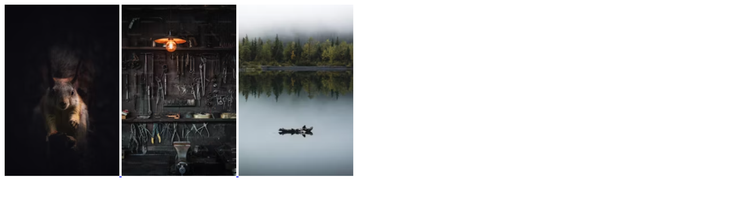

Requirements
- HTML Document Setup:
  - Create an HTML document named image-gallery.html.
  - Include a <div> container to hold the image gallery.
- CSS File Setup:
  - Create a CSS file named gallery-styles.css.
  - Link the gallery-styles.css file to your image-gallery.html document using the <link> tag in the <head> section.
- Gallery Structure:
  - Inside the gallery container, use <img> tags to include 3 images.
  - Optionally, wrap each <img> tag in an <a> tag so that the images can be clicked to view the full size in a new tab.

Resources
- https://unsplash.com/
- https://developer.mozilla.org/en-US/docs/Web/HTML/Element/img
- https://developer.mozilla.org/en-US/docs/Web/HTML/Element/div
- https://developer.mozilla.org/en-US/docs/Web/HTML/Element/ul

ToDo List
Build a simple ToDo List using HTML and CSS.
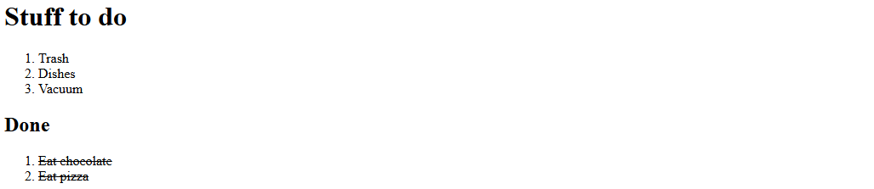

Requirements
- HTML Document Setup:
  - Create an HTML document named todo-list.html.
  - Include a basic HTML structure (<!DOCTYPE html>, <html>, <head>, <body>).
- CSS File Setup:
  - Create a CSS file named todo-list.css.
  - Link the todo-list.css file to your todo-list.html document using the <link> tag in the <head> section.
- Structure:
  - Use 2 ordered lists to represent tasks that are outstanding and tasks that are done

Resources
- https://developer.mozilla.org/en-US/docs/Web/HTML/Element/ul
- https://developer.mozilla.org/en-US/docs/Web/CSS/text-decoration

Navigation Bar
Build a simple navigation bar using HTML and CSS that includes links to different sections of a website.
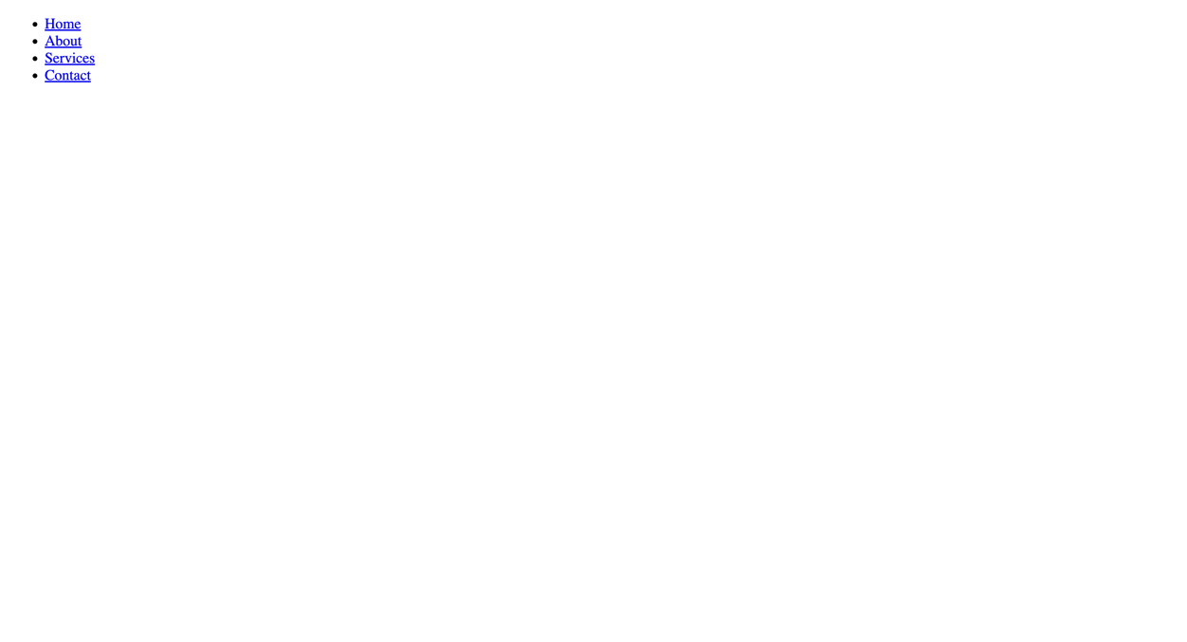

Requirements
- HTML Document Setup:
  - Create an HTML document named navigation.html.
  - Include the basic HTML structure (doctype, html, head, body).
- CSS File Setup:
  - Create a CSS file named navigation.css.
  - Link the navigation.css file to your navigation.html document using the <link> tag in the <head> section.
- Structure:
  - The navigation bar should be contained within a <nav> element.
  - Include an unordered list (<ul>) within the <nav> element. Each item in the list (<li>) represents a link (<a>) to a section of the website (e.g., Home, About, Services, Contact).

Resources
- https://developer.mozilla.org/en-US/docs/Web/HTML/Element/nav

List of blog posts
Develop a simple webpage that displays a list of blog posts, each with a title, an excerpt, and meta information including the post time and author.
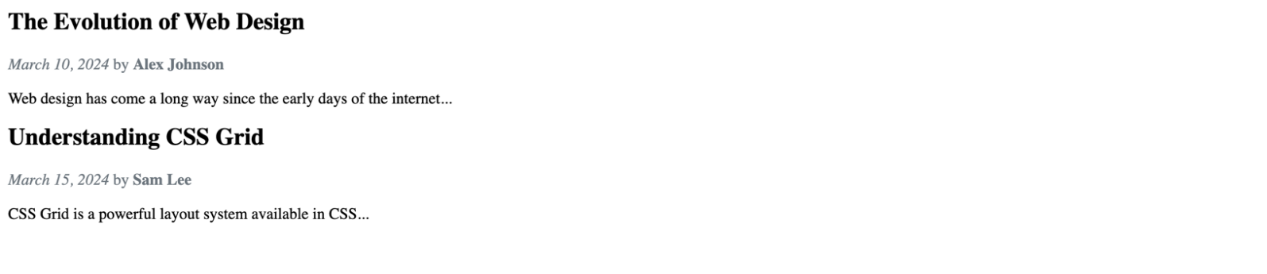

Requirements
- HTML Document Setup:
  - Create an HTML document named list-of-posts.html.
  - Ensure the document includes the basic HTML structure (doctype, html, head, body).
- CSS File Setup:
  - Create a CSS file named list-of-posts.css.
  - Link the list-of-posts.css file to your list-of-posts.html document using the <link> tag in the <head> section.
- Blog Posts Structure:
  - Use an <article> element for each blog post to semantically represent the content.
  - Within each <article>, include a <header> element that contains the post title (<h2>), post time (<time>), and author (<span> or <p>).
  - Follow the header with a paragraph (<p>) serving as the post excerpt or summary.

Resources
- https://developer.mozilla.org/en-US/docs/Web/HTML/Element/article
- https://developer.mozilla.org/en-US/docs/Web/HTML/Element/header
- https://developer.mozilla.org/en-US/docs/Web/HTML/Element/section
- https://developer.mozilla.org/en-US/docs/Web/HTML/Element/footer
- https://developer.mozilla.org/en-US/docs/Web/HTML/Element/p
- https://developer.mozilla.org/en-US/docs/Web/HTML/Element/blockquote

Single blog post page with comments
Create a single blog post page that displays the post content along with a comments section below it.
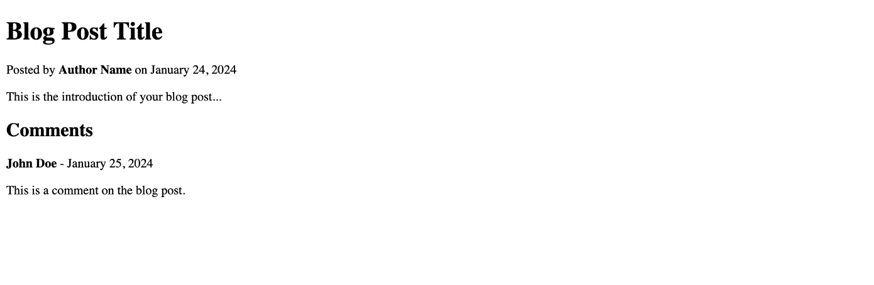

Requirements
- HTML Document Setup:
  - Create an HTML document named single-post.html.
  - Include the standard HTML structure (<!DOCTYPE html>, <html>, <head>, <body>).
- CSS File Setup:
  - Create a CSS file named single-post.css.
  - Link the single-post.css file to your single-post.html document using the <link> tag in the <head> section.
- Structure:
  - Use semantic HTML to structure the blog post. This should include a <header> with the post title (<h1>) and metadata such as the author and publish date (<p>).
  - Include a <main> section for the blog post content, utilizing <p> for paragraphs, <h2> for subheadings, and other relevant tags as needed for the content (e.g., <img> for images, <blockquote> for quotes).
  - Below the blog post, include a <section> for comments. Each comment should be contained within an <article> tag, with a <header> for the commenter's name and the comment date, and a <p> for the comment text.

Resources
- https://developer.mozilla.org/en-US/docs/Web/HTML/Element/article
- https://developer.mozilla.org/en-US/docs/Web/HTML/Element/header
- https://developer.mozilla.org/en-US/docs/Web/HTML/Element/section
- https://developer.mozilla.org/en-US/docs/Web/HTML/Element/footer
- https://developer.mozilla.org/en-US/docs/Web/HTML/Element/p

Blog layout
Create a responsive blog layout with a main content area for blog posts and a sidebar for supplementary content, using HTML and CSS.
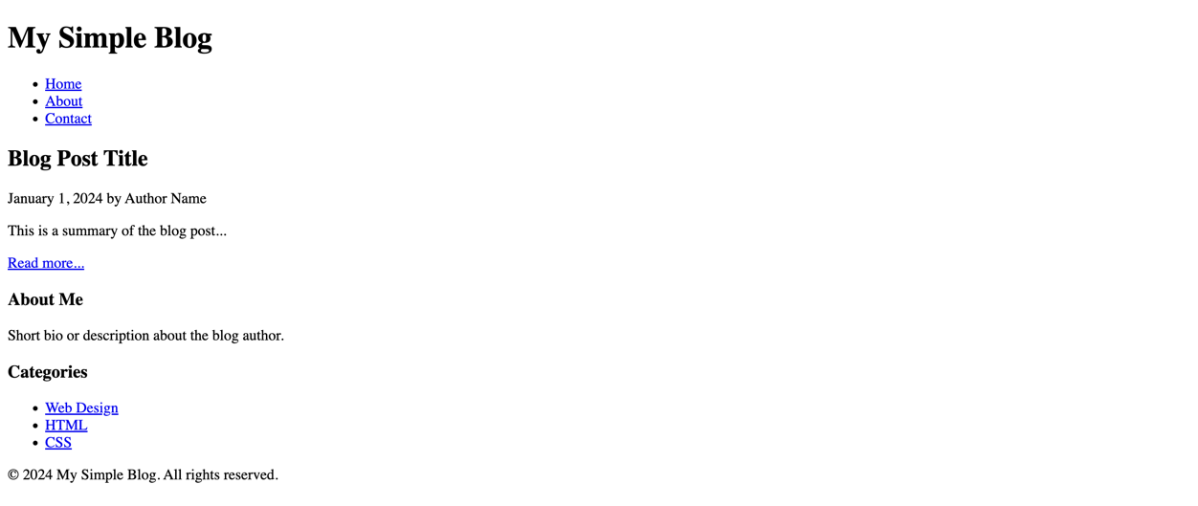

Requirements
- HTML Document Setup:
  - Create an HTML document named blog-layout.html.
  - Include the standard HTML5 structure (doctype, html, head, body).
- CSS File Setup:
  - Create a CSS file named blog-layout-styles.css.
  - Link the blog-layout-styles.css file to your blog-layout.html document using the <link> tag in the <head> section.
- Blog Layout Structure:
  - Utilize semantic HTML tags to structure the layout, including <header>, <main>, <article>, <aside>, and <footer>.
  - The <header> should contain the blog’s title or logo and a navigation menu.
  - The <main> area should display blog posts, each wrapped in an <article> tag, including titles (<h2>), publication dates (<time>), authors, summaries (<p>), and read more links (<a>).
  - The <aside> should serve as a sidebar, containing widgets or links such as "About Me", categories, recent posts, or social media links.
  - The <footer> should contain copyright information and/or links to privacy policy, terms of service, etc.

