Wild Survival
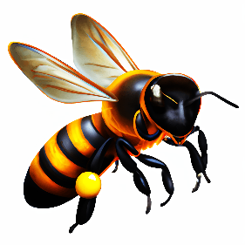 | 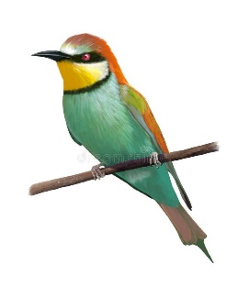
Bees: Nature's diligent pollinators, sustaining life with every buzz and bloom. Bee-eaters: Elegant hunters, who balance ecosystems with precision and grace.
On the first line, you will be given a sequence containing integers representing bee groups that live in a beehive.
On the second line, you will be given another sequence of integers representing bee-eaters groups living near the beehive.
Bees and bee-eaters are eternal enemies and are always fighting. Bees are known as the defenders of their hive while the bee-eaters are known as the attackers.
Until there are bees and bee-eaters available, the program will continue running.
You need to compare the first group of bees to the last group of bee-eaters (See the Examples):
- They start a fight until at least one of the groups is defeated.
One bee-eater can kill 7 (seven) bees at once, per each fight, then dies.
If one attacker needs to fight fewer defenders in number (less than 7), it survives while the defenders are considered defeated. In the next battle, it can kill 7 (seven) defenders again.
  - If the bee-eaters from the current fighting group win (there are 0 (zero) remaining bees in the corresponding group) return the survived bee-eaters to the sequence (in their initial position). The defeated bee group is removed.
  - If the bees from the current fighting group win, (there are 0 (zero) remaining bee-eaters of the corresponding group) add the bees that survived to the back of the bees collection. The defeated group of bee-eaters is removed.
  - If the result is a draw, remove both groups from their collections and proceed to the next ones.

Input / Constraints
- On the first line, you will receive integers representing the bee groups, separated by a single space. (See the Examples)
- On the second line, you will receive integers representing the bee-eaters groups, separated by a single space. (See the Examples)
- The given numbers will be valid positive integers in the range [1 - 100] inclusive.

Output
The output of your program should be printed on the Console, on separate lines, depending on the following outcome variations:
- On the first line:
"The final battle is over!"
- On the second line:
  - If bees and bee-eaters have slaughtered each other, print:
"But no one made it out alive!"
  - If there are bees that survived, print:
"Bee groups left: {bee_group₁, bee_group₂, …, bee_group_{N}}"
    - Print the bee groups in their current order, separated by comma and space ", ".
  - If there are bee-eater groups that have survived, print:
"Bee-eater groups left: {bee_eaters_group₁, …, bee_eaters_group_{N}}"
    - Print the bee-eater groups in their current order, separated by comma and space ", ".

Examples
Input | Output | Comment
32 42 7 28 3  1 5 6 | The final battle is over!  Bee groups left: 21 | We start with the first group of bees and the last group of bee-eaters: 32 vs 6.  They begin to fight until one of the groups defeats the other. Each bee-eater can kill 7 bees in the current battle before dying:  32 vs 6 -> 25 vs 5 -> 18 vs 4 -> 11 vs 3 -> 4 vs 2 -> 0 vs 2  4 fighting bee-eaters die, killing 28 bees (4x7=28)  The last 2 fighting bee-eaters defeat the remaining 4 bees and survive the battle. The bee group is removed from its collection. Finally, the 2 bee-eaters go back to the initial position of their collection:  42 7 28 3  1 5 2  The next fight continues with the next group of bees:  42 vs 2 -> 35 vs 1 -> 28 vs 0  The fighting bees kill all bee-eaters from the group, part of them survive and go to the back of their collection:  7 28 3 28  1 5  The third battle begins with 7 vs 5.  7 vs 5 -> 0 vs 4  Four bee-eaters survive and go back to their initial position in the sequence. 0 bees left, so their group is removed.  28 3 28  1 4  The next battle results in a draw: 28 vs 4 -> 21 vs 3 -> 14 vs 2 -> 7 vs 1 -> 0 vs 0, and no one survives. Both groups are removed.  3 28  1  Next, we have 3 vs 1. The bee-eater wins over the three bees. They are removed and the bee-eater is returned to its collection.  28  1  28 vs 1 -> 21 vs 0  The remaining 21 bees from the group survive and go to the end of their sequence. As there are no bee-eater groups left the program finishes.  21  Finally, only one group of bees survived, containing 21 bees.
21 14 14 7  1 2 2 3 | The final battle is over!  But no one made it out alive! | The first group of bees fights the last group of bee-eaters: 21 vs 3.  21 vs 3 -> 14 vs 2 -> 7 vs 1 -> 0 vs 0 results in a draw.  14 14 7  1 2 2  14 vs 2 -> 7 vs 1 -> 0 vs 0 results in another draw.  14 7  1 2  14 vs 2 -> 7 vs 1 -> 0 vs 0 results in a third draw.  7  1  7 vs 1 -> 0 vs 0 results in a final draw. No groups left.
14 6  1 3 2 | The final battle is over!  Bee-eater groups left: 1, 3 | 14 vs 2 results in a draw. Both groups are removed.  6  1 3  6 vs 3 -> 0 vs 3  The last group of 6 bees fights against a group of 3 bee-eaters. Bees are defeated while the 3 attackers survive and return to their initial position in the collection.  1 3  No bee groups left and the program finishes.
29 41 9  1 6 | The final battle is over!  Bee groups left: 27, 2

