Python OOP Regular Exam
Medieval Guild

In the legendary realm of Eldoria, guild halls are the foundation of strength and knowledge. Each guild hall recruits specialized members (warriors and mages) to master their skills and take on quests. The Guild Master oversees recruitment, assignments, skill development, and the management of gold coins.

Note: You must follow the provided structure, class names, method names, and file names exactly.
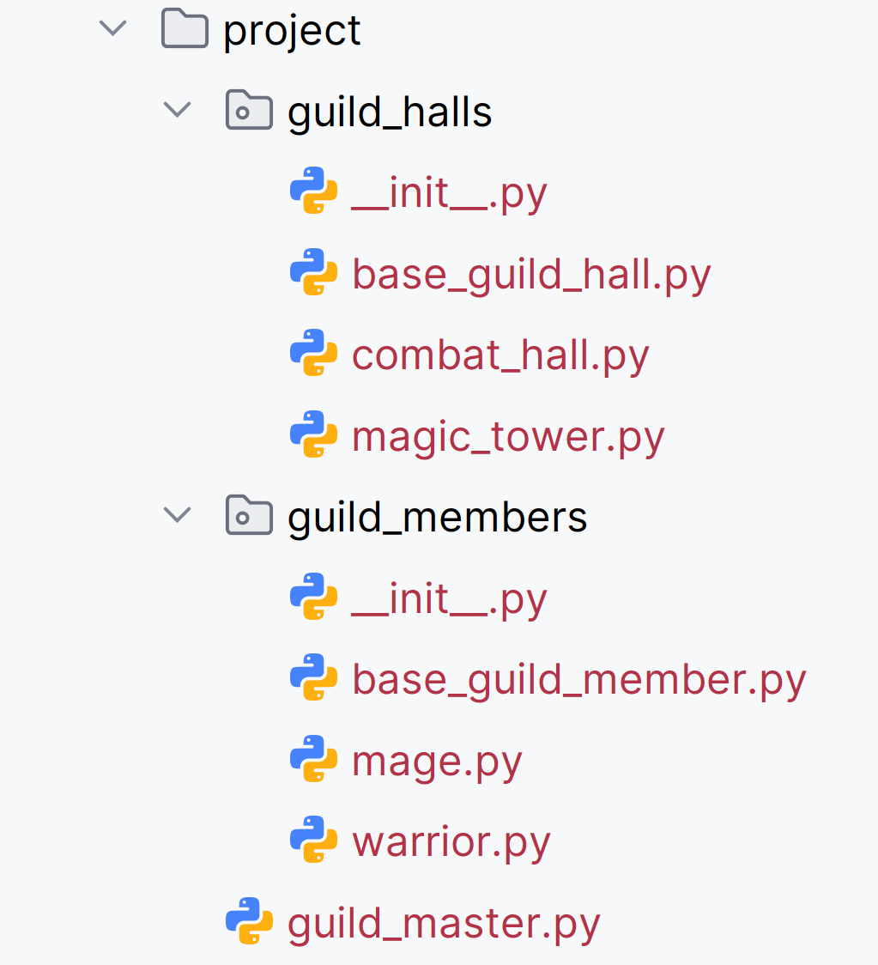
Judge Upload
For the first two problems, create a zip file with the project folder and upload it to the Judge system.
For the last problem, create a zip file with the test folder and upload it to the judge system.
You do not need to include your venv, .idea, pycache, and __MACOSX (for Mac users) in the zip file, so you do not exceed the maximum allowed size of 16.00 KB.

Structure (Problem 1) and Functionality (Problem 2)
You must implement all class definitions and functionality (abstraction, inheritance, polymorphism, validations, encapsulation).
You are free to add additional attributes (instance attributes, class attributes, methods, dunder methods, etc.) to simplify your code and increase readability if it does not change the project's final result under its requirements, so the program works properly.

Class BaseGuildMember
In the base_guild_member.py file, the class BaseGuildMember should be implemented. It is a base class for all types of guild members. This class cannot be instantiated directly.

Structure
The class should have the following attributes:
- tag: str
  - The value represents the tag of the member.
  - The tag can contain only letters and digits. Otherwise, raise a ValueError with the message: "Tag must contain only letters and digits!"
- gold: int
  - Represents the gold coins each member has.
  - If the gold is less than 0, raise a ValueError with the message: "Gold must be a non-negative integer!"
- role: str
  - The value represents the role of the member.
  - The role cannot be empty or whitespace-only. If so, raise a ValueError with the message: "Role cannot be empty!"
- skill_level: int
  - Represents the skill level of the member.
  - Skill level must be between 1 and 10, both inclusive. If not, raise a ValueError with the message: "Skill level is out of range!"

Methods

__init__(tag: str, gold: int, role: str, skill_level: int)
- In the __init__ method, all the needed attributes must be set.

practice()
- A method that increases members' skill level for each practice session.
- Remember that each member type implements the method differently.

Class Warrior
In the warrior.py file, the class Warrior should be implemented. A warrior is a type of base guild member. Warrior members have their role set to "Warrior", and their skill level is initially set to 2 units (inexperienced).

Methods

__init__(tag: str, gold: int)
- In the __init__ method, all the needed attributes must be set.

practice()
- The method increases warriors' skill level by 2 units per practice (call). Make sure it does not exceed the maximum level of 10 units.

Class Mage
In the mage.py file, the class Mage should be implemented. A mage is a type of base guild member. Mages have their role set to "Mage" and their skill level is initially set to 1 unit (unskilled).

Methods

__init__(tag: str, gold: int)
- In the __init__ method, all the needed attributes must be set.

practice()
- The method doubles the mages' skill level per practice (call). Make sure it does not exceed the maximum level of 10 units.

Class BaseGuildHall
In the base_guild_hall.py file, the class BaseGuildHall should be implemented. It is a base class for all types of guild halls. This class cannot be instantiated directly.

Structure
The class should have the following attributes:
- alias: str
  - The value represents the alias of the guild hall.
  - The alias can contain only letters and spaces and must be at least 2 characters long, excluding leading/trailing spaces. If it doesn't meet the criteria, raise a ValueError with the following message: "Guild hall alias is invalid!"
- max_member_count: int
  - Represents the maximum number of members the guild hall can accommodate.
  - Each guild hall type must define its own fixed value.
  - This value should not be passed via the constructor (__init__ method).
Hint: You can utilize various approaches. However, the cleanest approach is to define it as an abstract, read-only property in the base class and override it in each subclass to return a constant.
- members: list
  - Initially set to an empty list.
  - It will store a collection of guild members (objects) assigned to the guild hall.

Methods

__init__(alias: str)
- In the __init__ method, all the needed attributes must be set.

calculate_total_gold()
- Calculates the value of total gold for all assigned members.
- Returns the calculated value as an integer (returns zero (0) if there are no members).

status()
- Returns a string containing information about the guild hall in the format below.
  - The tags of the assigned members should be separated by a space and an asterisk (" *") and sorted alphabetically in ascending order.
    - If there are no members, use the string "N/A" instead.

"Guild hall: {alias}; Members: {member_tag₁ *member_tag₂ *… *member_tag_{n}/'N/A'}; Total gold: {total_gold}"

increase_gold(min_skill_level_value: int)
- The method increases the gold coins for certain members assigned to the guild hall whose skill level is more than or equal to the given min_skill_level_value.
  - The method increases the gold coins for the selected members by a certain amount based on the guild hall type.

Class CombatHall
In the combat_hall.py file, the class CombatHall should be implemented. A combat hall is a type of base guild hall. A combat hall has a max_member_count fixed to 3 members. This value remains unchanged (constant).

Methods

__init__(alias: str)
- In the __init__ method, all the needed attributes must be set.

increase_gold(min_skill_level_value: int)
- The method increases the gold coins for warriors assigned to the combat hall whose skill level is more than or equal to the given min_skill_level_value.
  - The method increases the gold coins for the selected members by 300.

Class MagicTower
In the magic_tower.py file, the class MagicTower should be implemented. A magic tower is a type of base guild hall. A magic tower has a max_member_count fixed to 4 members. This value remains unchanged (constant).

Methods

__init__(alias: str)
- In the __init__ method, all the needed attributes must be set.

increase_gold(min_skill_level_value: int)
- The method increases the gold coins for mages assigned to the magic tower whose skill level is more than or equal to the given min_skill_level_value.
  - The method doubles the gold coins for the selected members.

Class GuildMaster
In the guild_master.py file, the class GuildMaster should be implemented. It manages the guild system and contains the project's functionality.

Structure
The class should have the following attributes:
- members: list
  - Initially, an empty list to store all member objects available for assignments.
- guild_halls: list
  - Initially, an empty list to store all guild hall objects managed by the guild master.

Methods

__init__()
- In the __init__ method, all the needed attributes must be set.

add_member(member_type: str, member_tag: str, member_gold: int)
The method adds (upon certain conditions) a member of the given type and adds them to the guild master's members collection:
- First, check if the member type is valid, and if not, raise a ValueError with the following message: "Invalid member type!"
- Then, check if a member with the same tag is already added to the collection, regardless of their type, do not duplicate tags, and raise a ValueError with the following message: "{member_tag} has already been added!"
- If none of the above cases are reached, create and add the member to the guild master's members collection. Return the following message:
"{member_tag} is successfully added as {member_type}."
- Valid types of members are: "Warrior" and "Mage".

add_guild_hall(guild_hall_type: str, guild_hall_alias: str)
The method creates (upon certain conditions) a guild hall of the given type and adds it to the guild master's guild halls collection:
- First, check if the guild hall type is valid, and if not, raise a ValueError with the following message: "Invalid guild hall type!"
- Then, check if a guild hall with the same alias is already added to the list, regardless of their type, do not duplicate aliases, and raise a ValueError with the following message:
"{guild_hall_alias} has already been added!"
- If none of the above cases are reached, create and add the guild hall to the guild master's guild halls collection. Return the following message:
"{guild_hall_alias} is successfully added as a {guild_hall_type}."
- Valid types of guild halls are: "CombatHall" and "MagicTower".

assign_member(guild_hall_alias: str, member_type: str)
The method performs an assignment under certain conditions. The guild master assigns a specific member of the given type to a guild hall with the given alias if all pre-defined conditions are met:
- First, check if such a guild hall exists:
  - Validate a guild hall's existence with the given alias in the collection of the guild master's guild halls.
  - If no guild hall is found, the method raises a ValueError with the following message:
"Guild hall {guild_hall_alias} does not exist!"
- Then, check if a member of the given type exists:
  - Validate the existence of a member of the given type in the guild master's collection of members. Take the first occurrence in insertion order if such exists.
  - If no member is found, the method raises a ValueError with the following message:
"No available members of the type!"
If both objects exist, proceed with the assigning attempt:
- First, check if the guild hall has not reached its maximum member count to accept the assignment:
  - If the guild hall has reached its maximum member count, the assignment is impossible.
  - Return the message: "Maximum member count reached. Assignment is impossible."
- Then, the guild master assigns the member to the guild hall. A series of actions is required:
  - The member is removed from the guild master's members collection.
  - The member is added to the guild hall's collection of assigned members.
  - Return the following message:
"{member_tag} was assigned to {guild_hall_alias}."

practice_members(guild_hall: BaseGuildHall, sessions_number: int)
The method performs practice sessions for all members assigned to the given guild hall object (always valid). The number of practice sessions is passed as an argument "sessions_number" and will always be a valid integer in the range [0-5] inclusive.
- The method performs as many practice sessions as the sessions_number argument dictates.
- Each type of member gains different skill level units per session.
  - Remember that practicing should not increase skill level above its maximum (10 units).
  - Hint: Use the practice() method for each member.
- Return the following message:
"{guild_hall_alias} members have {total_skill_level} total skill level after {sessions_number} practice session/s."
- The total_skill_level represents the sum of all skill levels for assigned members after the practice sessions.

unassign_member(guild_hall: BaseGuildHall, member_tag: str)
The method unassigns a member object with the given tag if it exists and is assigned to the given guild hall (always a valid object), according to the following conditions:
- First, check if such a member exists in the guild hall's collection of assigned members. If it does not exist or if the object exists but the skill level is at its maximum (10 units), cancel the process and return a message:
"The unassignment process was canceled."
- If the member object exists and the skill level is below maximum, remove it from the assigned members' collection, add it to the guild master's collection of unassigned members, and return the following message:
"Unassigned member {member_tag}."

guild_update(min_skill_level_value: int)
The method updates the gold coins for certain members assigned to guild halls, depending on the min_skill_level_value argument. Afterward, it should return detailed information about the guild master's halls, including the updated data.
- First, update all members' gold coins who have equal to or more than the min_skill_level_value, following the specific guild halls' rules.
  - Hint: Utilize the increase_gold() method to properly apply the updates for each guild hall.
  - You are not supposed to update the gold coins for unassigned members.
- Then, return information about guild halls and their assigned members after updates.
  - Sort them by the number of assigned members in descending order.
  - If there is more than one guild hall with the same number of assigned members, sort them by the guild hall's alias in ascending order.
  - Sort the member tags in the guild hall's collections alphabetically in ascending order.
    - If there are no members, use the "N/A" string instead. See the Examples.
  - Hint: Use the guild hall's status() method.
- The returned, up-to-date information should follow the format of the example below (each guild hall's info is on a new line):
"<<<Guild Updated Status>>>
Unassigned members count: {unassigned_members_count}
Guild halls count: {guild_halls_total_count}
>>>Guild hall: {alias₁}; Members: {member_tag₁ *member_tag₂ *… *member_tag_{n}/'N/A'}; Total gold: {total_gold}
>>>Guild hall: {alias₂}; Members: {member_tag₁ *member_tag₂ *… *member_tag_{n}/'N/A'}; Total gold: {total_gold}
...
>>>Guild hall: {alias_{n}}; Members: {member_tag₁ *member_tag₂ *… *member_tag_{n}/'N/A'}; Total gold: {total_gold}"

Examples
Test Code
# Create an instance of the Guild Master
manager = GuildMaster()

# Add members (warriors & mages)
print(manager.add_member("Warrior", "W02345", 100))
print(manager.add_member("Warrior", "12W34", 200))
print(manager.add_member("Warrior", "789123W", 250))
print(manager.add_member("Warrior", "WW45678999", 150))
print(manager.add_member("Mage", "M321654", 300))
print(manager.add_member("Mage", "654M3211", 320))
print(manager.add_member("Mage", "334654M", 350))
print(manager.add_member("Mage", "MM034654", 400))
print()

# Add guild halls
print(manager.add_guild_hall("MagicTower", "Silver Tower"))
print(manager.add_guild_hall("CombatHall", "Iron Bastion"))
print(manager.add_guild_hall("CombatHall", "Dragon Watch"))
print()

# Assign members to guild halls
print(manager.assign_member("Silver Tower", "Warrior"))
print(manager.assign_member("Silver Tower", "Mage"))
print(manager.assign_member("Silver Tower", "Mage"))
print(manager.assign_member("Dragon Watch", "Mage"))
print(manager.assign_member("Dragon Watch", "Warrior"))
print(manager.assign_member("Dragon Watch", "Warrior"))
print(manager.assign_member("Dragon Watch", "Warrior"))
print()

# Conduct practice sessions
print(manager.practice_members(manager.guild_halls[0], 0))
print(manager.practice_members(manager.guild_halls[0], 1))
print(manager.practice_members(manager.guild_halls[0], 2))
print(manager.practice_members(manager.guild_halls[0], 3))
print(manager.practice_members(manager.guild_halls[0], 5))
print(manager.practice_members(manager.guild_halls[1], 1))
print(manager.practice_members(manager.guild_halls[1], 0))
print(manager.practice_members(manager.guild_halls[2], 1))
print()

# Unassign a member
print(manager.unassign_member(manager.guild_halls[2], "334654M"))
print(manager.unassign_member(manager.guild_halls[0], "W02345"))
print(manager.guild_halls[0].members[0].tag, manager.guild_halls[0].members[0].skill_level)
print(manager.unassign_member(manager.guild_halls[0], "111111"))
print(manager.unassign_member(manager.guild_halls[1], "WW45678999"))
print()

# Perform a guild-wide update
print(manager.guild_update(8))
print()

# Check members gold after the update
print(manager.guild_halls[0].members[0].gold)
print(manager.guild_halls[0].members[1].gold)
print(manager.guild_halls[0].members[2].gold)
print()
print(manager.guild_halls[2].members[0].gold)
print(manager.guild_halls[2].members[1].gold)
print()
print(manager.members[0].gold)
print(manager.members[1].gold)
print(manager.members[2].gold)
Output
W02345 is successfully added as Warrior.
12W34 is successfully added as Warrior.
789123W is successfully added as Warrior.
WW45678999 is successfully added as Warrior.
M321654 is successfully added as Mage.
654M3211 is successfully added as Mage.
334654M is successfully added as Mage.
MM034654 is successfully added as Mage.

Silver Tower is successfully added as a MagicTower.
Iron Bastion is successfully added as a CombatHall.
Dragon Watch is successfully added as a CombatHall.

W02345 was assigned to Silver Tower.
M321654 was assigned to Silver Tower.
654M3211 was assigned to Silver Tower.
334654M was assigned to Dragon Watch.
12W34 was assigned to Dragon Watch.
789123W was assigned to Dragon Watch.
Maximum member count reached. Assignment is impossible.

Silver Tower members have 4 total skill level after 0 practice session/s.
Silver Tower members have 8 total skill level after 1 practice session/s.
Silver Tower members have 24 total skill level after 2 practice session/s.
Silver Tower members have 30 total skill level after 3 practice session/s.
Silver Tower members have 30 total skill level after 5 practice session/s.
Iron Bastion members have 0 total skill level after 1 practice session/s.
Iron Bastion members have 0 total skill level after 0 practice session/s.
Dragon Watch members have 10 total skill level after 1 practice session/s.

Unassigned member 334654M.
The unassignment process was canceled.
W02345 10
The unassignment process was canceled.
The unassignment process was canceled.

<<<Guild Updated Status>>>
Unassigned members count: 3
Guild halls count: 3
>>>Guild hall: Silver Tower; Members: 654M3211 *M321654 *W02345; Total gold: 1340
>>>Guild hall: Dragon Watch; Members: 12W34 *789123W; Total gold: 450
>>>Guild hall: Iron Bastion; Members: N/A; Total gold: 0

100
600
640

200
250

150
400
350

Problem 3: Unit Testing (100 points)
You will be provided with another skeleton for this problem. Open the new skeleton as a new project and write unit tests for the LegendaryItem class. The class will have methods, fields, and a constructor - all working properly.
- You are NOT ALLOWED to modify the class itself.
- Cover the class (all methods and attributes) with unit tests to verify it works as intended.
- Submit only the test folder.

