Python OOP Regular Exam - 10 August 2024
Link to Judge
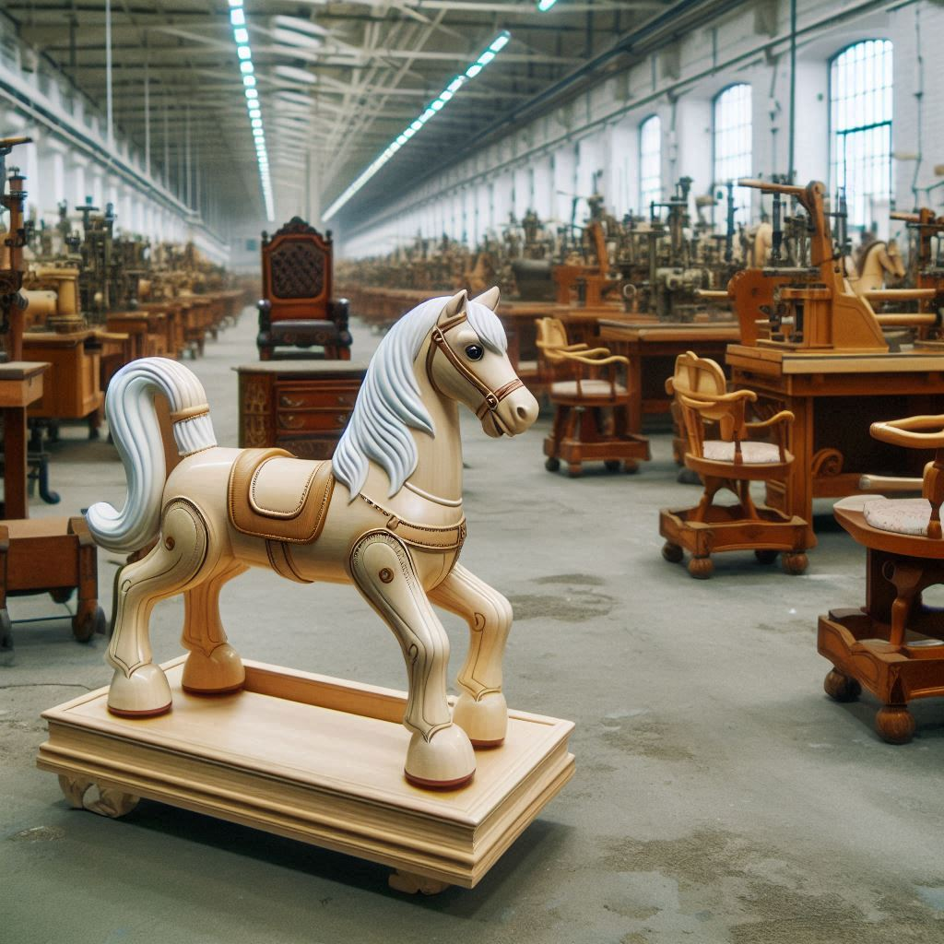
As a new enterprise dedicated to crafting high-quality wood products through specialized manufacturing processes, our primary focus is on producing exceptional furniture and toys, tailored to meet the unique demands of our diverse clientele. With a state-of-the-art factory and a commitment to excellence, we ensure that every product, from elegant chairs to delightful toys, embodies superior craftsmanship and innovative design.

You are provided with a skeleton that includes all folders and files you need.
Note: You are not allowed to change the folder and file structure or change their names!
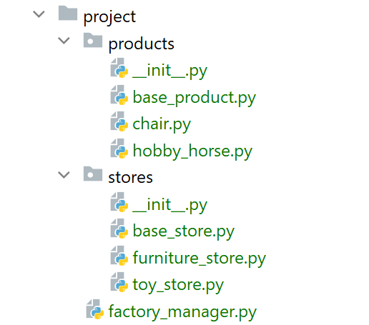
Judge Upload
For the first two problems, create a zip file with the project folder and upload it to the Judge system.
For the last problem, create a zip file with the test folder and upload it to the Judge system.
Do not include in the zip file your venv, .idea, pycache, and __MACOSX (for Mac users), so you do not exceed the maximum allowed size of 16.00 KB.

Structure (Problem 1) and Functionality (Problem 2)
Your task is to implement the structure and functionality of all classes (properties, methods, inheritance, abstraction, etc.)
You can add additional attributes (instance attributes, class attributes, methods, dunder methods, etc.) to simplify your code and increase readability if it does not change the project's final result following its requirements and proper workflow.

Class BaseProduct
In the base_product.py file, the class BaseProduct should be implemented. It serves as a base class for any type of product and should not be instantiated directly.

Structure
The class should have the following attributes:
- model: str
  - The value represents the model of the product.
  - If the model contains less than 3 characters or white spaces only, raise a ValueError with the message: "Product model must be at least 3 chars long!"
- price: float
  - The value represents the price of the product.
  - If the price is less than or equal to 0.0, raise a ValueError with the message: "Product price must be greater than zero!"
- material: str
  - The value represents the material of the product.
- sub_type: str
  - The value represents the sub-type of the product.

Methods

__init__(model: str, price: float, material: str, sub_type: str)
- In the __init__ method, all the needed attributes must be set.

discount()
- Decreases the product's price by applying a discount. Keep in mind that each type of product implements the method differently.

Class Chair
In the chair.py file, the class Chair should be implemented. The chair is a type of BaseProduct. Each chair is made of wood (the material property must be set to 'Wood') and has a sub-type of 'Furniture'.

Methods

__init__(model: str, price: float)
- In the __init__ method, all the needed attributes must be set.

discount()
- The method applies a discount of 10% to the chair's price.

Class HobbyHorse
In the hobby_horse.py file, the class HobbyHorse should be implemented. The hobby horse is a type of BaseProduct. Each hobby horse is made of wood and plastic parts (the material property must be set to 'Wood/Plastic') and has a sub-type of 'Toys'.

Methods

__init__( model: str, price: float)
- In the __init__ method, all the needed attributes must be set.

discount()
- The method applies a discount of 20% to the hobby horse's price.

Class BaseStore
In the base_store.py file, the class BaseStore should be implemented. It serves as a base class for any type of store and should not be instantiated directly.

Structure
The class should have the following attributes:
- name: str
  - The value represents the name of the store.
  - If the name is an empty string or contains only white spaces, raise a ValueError with the message: "Store name cannot be empty!"
- location: str
  - The value represents the abbreviation of the store location. Example: 'LA2'
  - The location must contain exactly 3 characters and should have no white spaces. If it does not, raise a ValueError with the message: "Store location must be 3 chars long!"
- capacity: int
  - The value represents the store's capacity.
  - If the capacity drops below zero, raise a ValueError with the message: "Store capacity must be a positive number or 0!"
- products: list
  - A list containing products (objects) each store has for sale.
  - Initially set to an empty list.

Methods

__init__(name: str, location: str, capacity: int)
- In the __init__ method, all needed attributes must be set.

get_estimated_profit()
- Computes the estimated future profit, based on the products the store has in stock (products collection) and an additional percentage of 10%.
- Sum the prices for all products in stock, then compute the estimated profit by multiplying the sum and the given percentage value of 10%.
Example: If the total sum of all product prices is 100.0, then the estimated profit is calculated as 100.0 * 10% = 10.0
- Returns a string in the format: "Estimated future profit for {products_count} products is {profit}"
- Format the profit value to the second decimal place.

store_type()
- Returns the type of the store as a property. Keep in mind that each type of store implements the method differently.
Hint: Use a property decorator to define this method as a property, making it accessible like <store_object>.store_type

store_stats()
- Returns detailed information about the store. Keep in mind that each type of store implements the method differently.

Class FurnitureStore
In the furniture_store.py file, the class FurnitureStore should be implemented. A furniture store is a type of BaseStore. The furniture store sells only furniture products and has an initial capacity of 50.

Methods

__init__(name: str, location: str)
- In the __init__ method, all needed attributes must be set.

store_type()
- Returns the type of the store as a property, set to: "FurnitureStore"
Hint: Use a property decorator to define this method as a property, making it accessible like <store_object>.store_type

store_stats()
- The method returns detailed information about the available products, prices, and capacity in the following format (each row on a new line):
"Store: {name}, location: {location}, available capacity: {capacity}
Estimated future profit for {products_count} products is {profit}
**Furniture for sale:
{model1}: {num_of_product_pieces}pcs, average price: {avg_price_per_model}
...
{modeln}: {num_of_product_pieces}pcs, average price: {avg_price_per_model}"
- Sort the available furniture by their model ascending and provide the number of products per model.
- The average price per model is calculated based on the prices of the products under this model and their number.
- Format the profit and average price to the second decimal place.
Hint: You can use the get_estimated_profit() method.

Class ToyStore
In the toy_store.py file, the class ToyStore should be implemented. A toy store is a type of BaseStore. The toy store sells only toy products and has an initial capacity of 100.

Methods

__init__(name: str, location: str)
- In the __init__ method, all the needed attributes must be set.

store_type()
- Returns the type of the store as a property, set to: "ToyStore"
Hint: Use a property decorator to define this method as a property, making it accessible like <store_object>.store_type

store_stats()
- The method returns detailed information about the available products, prices, and capacity in the following format (each row on a new line):
"Store: {name}, location: {location}, available capacity: {capacity}
Estimated future profit for {products_count} products is {profit}
**Toys for sale:
{model1}: {num_of_product_pieces}pcs, average price: {avg_price_per_model}
...
{modeln}: {num_of_product_pieces}pcs, average price: {avg_price_per_model}"
- Sort the available toys by their model ascending and provide the number of products per model.
- The average price per model is calculated based on the prices of the products under this model and their number.
- Format the profit and average price to the second decimal place.
Hint: You can use the get_estimated_profit() method.

Class FactoryManager
In the factory_manager.py file, the class FactoryManager should be implemented. It will manage the production and sales to stores.

Structure
The class should have the following attributes:
- name: str
  - The value represents the name of the factory.
- income: float
  - The value represents the income the factory generates by selling products.
  - Initially set to zero (0.0).
- products: list
  - A list containing all products (objects) that the factory produces.
  - Initially an empty list.
- stores: list
  - A list containing all stores (objects) the factory has as partners.
  - Initially an empty list.

Methods

__init__(name: str)
- In the __init__ method, all the needed attributes must be set.

produce_item(product_type: str, model: str, price: float)
The method produces(creates) a product object of the given type, model, and price and adds it to the products collection.
- If the type is not valid, raise an Exception with the following message:
"Invalid product type!"
- Otherwise, create the product, add it to the products list, and return the following message:
"A product of sub-type {product_sub_type} was produced."
- Valid types of products are: "Chair" and "HobbyHorse"

register_new_store(store_type: str, name: str, location: str)
The method registers(creates) a store object of the given type with the given name and location and adds it to the stores collection.
All store names will be unique.
- First, check if the store type is valid: 'FurnitureStore' or 'ToyStore'.
If not, raise an Exception with the following message:
"{store_type} is an invalid type of store!"
- Otherwise, create the store object, add it to the stores list, and return the following message:
"A new {store_type} was successfully registered."

sell_products_to_store(store: BaseStore, *products: BaseProduct)
The method initiates a sale of the provided collection of product objects (one or many) to the given store object. The store and products will always exist, and product objects will be unique.
- First, check if the store has enough capacity to buy all items.
If not, return the following message:
"Store {name} has no capacity for this purchase."
- Then, start checking the product sub-types to see if they match the store type:
  - FurnitureStore sells products of the sub-type 'Furniture', while ToyStore sells only items with the sub-type 'Toys'.
  - Filter only those that match and add them to the store products collection.
- You should also remove them from the factory collection of products.
- Decrease the store's available capacity with the number of purchased products.
- Sum up the prices of the purchased products and add the amount to the factory income.
  - If there are suitable items that the store can accept and sell, return the following message:
"Store {name} successfully purchased {num_of_purchased_products} items."
- If no products were sold due to type mismatch, return:
"Products do not match in type. Nothing sold."

unregister_store(store_name: str)
The method removes the store with the given name from the factory stores collection.
- First, check if there is a store with the given name in the stores collection.
If not, raise an Exception with the following message:
"No such store!"
- Then, check if the store has unsold products. If so, return the following message:
"The store is still having products in stock! Unregistering is inadvisable."
- If the store can be unregistered successfully, remove it from the factory stores collection, and return the following message:
"Successfully unregistered store {store_name}, location: {store_location}."

discount_products(product_model: str)
The method decreases the prices for the unsold products from the factory products collection, filtered by the provided model (which will always be an existing model, but can be of a sold item), and returns the following message:
"Discount applied to {products_count} products with model: {model}"
- The discount depends on the product sub-type:
  - Furniture products get a 10% discount while toy products get a 20% discount.
Hint: Use the product's discount() method to decrease the prices for the different types of products properly.

request_store_stats(store_name: str)
The method returns up-to-date store statistics for the store with the given name.
- If there is no such store, return a message:
"There is no store registered under this name!"
- Otherwise, return the string that the store statistics method generates.
Note: Use the store's store_stats() method to generate the statistics properly.

statistics()
Returns structured and sorted information about the factory and its partner stores. Each string is on a new line.
"Factory: {factory_name}
Income: {factory_income}
***Products Statistics***
Unsold Products: {factory_products_count}. Total net price: {products_sum_price}
{product_model1}: {count}
...
{product_modeln}: {count}
***Partner Stores: {total_stores_count}***
{store_name1}
...
{store_namen}"
- The factory income and the total products' net price should be formatted to the 2nd decimal place.
- Include a breakdown of unsold products by model, showing each product model and its count.
- Product models and store names are sorted in ascending order.

Examples
Test Code
# Initialize the FactoryManager
factory_manager = FactoryManager("Cool Factory")

# Produce some items
print(factory_manager.produce_item("Chair", "Classic", 80.0))
print(factory_manager.produce_item("Chair", "Modern", 100.0))
print(factory_manager.produce_item("Chair", "Modern", 200.0))
print(factory_manager.produce_item("HobbyHorse", "Rocking Horse", 120.0))
print(factory_manager.produce_item("HobbyHorse", "Rocking Horse", 100.0))
print()

# Register new stores
print(factory_manager.register_new_store("FurnitureStore", "Furniture Outlet", "SOF"))
print(factory_manager.register_new_store("ToyStore", "Toy World", "VAR"))
print()

# Sell products to stores
chair1 = factory_manager.products[0]
chair2 = factory_manager.products[1]
chair3 = factory_manager.products[2]
store1 = factory_manager.stores[0]
store2 = factory_manager.stores[1]
print(factory_manager.sell_products_to_store(store2, chair1, chair2))
print(factory_manager.sell_products_to_store(store1, chair1, chair2, chair3))
print()

# Unregister store
print(factory_manager.unregister_store("Furniture Outlet"))
print()

# Discount products
print(factory_manager.discount_products("Classic"))
print(factory_manager.discount_products("Rocking Horse"))
print()

# Request store statistics
print(factory_manager.request_store_stats("Furniture Outlet"))
print(factory_manager.request_store_stats("Toy World"))
print()

# Factory statistics
print(factory_manager.statistics())
print()

# Unregister store
print(factory_manager.unregister_store("Toy World"))

Output
A product of sub-type Furniture was produced.
A product of sub-type Furniture was produced.
A product of sub-type Furniture was produced.
A product of sub-type Toys was produced.
A product of sub-type Toys was produced.

A new FurnitureStore was successfully registered.
A new ToyStore was successfully registered.

Products do not match in type. Nothing sold.
Store Furniture Outlet successfully purchased 3 items.

The store is still having products in stock! Unregistering is inadvisable.

Discount applied to 0 products with model: Classic
Discount applied to 2 products with model: Rocking Horse

Store: Furniture Outlet, location: SOF, available capacity: 47
Estimated future profit for 3 products is 38.00
**Furniture for sale:
Classic: 1pcs, average price: 80.00
Modern: 2pcs, average price: 150.00
Store: Toy World, location: VAR, available capacity: 100
Estimated future profit for 0 products is 0.00
**Toys for sale:

Factory: Cool Factory
Income: 380.00
***Products Statistics***
Unsold Products: 2. Total net price: 176.00
Rocking Horse: 2
***Partner Stores: 2***
Furniture Outlet
Toy World

Successfully unregistered store Toy World, location: VAR.

Task 3: Unit Tests (100 points)
You will be provided with another skeleton for this problem. Open the new skeleton as a new project and write tests for the SoccerPlayer class. The class will have some methods, fields, and one constructor, all of them working properly. You are NOT ALLOWED to change anything in the class code. Cover the whole class with unit tests to make sure that the class is working as intended. Submit only the test folder.

