Workshop: Console Tic-Tac-Toe
In this workshop, we will create a simple two-player "Tic-Tac-toe" game. Here is how the game is going to look in the end:
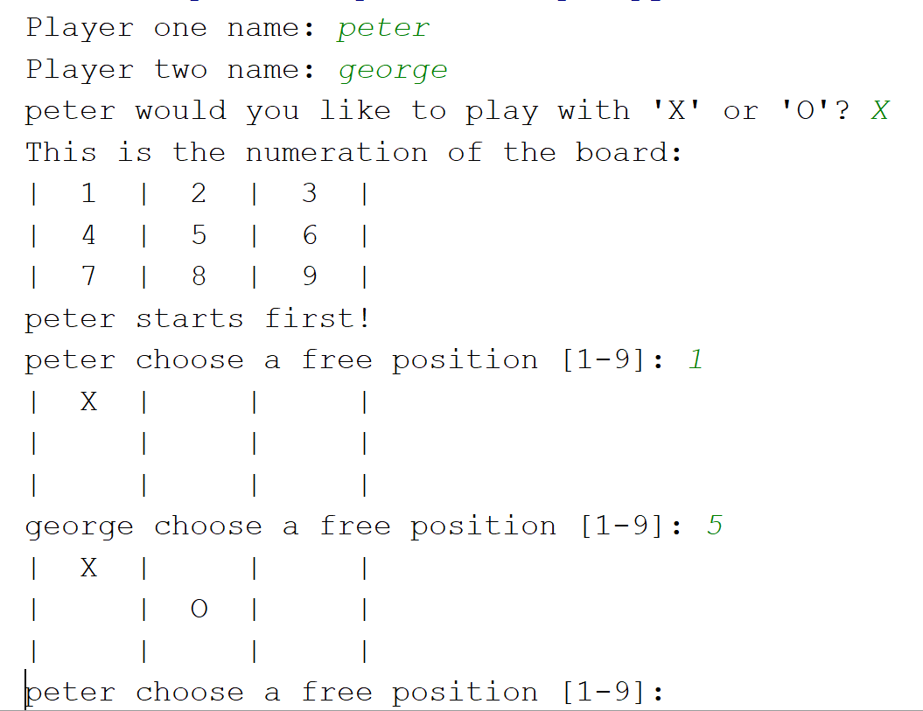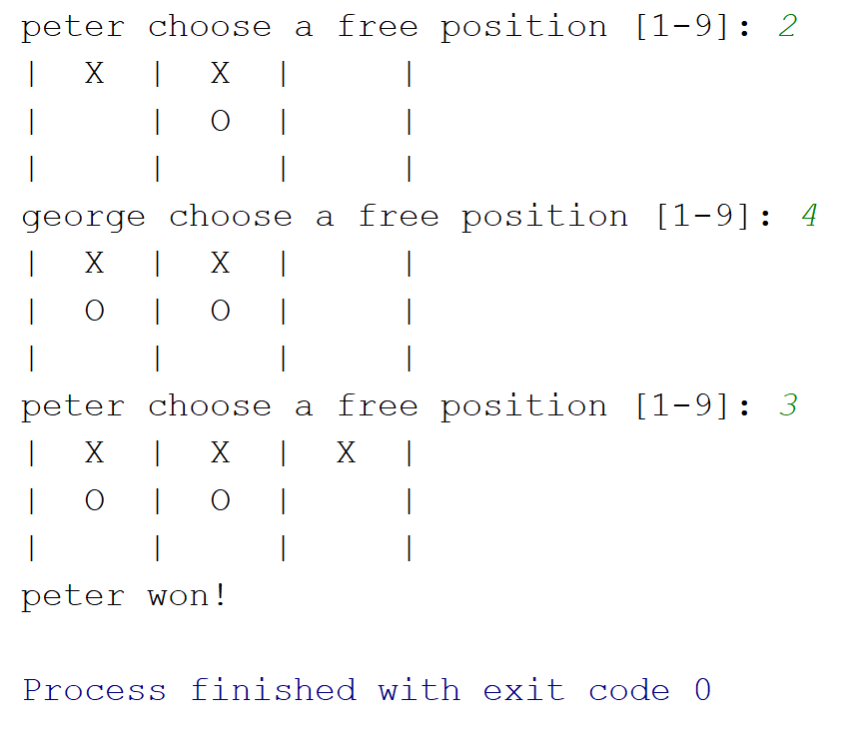

The Main Logic

Global Variables
The global variables will be player_one, player_two, board (the state of the game), and loop (boolean to check if the game should continue or not)

Implementation
Let us now create our main logic of the game
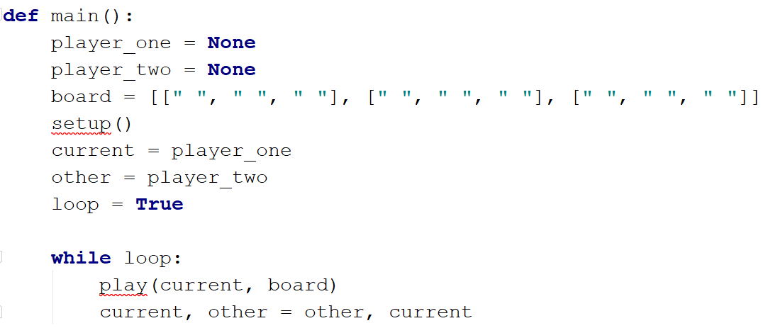
- We create our global variables player_one, player_two (None to start with), board (empty to start with), and loop (game loop)
- We also create variables current and other (to switch turns of the players)
- We call a setup() function, which we will implement later (it should take the info of the players and draw the initial state of the board)
- We create a while loop to keep playing until a player win
- In there, we call a function called play() which will take the choice of the current player and apply his/her choice to the board
- Finally, we switch the players, so in the next iteration, the other player should choose

Creating the Setup() Function
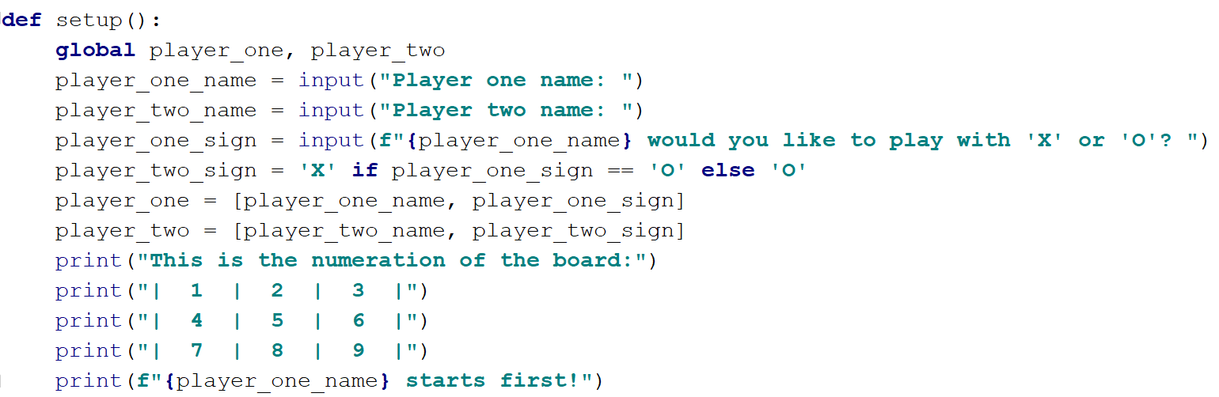
- We take the names of the two players
- Then we ask player one for his sign and set the sign of the second player
- We save the info in the global variables player_one and player_two as a list of their names and signs
- We display some info about the game rules and start with player one

Creating the Play() Function
Now, let us implement the play() function, which will ask the current player to choose the following action and apply his/her sign on the board
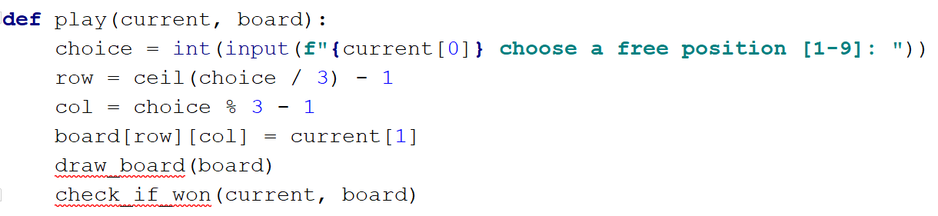
- Here we ask the player to choose a free space to apply his/her sign
- We create the variables row and col, which calculate the row and col of the selected label (don't forget to import ceil from the math library)
- Then we apply the sign of the current player on the board
- We call two functions which we will implement next:
  - draw_board(board) - loops through the board and draws its current state
  - check_if_won(current, board) - checks if the current player has won after choosing his action

Creating the Draw_board() Function
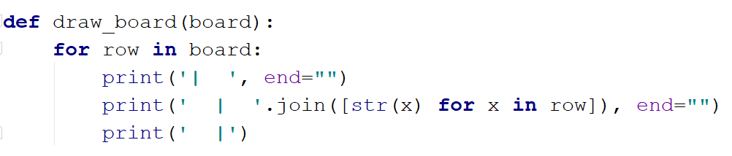
- Here we loop through each row in the board and print its state

Creating the Check_if_won() Function
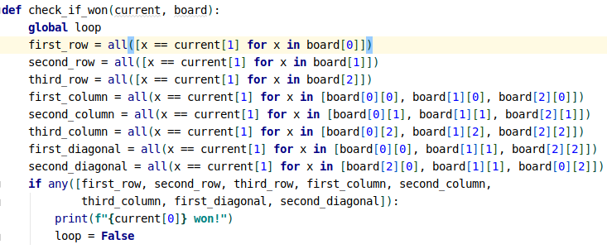
- In this function, we first use the global loop variable, because we will use it later
- Then we create a boolean variable for each win condition
- We then check if any of these conditions is True and if there are, we print that the current player has won and then stop the loop (we set the loop variable to False)

BONUS
- Try writing validation logic for:
  - The signs can only be "X" and "O"
  - The users can only choose from the numbers 1 to 9
  - The users can only choose a free space
- Try adding error messages for those validations

