Workshop: Console Connect Four
We will create a simple two-player "Connect Four" game in this workshop. Here is how the game is going to look in the end:
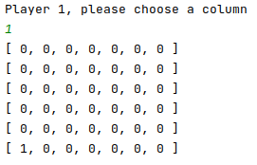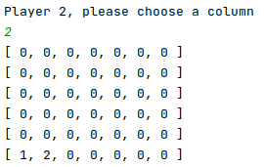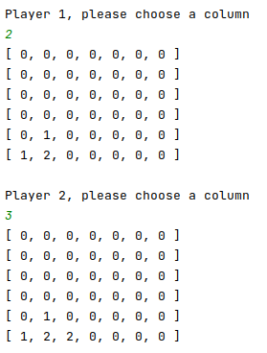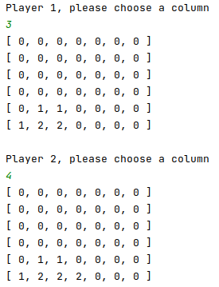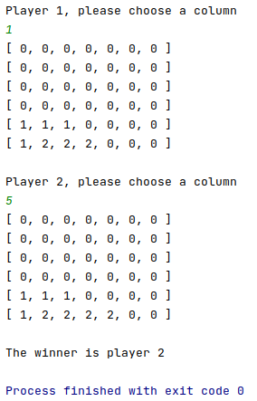

The Main Logic
- A player wins when he/she connects four slots.
- The winning connected slots must be consecutive
- A connection can be
  - Horizontal
  - Vertical
  - Diagonal

BONUS
- Try writing validation logic for:
  - More than one player
  - Reset logic
- Try adding error messages for invalid column

