CMPG 323

Project 2

**S Strydom**

Project documentation submitted for the degree *Bachelor Scientiae* in Information Technology at the North-West University

Lecturer: Dr. JT Janse van Rensburg

Mr. Zander Boonzaaier

Supervisor: Me. Jaqui Muller

Graduation: 2022

Student number: 24306223

Table of contents (Heading 0)

Chapter 1 INTRODUCTION (Chapter) 1

1.1 Project introduction 1

1.2 Technologies 1

Chapter 2 Entity Relationship diagram (Chapter) 2

3.1 Database and the ERD 2

Chapter 3 use case diagram (Chapter) 3

4.1 Explaining the uses of services 3

Chapter 4 DATA FLOW DIAGRAM (Chapter) 4

5.1 The logic flow 4

Chapter 5 user how-to guide (Chapter) 7

6.1 Heading 2 7

List of Figures (Heading 0)

Figure 3‑1: Entity Relationship Diagram 2

Figure 4‑1: Use Case Diagram 3

Figure 5‑1: Create logic flow 4

Figure 5‑2: Update logic flow 5

Figure 5‑3: Delete logic flow 5

Figure 5‑4: Search logic flow 6

Figure 6‑1. Photo index page. 7

Figure 6‑2. Create photo page. 7

Figure 6‑3. Create metadata page. 8

Figure 6‑4: Photo page- select Edit 8

Figure 6‑5: Edit photo 8

Figure 6‑6: Edit metadata 9

Figure 6‑7: Photo page - select Delete 9

Figure 6‑8: Confirm Delete 10

Figure 6‑9. Login page. 10

Figure 6‑10. Search page. 11

Chapter 1 INTRODUCTION (Chapter)

# Heading 1 won’t print. Don’t delete – doing so will lead to incorrect numbering.

## Project introduction

This project involved the development of a cloud-hosted web application for a South African digital marketing company. The web application was to serve as an online platform for the storage, viewing and sharing of photos by users. Requirements of the system included the ability for users to create an account, login before using the platform where after users are to create and manage photo metadata, share content and download photos, with the application being easy-to-use and intuitive without excessive instruction.

The two greatest challenges encountered included unfamiliarity with the MVC architecture and setting up of Microsoft Azure services for cloud-hosting of the application.

## Technologies

Technologies used to develop the web application included C# ASP.NET core framework and MVC architecture for the development of the back-end, HTML, CSS and Bootstrap for the development of the front-end, SQL server for the creation of the database and Microsoft Azure for cloud-hosting. C# was used for front-end development due to it being the programming language I am most proficient in, while MVC architecture was used because it is integrated into Visual Studio and together with ASP.NET core framework, it performs a lot of code generation. Bootstrap is included in the MVC architecture template. Azure was selected for cloud-hosting since it is integrated into Visual studio and makes it easy to publish web applications without additional configuration.

# 

Chapter 2 Entity Relationship diagram (Chapter)

# Heading 1 won’t print. Don’t delete – doing so will lead to incorrect numbering.

## Database and the ERD

The ERD is a visual representation of the database used by the web app. It has 5 tables with the following relationships: PHOTO and METADATA has a mandatory one-to-one because every photo can have only one set of metadata and vice versa. METADATA and TAG has an optional many-to-many relationship because the metadata can have no or multiple tags. PHOTO and SHAREDIMAGE has an optional many-to-many relationship because a photo can be shared with no one or multiple people. PHOTO and ALBUM has an optional many-to-many relationship because a photo can be in no or multiple albums.

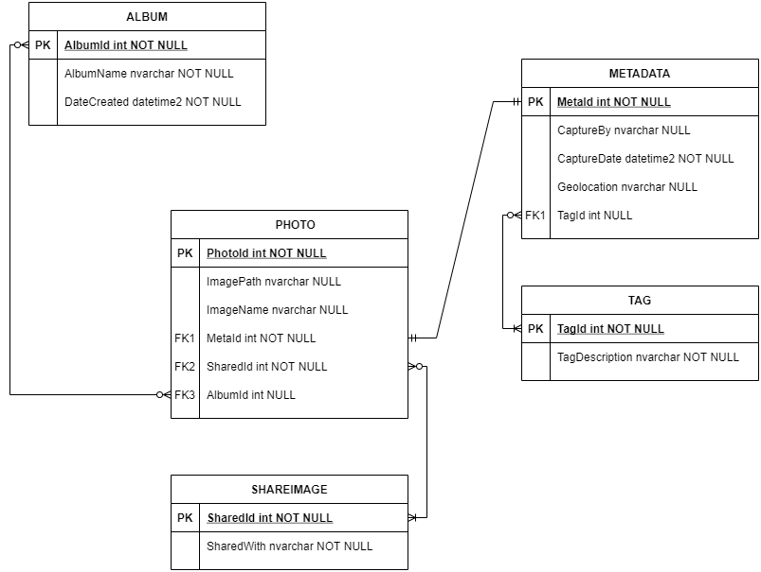

Figure 3‑1: Entity Relationship Diagram

Chapter 3 use case diagram (Chapter)

# Heading 1 won’t print. Don’t delete – doing so will lead to incorrect numbering.

## Explaining the uses of services

The use-case diagram depicts how the actors/users interact with the Web Application and how the services within the application interact with each other. The Web Application is hosted on Azure and makes use of the azure DB hosting and blob storage, thus all go through the Azure VM. The user interacts with the application through the HTML frontend in their browser. As mentioned, all services go to the Azure VM that contains all the controllers for the services. From here the controllers interacts with the DB and blob storage to retrieve the data and return it to the HTML page for the user.

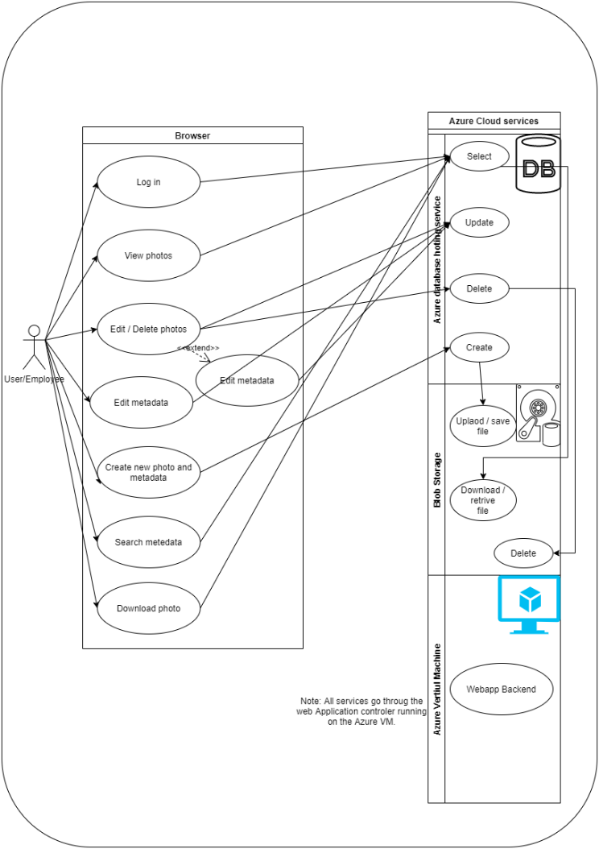

Figure 4‑1: Use Case Diagram

Chapter 4 DATA FLOW DIAGRAM (Chapter)

# Heading 1 won’t print. Don’t delete – doing so will lead to incorrect numbering.

## The logic flow

With the MVC architecture the business logic flow is sort of predetermined. The controllers are the heart of the logic flow and dictates the flow of logic to the different services and view. Input is received from a view and is relayed to the controller which redirects this data to the appropriate service that performs the necessary operations like DB queries and file handling. There after the controller redirects the results of the operation to the correct view and displays the data.

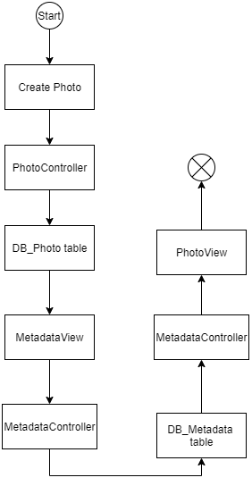

Figure 5‑1: Create logic flow

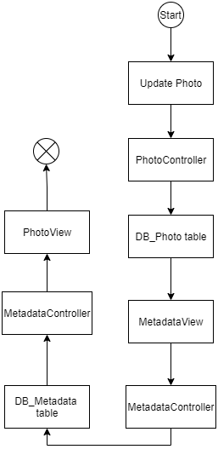

Figure 5‑2: Update logic flow

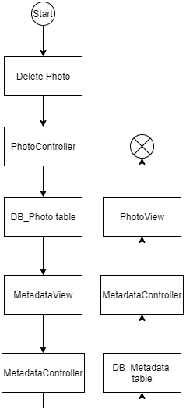

Figure 5‑3: Delete logic flow

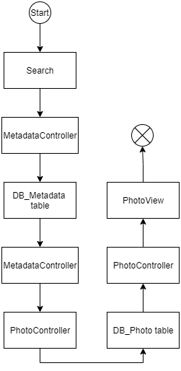

Figure 5‑4: Search logic flow

Chapter 5 user how-to guide (Chapter)

# Heading 1 won’t print. Don’t delete – doing so will lead to incorrect numbering.

## Heading 2

Create new photos

Navigate to Photos in the navigation bar at the top of the screen

Click on Create New

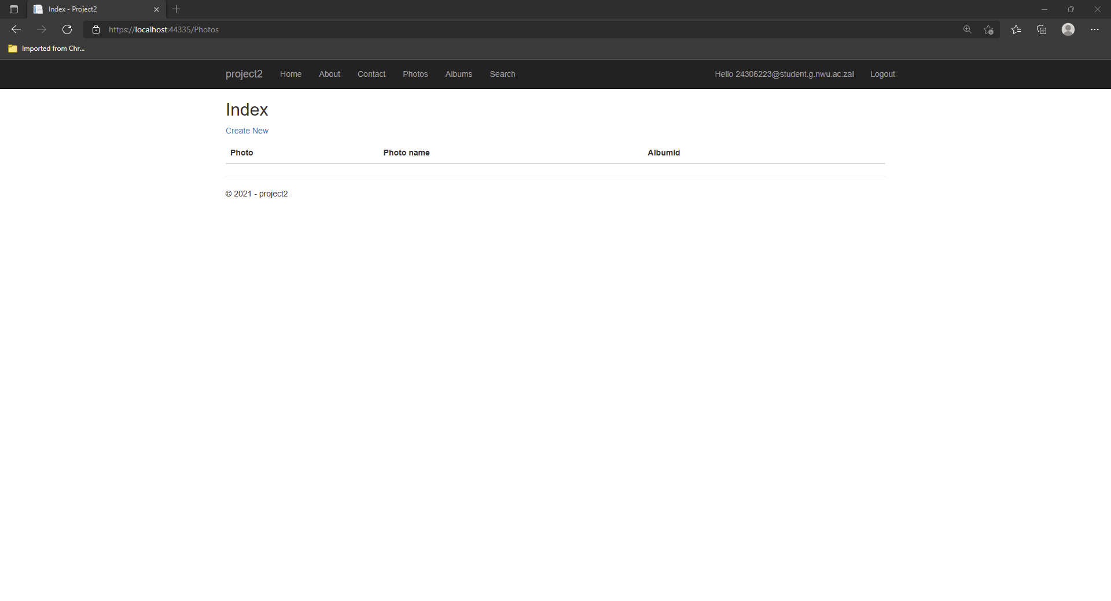

Figure 6‑1. Photo index page.

Select Choose file to upload the file

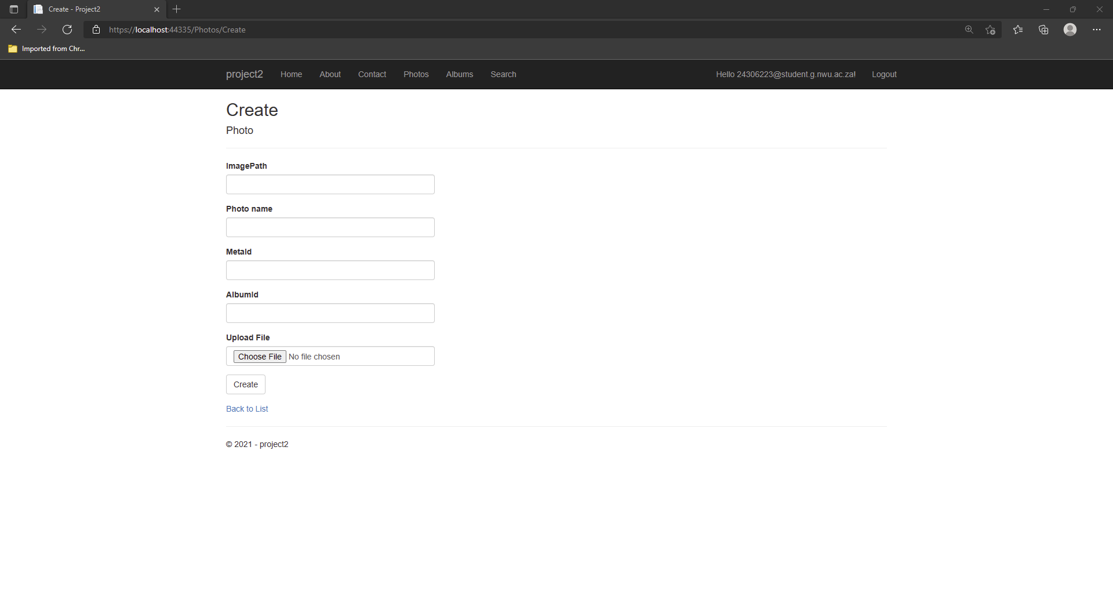

Figure 6‑2. Create photo page.

Click create

Enter metadata into the required fields

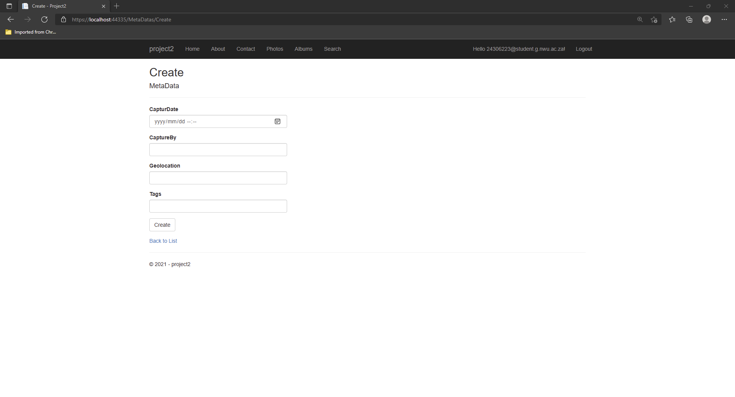

Figure 6‑3. Create metadata page.

Click on Create.

Editing (updating) photos or metadata

Navigate to Photos in the navigation bar at the top of the screen.

On the right-hand side of the screen, click on Edit.

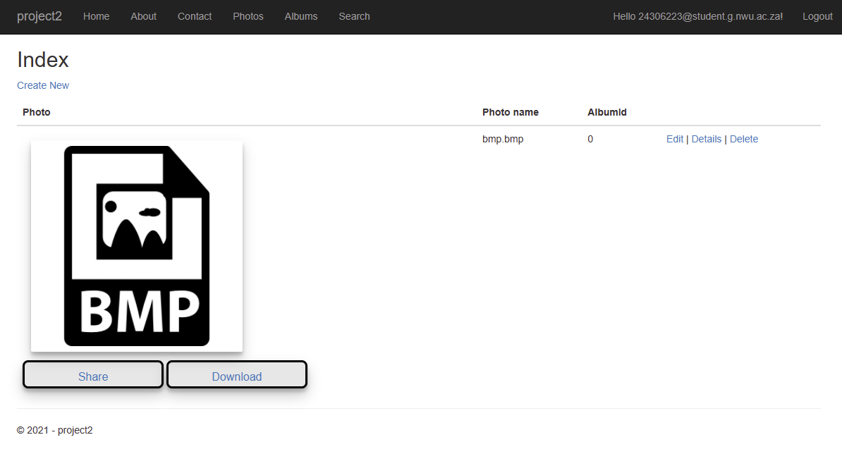

Figure 6‑4: Photo page- select Edit

Edit the desired fields.

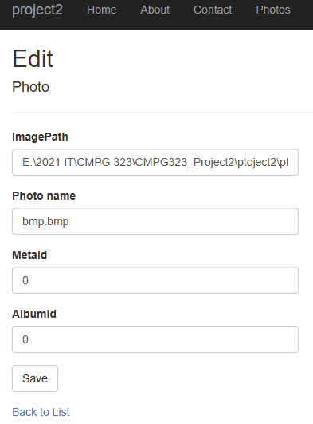

Figure 6‑5: Edit photo

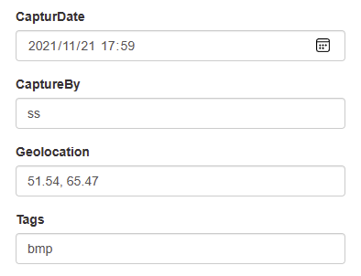

Figure 6‑6: Edit metadata

Click save

Deleting photos

Navigate to Photos in the navigation bar at the top of the screen.

On the right-hand side of the screen, click on Delete.



Figure 6‑7: Photo page - select Delete

Confirm delete action by clicking on delete again.

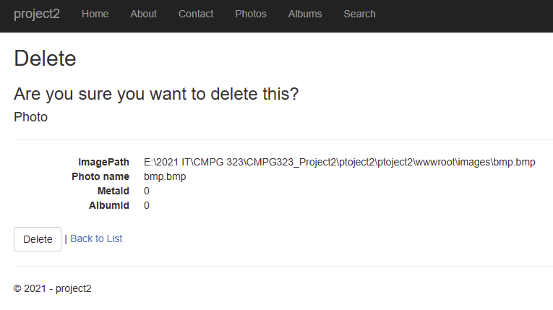

Figure 6‑8: Confirm Delete

Logging in

On the home page, click on Login at the top right-hand side of the navigation bar.

Enter your email address and password into the required fields.

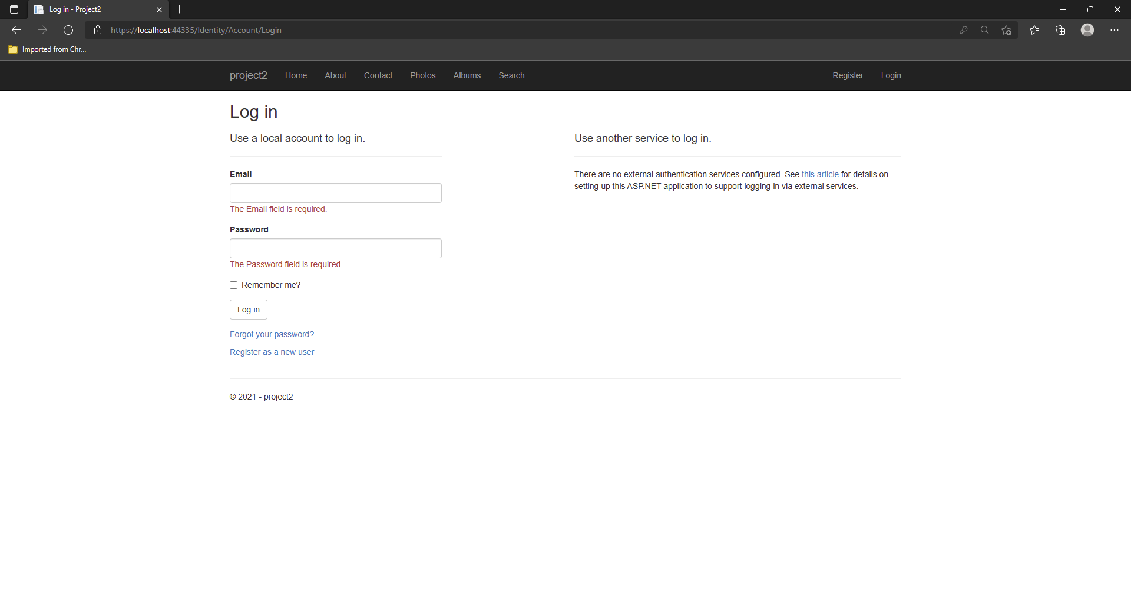

Figure 6‑9. Login page.

Click on Log in.

Searching for photos by metadata

Navigate to Search in the navigation bar at the top of the screen.

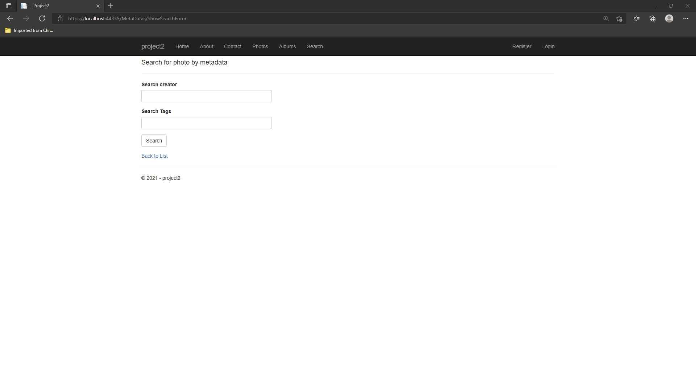

Figure 6‑10. Search page.

Fill in either or both of the required fields.

Click on Search.