Finovate
Complete Website Documentation & Visual Feature Guide
Version 1.0.0 · Last reviewed 2026-10-11
This document is generated from the live Finovate Django implementation. Screenshots use synthetic demo data. Investing features are simulated.

Contents
- 1. Product overview & architecture
- 2. Getting started
- 3. Feature inventory & routes
- 4. Authentication & account management
- 5. Core features (visual walkthroughs)
- 6. Workflows & business logic
- 7. Data model, API, integrations
- 8. Security, deployment, testing
- 9. Troubleshooting & glossary
- 10. Coverage matrix & audit notes

1. Product overview
Finovate is a personal-finance web app: track spending, plan budgets, pursue savings goals, receive a recommendation-only savings plan, and preview simulated round-up/ETF investing. Stack: Django 6.1, server-rendered templates, Decimal money math, SQLite or Postgres, Auth0 and/or Supabase Auth, optional Twelve Data and Photon Spectrum.

System context
- Browser → Django apps → ORM → SQLite/Postgres
- Auth0/Supabase for identity (passwords never stored in Finovate)
- Twelve Data for optional live demo quotes
- Spectrum webhook inbound; Django does not send iMessage

Apps
- core — landing, dashboard, insights, seeds
- accounts — profile, auth, onboarding, settings, /api/me/
- transactions — accounts, categories, transactions, statements
- budgets — periods, limits, income, recurring expenses, txn UI
- savings — goals, pools, plan engine, debts
- investing — simulated portfolio tools + market data
- imports — CSV wizard
- assistant — Spectrum intents/webhook

2. Getting started
Local setup:
- python -m venv .venv && source .venv/bin/activate
- pip install -r requirements.txt
- python manage.py migrate
- python manage.py seed_demo
- python manage.py runserver → http://127.0.0.1:8000/
Website signup/login require Auth0 and/or Supabase configuration. seed_demo creates a fixture user for management commands and documentation capture.
Copy .env.example to .env for secrets — never commit real values.

3. Feature inventory (high level)
- Public: landing, login, signup
- App: dashboard, insights, transactions, statements, imports
- Budgets: periods, limits, income, expenses, categories
- Savings: index, pools, goals, plan, debts
- Investing: portfolio, round-ups, surplus, demo AI, explore, historical demo
- Settings: theme, notifications, messaging link, placeholders
- APIs: GET /api/me/, POST /assistant/photon-webhook/, live-quotes JSON
Full path listing lives in docs/feature-inventory.md.

4. Authentication & accounts
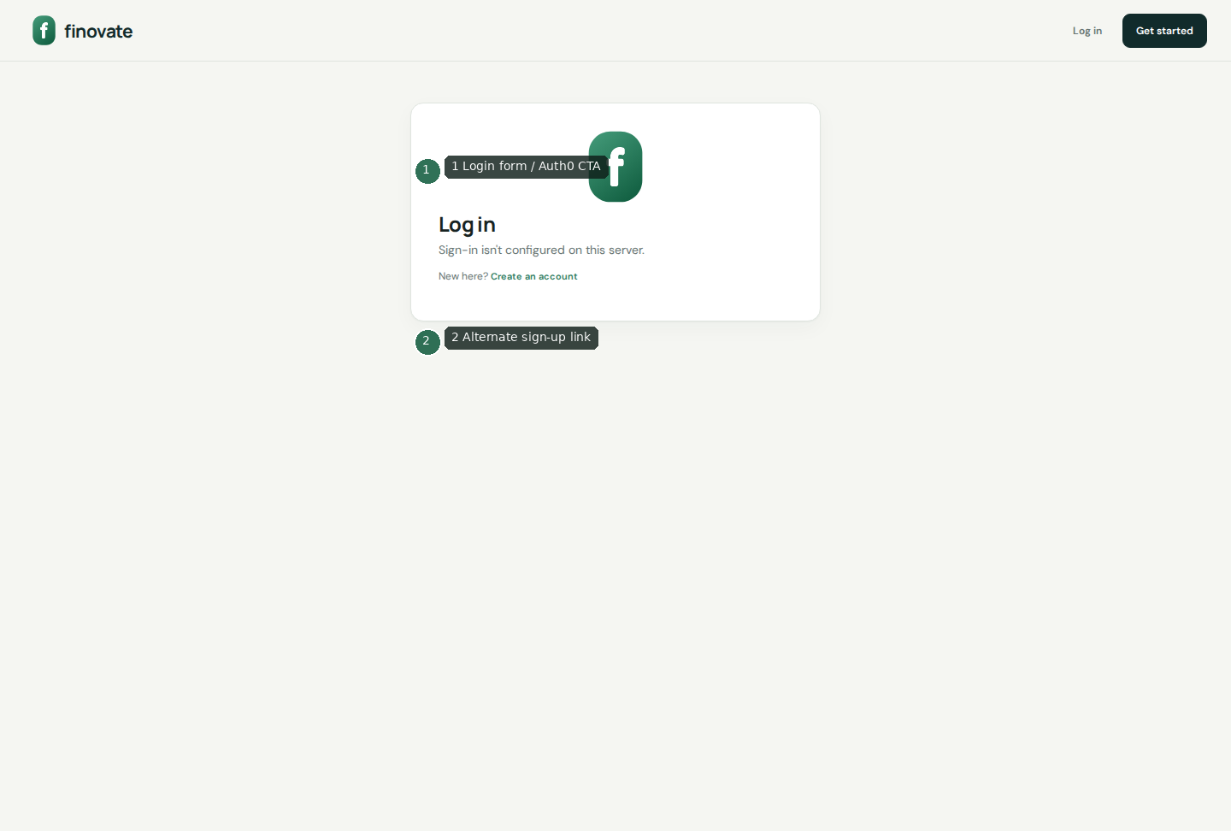
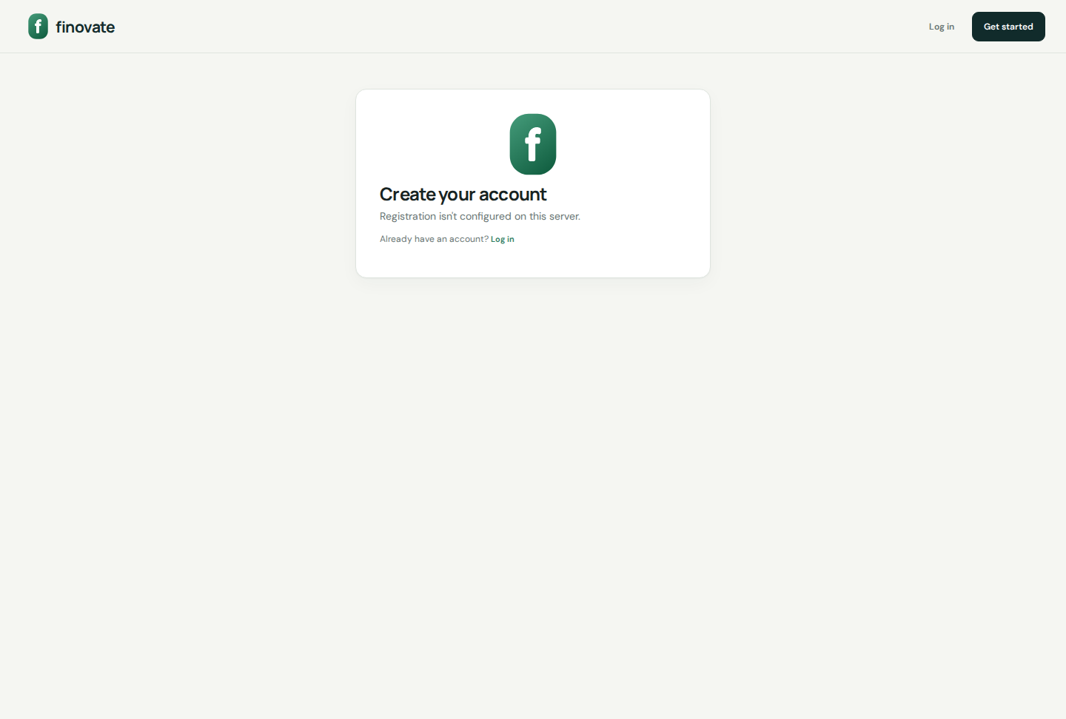
- Auth0: Universal Login; profile keyed by auth0_sub; /callback
- Supabase: email/password over HTTPS; profile keyed by supabase_uid
- Verify gate for unverified Auth0 emails
- Onboarding → optional CSV/manual setup → preferences
- Rate limits: signup 10/10m, login 20/10m, resend 3/15m
- Logout: Django session clear + Auth0 federated logout when applicable

5. Dashboard
Home of recorded cash, monthly flows, chart, recent transactions, and savings opportunity.
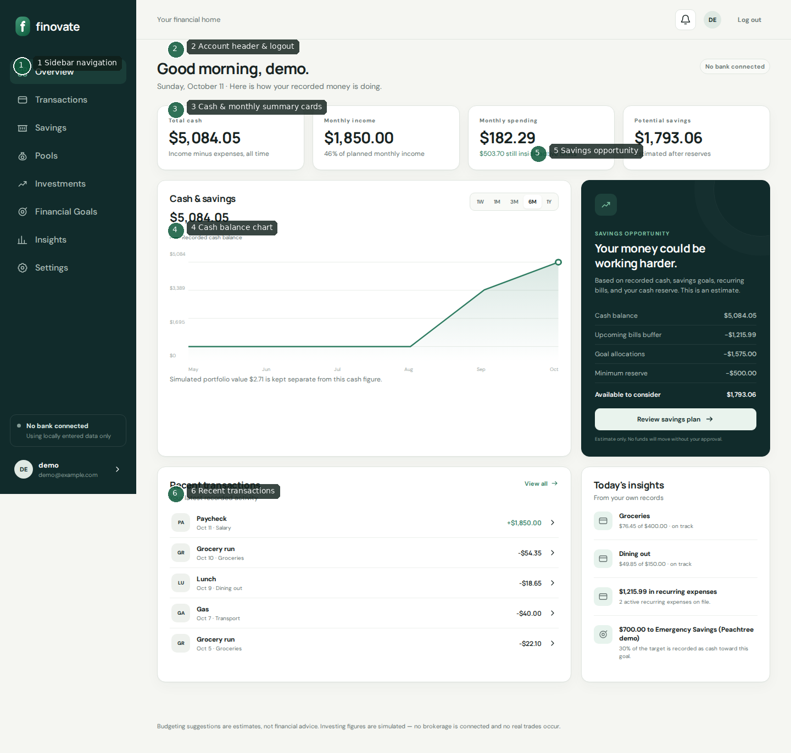
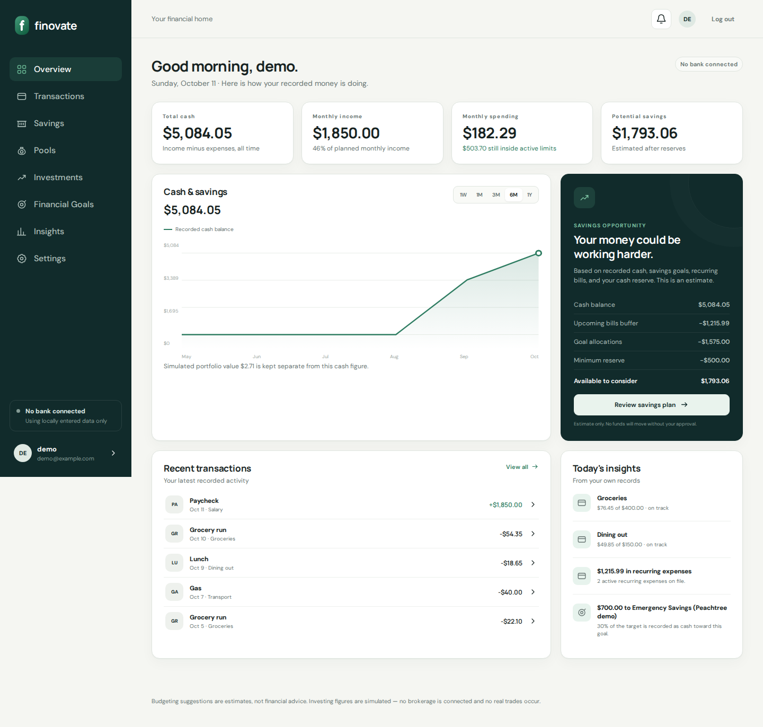
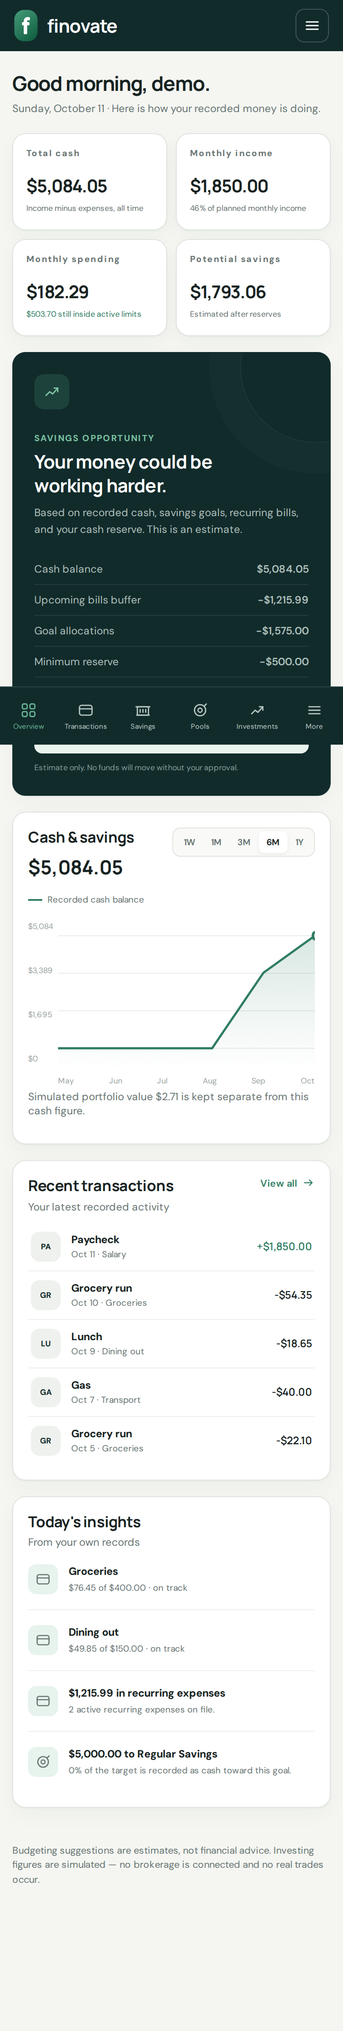
- Cards: total cash, monthly income, monthly spending, potential savings
- Chart ranges 1W–1Y; simulated portfolio called out separately
- CTA into savings plan; recent txn jump list

6. Transactions & statements
Manual CRUD, search, CSV export; fictional statement reconciliation demo.
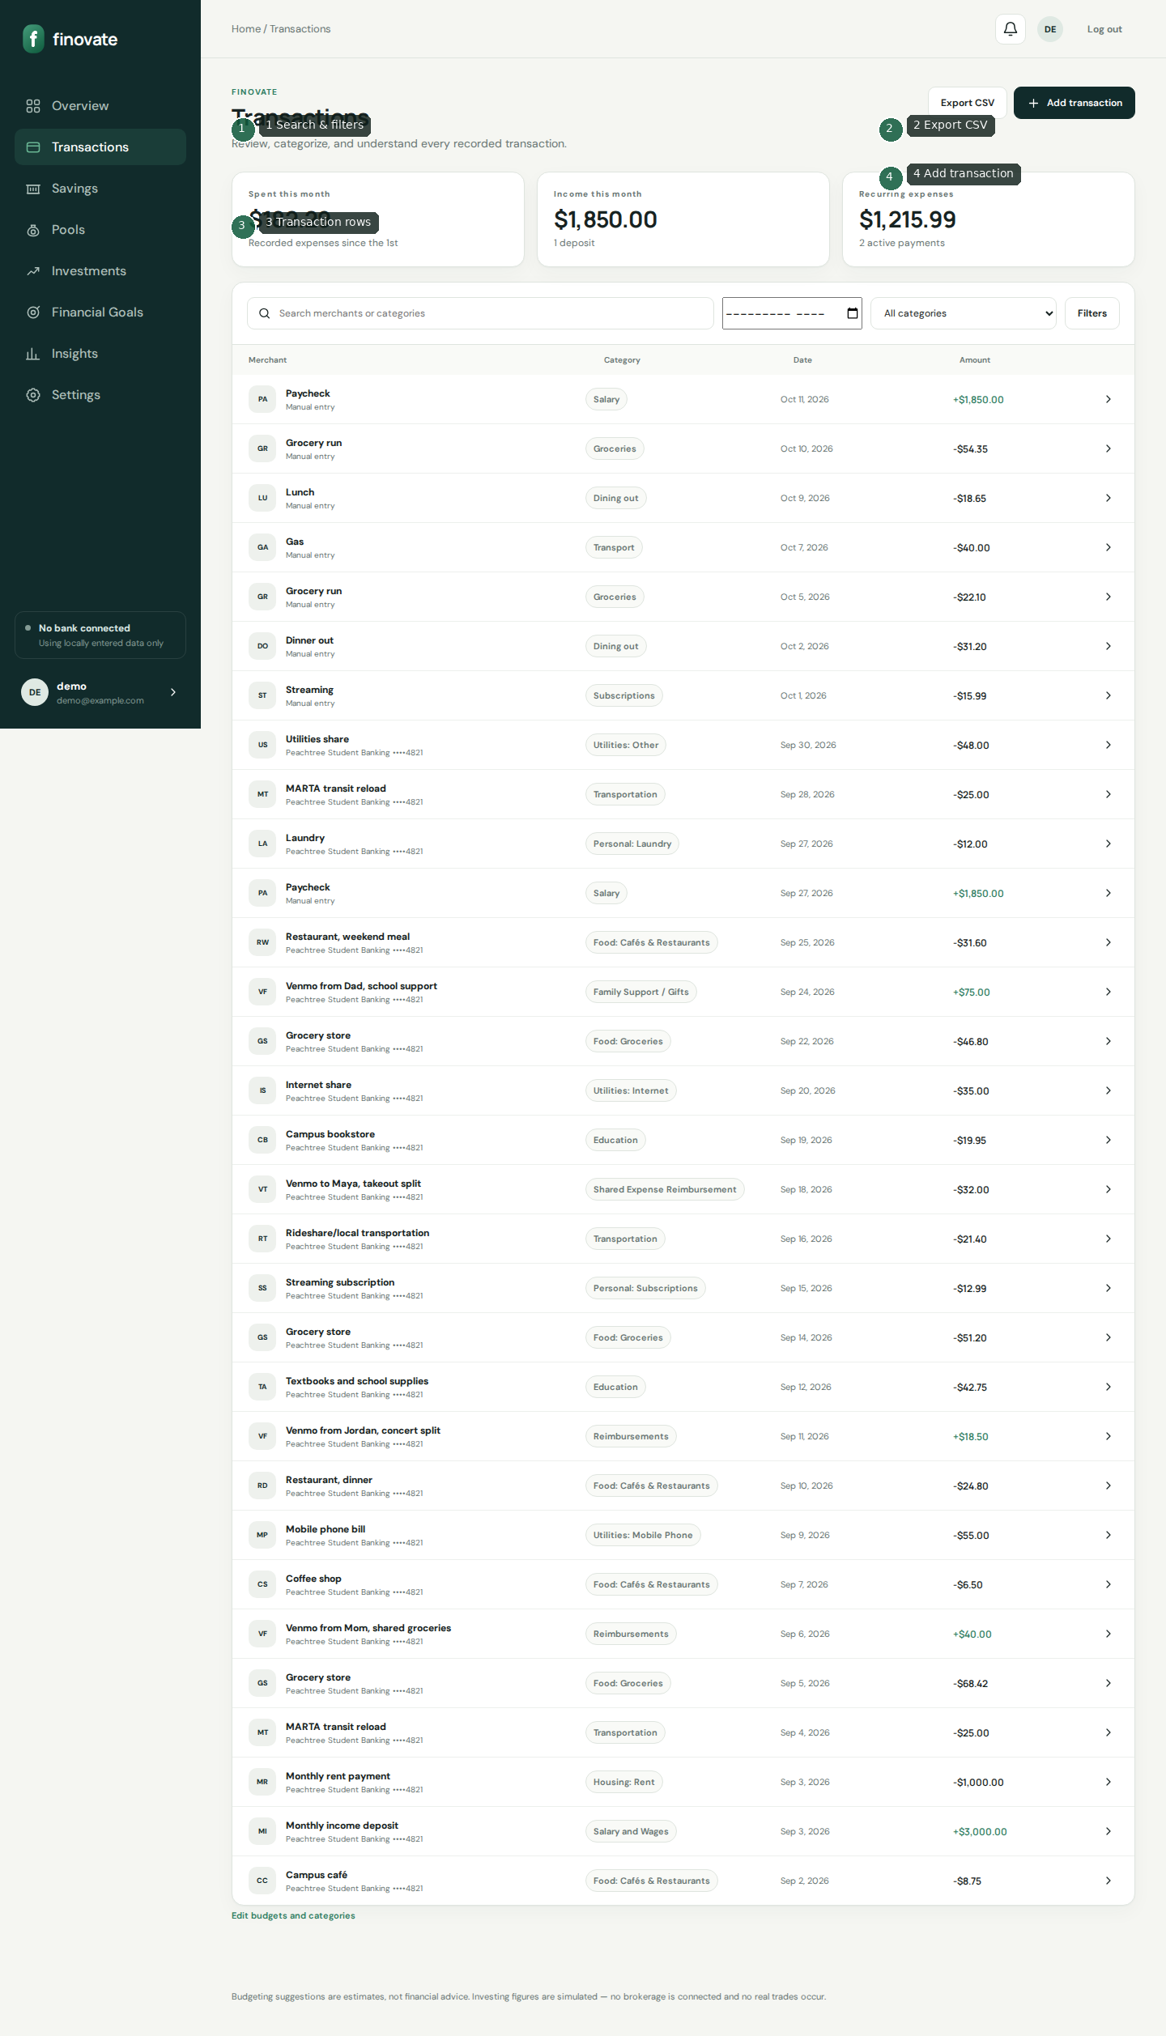
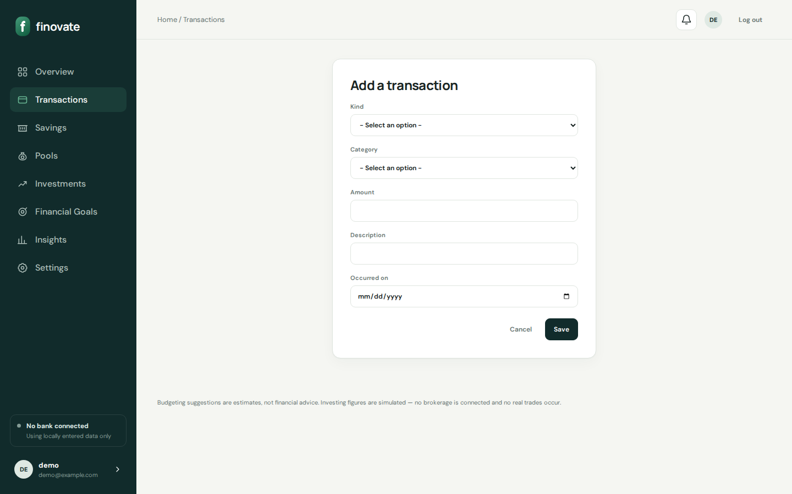
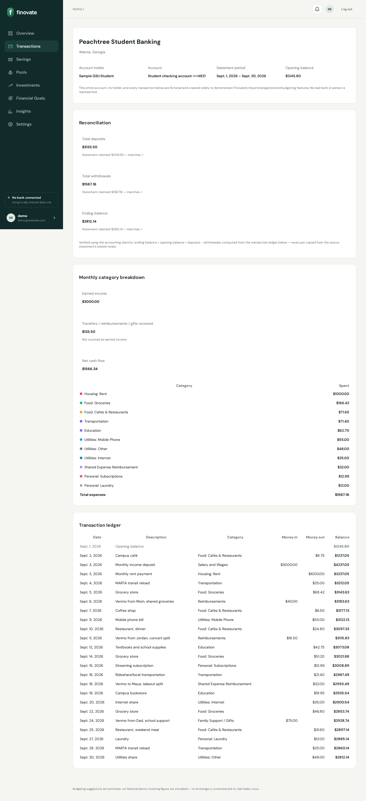
- Amounts stored positive; kind supplies sign
- Decimal ROUND_HALF_UP to 2 places
- Peachtree seed demonstrates ledger reconciliation

7. CSV import
Upload → account → preview → commit. Max 2MB CSV. No fabricated rows.
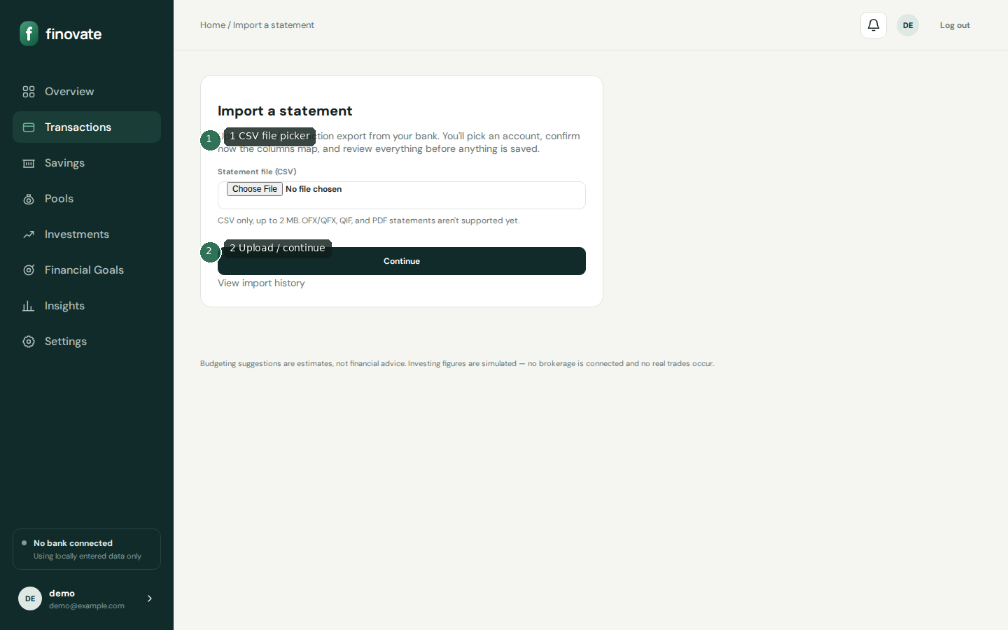
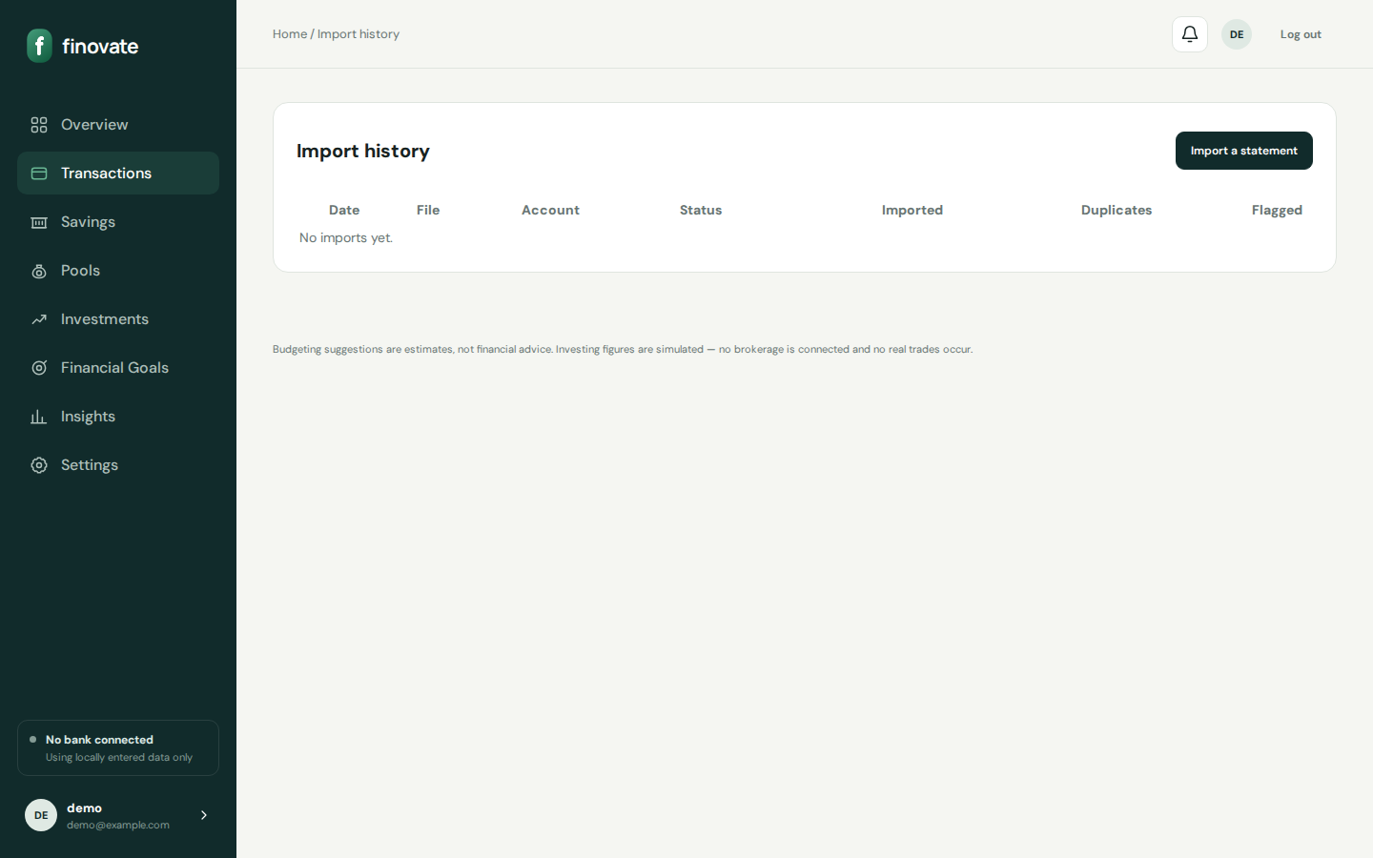
- ImportBatch tracks status and raw bytes
- Dedupe via fingerprints/external_id
- Unreadable files guide users to manual setup

8. Budgets
Live progress from transactions; income/expense plan estimates.
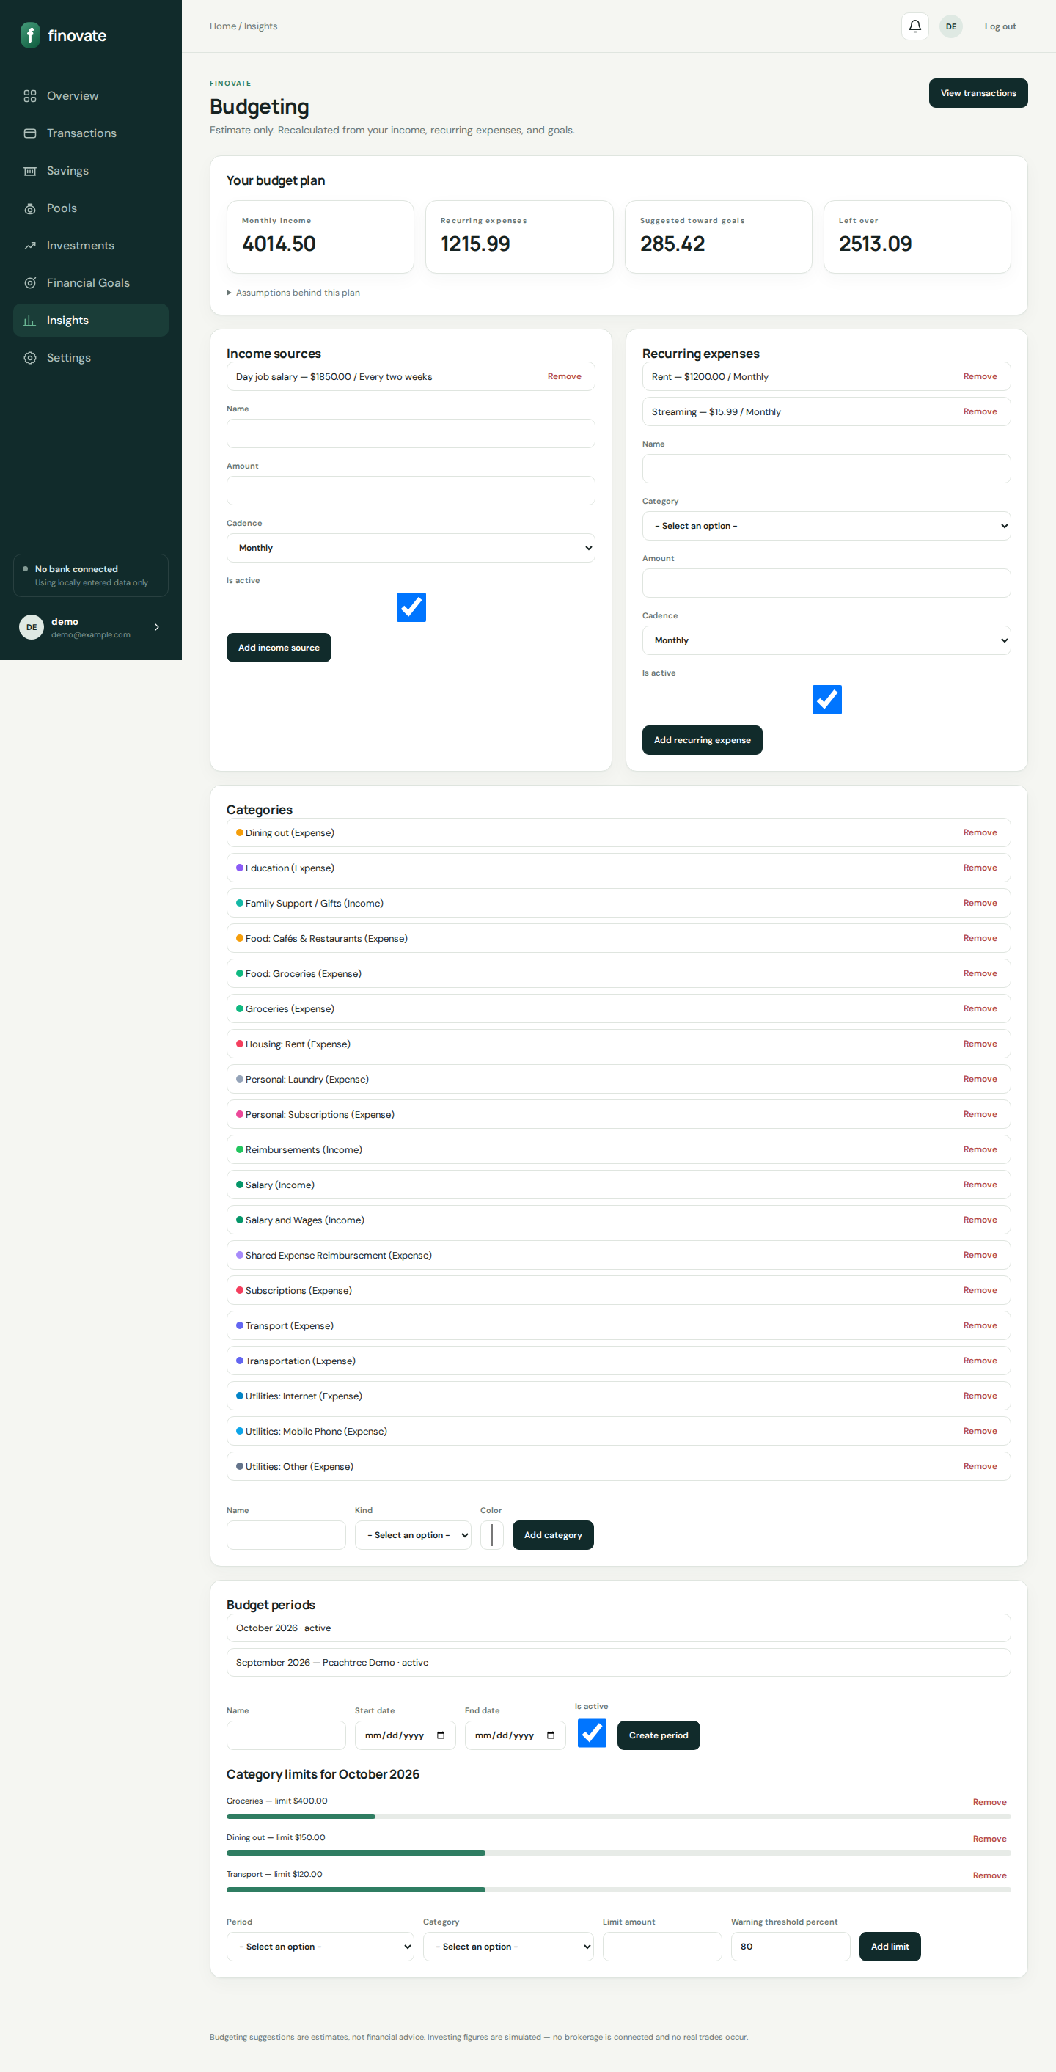
- spent = sum(expenses in period/category)
- warning/over from percent_used vs threshold
- Cadence factors weekly 4.33 / biweekly 2.17

9. Savings, pools, goals, plan
Goals with milestones; system pools; recommendation-only plan engine.
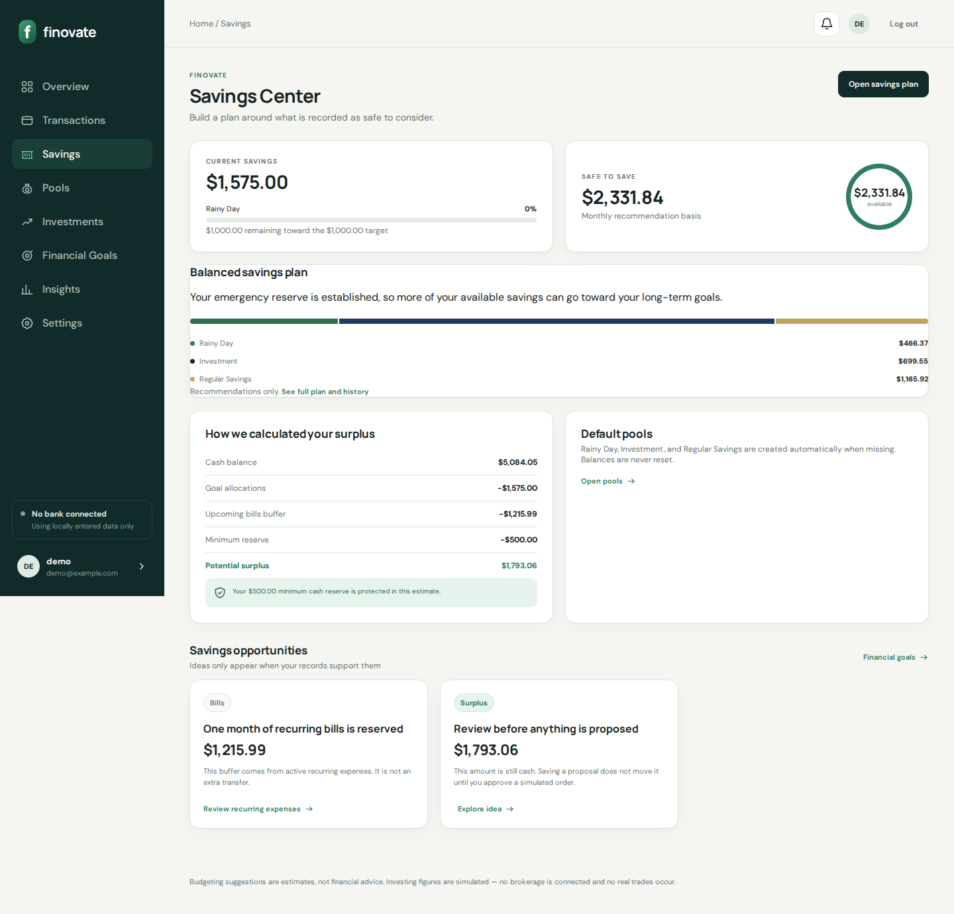
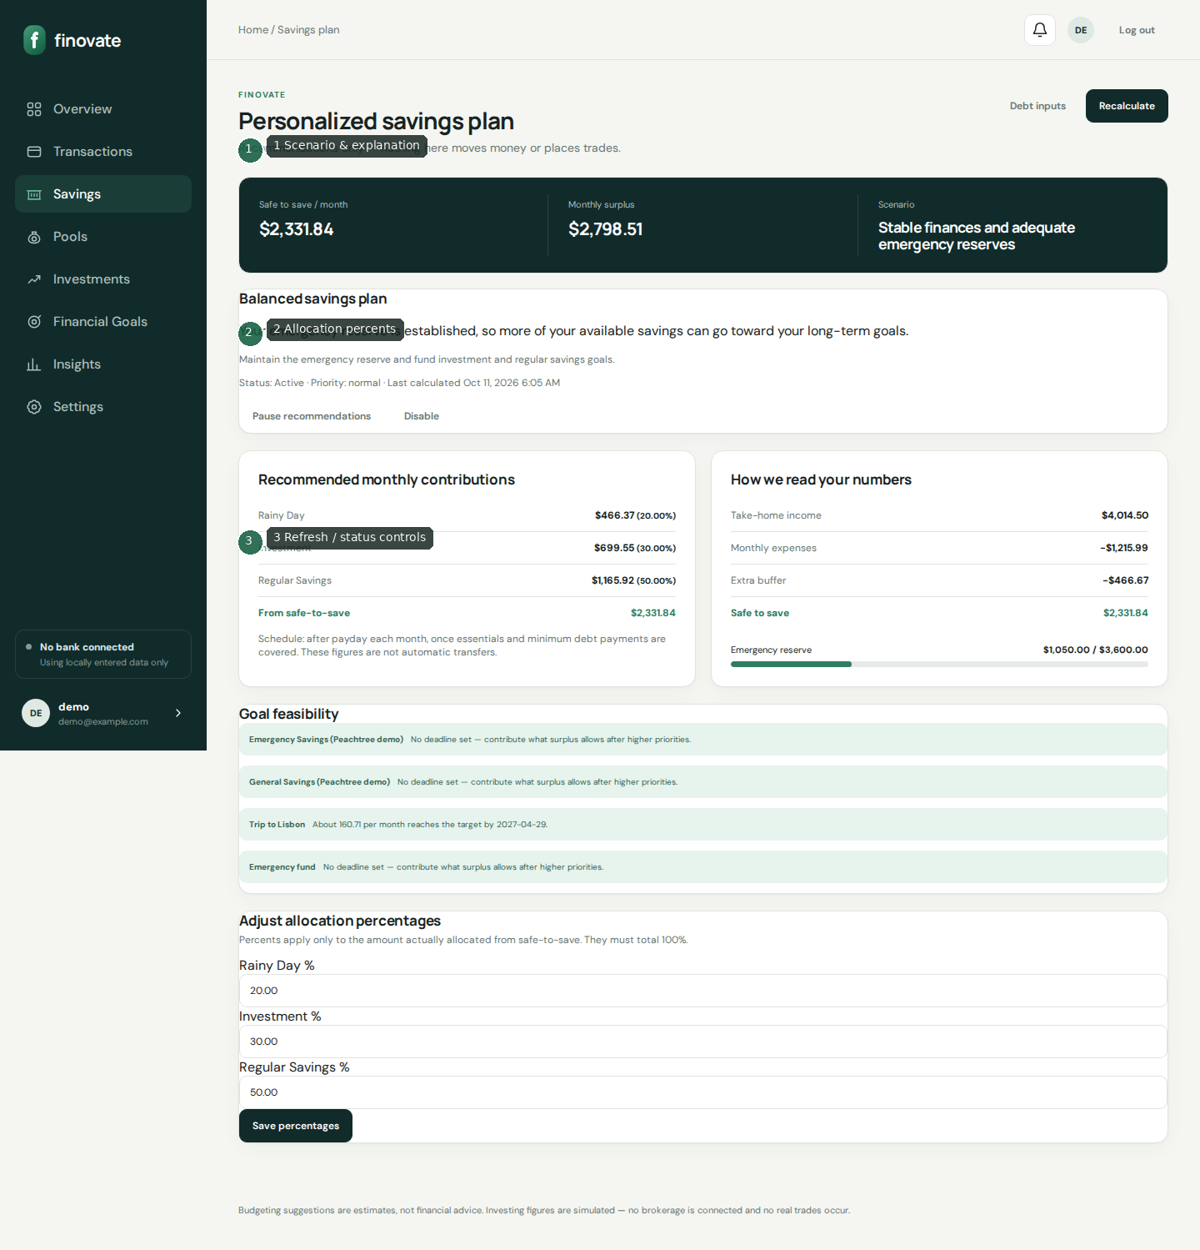
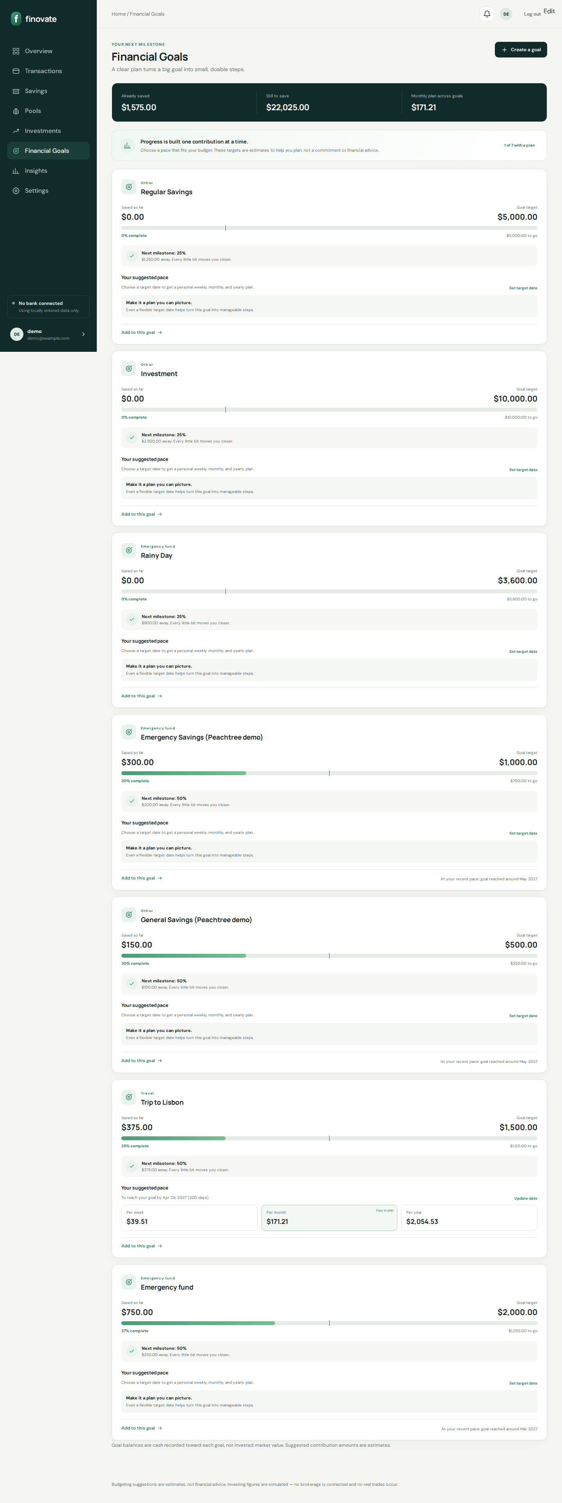
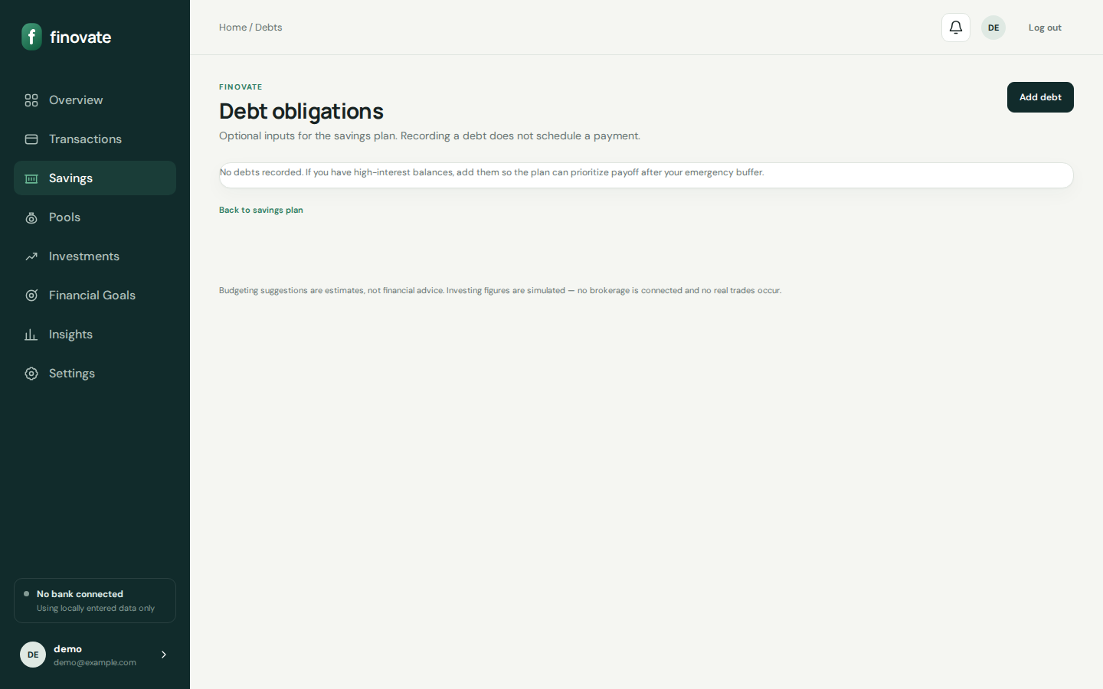
- Scenarios: stabilization, build_reserve, debt_focus, stable, strong
- Safe-to-save = max(0, surplus − buffer)
- Never moves money or places trades

10. Simulated investing
Round-ups, surplus proposals, demo AI, explore — all simulated.
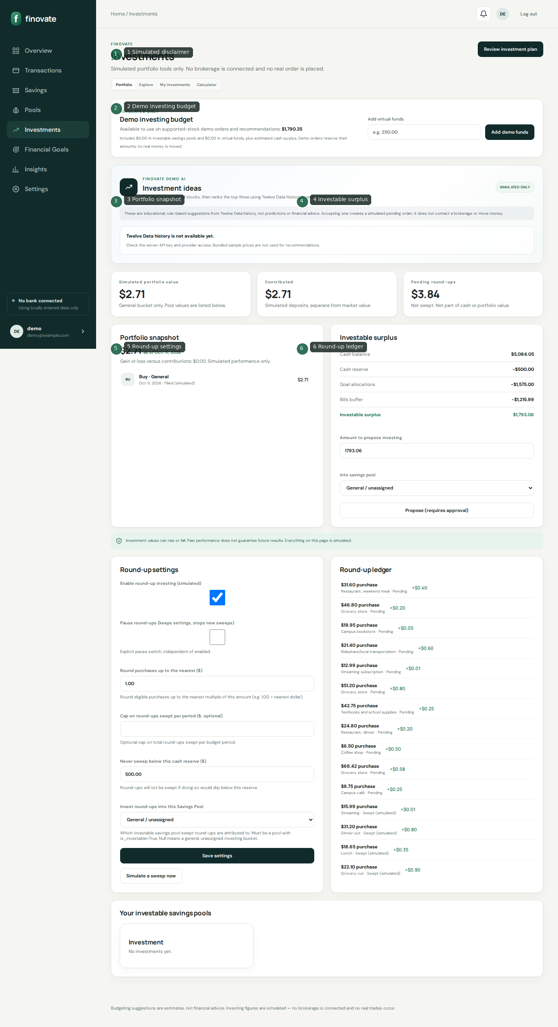
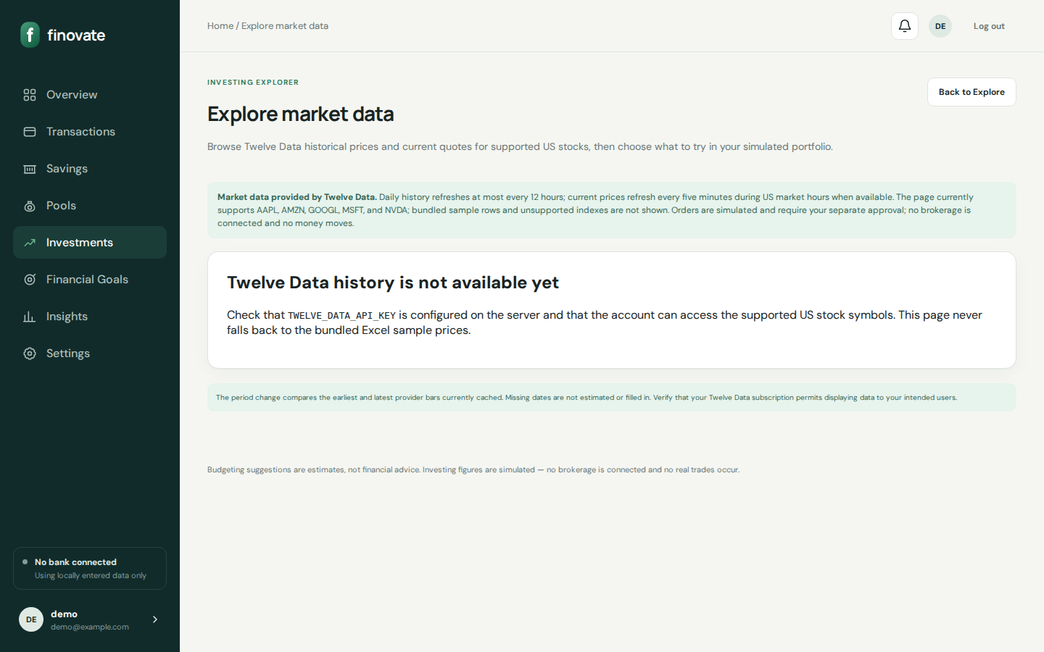
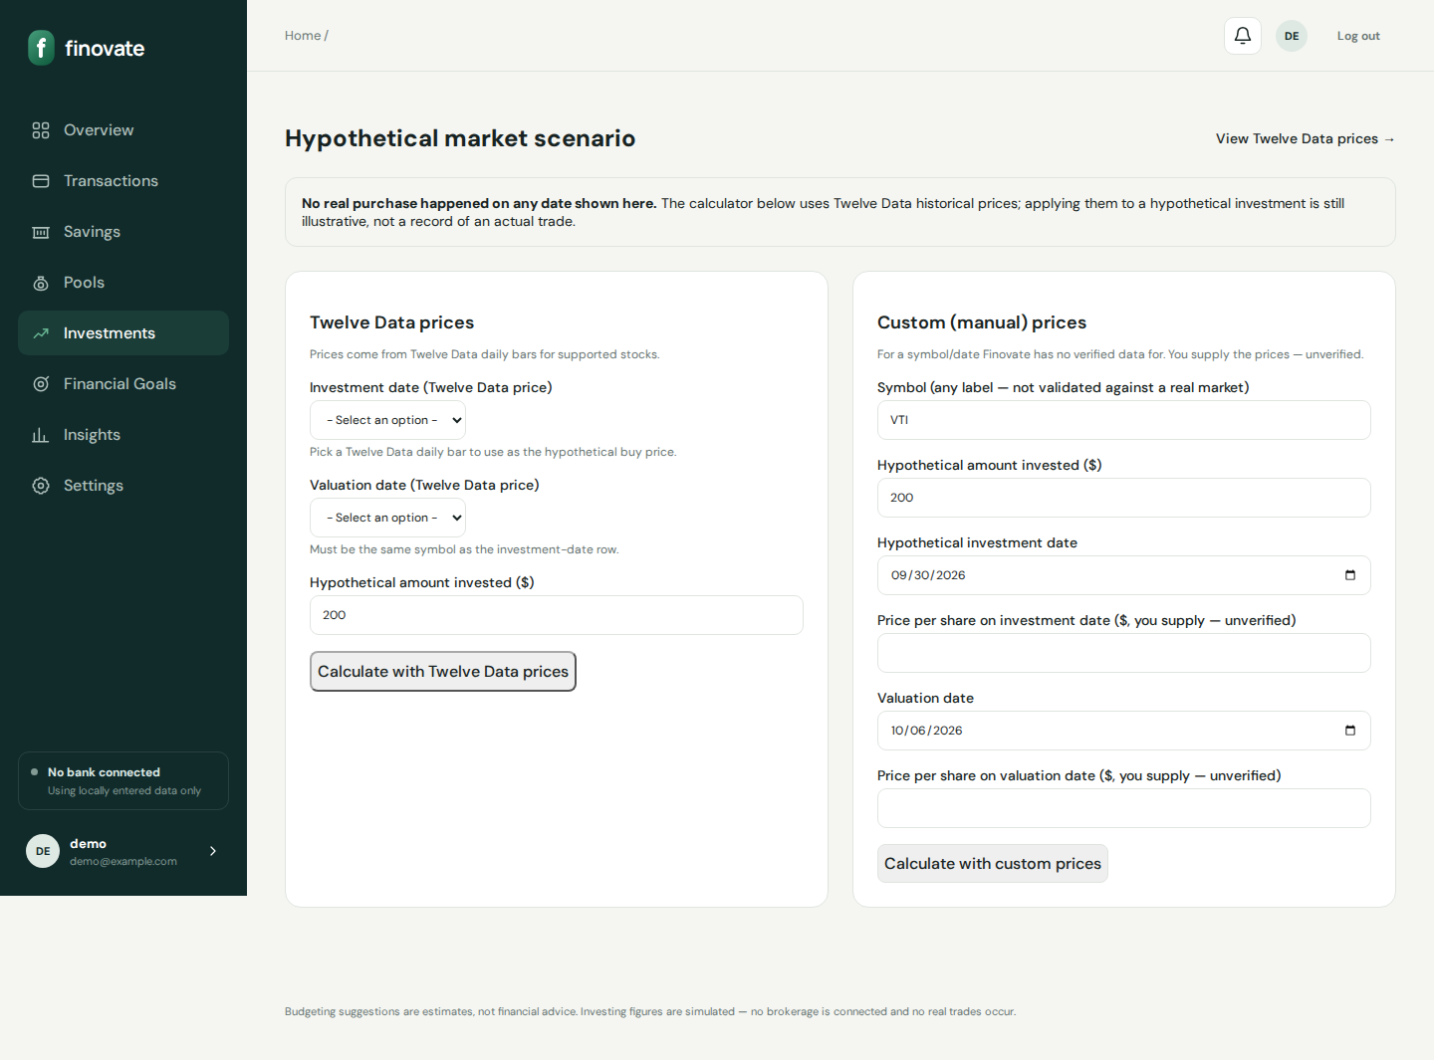
- Round-up example: $4.35 → $0.65 to nearest $1
- Sweep respects pause, cap, cash reserve
- Twelve Data optional for live quotes

11. Insights & settings
Analytics visuals; preferences, theme, messaging link, placeholders.
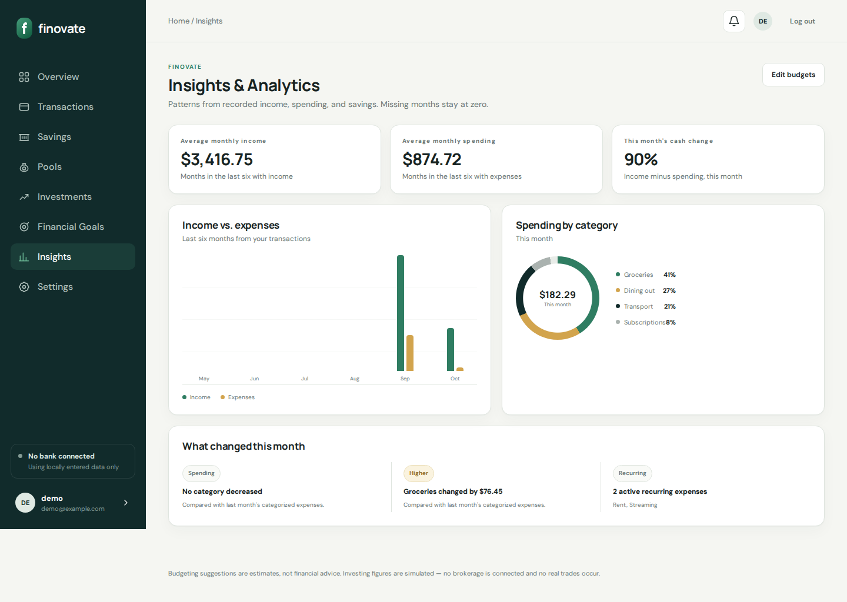
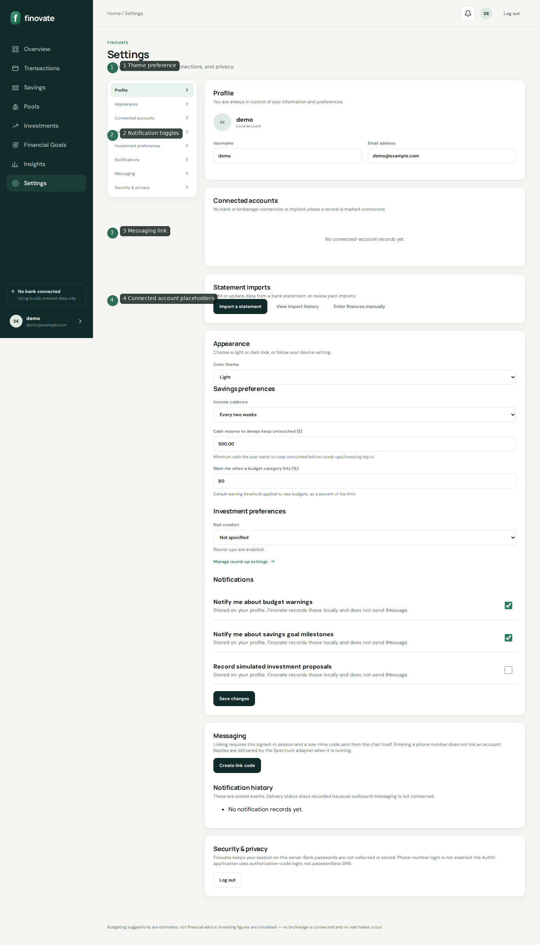
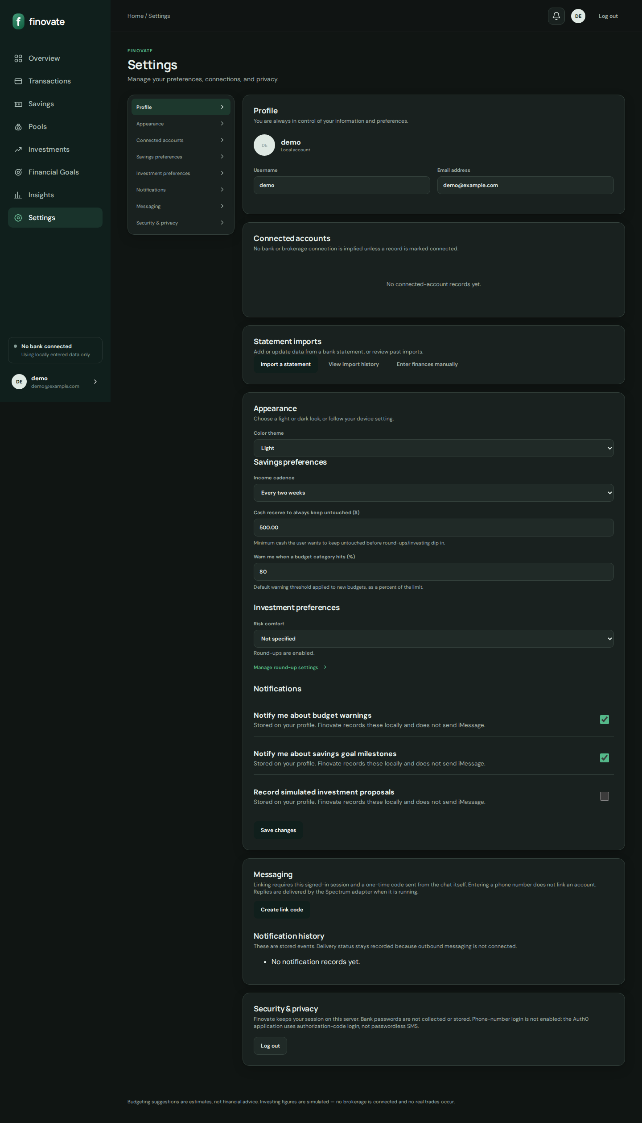
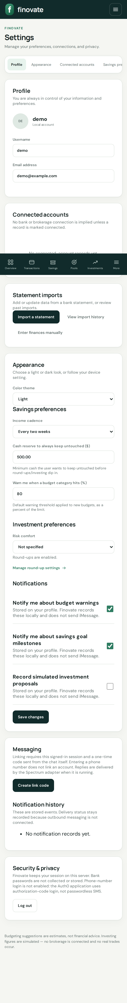
- Theme light/dark/system via data-theme
- Notification events recorded only
- Connected accounts are placeholders

12. Key workflows

Registration
- Signup → Auth0 or Supabase → profile create by subject/uid
- Verify if needed → onboarding → preferences → dashboard

Round-up sweep
- Enable settings → expenses create pending ledger → sweep → simulated portfolio update

Savings plan refresh
- analyze_finances → choose_scenario → build_recommendation → persist if material change

13. Data, API, integrations
Primary models: Profile, Transaction, Category, Account, Budget*, Goal, Contribution, DebtObligation, SavingsPlan*, ImportBatch, RoundUp*, SimulatedOrder, MarketPrice, assistant models.
JSON APIs: GET /api/me/; POST /assistant/photon-webhook/; investing live-quotes endpoints. Other mutations are CSRF-protected form posts.
- Auth0 / Supabase Auth / Postgres
- Twelve Data (optional)
- Photon Spectrum inbound
- Bank/Brokerage keys: placeholders only

14. Security, deployment, testing
- Security: IdP auth, CSRF, user-scoped queries, rate limits, webhook signatures, JWT for /api/me/
- Deploy: Vercel Django (vercel.json), migrate on boot, prefer Postgres
- Test: python manage.py test — broad unit/integration coverage across apps

15. Troubleshooting (selected)
- Login unavailable → configure Auth0/Supabase
- Callback errors → APP_BASE_URL / Auth0 URL mismatch
- Vercel data loss → use Postgres not /tmp SQLite
- Twelve Data warnings → key/credits
- Investing not in real brokerage → expected (simulated)

16. Coverage & audit summary
All major product surfaces listed in docs/coverage-matrix.md have Markdown specs and screenshot coverage except webhook-only assistant (no page) and external Auth0 hosted UI. Discrepancies (README test count/stack wording, undelivered notifications, echo Spectrum sidecar, client-only review modal) are reported in docs/audit-report.md without changing production behavior.
Definition of done: a new developer can set up, trace architecture/processes, test, and troubleshoot; an end user can operate major features via instructions and visuals.

