JAVA REVIEW – 2

Write a Java program to read an integer input from the user and find its prime factors. Display the prime factorization in powers format.

# PSEUDOCODE:

BEGIN

CREATE a scanner object for user input

DISPLAY “Enter the input number”

READ input number

DISPLAY “The Prime Factors are”

DECLARE a LinkedHashMap with <Integer, Integer> to store the prime factors and its frequencies

WHILE input is DIVISIBLE by 2

ADD 2 as a key to the map and increment its frequency

DIVIDE input by 2

END WHILE

FOR value from 3 to input, incrementing by 2

WHILE input is divisible by value

ADD value as a key to the map and increment its frequency

DIVIDE input by value

END WHILE

END FOR

IF input > 2 THEN

ADD input as a key to the map with frequency 1

END IF

FOR Each entry in object:

DISPLAY key followed by “^” followed by value and “ ”

END FOR

END

# ALGORITHM:

1. START
2. INITIALIZE the scanner to read the input from the user.
3. Prompt the user to DISPLAY “Enter the input number:”
4. And next READ the input number in a variable “input”
5. DISPLAY the message “The Prime Factors are:”
6. CREATE a LinkedHashMap<Integer, Integer> called object to store the prime factors and their frequencies
7. Handling factor 2:
   1. WHILE input is divisible by 2
      1. IF 2 is already a key in the object, increase its frequency by 1.
      2. ELSE add 2 to object with frequency 1
      3. DIVIDE the value by 2
8. Handling odd factors:
   1. FOR value from 3 to input
      1. WHILE input is divisible by value
         1. If the value is already a key in the object, increase its frequency by 1.
         2. ELSE add value to object with frequency 1
         3. DIVIDE the value by 2
9. Handle remaining prime:
   1. If input is greater than 2
      1. ADD input to object with frequency 1
10. To DISPLAY results:
    1. For each entry (key, frequency) in object:
       1. DISPLAY key ^ frequency followed by a space
11. STOP

# FLOW CHART:

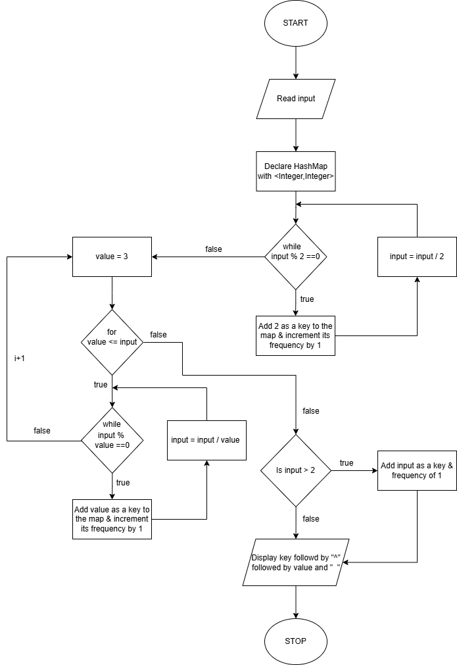

# PROGRAM:

import java.util.Map;

import java.util.LinkedHashMap;

import java.util.Scanner;

public class PrimeFactorization

{

public static void main (String[] args)

{

Scanner scanner = new Scanner(System.in);

System.out.print(“Enter the input number: ”);

int input = scanner.nextInt();

Map<Integer, Integer> object = new LinkedHashMap<Integer, Integer>();

System.out.println(“The prime factors are: ”);

while(input % 2 == 0)

{

object.put(2, object.getOrDefault(2, 0) +1);

input = input / 2;

}

for(int value = 3 ; value <= input ; value +=2)

{

while(input % value == 0)

{

object.put(value, object.getOrDefault(value, 0) +1);

input = input / value;

}

}

if(input > 2)

{

Object.put(input , 1);

}

for (Map.Entry<Integer , Integer> entry : object.entrySet())

{

System.out.print(entry.getKey() + “^” + entry.getValue() + “ ” +);

}

}

}