* ***HealthAI: Intelligent Healthcare Assistant Using IBM Granite***

**Team ID : LTVIP2025TMID32705**

**Team Leader : Bhodanapu Ramanjaneyulu**

**Team member : Chekka Simhadri**

**Team member : Dayaka Dinesh Kumar**

**Team member : Kotana Karthik**

Project Description:

HealthAI harnesses IBM Watson Machine Learning and Generative AI to provide intelligent healthcare assistance, offering users accurate medical insights. The platform includes a Patient Chat for answering health-related questions, Disease Prediction that evaluates user-reported symptoms to deliver potential condition details, Treatment Plans that provide personalized medical recommendations, and Health Analytics to visualize and monitor patient health metrics.

Utilizing IBM's Granite-13b-instruct-v2 model, HealthAI processes user inputs to deliver personalized and data-driven medical guidance, improving accessibility to healthcare information. Built with Streamlit and powered by IBM Watson, the platform ensures a seamless and user-friendly experience. With secure API key management and responsible data handling, HealthAI empowers users to make informed health decisions with confidence.

**Scenarios:**

Scenario 1: A user inputs their symptoms into the Disease Prediction system, describing issues like persistent headache, fatigue, and mild fever. The system analyzes the symptoms along with the patient's profile and health data to provide potential condition predictions, including likelihood assessments and recommended next steps.

Scenario 2: A user needs personalized treatment recommendations for a diagnosed condition. By entering their condition in the Treatment Plans generator, the AI processes the information along with patient data to create a comprehensive, evidence-based treatment plan that includes medications, lifestyle modifications, and follow-up testing.

Scenario 3: A user wants insights about their health trends. Using the Health Analytics dashboard, they can visualize their vital signs over time (heart rate, blood pressure, blood glucose, etc.) and receive AI-generated insights about potential health concerns and improvement recommendations.

Scenario 4: A user has a health-related question. Through the Patient Chat interface, they can ask any medical query and receive a clear, empathetic response that includes relevant medical facts, acknowledges limitations, and suggests when to seek professional medical advice.

### Technical Architecture:

**The emergence of artificial intelligence (AI) in healthcare has been groundbreaking, reshaping the way we diagnose, treat and monitor patients. This technology is drastically improving healthcare research and outcomes by producing more accurate diagnoses and enabling more personalized treatments. AI in healthcare’s ability to analyze vast amounts of clinical documentation quickly helps medical professionals identify disease markers and trends that would otherwise be overlooked. The potential applications of AI and healthcare are broad and far-reaching, from scanning radiological images for early detection to predicting outcomes from** [**electronic health records**](https://www.foreseemed.com/blog/ehr-software-and-interoperability)**. By leveraging artificial intelligence in hospital settings and clinics, healthcare systems can become smarter, faster, and more efficient in providing care to millions of people worldwide. Artificial intelligence in healthcare is truly turning out to be the future – transforming how patients receive quality care while mitigating costs for providers and improving health outcomes.**

### https://lh7-rt.googleusercontent.com/docsz/AD_4nXcZJ4ngA2Pz9gZ9PjzzuoZMt-ehvfFdCX8sj99dcFuzSVWat2X-PHvPn7Vmw87naxVJuu5zJA9VjjROyYBd8f5pPheFKGBlSXOuSsm6O1b-uPe2uyOJfV8PkvlvuFXdTJsL9V-H?key=xK92Xra24GI-Oi3NurUN5t0n

### Pre-requisites:

1. **Streamlit Framework Knowledge:**[**Streamlit Documentation**](https://docs.streamlit.io/)
2. **IBM Watson Machine Learning:**[**IBM Watson ML Documentation**](https://www.ibm.com/docs/en/watson-studio/1.2.0?topic=models-watson-machine-learning)
3. **Python Programming Proficiency:**[**Python Documentation**](https://docs.python.org/3/)
4. **Data Visualization Libraries:**[**Plotly Documentation**](https://plotly.com/python/)
5. **Version Control with Git:**[**Git Documentation**](https://git-scm.com/doc)
6. **Development Environment Setup:**[**Flask Installation Guide**](https://www.google.com/search?q=Development+Environment+Setup%3A+Flask+Installation+Guide&oq=Development+Environment+Setup%3A+Flask+Installation+Guide&gs_lcrp=EgZjaHJvbWUyBggAEEUYOdIBBzM0MmowajSoAgCwAgA&sourceid=chrome&ie=UTF-8)

### project workflow:

#### Activity 1: Model Selection and Architecture

* Activity 1.1: Research and select the appropriate AI model from IBM Watson for medical assistance (IBM Granite 13B Instruct v2).
* Activity 1.2: Define the architecture of the application, detailing interactions between the frontend, backend, and AI integration.
* Activity 1.3: Set up the development environment, installing necessary libraries and dependencies for Streamlit and IBM Watson ML.

#### Activity 2: Core Functionalities Development

* Activity 2.1: Develop the core functionalities: Patient Chat, Disease Prediction, Treatment Plan Generation, and Health Analytics.
* Activity 2.2: Implement patient data utilities to manage and visualize health metrics.

Activity 3: App.py Development

* Activity 3.1: Write the main application logic in app.py, establishing functions for each feature and integrating AI responses.
* Activity 3.2: Create prompting strategies for the IBM Granite model to generate high-quality medical content.

#### Activity 4: Frontend Development

* Activity 4.1: Design and develop the user interface using Streamlit components, ensuring a responsive and intuitive layout.
* Activity 4.2: Create dynamic visualizations with Plotly to display health metrics and trends.

#### Activity 5: Deployment

* Activity 5.1: Prepare the application for deployment by configuring environment variables for API credentials.
* Activity 5.2: Deploy the application on a suitable hosting platform to make it accessible to users.

### Milestone 1: Model Selection and Architecture:

In this milestone, we focus on selecting the appropriate AI model from IBM Watson for our medical assistance needs. This involves researching the capabilities and performance of various models, ensuring that the chosen model aligns well with our application's objectives of creating a Patient Chat system, Disease Prediction, Treatment Plan Generation, and Health Analytics.

**Research and select the appropriate AI model**

1. Understand the Project Requirements: Review the specific needs of the healthcare application.
2. Explore IBM Watson ML Documentation: Examine the various models available, including their functionalities and limitations.
3. Select the Optimal Model: Choose IBM's Granite 13B Instruct v2 model for its strong performance with healthcare-related content.

#### Activity 1.2: Define the architecture of the application

1. Draft an Architectural Diagram: Create a visual representation of the application architecture.
2. Detail Frontend Functionality: Outline how users will interact with the application through a Streamlit interface.
3. Outline Backend Responsibilities: Specify how the backend will process user input and communicate with the IBM Granite model.
4. Describe AI Integration Points: Define how the application will make API calls to IBM Watson ML.

#### Activity 1.3: Set up the development environment

1. Install Python and Pip: Ensure Python is installed along with pip for managing dependencies.
2. Create a Virtual Environment: Set up a virtual environment to isolate project dependencies.
3. Install Required Libraries:  
   pip install streamlit pandas numpy plotly ibm-watson-machine-learning python-dotenv
4. Set Up Application Structure: Create the initial directory structure for the HealthAI application.

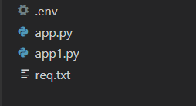

### Milestone 2: Core Functionalities Development

This Milestone contains about Core Functionalities Development.

### Develop core functionalities

#### Activity 2.1: Develop core functionalities

1. Patient Chat System:
   * Implement conversational interface for answering health questions
   * Create prompting system for the IBM Granite model to provide medical advice
   * Develop session-based chat history management
2. Disease Prediction System:
   * Create symptom input interface
   * Develop prediction function using patient data and reported symptoms
   * Structure output format to show potential conditions with likelihood and next steps
3. Treatment Plan Generator:
   * Build input interface for condition and patient details
   * Create prompting system for personalized treatment plans
   * Structure output to include medications, lifestyle changes, and follow-up care
4. Health Analytics Dashboard:
   * Implement patient data visualization with interactive charts
   * Create metrics summary with trend indicators
   * Develop AI-generated insights based on health trends

#### Activity 2.2: Implement data management utilities

1. Patient Data Generation:
   * Create sample data with realistic health metrics
   * Implement date-based trend generation for visualization
   * Structure data for efficient analysis and display
2. Patient Profile Management:
   * Develop interface for managing patient details
   * Create session state handling for persistent data
   * Implement profile update functionality

* and return JSON responses.

1. Integrate the Gemini AI Responses in Each Function
   * Implement function calls within each route to leverage Gemini's models based on user-provided details.
   * Ensure each response from Gemini API is processed in a way that enhances readability and displays clearly to the use.
   * Implement profile update functionality.

### App.py Development:

1. In this activity App.py Development is being explained.

**Design and develop the user interface:**

Activity 4.1: Design and develop the user interface

1. Main Application Layout:
   * Configure page title, icon, and layout preferences
   * Implement a sidebar for patient profiles and feature selection
   * Create custom CSS for enhanced visual appearance
2. Feature-Specific Interfaces:
   * Patient Chat: Chat-style interface with message history
   * Disease Prediction: Symptom input form and prediction display
   * Treatment Plans: Condition input and treatment plan output
   * Health Analytics: Interactive charts and metrics summary

#### Activity 4.2: Create dynamic visualizations

1. Health Metric Charts:
   * Heart rate trend line chart
   * Blood pressure dual-line chart
   * Blood glucose trend line chart with reference line
   * Symptom frequency pie chart
2. Metrics Summary:
   * Key health indicators with trend deltas
   * Color-coded metrics to indicate normal/abnormal ranges
   * Interactive tooltip information.

### Deployment:

### In this milestone the Deployment topic is being explained.

### Prepare for deployment:

#### Activity 5.1: Prepare for deployment

1. Environment Variable Configuration:

Create a .env file for IBM Watson API credentials:  
WATSONX_API_KEY=your_api_key_here

* WATSONX_PROJECT_ID=your_project_id_here
* Implement secure loading of credentials

1. Dependency Management:
   * Create requirements.txt file with all necessary packages
   * Document installation process for deployment

#### Activity 5.2: Deploy the application

1. Local Deployment Testing:
   * Run the application using streamlit run app.py
   * Test all features for functionality
   * Verify responsive design and performance
2. Cloud Deployment Options:
   * Deploy on Streamlit Cloud for public access
   * Configure environment variables in the deployment platform
   * Set up monitoring and error logging

## Exploring Website's Web Pages:

### Patient Chat Page

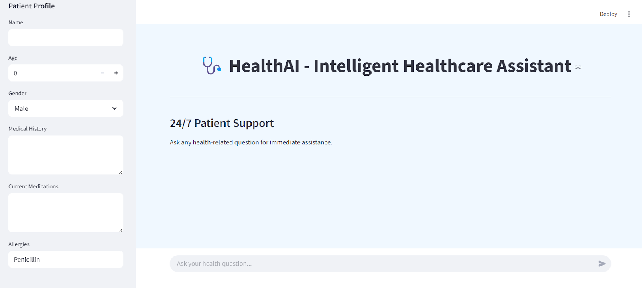

Description: Here user have access to responsive healthcare communication platform enabling seamless dialogue about wellness concerns, with chronological message tracking for context retention. The system delivers intelligent, algorithmically-generated wellness guidance while providing verifiable medical insights supported by authoritative healthcare sources, creating a comprehensive virtual consultation experience.

### Patient Chat output: https://lh7-rt.googleusercontent.com/docsz/AD_4nXdZjBKdDJ46eXKocigHD1hUkaLeSJFwBbEX1rdvwmF3tFI_1uk_98diH4y3elpALQTYlbQy8BB9La9f6EEqnlrqI0gJAQ2P68GZP6YN6ekO7-hESOh5aOCQm17ptIzCBrJRni0VFg?key=xK92Xra24GI-Oi3NurUN5t0n

### Disease Prediction Page:

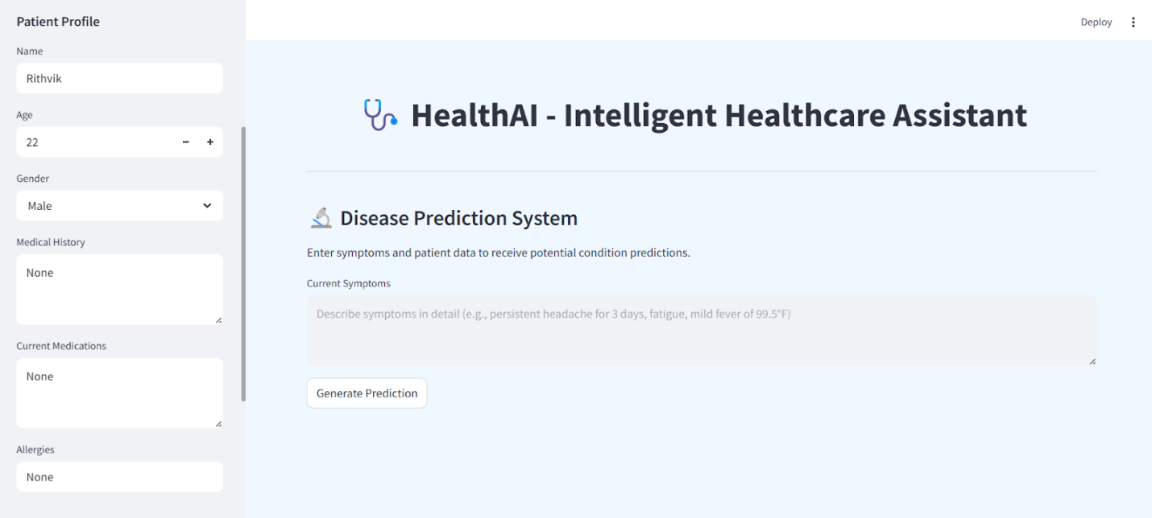

Description:   The webpage presents sophisticated diagnostic assessment tool featuring an intuitive symptom documentation section where users can detail their health concerns in depth. The interface includes a prominent analysis initiation control that, when activated, processes entered data to generate a comprehensive analysis of possible medical conditions. Results are presented with statistical probability indicators and detailed explanatory content for each potential diagnosis. The system incorporates essential medical advisories emphasizing the informational nature of the analysis and recommending professional healthcare consultation.

### Disease Prediction Output:

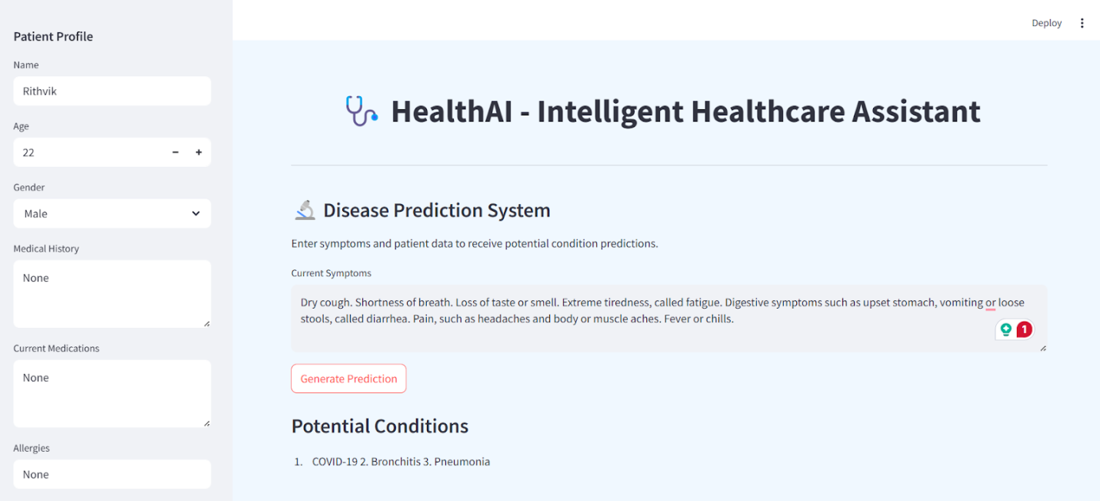

### Treatment Plans Page: https://lh7-rt.googleusercontent.com/docsz/AD_4nXcynGf-v04jKwJi9MJ7IwPf4lpXggmk_xQgu90Nmtu2IfGzJTR7e2Mnmk68p5HaL0zEsl7o_fwUsFz4huiannRxN1VWM-WDB2ualn5lrMBIiAcuUyOHQs3aFNz8aASVehannGT6nQ?key=xK92Xra24GI-Oi3NurUN5t0n

Description:  This page contains medical condition entry area where users can specify their health concerns, complemented by a prominent action button for plan creation. Upon activation, the system produces comprehensive, organized therapeutic recommendations tailored to the specified condition. The interface includes essential medical advisories clarifying the informational nature of the provided guidance.

### Health Analytics Dashboard:

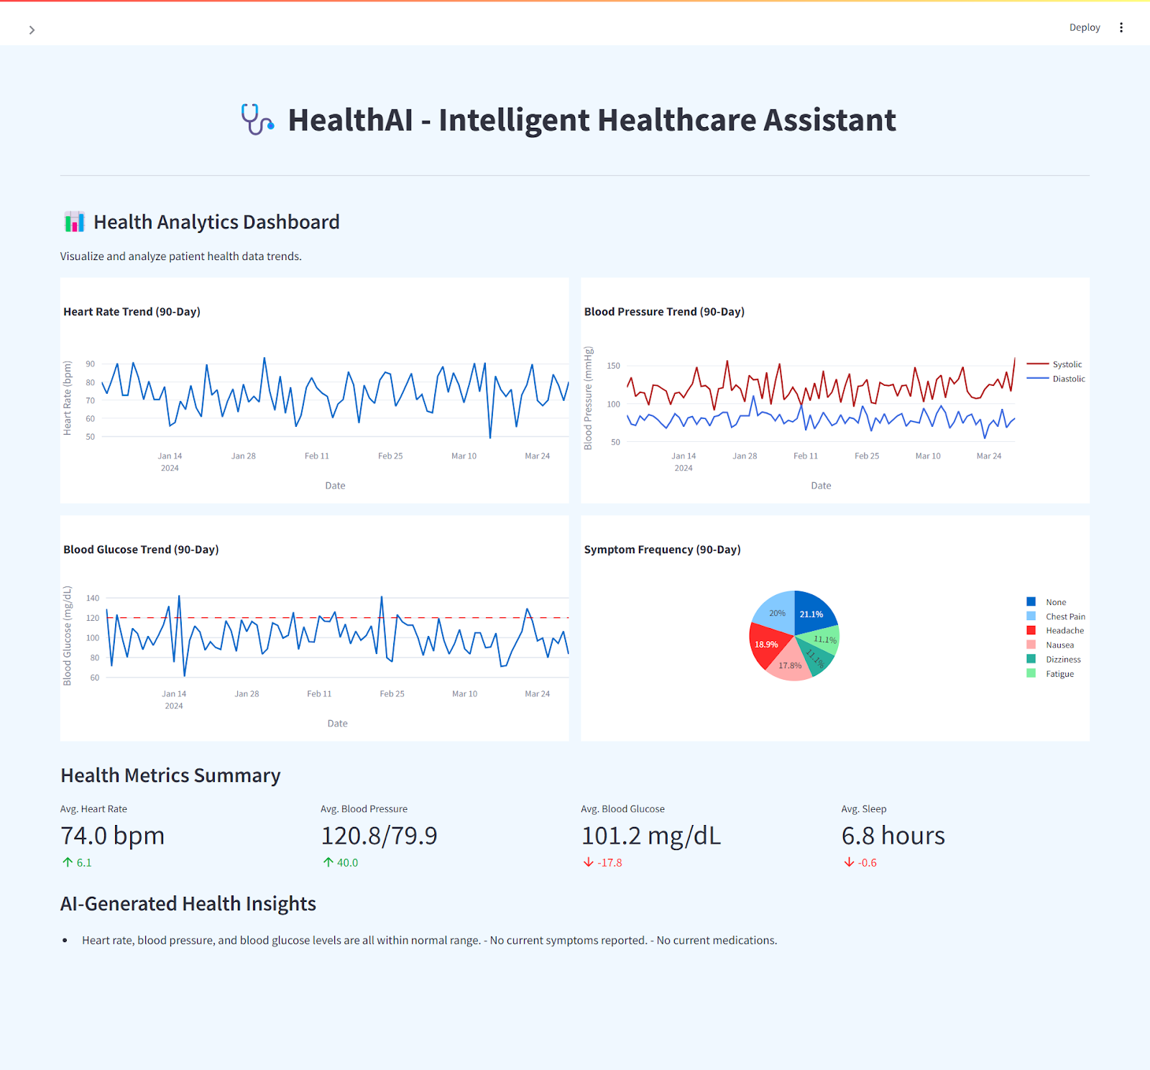

Description:  The interface features dynamic visualizations including heart rate trends, blood pressure patterns, and blood glucose fluctuations over time. A color-coded pie chart illustrates symptom occurrence frequency, while the metrics summary section provides key health indicators with directional trend markers. The dashboard is enhanced with AI-powered insights that analyze collected data to offer personalized health recommendations and observations.

**Conclusion:**

The HealthAI project effectively demonstrates the potential of AI in revolutionizing healthcare assistance. By integrating IBM's Granite language model, the platform enables users to receive personalized health insights through Patient Chat, Disease Prediction, Treatment Plan Generation, and Health Analytics, making healthcare information more accessible.

Utilizing IBM Watson Machine Learning, the application ensures accurate health question answering, detailed disease prediction, personalized treatment recommendations, and insightful health trend analysis. The structured development process—spanning model selection, core feature implementation, backend and frontend development, and deployment—led to the creation of an interactive, user-friendly platform.

Built with Streamlit, HealthAI facilitates seamless visualization of health data and AI-generated insights, ensuring an efficient and responsive experience. This project highlights how targeted AI models and a well-structured framework can enhance healthcare accessibility. With future scalability in mind, HealthAI has the potential to expand its capabilities, incorporating more advanced diagnostics and broader medical applications.