1. Write a program to set your name and age by a instance method and get them in an another instance method.

class NameAgeInstanceMethod{

public void printNameage(String name, int age){

System.out.println("name "+name);

System.out.println("age " +age);

}

public static void main(String args[]){

NameAgeInstanceMethod s1 = new NameAgeInstanceMethod();

s1.printNameage("simi",28);

}

}

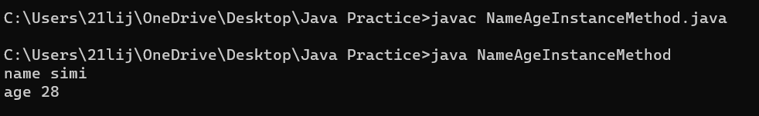

2 . Write a program to find the factorial of a number(**instance** **method**)

* Output – “Factorial of <given number> is <result>.

class FactorialInstanceMethod{

public void printfactorial(int num){

int i;

long factorial=1;

for(i=1;i<=num;i++)

{

factorial =factorial*i;

}

System.out.println("factorial of given number is " +factorial);

}

public static void main(String args[]){

FactorialInstanceMethod s = new FactorialInstanceMethod();

s.printfactorial(4);

}

}

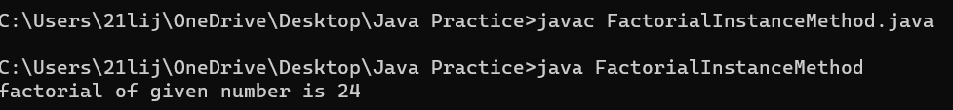

3. Write a program to check whether the given number is Palindrome/Not by using **instance** **method**.

* Method 1- to find the reverse(pass the number in argument)
* Method 2-to check palindrome/not

class PalindromeInstMethods{

public int reverseOfNumber(int number){

int reverse=0;

int rem=0;

int input=number;

while(number!=0){

rem=number%10;

reverse= (reverse*10)+rem;

number=number/10;

}

return reverse;

}

public boolean isPalindromeOrNot(int input)

{

int reverseOfInput = PalindromeMethods.reverseOfNumber(input);

if(input==reverseOfInput)

{

return true;

}

else

{

return false;

}

}

public static void main(String args[]){

int number=121;

PalindromeInstMethods s = new PalindromeInstMethods();

boolean status = s.isPalindromeOrNot(number);

if (status){

System.out.println(number + " is a pallindrome number.");

}

else{

System.out.println(number + "is not a pallindrome.");

}

}

}



4.Write a program to check whether the candidate is eligible for Voting(Use **instance** **method** and boolean return type).

class VotingBooleanInstMethod{

public boolean isEligibleforVote(int age){

if(age>18)

{

return true;

}

else

{

return false;

}

}

public static void main(String args[]){

VotingBooleanInstMethod s =new VotingBooleanInstMethod();

boolean status= s.isEligibleforVote(20);

if (status==true){

System.out.println("Eligible for voting");

}

else{

System.out.println("Eligible for voting");

}

}

}

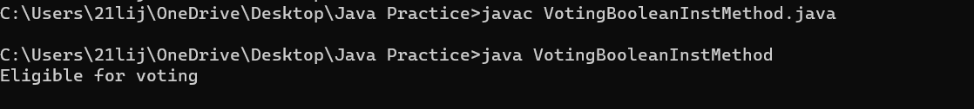

5. Write a program to deposit and withdraw amount from bank account(Withdrawal amount do not exceeds the current balance). Add an extra method to check the account balance. (**instance** **method**)

class BankingInst{

static int currentbalance=24500,withdraw=15000,deposit=2000,newbalance;

public void deposit()

{

newbalance=currentbalance+deposit;

System.out.println("After Deposit,Your Current balance is : " +newbalance);

}

public void withdrawal()

{

if(newbalance>=withdraw){

System.out.println("transaction under progress");

}

else{

System.out.println("insufficient balance");

}

int cur_newbal=newbalance-withdraw;

System.out.println("Balance amount in your account : "+cur_newbal);

}

public static void main(String args[])

{

Banking s=new Banking();

s.deposit();

Banking s1=new Banking();

s1.withdrawal();

}

}

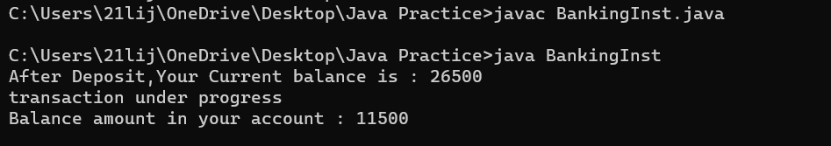

6. Write a program to check whether the customer have discount (get 20% discount if total amount is greater than 5000) or not and get the final amount in main method. (**instance** **method**)

* Get prices of items using parameterized method
* Method 1 - Calculate total amount
* Method 2 - Check discount

class ShoppingInstMethod

{

static int total,discount,pay_amount;

public void listItem(int a,int b,int c,int d)

{

total=a=b+c+d;

System.out.println("Total Amount : " + total);

}

public void discount()

{

if(total>=5000)

{

discount=(total*20)/100;

pay_amount=total-discount;

System.out.println("You get " +discount+ " money back ");

System.out.println("Payable amount : "+pay_amount);

}

else

{

System.out.println("Payable amount : "+total);

System.out.println("Purchase above 5000 You get 20% off");

}

}

public static void main(String args[])

{

ShoppingInstMethod s= new ShoppingInstMethod();

ShoppingInstMethod s1= new ShoppingInstMethod();

s.listItem(100,2300,300,700);

s1.discount();

s.listItem(1000,23000,300,700);

s1.discount();

}

}

