Constructor

1. Write the below program with the parameterized constructor.
   1. Average of three integer numbers, three float numbers(should have same method name)

class ConstructorAverage

{

int a,b,c;

float x,y,z;

public ConstructorAverage(int a1,int b1,int c1)

{

a=a1;

b=b1;

c=c1;

}

public ConstructorAverage(float x1,float y1,float z1)

{

x=x1;

y=y1;

z=z1;

}

public void average(int a,int b,int c)

{

int avg=(a+b+c)/3;

System.out.println("Average of three integer number is : " +avg);

}

public void average(float x,float y,float z)

{

float avg1=(x+y+z)/3;

System.out.println("Average of three float number is : " +avg1);

}

public static void main(String args[])

{

ConstructorAverage obj=new ConstructorAverage(12,31,50);

obj.average(12,31,50);

ConstructorAverage obj1=new ConstructorAverage(50.1f,31.1f,27.1f);

obj1.average(50.1f,31.1f,27.1f);

}

}

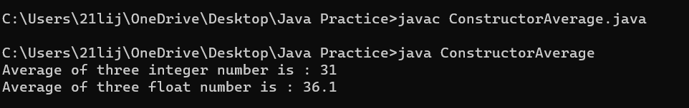

Area of figures(circle, rectangle, square) by using three methods(should have same method name)

class ConstructorArea

+{

float r;

float pie=3.14f;

int side;

int length;

int breadth;

public ConstructorArea(float rad)

{

r=rad;

}

public ConstructorArea(int side1)

{

side=side1;

}

public ConstructorArea(int length1, int breadth1)

{

length=length1;

breadth=breadth1;

}

public void area(float r)

{float area1=pie\*r\*r;

System.out.println("Area of circle : "+area1);

}

public void area(int side)

{

int area2 = side\*side;

System.out.println("Area of square : "+area2);

}

public void area(int length, int breadth)

{

int area3 = length\*breadth;

System.out.println("Area of rectangle: "+area3);

}

public static void main(String args[]){

ConstructorArea s1 = new ConstructorArea(6.2f);

s1.area(6.2f);

ConstructorArea s2 = new ConstructorArea(5);

s2.area(5);

ConstructorArea s3 = new ConstructorArea(4,2);

s3.area(4,2);

}

}

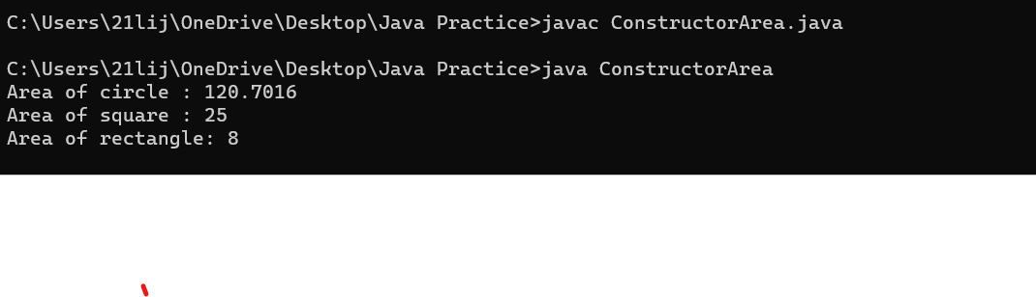

1. Write a program to find the grade of 2 students based on total marks(3 subjects)
   1. Get the student’s marks by constructor
   2. Return total mark to in main method
   3. Find the grade of each student.

class ConstructorStudentGrade

{

String name;

String rollno;

int m1,m2,m3,tot;

static String department="Electronics";

static String division="S2";

public ConstructorStudentGrade(String nam,String rno,int m11,int m22,int m33)

{

name=nam;

rollno=rno;

m1=m11;

m2=m22;

m3=m33;

}

public int total()

{

tot=m1+m2+m3;

return (tot);

}

public void disp()

{

if(tot>=260)

{

System.out.println("Name : " +name);

System.out.println("Roll No : " +rollno);

System.out.println("Department : "+department);

System.out.println("Division : "+division);

System.out.println("C : "+m1);

System.out.println("Digital Electronics : " +m2);

System.out.println("Mathematics : " +m3);

System.out.println("Total : " +tot);

System.out.println("Grade : A");

System.out.println("You are Passed");

}

else if(tot>=230)

{

System.out.println("Name : " +name);

System.out.println("Roll No : " +rollno);

System.out.println("Department : "+department);

System.out.println("Division : "+division);

System.out.println("C : "+m1);

System.out.println("Digital Electronics : " +m2);

System.out.println("Mathematics : " +m3);

System.out.println("Total : " +tot);

System.out.println("Grade : B");

System.out.println("You are Passed");

}

else if(tot>=190)

{

System.out.println("Name : " +name);

System.out.println("Roll No : " +rollno);

System.out.println("Department : "+department);

System.out.println("Division : "+division);

System.out.println("C : "+m1);

System.out.println("Digital Electronics : " +m2);

System.out.println("Mathematics : " +m3);

System.out.println("Total : " +tot);

System.out.println("Grade : C");

System.out.println("You are Passed");

}

else if(tot>=170)

{

System.out.println("Name : " +name);

System.out.println("Roll No : " +rollno);

System.out.println("Department : "+department);

System.out.println("Division : "+division);

System.out.println("C : "+m1);

System.out.println("Digital Electronics : " +m2);

System.out.println("Mathematics : " +m3);

System.out.println("Total : " +tot);

System.out.println("Grade : D");

System.out.println("You are Passed");

}

else

{

System.out.println("Name : " +name);

System.out.println("Roll No : " +rollno);

System.out.println("Department : "+department);

System.out.println("Division : "+division);

System.out.println("C : "+m1);

System.out.println("Digital Electronics : " +m2);

System.out.println("Mathematics : " +m3);

System.out.println("Total : " +tot);

System.out.println("Grade : E");

System.out.println("You are Failed");

}

}

public static void main(String args[])

{

ConstructorStudentGrade obj=new ConstructorStudentGrade("Simi","S101",98,97,95);

int r1=obj.total();

obj.disp();

ConstructorStudentGrade obj1=new ConstructorStudentGrade("Haritha","S102",58,68,94);

int r2=obj1.total();

obj1.disp();

}

}

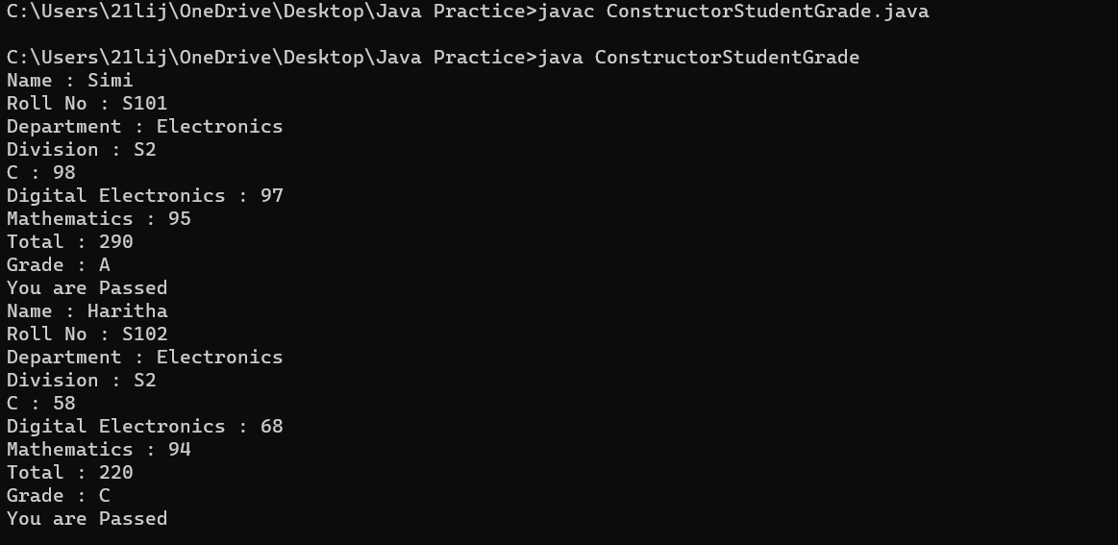

1. Program to find the reverse of a number
   1. Two constructors, one for calculation reverse and the other for display “Finding reverse…”
   2. Argument variable and instance variable should be the same
   3. The main method allows invoking only one constructor

class ConstructorReverse1{

int num;

public ConstructorReverse1(){

System.out.println(" finding thereverse ");

}

public ConstructorReverse1(int num){

this();

this.num=num;

}

public void reverse(int num){

int rem = 0;

int sum=0;

while(num>0)

{

rem = num % 10;

sum = sum \* 10 + rem;

num =num/10;

}

System.out.println(" reverse of the given number is" +sum);

}

public static void main(String args[]){

ConstructorReverse1 obj1= new ConstructorReverse1( 123);

obj1.reverse(123);

}

}

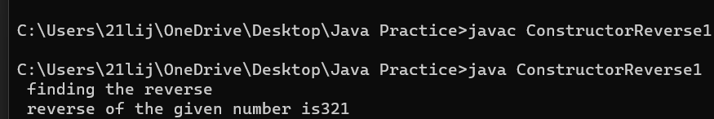

1. Program to find the factorial of a number
   1. Two constructors, one for find calculate and the other for the print result.
   2. Pass the number as argument
   3. The main method allows to invoke only one constructor

class FactorialConstructor{

int num;

public FactorialConstructor(){

System.out.println(" finding the factorial ");

}

public FactorialConstructor(int num){

this();

this.num=num;

}

public void factorial(int num){

int i;

int factorial=1;

for(i=1;i<=num;i++)

{

factorial =factorial\*i;

}

System.out.println("factorial of given number is " +factorial);

}

public static void main(String args[]){

FactorialConstructor obj1= new FactorialConstructor(4);

obj1.factorial(4);

}

}

