Running in visual studio code now. Where did we leave off? I want to get ai to automate posts from the 4 personalities using ai by using a cron in my bluehost and some php and config, and managed via a custom plugin in my manifested fit blog. Once drafts are ready for me to check, i want a telegram notification. I think i have a telegram bot for my spinning monkey studios but hgavent wired it up yet.. I can do another from scratch for this. Also, once we have those drafts, we still need to use the material to create youtube videos to embed. Regular youtube videos leveraging ai is the goal here, asp per thaty video from the oither day that i shared with you on monetising faceless ai generated videos. Lets make me a new step by step plan for me to get cloaser to thios goal today. I am not averse to using make.com for some auto posting workflow but as youc an see we have a ps1 file that is successfully abel to post. Also, can you check, in the context of vscode here, you shoudl be able to run a ps1 file th at posts a draft to my blog. I thing claude code is siloed but this is vscode right on my windows.
Show less
Let me get caught up on where things stand — reading the context brief, Brain docs, and recent planning files.
Read d:\JonoFiles\Projects\01_Business\Spinning_Monkey_Studios\02_Active_Projects\Manifested_Fit\NEXT_CONTEXT_BRIEF.md
Read d:\JonoFiles\Projects\01_Business\Spinning_Monkey_Studios\02_Active_Projects\Manifested_Fit\Brain\CURRENT_STATE.md
Read d:\JonoFiles\Projects\01_Business\Spinning_Monkey_Studios\02_Active_Projects\Manifested_Fit\07_Deploy\tools\push-draft.ps1
Read d:\JonoFiles\Projects\01_Business\Spinning_Monkey_Studios\02_Active_Projects\Manifested_Fit\Brain\TASKS.md
Globpattern: "05_Content/blog/*"
Found 5 files
Globpattern: "07_Deploy/targets/wordpress/*"
Found 1 file
Read d:\JonoFiles\Projects\01_Business\Spinning_Monkey_Studios\02_Active_Projects\Manifested_Fit\05_Content\blog\_sample-push-test.md
Read d:\JonoFiles\Projects\01_Business\Spinning_Monkey_Studios\02_Active_Projects\Manifested_Fit\06_Planning\ACTION_PLAN_2026-07.md
PowerShell Run push-draft.ps1 to post the sample test draft to WordPress
IN
& "d:\JonoFiles\Projects\01_Business\Spinning_Monkey_Studios\02_Active_Projects\Manifested_Fit\07_Deploy\tools\push-draft.ps1" -File "d:\JonoFiles\Projects\01_Business\Spinning_Monkey_Studios\02_Active_Projects\Manifested_Fit\05_Content\blog\_sample-push-test.md"
OUT
Exit code 1
Invoke-RestMethod : The remote server returned an error: (400) Bad Request.
At D:\JonoFiles\Projects\01_Business\Spinning_Monkey_Studios\02_Active_Projects\Manifested_Fit\07_Deploy\tools\push-dra
ft.ps1:103 char:14
+ ... $new = Invoke-RestMethod -Uri "$base/wp-json/wp/v2/categories" - ...
+ ~~~~~~~~~~~~~~~~~~~~~~~~~~~~~~~~~~~~~~~~~~~~~~~~~~~~~~~~~
+ CategoryInfo : InvalidOperation: (System.Net.HttpWebRequest:HttpWebRequest) [Invoke-RestMethod], WebExc
eption
+ FullyQualifiedErrorId : WebCmdletWebResponseException,Microsoft.PowerShell.Commands.InvokeRestMethodCommand
Edit d:\JonoFiles\Projects\01_Business\Spinning_Monkey_Studios\02_Active_Projects\Manifested_Fit\07_Deploy\tools\push-draft.ps1
Added 13 lines
PowerShell Re-run push-draft.ps1 after the category fix
IN
& "d:\JonoFiles\Projects\01_Business\Spinning_Monkey_Studios\02_Active_Projects\Manifested_Fit\07_Deploy\tools\push-draft.ps1" -File "d:\JonoFiles\Projects\01_Business\Spinning_Monkey_Studios\02_Active_Projects\Manifested_Fit\05_Content\blog\_sample-push-test.md"
OUT
Category already exists: Rituals & Routines (id 5)

Draft created (id 29) - status: draft
Edit it here: https://manifestedfit.com/blog/wp-admin/post.php?post=29&action=edit
PowerShell Query WordPress REST API for user IDs (names and IDs only, no credentials printed)
IN
$cfg = Get-Content "d:\JonoFiles\Projects\01_Business\Spinning_Monkey_Studios\02_Active_Projects\Manifested_Fit\07_Deploy\targets\wordpress\config.json" -Raw | ConvertFrom-Json; $auth = @{ Authorization = 'Basic ' + [Convert]::ToBase64String([Text.Encoding]::UTF8.GetBytes("$($cfg.username):$($cfg.app_password)")) }; try { $users = Invoke-RestMethod -Uri "$($cfg.site_url.TrimEnd('/'))/wp-json/wp/v2/users?context=edit&per_page=100" -Headers $auth; $users | Select-Object id, name, slug | Format-Table -AutoSize } catch { Write-Host "context=edit failed: $($_.Exception.Message)"; $users = Invoke-RestMethod -Uri "$($cfg.site_url.TrimEnd('/'))/wp-json/wp/v2/users?per_page=100" -Headers $auth; $users | Select-Object id, name, slug | Format-Table -AutoSize }
OUT
context=edit failed: The remote server returned an error: (403) Forbidden.

id name slug
-- ---- ----
1 admin admin
PowerShell List all posts and pages with author IDs via REST API
IN
$cfg = Get-Content "d:\JonoFiles\Projects\01_Business\Spinning_Monkey_Studios\02_Active_Projects\Manifested_Fit\07_Deploy\targets\wordpress\config.json" -Raw | ConvertFrom-Json; $auth = @{ Authorization = 'Basic ' + [Convert]::ToBase64String([Text.Encoding]::UTF8.GetBytes("$($cfg.username):$($cfg.app_password)")) }; $posts = Invoke-RestMethod -Uri "$($cfg.site_url.TrimEnd('/'))/wp-json/wp/v2/posts?status=draft,pending,publish&context=edit&per_page=50" -Headers $auth; $posts | Select-Object id, author, status, @{n='title';e={$_.title.raw}} | Format-Table -AutoSize; $pages = Invoke-RestMethod -Uri "$($cfg.site_url.TrimEnd('/'))/wp-json/wp/v2/pages?status=draft,publish&context=edit&per_page=50" -Headers $auth; $pages | Select-Object id, author, status, @{n='title';e={$_.title.raw}} | Format-Table -AutoSize
OUT
id author status title
-- ------ ------ -----
29 6 draft Pipeline Test — Safe to Delete
28 6 draft Pipeline Test — Safe to Delete
17 4 draft Your Nervous System Is a Golden Retriever. Here's Its 5-Minute Walk.

id author status title
-- ------ ------ -----
21 5 draft The 7-Day Mind-Body Reset
You coudl also read that NEXT_CONTEXT_BRIEF if it helps too
PowerShell Identify author names for user IDs 2, 3, 5 by reassigning the throwaway draft and reading the embedded author
IN
$cfg = Get-Content "d:\JonoFiles\Projects\01_Business\Spinning_Monkey_Studios\02_Active_Projects\Manifested_Fit\07_Deploy\targets\wordpress\config.json" -Raw | ConvertFrom-Json; $base = $cfg.site_url.TrimEnd('/'); $auth = @{ Authorization = 'Basic ' + [Convert]::ToBase64String([Text.Encoding]::UTF8.GetBytes("$($cfg.username):$($cfg.app_password)")) }; foreach ($id in 2,3,5) { try { $body = [Text.Encoding]::UTF8.GetBytes((@{ author = $id } | ConvertTo-Json)); $null = Invoke-RestMethod -Uri "$base/wp-json/wp/v2/posts/29" -Method Post -Headers $auth -ContentType 'application/json; charset=utf-8' -Body $body; $p = Invoke-RestMethod -Uri "$base/wp-json/wp/v2/posts/29?_embed=author&context=edit" -Headers $auth; $name = $p._embedded.author[0].name; Write-Host ("ID {0} = {1}" -f $id, $name) } catch { Write-Host ("ID {0}: {1}" -f $id, $_.Exception.Message) } }; $null = Invoke-RestMethod -Uri "$base/wp-json/wp/v2/posts/29" -Method Post -Headers $auth -ContentType 'application/json; charset=utf-8' -Body ([Text.Encoding]::UTF8.GetBytes((@{ author = 6 } | ConvertTo-Json)))
OUT
ID 2 =
ID 3 =
ID 5 =
(Yes — the NEXT_CONTEXT_BRIEF was the first thing I read; everything below builds on it.)
Where we left off + what I just verified
As of 2026-07-05: the blog is live, four persona authors exist, the voice schedule is decided (Mon Frankie / Tue Dana / Wed Nadia / Thu Dana / Fri Rowan), and the plugin-plus-cron engine you just described is already item 5 in the brief — so today is about building it, with Telegram as a new addition.
Your ps1 question: confirmed. You're right — this is real PowerShell on your Windows machine, not a silo. I ran push-draft.ps1 and it created draft id 29 on manifestedfit.com. It actually failed on first run — a real bug where an already-existing category ("Rituals & Routines") came back HTML-encoded from WordPress, failed the name match, and crashed on re-creation. I fixed the script (push-draft.ps1:97-119) and it now runs clean. Housekeeping: trash drafts 28 and 29 ("Pipeline Test") in wp-admin.
I also chipped at the author-ID blocker via the REST API: FrankieMoon = ID 4 (confirmed), the 7-Day Reset page author is ID 5 (almost certainly RowanEllis), ContentEngine = 6, admin = 1, which leaves Dana and Nadia as 2 and 3 in some order. The Editor account can't list users, so I couldn't fully resolve them — but the plugin will look up personas by login name server-side, so this blocker disappears once it exists. (If you want it now: wp-admin → Users → hover DanaCole/NadiaBrooks, read user_id=N.)
Step-by-step plan for today
Step 1 — Telegram bot (you, ~10 min). Make a fresh one for Manifested Fit rather than repurposing the Spinning Monkey bot — one bot per brand keeps notifications sane. In Telegram: talk to @BotFather → /newbot → name it (e.g. "Manifested Fit Engine") → copy the token into a new git-ignored 07_Deploy/targets/telegram/config.json. Then send the bot any message ("hi"). Once you've done that, I can fetch your chat_id locally via getUpdates and send a test notification from here to prove the channel works — token never enters chat.
Step 2 — I build the WP plugin (me, today's main build). manifested-fit-content-engine, drafts-only by design:
- Settings page: Anthropic API key, Telegram token + chat_id, on/off switch.
- The persona schedule baked in (incl. Canadian-holiday rules), resolving authors by login so no IDs needed.
- A topic queue you manage in wp-admin (I'll pre-seed it from the idea bank/categories).
- A secured cron endpoint + a "Run now" button so you can test without waiting for cron.
- Runner: pick today's persona + next topic → call the Anthropic API → create a draft with the right byline + categories → Telegram message with the edit link.
Step 3 — Anthropic API key (you, ~5 min). console.anthropic.com → create a key, fund it $5–10. This is the paid metered API — separate from your Claude subscription, per the decision in the brief. Goes in the plugin settings page, never in chat.
Step 4 — Install + test (~15 min). Upload the plugin folder via FTP (or I extend your existing FTP deploy tooling to push it), activate, paste keys, hit "Run now" → confirm a persona draft appears and your phone buzzes.
Step 5 — Bluehost cron (you, ~5 min, with my exact string). cPanel → Cron Jobs → one daily job (e.g. 6:00 AM) hitting the plugin's runner. From then on it's fully self-running: wake up → Telegram ping → review draft → publish.
Step 6 — Bridge to YouTube (the money lane). The plan's core loop is one topic → blog post + video. So once the engine drafts posts, each approved draft becomes video source material. Today's realistic contribution: I generate the full production kit for video #1 (the morning-reset topic that post 1 needs): retention-structured script, voiceover text, ~5s-interval shot prompts, title/description/tags, thumbnail brief. Then your only manual work is voice + clips + assembly (Higgsfield/ElevenLabs + CapCut) — and post 1 can finally publish with its embed. Creating the Higgsfield Starter account is the one purchase decision still open from the action plan.
On Make.com: skip it for now. The plugin + Bluehost cron fully covers auto-drafting, and push-draft.ps1 covers manual pushes — Make.com would add a subscription and a third moving system for nothing. Revisit it later only if you want to automate YouTube uploads, which is the one step none of the current tooling touches.
Steps 2 and 6 are mine and I can start immediately — say the word and I'll build the plugin first, then the video kit. Steps 1 and 3 (Telegram bot + API key) are yours and can happen in parallel.
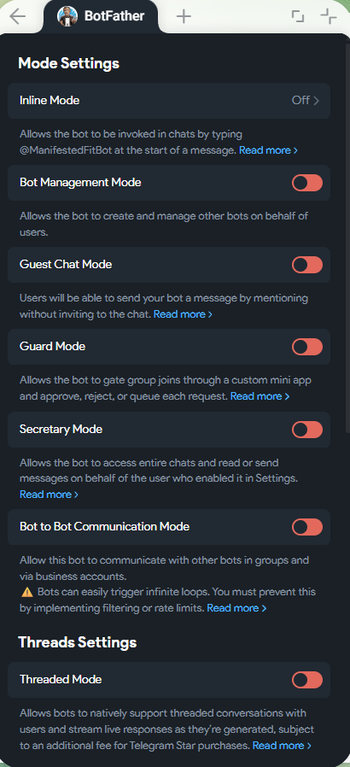image.png410×898
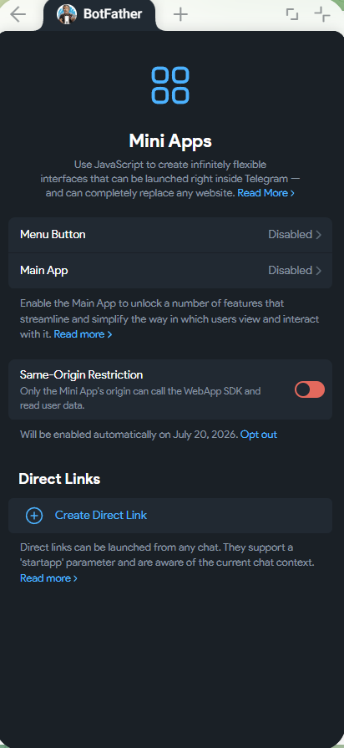image.png412×895
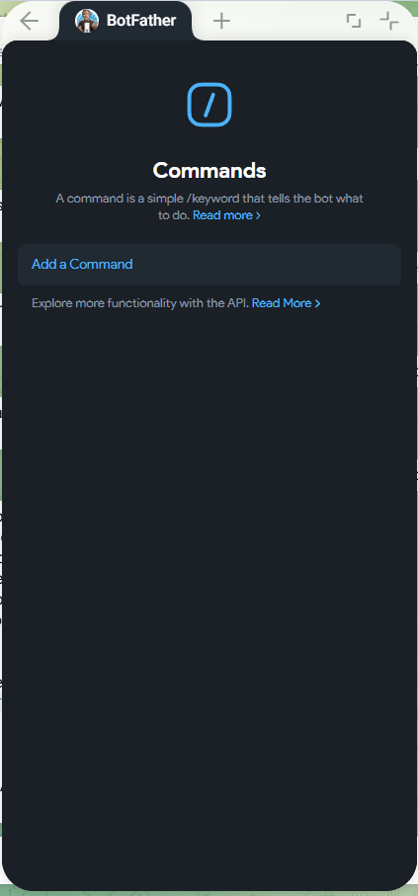image.png423×907
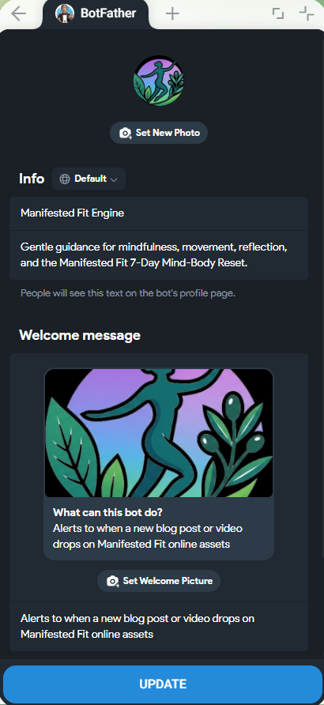image.png410×892
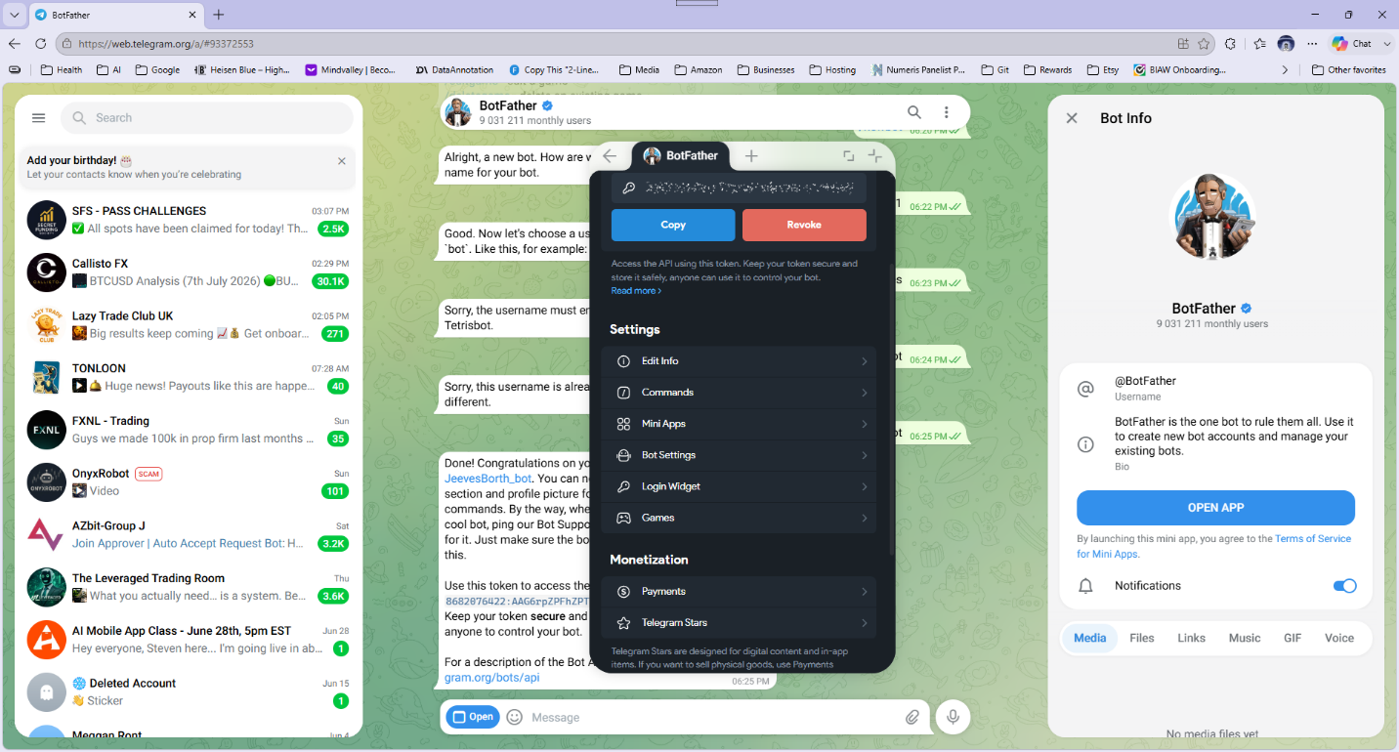image.png1920×1032
I am on step 1. I created a config_json file there with this structure: { "bot_name": "Manifested Fit Engine", "bot_key": "redacted_here" } I am using this BotFather App. See screen grab. Guide me please. Mode Settings has a lot mor eoptions btw. Thats just at the top.
Show less
Good news: you're done in BotFather — everything else in that mini app (Commands, Mini Apps, Mode Settings, all those toggles) is for building interactive/public bots. For a private notification bot, the defaults are exactly right: leave every toggle off and close the app. Nothing there needs configuring.
The only remaining Telegram-side step is: open a chat with your bot itself (search its @username, e.g. @ManifestedFitBot — not BotFather) and press Start / send it any message like "hi". That does two things: authorizes the bot to message you, and creates the chat I can read your chat_id from.
Meanwhile, let me check the config file you created and make sure it's git-ignored:
Globpattern: "07_Deploy/targets/telegram/*"
Found 1 file
Read d:\JonoFiles\Projects\01_Business\Spinning_Monkey_Studios\02_Active_Projects\Manifested_Fit\.gitignore
PowerShell Fetch Telegram getUpdates to discover the chat_id (token stays local)
IN
$cfg = Get-Content "d:\JonoFiles\Projects\01_Business\Spinning_Monkey_Studios\02_Active_Projects\Manifested_Fit\07_Deploy\targets\telegram\config.json" -Raw | ConvertFrom-Json; $r = Invoke-RestMethod -Uri "https://api.telegram.org/bot$($cfg.bot_key)/getUpdates"; if (-not $r.result -or $r.result.Count -eq 0) { Write-Host "No messages yet - send the bot a message first." } else { $r.result | ForEach-Object { $m = $_.message; if ($m) { Write-Host ("chat_id: {0} from: {1} text: {2}" -f $m.chat.id, $m.from.username, $m.text) } } }
OUT
No messages yet - send the bot a message first.
Two findings:
- Your token works — the Telegram API accepted it and responded. Config format is fine.
- The bot has no messages yet, so there's no chat to read your ID from.
Your one remaining step: in Telegram, search for your bot's @username (the one ending in bot that BotFather assigned — from your screenshots it looks like @ManifestedFitBot), open that chat — not the BotFather chat — and press Start (or just send "hi").
To be clear about why the BotFather app can't do this part: BotFather only manages the bot's settings. The bot itself is a separate chat, and Telegram bots can't message a person until that person messages them first — that first "hi" is what opens the channel and reveals your chat_id.
Tell me when you've sent it and I'll grab the chat_id, save it into the config, and fire a test notification at your phone to prove the whole channel end-to-end. While you do that, I'll get started on the plugin build if you're ready — just say go.
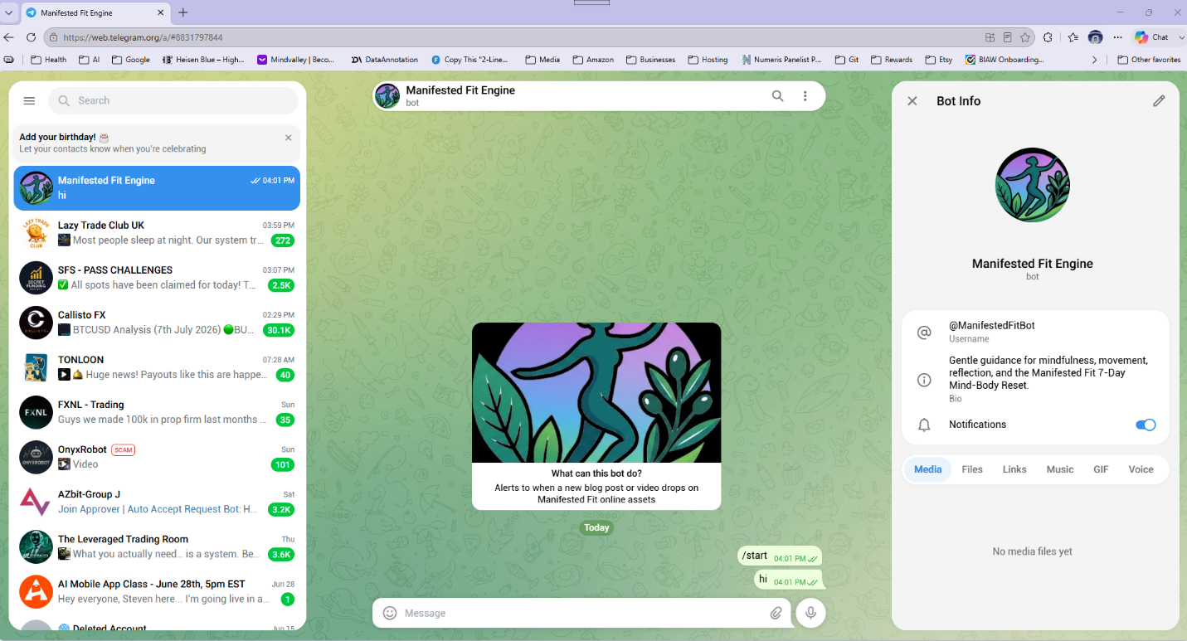image.png1906×1029
See what it looks liek in screen grab. I sent hi.
He's alive — @ManifestedFitBot with the brand artwork looks great. Grabbing your chat_id now:
PowerShell Read chat_id from getUpdates and save it into the telegram config
IN
$path = "d:\JonoFiles\Projects\01_Business\Spinning_Monkey_Studios\02_Active_Projects\Manifested_Fit\07_Deploy\targets\telegram\config.json"; $cfg = Get-Content $path -Raw | ConvertFrom-Json; $r = Invoke-RestMethod -Uri "https://api.telegram.org/bot$($cfg.bot_key)/getUpdates"; $chatId = ($r.result | Where-Object { $_.message } | Select-Object -Last 1).message.chat.id; if (-not $chatId) { Write-Host "Still no chat id found." } else { Write-Host "chat_id found: $chatId"; $out = [ordered]@{ bot_name = $cfg.bot_name; bot_key = $cfg.bot_key; chat_id = "$chatId" } | ConvertTo-Json; [IO.File]::WriteAllText($path, $out, [Text.UTF8Encoding]::new($false)); Write-Host "Saved chat_id into config.json" }
OUT
chat_id found: 6617208680
Saved chat_id into config.json
PowerShell Send a test notification via the Telegram bot
IN
$cfg = Get-Content "d:\JonoFiles\Projects\01_Business\Spinning_Monkey_Studios\02_Active_Projects\Manifested_Fit\07_Deploy\targets\telegram\config.json" -Raw | ConvertFrom-Json; $text = "Manifested Fit Engine: test notification. When the content engine drafts a post, this is where you'll get the link to review it."; $body = @{ chat_id = $cfg.chat_id; text = $text } | ConvertTo-Json; $r = Invoke-RestMethod -Uri "https://api.telegram.org/bot$($cfg.bot_key)/sendMessage" -Method Post -ContentType 'application/json; charset=utf-8' -Body ([Text.Encoding]::UTF8.GetBytes($body)); Write-Host ("Sent ok: {0}, message_id {1}" -f $r.ok, $r.result.message_id)
OUT
Sent ok: True, message_id 3
claude-api skill
Read d:\JonoFiles\Projects\01_Business\Spinning_Monkey_Studios\02_Active_Projects\Manifested_Fit\05_Content\blog\authors-and-schedule.md
Read d:\JonoFiles\Projects\01_Business\Spinning_Monkey_Studios\02_Active_Projects\Manifested_Fit\05_Content\blog\categories.md
Write d:\JonoFiles\Projects\01_Business\Spinning_Monkey_Studios\02_Active_Projects\Manifested_Fit\03_Website\wordpress\plugins\manifested-fit-content-engine\manifested-fit-content-engine.php
609 lines
<?php
/**
* Plugin Name: Manifested Fit Content Engine
* Description: Supervised AI drafting engine. A daily cron (or the Run Now button) picks the day's persona and next queued topic, asks Claude to write the post, saves it as a DRAFT under the persona's byline, and sends a Telegram notification for review. Nothing is ever auto-published.
* Version: 0.1.0
* Author: Spinning Monkey Studios
*/

if (!defined('ABSPATH')) { exit; }

class MFCE_Engine {

const OPT_SETTINGS = 'mfce_settings';
const OPT_TOPICS = 'mfce_topics';
const OPT_LOG = 'mfce_log';

/**
* Persona bylines mapped to their WP login names. Voice text is fed to the model.
*/
public static function personas() {
return array(
'dana' => array(
'login' => 'DanaCole',
'name' => 'Dana Cole',
'voice' => 'Grounded and practical. Direct, warm, no fluff. Cuts to the real reason something works. Short punchy sentences, concrete steps, zero mysticism in the delivery even when the topic is manifestation. Signature energy: "Here is the real reason, and here is what to do about it."',
),
'nadia' => array(
'login' => 'NadiaBrooks',
'name' => 'Nadia Brooks',
'voice' => 'Warm and story-led. Empathetic, a little vulnerable. Opens with a small personal-feeling story or scene, then draws the lesson out of it. Speaks reader-to-reader: "you are not alone in this." Gentle encouragement over instruction.',
),
'frankie' => array(
'login' => 'FrankieMoon',
'name' => 'Frankie Moon',
'voice' => 'Playful and curious. Witty, light, good vibes. Uses fun metaphors and a wink of humour to make wellness feel easy and unintimidating. Never snarky or mean; the joke is always on the situation, not the reader.',
),
'rowan' => array(
'login' => 'RowanEllis',
'name' => 'Rowan Ellis',
'voice' => 'Calm and minimal. Serene, spare, meditative. Fewer words, more space. Short paragraphs, soft imperatives, room to breathe. Lets the reader slow down just by reading. No exclamation marks.',
),
);
}

/** Category names must match 05_Content/blog/categories.md exactly. */
public static function categories() {
return array('Manifestation', 'Mindset', 'Rituals & Routines', 'Gentle Movement', 'Sleep & Rest', 'Recipes');
}

/** Canadian statutory holidays -> Frankie. Format: m-d => label. */
public static function holidays_2026() {
return array(
'01-01' => 'New Year\'s Day',
'02-16' => 'Family Day',
'04-03' => 'Good Friday',
'04-06' => 'Easter Monday',
'05-18' => 'Victoria Day',
'07-01' => 'Canada Day',
'08-03' => 'Civic Holiday',
'09-07' => 'Labour Day',
'10-12' => 'Thanksgiving',
'12-25' => 'Christmas Day',
'12-26' => 'Boxing Day',
);
}

/** Solemn days: calm, respectful Rowan piece. No jokes, no CTA. */
public static function solemn_days() {
return array(
'09-30' => 'National Day for Truth and Reconciliation',
'11-11' => 'Remembrance Day',
);
}

// ---------------------------------------------------------------- setup

public static function init() {
add_action('admin_menu', array(__CLASS__, 'admin_menu'));
add_action('admin_post_mfce_save_settings', array(__CLASS__, 'handle_save_settings'));
add_action('admin_post_mfce_add_topics', array(__CLASS__, 'handle_add_topics'));
add_action('admin_post_mfce_delete_topic', array(__CLASS__, 'handle_delete_topic'));
add_action('admin_post_mfce_run_now', array(__CLASS__, 'handle_run_now'));
add_action('admin_post_mfce_test_telegram', array(__CLASS__, 'handle_test_telegram'));
add_action('rest_api_init', array(__CLASS__, 'register_rest'));
}

public static function defaults() {
return array(
'enabled' => 0,
'anthropic_api_key' => '',
'model' => 'claude-opus-4-8',
'max_tokens' => 8000,
'telegram_bot_token' => '',
'telegram_chat_id' => '',
'cron_secret' => '',
'last_run_date' => '',
);
}

public static function settings() {
$s = get_option(self::OPT_SETTINGS, array());
$s = wp_parse_args(is_array($s) ? $s : array(), self::defaults());
if (empty($s['cron_secret'])) {
$s['cron_secret'] = wp_generate_password(32, false, false);
update_option(self::OPT_SETTINGS, $s, false);
}
return $s;
}

// ------------------------------------------------------------- schedule

/**
* Decide who writes today. Returns array with persona key, mode and note.
* Modes: normal | holiday | solemn
*/
public static function persona_for_date($dt) {
$md = $dt->format('m-d');

$solemn = self::solemn_days();
if (isset($solemn[$md])) {
return array('persona' => 'rowan', 'mode' => 'solemn', 'occasion' => $solemn[$md]);
}

$holidays = self::holidays_2026();
if (isset($holidays[$md]) && (int) $dt->format('Y') === 2026) {
return array('persona' => 'frankie', 'mode' => 'holiday', 'occasion' => $holidays[$md]);
}

$dow = (int) $dt->format('N'); // 1 = Monday
$map = array(
1 => 'frankie', // Monday: defuse the dread
2 => 'dana', // Tuesday: get to work
3 => 'nadia', // Wednesday: hump-day warmth
4 => 'dana', // Thursday: keep momentum
5 => 'rowan', // Friday: wind down
);
if (isset($map[$dow])) {
return array('persona' => $map[$dow], 'mode' => 'normal', 'occasion' => '');
}

$keys = array_keys(self::personas());
return array('persona' => $keys[wp_rand(0, count($keys) - 1)], 'mode' => 'normal', 'occasion' => '');
}

// ----------------------------------------------------------- the runner

/**
* The whole pipeline: persona -> topic -> Claude -> draft -> Telegram.
* Returns array('ok' => bool, 'message' => string, 'post_id' => int|null).
*/
public static function run($force = false, $context = 'manual') {
if (function_exists('set_time_limit')) { @set_time_limit(300); }

$s = self::settings();

if (!$force && empty($s['enabled'])) {
return self::finish(false, 'Engine is disabled in settings (cron run skipped).', null, false);
}
if (empty($s['anthropic_api_key'])) {
return self::finish(false, 'No Anthropic API key configured.', null, true);
}

$now = new DateTime('now', wp_timezone());
$today = $now->format('Y-m-d');

if (!$force && $s['last_run_date'] === $today) {
return self::finish(false, 'Already ran today (' . $today . '). Use Run Now to force another draft.', null, false);
}

$pick = self::persona_for_date($now);
$personas = self::personas();
$persona = $personas[$pick['persona']];

$author = get_user_by('login', $persona['login']);
if (!$author) {
return self::finish(false, 'WP user not found for persona login "' . $persona['login'] . '".', null, true);
}

// Solemn days write a fixed-purpose piece and do not consume a queue topic.
$topic = null;
if ($pick['mode'] === 'solemn') {
$topic = array(
'title' => 'A quiet reflection for ' . $pick['occasion'],
'notes' => 'This is ' . $pick['occasion'] . ' in Canada, a day of mourning and remembrance. Write a short, respectful, calm reflection. No humour, no product mentions, no calls to action, no manifestation framing. Simply honour the day and invite stillness.',
);
} else {
$topic = self::next_topic();
if (!$topic) {
return self::finish(false, 'Topic queue is empty - add topics in the Content Engine admin page.', null, true);
}
}

$result = self::generate_post($s, $persona, $pick, $topic);
if (is_wp_error($result)) {
return self::finish(false, 'Claude call failed: ' . $result->get_error_message(), null, true);
}

// Resolve categories by name, creating them if missing.
$cat_ids = array();
$allowed = self::categories();
foreach ((array) $result['categories'] as $cat_name) {
if (!in_array($cat_name, $allowed, true)) { continue; }
$term = get_term_by('name', $cat_name, 'category');
if (!$term) {
$created = wp_insert_term($cat_name, 'category');
if (!is_wp_error($created)) { $cat_ids[] = (int) $created['term_id']; }
} else {
$cat_ids[] = (int) $term->term_id;
}
}

$post_id = wp_insert_post(array(
'post_title' => wp_strip_all_tags($result['title']),
'post_name' => sanitize_title($result['slug']),
'post_content' => wp_kses_post($result['content_html']),
'post_excerpt' => sanitize_text_field($result['excerpt']),
'post_status' => 'draft', // ALWAYS draft. The engine never publishes.
'post_author' => $author->ID,
'post_category' => $cat_ids,
), true);

if (is_wp_error($post_id)) {
return self::finish(false, 'wp_insert_post failed: ' . $post_id->get_error_message(), null, true);
}

if (!empty($result['focus_keyword'])) {
update_post_meta($post_id, 'rank_math_focus_keyword', sanitize_text_field($result['focus_keyword']));
}

if ($pick['mode'] !== 'solemn' && isset($topic['id'])) {
self::mark_topic_used($topic['id'], $post_id);
}

$s = self::settings();
$s['last_run_date'] = $today;
update_option(self::OPT_SETTINGS, $s, false);

$edit_url = admin_url('post.php?post=' . $post_id . '&action=edit');
$msg = "Manifested Fit Engine\n"
. "New draft by {$persona['name']} (" . $now->format('D M j') . ", {$pick['mode']}):\n"
. '"' . $result['title'] . "\"\n"
. "Review: {$edit_url}";
self::telegram_send($s, $msg);

return self::finish(true, 'Draft #' . $post_id . ' created by ' . $persona['name'] . ' via ' . $context . ': "' . $result['title'] . '"', $post_id, false);
}

/** Log + optionally notify Telegram about failures, then return a result array. */
private static function finish($ok, $message, $post_id, $notify_failure) {
self::log(($ok ? 'OK: ' : 'SKIP/FAIL: ') . $message);
if (!$ok && $notify_failure) {
self::telegram_send(self::settings(), "Manifested Fit Engine problem:\n" . $message);
}
return array('ok' => $ok, 'message' => $message, 'post_id' => $post_id);
}

// -------------------------------------------------------------- Claude

private static function generate_post($s, $persona, $pick, $topic) {
$cats = self::categories();

$system = "You are a columnist for Manifested Fit (manifestedfit.com/blog), a wellness brand blending manifestation, gentle fitness, and mindset for everyday people.\n\n"
. "You write as the persona \"{$persona['name']}\". Voice: {$persona['voice']}\n\n"
. "House rules:\n"
. "- 700-1200 words (solemn reflections may be shorter).\n"
. "- Personas are voice bylines only: never claim credentials, cite fake studies, or present yourself as a doctor, therapist, or scientist.\n"
. "- No medical claims or income promises. Educational, encouraging framing only.\n"
. "- Practical and genuinely useful: the reader should be able to DO something after reading.\n"
. "- Mention the free 7-Day Mind-Body Reset at manifestedfit.com once, naturally, near the end (skip this on solemn pieces).\n"
. "- content_html must be clean HTML using only <h2>, <h3>, <p>, <ul>, <ol>, <li>, <blockquote>, <strong>, <em>, <a>. No <h1> (the title is separate), no inline styles, no scripts.\n"
. "- excerpt: one sentence, max 155 characters, written like a meta description.\n"
. "- slug: lowercase words joined by hyphens.\n"
. "- focus_keyword: the 2-4 word phrase the post should rank for.\n"
. "- categories: pick 1 (max 2) from exactly this list: " . implode(', ', $cats) . '.';

$user = "Write today's blog post.\n\nTopic: {$topic['title']}";
if (!empty($topic['notes'])) {
$user .= "\n\nEditor notes: {$topic['notes']}";
}
if ($pick['mode'] === 'holiday') {
$user .= "\n\nToday is {$pick['occasion']} in Canada - weave a celebratory, feel-good holiday angle into the post.";
}

$schema = array(
'type' => 'object',
'properties' => array(
'title' => array('type' => 'string'),
'slug' => array('type' => 'string'),
'excerpt' => array('type' => 'string'),
'focus_keyword' => array('type' => 'string'),
'categories' => array('type' => 'array', 'items' => array('type' => 'string', 'enum' => $cats)),
'content_html' => array('type' => 'string'),
),
'required' => array('title', 'slug', 'excerpt', 'focus_keyword', 'categories', 'content_html'),
'additionalProperties' => false,
);

$body = array(
'model' => $s['model'],
'max_tokens' => (int) $s['max_tokens'],
'system' => $system,
'messages' => array(array('role' => 'user', 'content' => $user)),
'output_config' => array(
'format' => array('type' => 'json_schema', 'schema' => $schema),
),
);

$response = wp_remote_post('https://api.anthropic.com/v1/messages', array(
'timeout' => 280,
'headers' => array(
'Content-Type' => 'application/json',
'x-api-key' => $s['anthropic_api_key'],
'anthropic-version' => '2023-06-01',
),
'body' => wp_json_encode($body),
));

if (is_wp_error($response)) {
return $response;
}

$code = wp_remote_retrieve_response_code($response);
$data = json_decode(wp_remote_retrieve_body($response), true);

if ($code !== 200) {
$api_msg = isset($data['error']['message']) ? $data['error']['message'] : ('HTTP ' . $code);
return new WP_Error('mfce_api', $api_msg);
}
if (isset($data['stop_reason']) && $data['stop_reason'] === 'refusal') {
return new WP_Error('mfce_refusal', 'The model refused this request.');
}
if (isset($data['stop_reason']) && $data['stop_reason'] === 'max_tokens') {
return new WP_Error('mfce_truncated', 'Output hit max_tokens and is incomplete - raise max_tokens in settings.');
}

$text = '';
foreach ((array) $data['content'] as $block) {
if (isset($block['type']) && $block['type'] === 'text') { $text = $block['text']; break; }
}
$parsed = json_decode($text, true);
if (!is_array($parsed) || empty($parsed['title']) || empty($parsed['content_html'])) {
return new WP_Error('mfce_parse', 'Could not parse structured JSON from the model response.');
}
return $parsed;
}

// -------------------------------------------------------------- topics

public static function topics() {
$t = get_option(self::OPT_TOPICS, array());
return is_array($t) ? $t : array();
}

private static function next_topic() {
foreach (self::topics() as $topic) {
if (isset($topic['status']) && $topic['status'] === 'pending') { return $topic; }
}
return null;
}

private static function mark_topic_used($id, $post_id) {
$topics = self::topics();
foreach ($topics as &$t) {
if ($t['id'] === $id) {
$t['status'] = 'used';
$t['post_id'] = $post_id;
$t['used_at'] = current_time('mysql');
}
}
update_option(self::OPT_TOPICS, $topics, false);
}

// ------------------------------------------------------------ telegram

public static function telegram_send($s, $text) {
if (empty($s['telegram_bot_token']) || empty($s['telegram_chat_id'])) { return false; }
$response = wp_remote_post('https://api.telegram.org/bot' . $s['telegram_bot_token'] . '/sendMessage', array(
'timeout' => 20,
'body' => array('chat_id' => $s['telegram_chat_id'], 'text' => $text),
));
if (is_wp_error($response)) {
self::log('Telegram send failed: ' . $response->get_error_message());
return false;
}
return wp_remote_retrieve_response_code($response) === 200;
}

// ----------------------------------------------------------------- log

private static function log($message) {
$log = get_option(self::OPT_LOG, array());
if (!is_array($log)) { $log = array(); }
array_unshift($log, current_time('mysql') . ' - ' . $message);
update_option(self::OPT_LOG, array_slice($log, 0, 20), false);
}

// ---------------------------------------------------------------- REST

public static function register_rest() {
register_rest_route('mfce/v1', '/run', array(
'methods' => 'GET',
'permission_callback' => '__return_true', // guarded by the secret below
'callback' => function ($request) {
$s = self::settings();
$secret = (string) $request->get_param('secret');
if (empty($s['cron_secret']) || !hash_equals($s['cron_secret'], $secret)) {
return new WP_Error('mfce_forbidden', 'Bad secret.', array('status' => 403));
}
$force = (bool) $request->get_param('force');
$result = self::run($force, 'rest-cron');
return rest_ensure_response($result);
},
));
}

// --------------------------------------------------------------- admin

public static function admin_menu() {
add_menu_page('Content Engine', 'Content Engine', 'manage_options', 'mfce', array(__CLASS__, 'render_admin'), 'dashicons-superhero', 58);
}

public static function handle_save_settings() {
if (!current_user_can('manage_options')) { wp_die('Nope.'); }
check_admin_referer('mfce_save_settings');
$s = self::settings();
$s['enabled'] = isset($_POST['enabled']) ? 1 : 0;
$s['model'] = sanitize_text_field(wp_unslash($_POST['model'] ?? $s['model']));
$s['max_tokens'] = max(1000, (int) ($_POST['max_tokens'] ?? $s['max_tokens']));
$s['telegram_chat_id'] = sanitize_text_field(wp_unslash($_POST['telegram_chat_id'] ?? ''));
// Secret fields: keep the stored value when the input is left blank.
$key = trim((string) wp_unslash($_POST['anthropic_api_key'] ?? ''));
if ($key !== '') { $s['anthropic_api_key'] = $key; }
$tg = trim((string) wp_unslash($_POST['telegram_bot_token'] ?? ''));
if ($tg !== '') { $s['telegram_bot_token'] = $tg; }
update_option(self::OPT_SETTINGS, $s, false);
wp_safe_redirect(admin_url('admin.php?page=mfce&notice=saved'));
exit;
}

public static function handle_add_topics() {
if (!current_user_can('manage_options')) { wp_die('Nope.'); }
check_admin_referer('mfce_add_topics');
$raw = (string) wp_unslash($_POST['topics'] ?? '');
$topics = self::topics();
foreach (explode("\n", $raw) as $line) {
$line = trim($line);
if ($line === '') { continue; }
// Optional "Title | editor notes" format.
$parts = array_map('trim', explode('|', $line, 2));
$topics[] = array(
'id' => uniqid('t'),
'title' => sanitize_text_field($parts[0]),
'notes' => isset($parts[1]) ? sanitize_text_field($parts[1]) : '',
'status' => 'pending',
);
}
update_option(self::OPT_TOPICS, $topics, false);
wp_safe_redirect(admin_url('admin.php?page=mfce&notice=topics'));
exit;
}

public static function handle_delete_topic() {
if (!current_user_can('manage_options')) { wp_die('Nope.'); }
check_admin_referer('mfce_delete_topic');
$id = sanitize_text_field(wp_unslash($_GET['topic'] ?? ''));
$topics = array_values(array_filter(self::topics(), function ($t) use ($id) {
return $t['id'] !== $id;
}));
update_option(self::OPT_TOPICS, $topics, false);
wp_safe_redirect(admin_url('admin.php?page=mfce&notice=deleted'));
exit;
}

public static function handle_run_now() {
if (!current_user_can('manage_options')) { wp_die('Nope.'); }
check_admin_referer('mfce_run_now');
$result = self::run(true, 'run-now');
$notice = $result['ok'] ? 'ran' : 'runfail';
wp_safe_redirect(admin_url('admin.php?page=mfce&notice=' . $notice));
exit;
}

public static function handle_test_telegram() {
if (!current_user_can('manage_options')) { wp_die('Nope.'); }
check_admin_referer('mfce_test_telegram');
$ok = self::telegram_send(self::settings(), 'Manifested Fit Engine: Telegram test from the WordPress plugin. Wiring works.');
wp_safe_redirect(admin_url('admin.php?page=mfce&notice=' . ($ok ? 'tgok' : 'tgfail')));
exit;
}

public static function render_admin() {
if (!current_user_can('manage_options')) { return; }
$s = self::settings();
$topics = self::topics();
$pending = array_filter($topics, function ($t) { return $t['status'] === 'pending'; });
$now = new DateTime('now', wp_timezone());
$pick = self::persona_for_date($now);
$personas = self::personas();
$log = get_option(self::OPT_LOG, array());
$cron_url = rest_url('mfce/v1/run') . '?secret=' . rawurlencode($s['cron_secret']);

$notices = array(
'saved' => array('success', 'Settings saved.'),
'topics' => array('success', 'Topics added to the queue.'),
'deleted' => array('success', 'Topic removed.'),
'ran' => array('success', 'Engine ran - check the log below and your Telegram.'),
'runfail' => array('error', 'Engine run did not create a draft - see the log below.'),
'tgok' => array('success', 'Telegram test message sent.'),
'tgfail' => array('error', 'Telegram test failed - check token and chat id.'),
);
$notice = sanitize_text_field(wp_unslash($_GET['notice'] ?? ''));
?>
<div class="wrap">
<h1>Manifested Fit Content Engine</h1>
<?php if (isset($notices[$notice])) : ?>
<div class="notice notice-<?php echo esc_attr($notices[$notice][0]); ?> is-dismissible"><p><?php echo esc_html($notices[$notice][1]); ?></p></div>
<?php endif; ?>

<h2>Status</h2>
<table class="widefat striped" style="max-width:720px">
<tbody>
<tr><td>Engine</td><td><?php echo $s['enabled'] ? '<strong style="color:green">Enabled</strong>' : '<strong style="color:#b00">Disabled</strong> (cron runs are skipped; Run Now still works)'; ?></td></tr>
<tr><td>Today's persona</td><td><?php echo esc_html($personas[$pick['persona']]['name'] . ' (' . $pick['mode'] . ($pick['occasion'] ? ': ' . $pick['occasion'] : '') . ')'); ?></td></tr>
<tr><td>Pending topics</td><td><?php echo (int) count($pending); ?></td></tr>
<tr><td>Last run</td><td><?php echo esc_html($s['last_run_date'] ?: 'never'); ?></td></tr>
<tr><td>API key</td><td><?php echo $s['anthropic_api_key'] ? 'set (hidden)' : '<strong style="color:#b00">missing</strong>'; ?></td></tr>
<tr><td>Telegram</td><td><?php echo ($s['telegram_bot_token'] && $s['telegram_chat_id']) ? 'configured' : '<strong style="color:#b00">not configured</strong>'; ?></td></tr>
</tbody>
</table>

<p style="margin-top:12px">
<form method="post" action="<?php echo esc_url(admin_url('admin-post.php')); ?>" style="display:inline">
<?php wp_nonce_field('mfce_run_now'); ?>
<input type="hidden" name="action" value="mfce_run_now">
<button class="button button-primary" onclick="this.disabled=true;this.form.submit();this.textContent='Writing... (takes a minute or two)'">Run Now (writes one draft)</button>
</form>
<form method="post" action="<?php echo esc_url(admin_url('admin-post.php')); ?>" style="display:inline;margin-left:8px">
<?php wp_nonce_field('mfce_test_telegram'); ?>
<input type="hidden" name="action" value="mfce_test_telegram">
<button class="button">Send Telegram test</button>
</form>
</p>

<h2>Settings</h2>
<form method="post" action="<?php echo esc_url(admin_url('admin-post.php')); ?>" style="max-width:720px">
<?php wp_nonce_field('mfce_save_settings'); ?>
<input type="hidden" name="action" value="mfce_save_settings">
<table class="form-table">
<tr><th>Enabled (daily cron)</th><td><label><input type="checkbox" name="enabled" <?php checked($s['enabled'], 1); ?>> Allow the daily cron to create a draft</label></td></tr>
<tr><th>Anthropic API key</th><td><input type="password" name="anthropic_api_key" class="regular-text" placeholder="<?php echo $s['anthropic_api_key'] ? 'saved - leave blank to keep' : 'sk-ant-...'; ?>" autocomplete="off"></td></tr>
<tr><th>Model</th><td><input type="text" name="model" class="regular-text" value="<?php echo esc_attr($s['model']); ?>"> <p class="description">Default: claude-opus-4-8</p></td></tr>
<tr><th>Max tokens</th><td><input type="number" name="max_tokens" value="<?php echo esc_attr($s['max_tokens']); ?>"></td></tr>
<tr><th>Telegram bot token</th><td><input type="password" name="telegram_bot_token" class="regular-text" placeholder="<?php echo $s['telegram_bot_token'] ? 'saved - leave blank to keep' : '123456:ABC...'; ?>" autocomplete="off"></td></tr>
<tr><th>Telegram chat id</th><td><input type="text" name="telegram_chat_id" class="regular-text" value="<?php echo esc_attr($s['telegram_chat_id']); ?>"></td></tr>
</table>
<p><button class="button button-primary">Save settings</button></p>
</form>

<h2>Bluehost cron</h2>
<p style="max-width:720px">Create a daily cron job in cPanel (e.g. 6:00 AM) with this command:</p>
<code style="display:block;max-width:720px;padding:8px;background:#fff;word-break:break-all">curl -s "<?php echo esc_html($cron_url); ?>" &gt; /dev/null 2&gt;&amp;1</code>
<p class="description">The engine runs at most once per calendar day, so an accidental second cron hit is harmless.</p>

<h2>Topic queue (<?php echo (int) count($pending); ?> pending)</h2>
<form method="post" action="<?php echo esc_url(admin_url('admin-post.php')); ?>" style="max-width:720px">
<?php wp_nonce_field('mfce_add_topics'); ?>
<input type="hidden" name="action" value="mfce_add_topics">
<textarea name="topics" rows="4" class="large-text" placeholder="One topic per line. Optional editor notes after a pipe:&#10;The 5-minute morning reset | angle: for people who hate mornings"></textarea>
<p><button class="button">Add topics</button></p>
</form>
<table class="widefat striped" style="max-width:900px">
<thead><tr><th>Topic</th><th>Notes</th><th>Status</th><th></th></tr></thead>
<tbody>
<?php if (!$topics) : ?>
<tr><td colspan="4">Queue is empty.</td></tr>
<?php endif; ?>
<?php foreach ($topics as $t) : ?>
<tr>
<td><?php echo esc_html($t['title']); ?></td>
<td><?php echo esc_html($t['notes']); ?></td>
<td><?php echo esc_html($t['status'] . (isset($t['post_id']) ? ' (draft #' . $t['post_id'] . ')' : '')); ?></td>
<td>
<?php if ($t['status'] === 'pending') : ?>
<a class="button button-small" href="<?php echo esc_url(wp_nonce_url(admin_url('admin-post.php?action=mfce_delete_topic&topic=' . $t['id']), 'mfce_delete_topic')); ?>">Delete</a>
<?php endif; ?>
</td>
</tr>
<?php endforeach; ?>
</tbody>
</table>

<h2>Recent activity</h2>
<table class="widefat striped" style="max-width:900px">
<tbody>
<?php if (!$log) : ?>
<tr><td>No activity yet.</td></tr>
<?php endif; ?>
<?php foreach ((array) $log as $line) : ?>
<tr><td><?php echo esc_html($line); ?></td></tr>
<?php endforeach; ?>
</tbody>
</table>
</div>
<?php
}
}

MFCE_Engine::init();
Write d:\JonoFiles\Projects\01_Business\Spinning_Monkey_Studios\02_Active_Projects\Manifested_Fit\03_Website\wordpress\plugins\manifested-fit-content-engine\cron-runner.php
35 lines
<?php
/**
* CLI cron entry point (alternative to the REST endpoint).
*
* Use this if the curl/REST cron ever times out on shared hosting - PHP CLI
* has no web-server timeout. Bluehost cron command example:
*
* php -q /home2/USERNAME/public_html/blog/wp-content/plugins/manifested-fit-content-engine/cron-runner.php YOUR_CRON_SECRET
*
* The secret is the same one shown on the plugin's admin page (in the cron URL).
*/

if (PHP_SAPI !== 'cli') {
exit('CLI only.');
}

// Walk up to the WordPress root: plugins/mfce -> plugins -> wp-content -> root.
$wp_load = dirname(__DIR__, 3) . '/wp-load.php';
if (!file_exists($wp_load)) {
fwrite(STDERR, "Could not find wp-load.php at {$wp_load}\n");
exit(1);
}
require $wp_load;

$settings = MFCE_Engine::settings();
$secret = isset($argv[1]) ? (string) $argv[1] : '';
if (empty($settings['cron_secret']) || !hash_equals($settings['cron_secret'], $secret)) {
fwrite(STDERR, "Bad or missing secret argument.\n");
exit(1);
}

$result = MFCE_Engine::run(false, 'cli-cron');
echo ($result['ok'] ? 'OK: ' : 'SKIP/FAIL: ') . $result['message'] . "\n";
exit($result['ok'] ? 0 : 0); // non-fatal skips shouldn't alarm cron; failures are Telegram-notified
Write d:\JonoFiles\Projects\01_Business\Spinning_Monkey_Studios\02_Active_Projects\Manifested_Fit\03_Website\wordpress\plugins\manifested-fit-content-engine\README.md
62 lines
# Manifested Fit Content Engine (WordPress plugin)

Supervised AI drafting engine for manifestedfit.com/blog. Once a day (Bluehost cron)
it picks the day's persona, takes the next topic from the queue, asks Claude to write
the post, saves it as a **draft** under the persona's byline, and sends a Telegram
notification with the review link. **It never publishes anything.**

## What's baked in

- Persona rotation: Mon Frankie, Tue Dana, Wed Nadia, Thu Dana, Fri Rowan, weekends random.
- Canadian statutory holidays (2026) -> Frankie with a celebratory angle.
- Solemn days (Sep 30, Nov 11) -> short respectful Rowan reflection, no CTA, no queue topic consumed.
- Personas resolved by WP login name (DanaCole, FrankieMoon, NadiaBrooks, RowanEllis) - no user IDs needed.
- Categories assigned by name from the fixed six (created if missing).
- RankMath focus keyword set on each draft (`rank_math_focus_keyword` meta).
- Structured JSON output from the Claude API - no fragile text parsing.
- At most one draft per calendar day from cron (Run Now can force extras).
- Failures (empty queue, API error, missing key) are Telegram-notified so silence means "nothing to do".

## Install

1. Upload the `manifested-fit-content-engine` folder to
`/wp-content/plugins/` on the blog (FileZilla, same as the theme).
2. Activate it in wp-admin -> Plugins.
3. Open the new **Content Engine** menu item and fill in:
- Anthropic API key (create at console.anthropic.com - the paid metered API).
- Telegram bot token + chat id (from `07_Deploy/targets/telegram/config.json`).
4. Click **Send Telegram test** - your phone should buzz.
5. Add a few topics to the queue (one per line; optional `| editor notes`).
6. Click **Run Now** - after a minute or two a draft appears in Posts and
Telegram pings you with the edit link.
7. Tick **Enabled** and save, then set up the cron (below).

## Bluehost cron

cPanel -> Cron Jobs -> add a daily job (e.g. 6:00 AM). The plugin admin page
shows the exact command, which looks like:

curl -s "https://manifestedfit.com/blog/wp-json/mfce/v1/run?secret=XXXX" > /dev/null 2>&1

If that ever times out on shared hosting (the AI call can take 1-3 minutes),
switch to the CLI runner instead - no web-server timeout:

php -q /home2/USERNAME/public_html/blog/wp-content/plugins/manifested-fit-content-engine/cron-runner.php XXXX

(`XXXX` = the cron secret from the admin page; adjust the path to your account.)

## Cost

Default model is `claude-opus-4-8` ($5/$25 per million tokens). A daily post is
roughly 1k input + 2.5k output tokens, i.e. about $0.07/post or ~$2/month.
Swap the model in settings if you want cheaper (e.g. `claude-sonnet-5`).

## Safety posture

- Drafts only - `post_status` is hard-coded to `draft`.
- The API key is stored in WP options on the server and never leaves it (password
field in the admin never echoes it back).
- The cron endpoint is guarded by a random 32-char secret (constant-time compare).
- Persona guardrails are in the system prompt: no fabricated credentials, no
medical/income claims, honest voice-byline framing.
PowerShell Lint both plugin PHP files
IN
php -l "d:\JonoFiles\Projects\01_Business\Spinning_Monkey_Studios\02_Active_Projects\Manifested_Fit\03_Website\wordpress\plugins\manifested-fit-content-engine\manifested-fit-content-engine.php"; php -l "d:\JonoFiles\Projects\01_Business\Spinning_Monkey_Studios\02_Active_Projects\Manifested_Fit\03_Website\wordpress\plugins\manifested-fit-content-engine\cron-runner.php"
OUT
No syntax errors detected in d:\JonoFiles\Projects\01_Business\Spinning_Monkey_Studios\02_Active_Projects\Manifested_Fit\03_Website\wordpress\plugins\manifested-fit-content-engine\manifested-fit-content-engine.php
No syntax errors detected in d:\JonoFiles\Projects\01_Business\Spinning_Monkey_Studios\02_Active_Projects\Manifested_Fit\03_Website\wordpress\plugins\manifested-fit-content-engine\cron-runner.php
Both files pass php -l. Let me update the project's handoff docs so the next session picks this up correctly:
Edit d:\JonoFiles\Projects\01_Business\Spinning_Monkey_Studios\02_Active_Projects\Manifested_Fit\NEXT_CONTEXT_BRIEF.md
Modified
Edit d:\JonoFiles\Projects\01_Business\Spinning_Monkey_Studios\02_Active_Projects\Manifested_Fit\NEXT_CONTEXT_BRIEF.md
Added 8 lines
I need this bot to alow me to send an ai of my choice a message to aprove or not, where the configuration exists soimewhere sensible. I am loooking on my phone in telegram and see the test notificatrion. It woud be nice to communicate with said configured ai. In this case, my claude subscription? Or how will this work?
The plugin is built, lint-clean, and documented. Here's where everything stands:
What just got done
The plugin exists at 03_Website/wordpress/plugins/manifested-fit-content-engine/ — three files:
- manifested-fit-content-engine.php — the whole engine. A "Content Engine" admin page with settings (API key, Telegram, model), a topic queue you paste topics into, a Run Now button, a Send Telegram test button, and an activity log. The runner picks the day's persona (your full schedule is baked in — Mon Frankie/Tue Dana/Wed Nadia/Thu Dana/Fri Rowan, weekends random, 2026 Canadian holidays → Frankie, and Sep 30 / Nov 11 → a short respectful Rowan piece with no CTA), takes the next queued topic, calls the Claude API with structured JSON output (so the title/slug/excerpt/categories/HTML always parse cleanly), creates the post as a draft under the persona's byline — resolved by login name, so the missing Dana/Nadia user IDs no longer matter — sets the RankMath focus keyword, and pings your Telegram with the edit link. Failures (empty queue, API error) also ping Telegram, so silence = nothing to review.
- cron-runner.php — a PHP-CLI fallback for Bluehost cron in case the curl/REST route ever hits shared-hosting timeouts (the AI call takes 1–3 minutes).
- README.md — install steps, the exact cron command (the admin page also displays it with your secret filled in), and cost notes (~$0.07/post on Opus, ~$2/month daily).
Both PHP files pass php -l, and I've updated NEXT_CONTEXT_BRIEF.md with today's progress.
Your remaining steps to go live (~20 min)
- Anthropic API key — console.anthropic.com → create key, fund $5–10 (paid metered API, separate from your subscription).
- FTP upload the manifested-fit-content-engine folder into /wp-content/plugins/ on the blog (same FileZilla routine as the theme), then activate it in wp-admin.
- In the new Content Engine menu: paste the API key, plus the Telegram token and chat id 6617208680 from 07_Deploy/targets/telegram/config.json. Hit Send Telegram test first.
- Paste some topics into the queue — here's a starter week you can paste straight in (format is topic | editor notes):
- Why your Monday dread is actually a manifestation opportunity | reframe, keep it fun
- The 10-minute evening ritual that makes tomorrow easier | practical checklist feel
- What I learned the week I stopped saying "I'm so busy" | story-led, language shapes reality
- Habit stacking for people who quit everything by Thursday | tiny wins, momentum
- Let the week be enough: a Friday wind-down practice | breathwork + gratitude, spacious
- Sleep manifestation: what it is and how to actually try it tonight | Sleep & Rest + Manifestation
- The gentle stretch sequence for desk-wrecked shoulders | Gentle Movement, step by step
- Run Now → draft appears, phone buzzes → tick Enabled, save, and add the daily Bluehost cron (the admin page shows the exact command).
Two bits of housekeeping while you're in wp-admin: trash the two "Pipeline Test" drafts (28 and 29), and finish removing SiteSEO/SiteSEO Pro if you haven't.
When that's live, the next build is Step 6 — the video production kit for post 1 so it can publish with a real YouTube embed. Say the word and I'll generate it.
Good question — and it splits into two parts: the approval loop (buttons on the Telegram message → tap → publish/trash), and "which AI, configured where." Let me answer the second first because it shapes everything:
Your Claude subscription cannot power this. The subscription (claude.ai / Claude Code) only covers Anthropic's own apps — there's no sanctioned way for your WordPress server or Telegram bot to call it. Server-side automation uses the metered API key (console.anthropic.com, pay-per-use, same models). That was already the decision recorded in the brief, and "where the configuration exists" is the plugin's own settings page — the model field there is your "AI of my choice" (today claude-opus-4-8, swappable to Sonnet, and multi-provider OpenAI/Gemini routing is the planned phase c).
The approval-and-chat loop is very buildable though: Telegram supports inline buttons and webhooks, and the plugin can be the webhook receiver. I'll extend it now so that:
- Draft notifications arrive with [Publish] [Trash] [Keep draft] buttons — tapping Publish is your human approval, so the "drafts only" safety posture stays intact (nothing publishes without your tap).
- Replying to a draft notification with text ("make the intro shorter") sends revision instructions to the configured AI, which rewrites the draft and re-notifies you.
- Sending the bot any other message gets a plain AI chat reply — so yes, you'll be able to talk to your configured AI from Telegram.
Building it:
Edit d:\JonoFiles\Projects\01_Business\Spinning_Monkey_Studios\02_Active_Projects\Manifested_Fit\03_Website\wordpress\plugins\manifested-fit-content-engine\manifested-fit-content-engine.php
Added 1 line
Edit d:\JonoFiles\Projects\01_Business\Spinning_Monkey_Studios\02_Active_Projects\Manifested_Fit\03_Website\wordpress\plugins\manifested-fit-content-engine\manifested-fit-content-engine.php
Added 30 lines
Edit d:\JonoFiles\Projects\01_Business\Spinning_Monkey_Studios\02_Active_Projects\Manifested_Fit\03_Website\wordpress\plugins\manifested-fit-content-engine\manifested-fit-content-engine.php
Modified
Edit d:\JonoFiles\Projects\01_Business\Spinning_Monkey_Studios\02_Active_Projects\Manifested_Fit\03_Website\wordpress\plugins\manifested-fit-content-engine\manifested-fit-content-engine.php
Added 65 lines
Now the webhook receiver — the piece that makes the bot two-way:
Edit d:\JonoFiles\Projects\01_Business\Spinning_Monkey_Studios\02_Active_Projects\Manifested_Fit\03_Website\wordpress\plugins\manifested-fit-content-engine\manifested-fit-content-engine.php
Added 124 lines
Edit d:\JonoFiles\Projects\01_Business\Spinning_Monkey_Studios\02_Active_Projects\Manifested_Fit\03_Website\wordpress\plugins\manifested-fit-content-engine\manifested-fit-content-engine.php
Added 1 line
Edit d:\JonoFiles\Projects\01_Business\Spinning_Monkey_Studios\02_Active_Projects\Manifested_Fit\03_Website\wordpress\plugins\manifested-fit-content-engine\manifested-fit-content-engine.php
Added 20 lines
Edit d:\JonoFiles\Projects\01_Business\Spinning_Monkey_Studios\02_Active_Projects\Manifested_Fit\03_Website\wordpress\plugins\manifested-fit-content-engine\manifested-fit-content-engine.php
Added 2 lines
Edit d:\JonoFiles\Projects\01_Business\Spinning_Monkey_Studios\02_Active_Projects\Manifested_Fit\03_Website\wordpress\plugins\manifested-fit-content-engine\manifested-fit-content-engine.php
Added 6 lines
PowerShell Lint the updated plugin file
IN
php -l "d:\JonoFiles\Projects\01_Business\Spinning_Monkey_Studios\02_Active_Projects\Manifested_Fit\03_Website\wordpress\plugins\manifested-fit-content-engine\manifested-fit-content-engine.php"
OUT
No syntax errors detected in d:\JonoFiles\Projects\01_Business\Spinning_Monkey_Studios\02_Active_Projects\Manifested_Fit\03_Website\wordpress\plugins\manifested-fit-content-engine\manifested-fit-content-engine.php
Edit d:\JonoFiles\Projects\01_Business\Spinning_Monkey_Studios\02_Active_Projects\Manifested_Fit\03_Website\wordpress\plugins\manifested-fit-content-engine\README.md
Added 27 lines
Edit d:\JonoFiles\Projects\01_Business\Spinning_Monkey_Studios\02_Active_Projects\Manifested_Fit\NEXT_CONTEXT_BRIEF.md
Added 1 line
Done — the plugin is now a two-way approval bot, and it lints clean. Here's the picture:
How your approval flow will work
Every draft notification on your phone now arrives with three buttons: [Publish] [Keep draft] [Trash]. Tapping Publish is the approval — the engine itself still never publishes anything, so the safety posture holds. You'll also get a follow-up message with the live link (and a SpeedyCache reminder).
Two more things the bot now does, both restricted to your chat id only:
- Revise by reply — reply to a draft notification with plain instructions ("shorter intro, punchier title") and the AI rewrites that draft, then re-notifies you with fresh buttons. You can go around this loop as many times as you like before tapping Publish.
- AI chat — any other message you send the bot gets answered by the configured model. So yes, you can "communicate with said configured AI" right from Telegram.
Technically: the plugin registers a Telegram webhook pointing at manifestedfit.com/blog/wp-json/mfce/v1/telegram. It's guarded three ways — a random secret token Telegram echoes in a header, a chat-id check so only you can drive it, and update-id dedup so Telegram's retries can't double-publish.
The answer on "my Claude subscription"
It can't be wired in — claude.ai subscriptions only cover Anthropic's own apps (claude.ai, Claude Code), not server-side calls from your WordPress host or a bot. The metered API key is the mechanism, and it's the same models, pay-per-use (~$0.07 per post, pennies per chat message on Opus). "Where the configuration exists" = the plugin's Content Engine settings page: API key, model (your "AI of choice" — default claude-opus-4-8, swap to claude-sonnet-5 for cheaper), and Telegram credentials all live there. When we do the multi-provider phase (OpenAI/Gemini routing), that choice lands on the same page.
What changes in your setup steps
Just one addition: after uploading and activating the plugin and pasting keys, click "Enable two-way Telegram (register webhook)" on the admin page. The bot will message you confirming two-way mode is on. One expected side effect: once the webhook is registered, the getUpdates polling I used from PowerShell earlier stops working — that's normal, they're mutually exclusive.
Everything else is as before: Anthropic API key → FTP upload → activate → keys in → Telegram test → topics in queue → Run Now → tap the buttons on your phone → enable + Bluehost cron. The README documents all of it, and NEXT_CONTEXT_BRIEF.md is updated for the next session.
I have a free tier Google Gemini key that I'd like to use later. Is the plugin set up for that?
Not yet — it's Anthropic-only right now — but multi-provider routing was always phase (c) of the plan, and it's cheap to add while I'm in the file. I'll wire in a provider switch (Anthropic / Gemini) with its own key and model fields, so when you're ready you just flip a dropdown.
Two things to know about the free Gemini tier first: it's rate-limited (fine — one post a day is nothing) and Google may use free-tier API content to improve its products — acceptable for blog drafts you'll publish anyway, but don't run anything private through it.
Wiring it in:
Edit d:\JonoFiles\Projects\01_Business\Spinning_Monkey_Studios\02_Active_Projects\Manifested_Fit\03_Website\wordpress\plugins\manifested-fit-content-engine\manifested-fit-content-engine.php
Added 3 lines
Edit d:\JonoFiles\Projects\01_Business\Spinning_Monkey_Studios\02_Active_Projects\Manifested_Fit\03_Website\wordpress\plugins\manifested-fit-content-engine\manifested-fit-content-engine.php
Modified
Edit d:\JonoFiles\Projects\01_Business\Spinning_Monkey_Studios\02_Active_Projects\Manifested_Fit\03_Website\wordpress\plugins\manifested-fit-content-engine\manifested-fit-content-engine.php
Added 101 lines
Now switch the three call sites to the router, and update the settings form:
Edit d:\JonoFiles\Projects\01_Business\Spinning_Monkey_Studios\02_Active_Projects\Manifested_Fit\03_Website\wordpress\plugins\manifested-fit-content-engine\manifested-fit-content-engine.php
Modified
Edit d:\JonoFiles\Projects\01_Business\Spinning_Monkey_Studios\02_Active_Projects\Manifested_Fit\03_Website\wordpress\plugins\manifested-fit-content-engine\manifested-fit-content-engine.php
Modified
Edit d:\JonoFiles\Projects\01_Business\Spinning_Monkey_Studios\02_Active_Projects\Manifested_Fit\03_Website\wordpress\plugins\manifested-fit-content-engine\manifested-fit-content-engine.php
Modified
Edit d:\JonoFiles\Projects\01_Business\Spinning_Monkey_Studios\02_Active_Projects\Manifested_Fit\03_Website\wordpress\plugins\manifested-fit-content-engine\manifested-fit-content-engine.php
Modified
Edit d:\JonoFiles\Projects\01_Business\Spinning_Monkey_Studios\02_Active_Projects\Manifested_Fit\03_Website\wordpress\plugins\manifested-fit-content-engine\manifested-fit-content-engine.php
Added 5 lines
Edit d:\JonoFiles\Projects\01_Business\Spinning_Monkey_Studios\02_Active_Projects\Manifested_Fit\03_Website\wordpress\plugins\manifested-fit-content-engine\manifested-fit-content-engine.php
Added 1 line
Edit d:\JonoFiles\Projects\01_Business\Spinning_Monkey_Studios\02_Active_Projects\Manifested_Fit\03_Website\wordpress\plugins\manifested-fit-content-engine\manifested-fit-content-engine.php
Added 9 lines
PowerShell Lint the plugin after the Gemini additions
IN
php -l "d:\JonoFiles\Projects\01_Business\Spinning_Monkey_Studios\02_Active_Projects\Manifested_Fit\03_Website\wordpress\plugins\manifested-fit-content-engine\manifested-fit-content-engine.php"
OUT
No syntax errors detected in d:\JonoFiles\Projects\01_Business\Spinning_Monkey_Studios\02_Active_Projects\Manifested_Fit\03_Website\wordpress\plugins\manifested-fit-content-engine\manifested-fit-content-engine.php
Edit d:\JonoFiles\Projects\01_Business\Spinning_Monkey_Studios\02_Active_Projects\Manifested_Fit\03_Website\wordpress\plugins\manifested-fit-content-engine\README.md
Added 8 lines
Edit d:\JonoFiles\Projects\01_Business\Spinning_Monkey_Studios\02_Active_Projects\Manifested_Fit\NEXT_CONTEXT_BRIEF.md
Added 1 line
It is now. The plugin has an AI provider dropdown — Anthropic (Claude) or Google Gemini — and the choice drives everything: daily post generation, revise-by-reply, and Telegram chat. Everything lints clean.
What I added:
- Settings fields: provider dropdown, Gemini API key (stored like the Anthropic one — password field, never echoed back), and Gemini model (default gemini-2.5-flash, editable).
- A Gemini backend that mirrors the Claude one, including structured JSON: Gemini's responseSchema speaks a slightly different schema dialect (uppercase types, no additionalProperties), so there's a converter — the same post schema works on both providers and drafts come out identical in shape either way.
- The status table now shows which provider/model is live, and all "missing API key" checks respect the selected provider.
A practical consequence you might like: you could go live today for free. Flip the provider to Gemini, paste your existing free-tier key, and skip the Anthropic key until you feel like comparing quality — one post a day is far below the free-tier rate limits. Two caveats worth knowing:
- Google may use free-tier API content to improve its products. For blog posts you're publishing anyway, that's a non-issue; just don't route anything private through it.
- Expect a quality difference — gemini-2.5-flash is a fast/cheap model; Claude Opus will generally produce stronger persona-voiced writing. Since the provider is one dropdown, the easy play is: run the first drafts on both (Run Now, flip provider, Run Now again) and compare side by side in wp-admin before settling.
Your go-live steps are unchanged, except step 1 (Anthropic key) is now optional if you start on Gemini. Everything's documented in the README, and the brief is updated. OpenAI can slot into the same router later if you ever want a three-way comparison.
While you are at it, we might as well add Grok and Open AI and if it is possible, a way to reach a vm that has a custom 'local' model liek some ollama thing?
All three are doable in one stroke, because OpenAI, Grok (xAI), and Ollama all speak the same OpenAI-compatible chat API — so I'll add one shared backend with three provider entries: OpenAI, Grok, and "Custom (OpenAI-compatible)" where you point a base URL at your VM's Ollama. One caveat to flag up front: the URL must be reachable from Bluehost's servers, not from your house — a home PC running Ollama needs a tunnel (Tailscale Funnel, cloudflared, ngrok) or the VM needs a public IP. More on that at the end.
Edit d:\JonoFiles\Projects\01_Business\Spinning_Monkey_Studios\02_Active_Projects\Manifested_Fit\03_Website\wordpress\plugins\manifested-fit-content-engine\manifested-fit-content-engine.php
Added 7 lines
Edit d:\JonoFiles\Projects\01_Business\Spinning_Monkey_Studios\02_Active_Projects\Manifested_Fit\03_Website\wordpress\plugins\manifested-fit-content-engine\manifested-fit-content-engine.php
Added 117 lines
Edit d:\JonoFiles\Projects\01_Business\Spinning_Monkey_Studios\02_Active_Projects\Manifested_Fit\03_Website\wordpress\plugins\manifested-fit-content-engine\manifested-fit-content-engine.php
Added 2 lines
Edit d:\JonoFiles\Projects\01_Business\Spinning_Monkey_Studios\02_Active_Projects\Manifested_Fit\03_Website\wordpress\plugins\manifested-fit-content-engine\manifested-fit-content-engine.php
Modified
Edit d:\JonoFiles\Projects\01_Business\Spinning_Monkey_Studios\02_Active_Projects\Manifested_Fit\03_Website\wordpress\plugins\manifested-fit-content-engine\manifested-fit-content-engine.php
Added 11 lines
PowerShell Lint the plugin after adding OpenAI/Grok/custom providers
IN
php -l "d:\JonoFiles\Projects\01_Business\Spinning_Monkey_Studios\02_Active_Projects\Manifested_Fit\03_Website\wordpress\plugins\manifested-fit-content-engine\manifested-fit-content-engine.php"
OUT
No syntax errors detected in d:\JonoFiles\Projects\01_Business\Spinning_Monkey_Studios\02_Active_Projects\Manifested_Fit\03_Website\wordpress\plugins\manifested-fit-content-engine\manifested-fit-content-engine.php
Edit d:\JonoFiles\Projects\01_Business\Spinning_Monkey_Studios\02_Active_Projects\Manifested_Fit\03_Website\wordpress\plugins\manifested-fit-content-engine\README.md
Added 11 lines
Edit d:\JonoFiles\Projects\01_Business\Spinning_Monkey_Studios\02_Active_Projects\Manifested_Fit\NEXT_CONTEXT_BRIEF.md
Modified
All in — the plugin now supports five providers, selectable from one dropdown, and it still lints clean. (The wall of red in VSCode's Problems panel is noise, by the way — the PHP extension doesn't know WordPress's functions like add_action; the code is valid and php -l confirms it.)
What the dropdown now offers
Provider | Key from | Default model
Anthropic (Claude) | console.anthropic.com | claude-opus-4-8
Google Gemini | aistudio.google.com (your free key) | gemini-2.5-flash
OpenAI | platform.openai.com | gpt-5.1
Grok (xAI) | console.x.ai | grok-4
Custom / local | — (key optional) | whatever you run, e.g. llama3.1:8b
Model fields are free text, so new model releases never need a plugin update. Only the selected provider's key needs to be filled in, and the chosen provider drives all three jobs: daily posts, revise-by-reply, and Telegram chat.
How the Ollama/VM option works
OpenAI, Grok, and Ollama all speak the same chat-completions API, so they share one backend — the custom provider just takes a base URL (Ollama's is http://host:11434/v1), an optional key, and a model name. Two things specific to local models:
- Reachability: Bluehost's server makes the call, so your VM must be reachable from the internet — a public-IP VPS running Ollama works directly; a home PC needs a tunnel (Tailscale Funnel, cloudflared, or ngrok). And don't expose a bare HTTP Ollama port publicly — use HTTPS or a private tunnel, ideally with an API key set.
- JSON reliability: small local models are worse at strict JSON, so the custom provider degrades gracefully — it tries strict json_schema, falls back to json_object mode, then to prompt-enforced JSON, and strips markdown code fences if the model wraps its answer anyway. OpenAI and Grok get the strict schema path.
README and the context brief are updated. The plugin folder is now feature-complete for launch: five providers, drafts-only engine, persona schedule, approval buttons, revise-by-reply, AI chat. Your path is unchanged — upload, activate, pick a provider and paste its key, Telegram test, webhook button, topics, Run Now, cron.
One suggestion since a lot got built today: this is a good moment to commit the working tree to git so the plugin has a checkpoint before you start testing it live. Want me to do that?

